Python4Capella Simplified Metamodel

Document generated automatically by M2Doc from Capella model

# Tables of Content

1 Tables of Content 2

2 Foreword 8

3 [Package] capellamodeller 12

3.1 [Type] CapellaModel 12

3.2 [Type] CapellaLibrary 13

3.3 [Type] SystemEngineering 14

4 [Package] capellacore 16

4.1 [Type] EObject [Abstract] 18

4.2 [Type] CapellaElement [Abstract] 19

4.3 [Type] Constraint 21

4.4 [Type] PropertyValue 24

4.5 [Type] PropertyValueGroup 27

4.6 [Type] PropertyValuePkg 30

4.7 [Type] EnumerationPropertyType 32

4.8 [Type] EnumerationPropertyLiteral 35

4.9 [Type] PropertyValuePkgContainer [Abstract] 37

4.10 [Enumeration] Status 38

4.11 [Enumeration] PropertyValueKind 41

4.12 [Enumeration] VisibilityKind 41

5 [Package] diagram 42

5.1 [Type] Diagram 42

6 [Package] re 46

6.1 [Type] AbstractReElement [Abstract] 46

6.2 [Type] AbstractCatalogElement [Abstract] 47

6.3 [Type] REC 48

6.4 [Type] RPL 49

6.5 [Type] CatalogElementPkg 50

6.6 [Type] RecCatalog 51

6.7 [Type] CompliancyDefinitionPkg 52

6.8 [Type] CompliancyDefinition 52

7 [Package] oa 54

7.1 [Type] OperationalAnalysis 56

7.2 [Type] OperationalActivityPkg 57

7.3 [Type] OperationalActivity 59

7.4 [Type] Interaction 61

7.5 [Type] OperationalProcess 62

7.6 [Type] OperationalCapabilityPkg 64

7.7 [Type] OperationalCapability 65

7.8 [Type] EntityPkg 67

7.9 [Type] OperationalEntity 68

7.10 [Type] OperationalActor 70

7.11 [Type] CommunicationMean 71

8 [Package] sa 74

8.1 [Type] SystemAnalysis 76

8.2 [Type] SystemFunctionPkg 78

8.3 [Type] SystemFunction 79

8.4 [Type] CapabilityPkg 81

8.5 [Type] Capability 82

8.6 [Type] SystemComponentPkg 84

8.7 [Type] System 86

8.8 [Type] SystemActor 88

8.9 [Type] MissionPkg 90

8.10 [Type] Mission 91

9 [Package] la 93

9.1 [Type] LogicalArchitecture 95

9.2 [Type] LogicalFunctionPkg 96

9.3 [Type] LogicalFunction 98

9.4 [Type] CapabilityRealizationPkg 100

9.5 [Type] CapabilityRealization 101

9.6 [Type] LogicalComponentPkg 103

9.7 [Type] LogicalSystem 105

9.8 [Type] LogicalComponent 107

9.9 [Type] LogicalActor 109

10 [Package] pa 111

10.1 [Type] PhysicalArchitecture 113

10.2 [Type] PhysicalFunctionPkg 114

10.3 [Type] PhysicalFunction 116

10.4 [Type] PhysicalComponentPkg 118

10.5 [Type] PhysicalSystem 119

10.6 [Type] AbstractPhysicalArtifact [Abstract] 120

10.7 [Type] PhysicalComponent [Abstract] 122

10.8 [Type] BehaviorPC 123

10.9 [Type] NodePC 125

10.10 [Type] PhysicalActor 127

10.11 [Enumeration] PhysicalComponentKind 129

11 [Package] epbs 130

11.1 [Type] EPBSArchitecture 130

11.2 [Type] ConfigurationItemPkg 132

11.3 [Type] ConfigurationItem 133

11.4 [Enumeration] ConfigurationItemKind 135

12 [Package] statemachine 136

12.1 [Type] StateMachine 136

12.2 [Type] AbstractState [Abstract] 138

12.3 [Type] State 139

12.4 [Type] Mode 141

12.5 [Type] Pseudostate 142

12.6 [Type] Region 143

12.7 [Type] StateTransition 145

12.8 [Type] ChangeEvent 146

12.9 [Type] TimeEvent 147

12.10 [Type] AbstractActivityFunction [Abstract] 149

12.11 [Type] AbstractAction [Abstract] 150

12.12 [Type] AbstractEvent [Abstract] 151

12.13 [Enumeration] PseudoStateKind 152

12.14 [Enumeration] TimeEventKind 152

13 [Package] scenario 153

13.1 [Type] Scenario 153

13.2 [Type] InstanceRole 155

13.3 [Type] AbstractInstance [Abstract] 156

13.4 [Type] SequenceMessage 157

13.5 [Type] AbstractExchange [Abstract] 158

13.6 [Type] StateFragment 159

13.7 [Type] CombinedFragment 160

13.8 [Type] Operand 161

13.9 [Type] ConstraintDuration 163

13.10 [Enumeration] ScenarioKind 164

13.11 [Enumeration] MessageKind 164

13.12 [Enumeration] InteractionOperatorKind 165

14 [Package] cs 166

14.1 [Type] Node [Abstract] 167

14.2 [Type] PhysicalPort 167

14.3 [Type] PhysicalLink 169

14.4 [Type] PhysicalLinkCategory 170

14.5 [Type] PhysicalPath 172

14.6 [Type] InterfacePkg 173

14.7 [Type] Interface 175

14.8 [Type] ExchangeItemAllocation 176

14.9 [Type] ExchangeItem 177

14.10 [Type] ExchangeItemElement 179

14.11 [Enumeration] ExchangeMechanism 180

14.12 [Enumeration] CommunicationLinkProtocol 181

15 [Package] fa 182

15.1 [Type] Function [Abstract] 184

15.2 [Type] FunctionPort [Abstract] 186

15.3 [Type] FunctionInputPort 187

15.4 [Type] FunctionOutputPort 188

15.5 [Type] FunctionalExchange 190

15.6 [Type] ExchangeCategory 191

15.7 [Type] FunctionalChain 193

15.8 [Type] BehavioralComponent [Abstract] 194

15.9 [Type] ComponentPort 196

15.10 [Type] ComponentExchange 198

15.11 [Type] ComponentExchangeCategory 199

15.12 [Type] AbstractCapability [Abstract] 201

15.13 [Type] AbstractSystemCapability [Abstract] 202

15.14 [Enumeration] FunctionKind 204

15.15 [Enumeration] OrientationPortKind 204

15.16 [Enumeration] ComponentExchangeKind 205

16 [Package] communication 206

16.1 [Type] Exception 206

16.2 [Type] Message 206

16.3 [Type] MessageReference 207

16.4 [Type] Signal 208

16.5 [Type] SignalInstance 208

17 [Package] datavalue 210

17.1 [Type] LiteralBooleanValue 210

17.2 [Type] BooleanReference 210

17.3 [Type] EnumerationLiteral 211

17.4 [Type] EnumerationReference 212

17.5 [Type] LiteralStringValue 212

17.6 [Type] StringReference 213

17.7 [Type] LiteralNumericValue 213

17.8 [Type] NumericReference 214

17.9 [Type] ComplexValue 215

17.10 [Type] ComplexValueReference 215

17.11 [Type] BinaryExpression 216

17.12 [Type] UnaryExpression 216

17.13 [Type] OpaqueExpression 217

18 [Package] classes 219

18.1 [Type] Association 219

18.2 [Type] Class 219

18.3 [Type] Collection 220

18.4 [Type] CollectionValue 221

18.5 [Type] CollectionValueReference 221

18.6 [Type] DataPkg 222

18.7 [Type] Parameter 222

18.8 [Type] Property 223

18.9 [Type] Service 224

18.10 [Type] Union 224

18.11 [Type] UnionProperty 225

18.12 [Type] Unit 226

19 [Package] datatype 227

19.1 [Type] BooleanType 227

19.2 [Type] Enumeration 227

19.3 [Type] StringType 228

19.4 [Type] NumericType 229

19.5 [Type] PhysicalQuantity 229

20 [Package] PVMT 231

20.1 [Type] PVMT 231

21 [Package] Requirement 233

21.1 [Type] RequirementAddOn 233

21.2 [Type] CapellaModule 234

21.3 [Type] Requirement 235

21.4 [Type] Folder 236

21.5 [Type] Attribute 236

21.6 [Enumeration] AttributeKind 237

# Foreword

Introduction

This model defines the Capella simplified metamodel for implementation of Python API.

The overview of the concepts is provided here: [[CDB] Capella Light Metamodel](hlink://_DEN_8IrrEeum3sRHbZTGzQ)

This diagrams provides links towards other diagrams.

Moreover, a simplified metamodel is also defined for:

* add-on PVMT: [[CDB] PVMT](hlink://_wM5H0NJrEeu6iLrOF9u83w)
* add-on Requirement: [[CDB] Requirement](hlink://_xe0CsNJrEeu6iLrOF9u83w)

Capella version

The model focus on the definition of Capella metamodel for version 1.4.0 / 1.4.1 / 1.4.2 / 5.0.0 (no difference between those versions).

Metamodel for Capella 1.3.x will be defined later.

Definition of the API

To support the definition of the Python API, some Abstract Types have been defined which are then specialized.

They are defined mainly to ease the definition of the API (to avoid repetition of similar definitions on similar types).

They are not necessarily to be retained by end user.

The main Abstract Types defined are:

* [CapellaElement](hlink://7bd88617-cd02-494f-b666-d250ff6417d6)
* [AbstractCapability](hlink://d26dd98c-93da-4303-92b8-187452212c79)
* [Function](hlink://9dff1e7f-c120-4fe8-bcb5-f3669b2a4a06)
* [BehavioralComponent](hlink://a5c9af0a-2b12-4b80-adff-c9307c2ab9e2)
* [Node](hlink://187ed12e-8722-4fef-b5a1-b605bd98840b)

Excluded elements

This first version only focuses on the definition of a simplified metamodel for Capella concepts (model elements).

The concept of diagram is defined (and its relation with model elements) in this diagram: [[CDB] Diagram](hlink://_TheWQM57EeurHu2jZJ4leA).

**However, the content of diagram (graphical elements) is not yet defined**.

Moreover, following elements are excluded from this simplified metamodel:

* All **technical elements** like traces which are only represented by a direct link between elements
* **Capella core requirements** (which are deprecated and replaced by the Requirement add-on)
* **Generic Traces**
* Functional Chain and Physical Path **involvement elements** (simplified metamodel defines a direct relation with Functions or NodePC)  
   As a result, it will not be possible to edit Functional Chain and Physical Path definition with the simplified metamodel  
   Moreover, Control Nodes and Sequence Links are excluded from Functional Chain definition as they rely on the involvement elements.
* **Roles in the Operational Analysis**
* **Technical elements in the definition of scenarios** allowing the definition of the fine grain sequence of events

Main differences with technical metamodel

In addition to the excluded elements presented before, some elements are defined differently in the model compared to the real Capella technical metamodel.

The main differences are:

* **definition of Abstract Types**: the Abstract Types defined in this model are different from the Abstract Types defined in the technical metamodel. They are introduced in order to simplify the definition of the API. Many levels of Abstract Types are not introduced here. Only the necessary Abstract Types have been introduced to avoid repetition, but Abstract Types have been avoided as much as possible to avoid complexity
* **definition of Packages**: the packages have been redefined in this model and do not strictly follow the same organization as the packages defined in the technical metamodel
* **definition of Actors as a specific type (same for the System)**: in the technical metamodel, actors are defined as a generic Component with a tag isActor. In this simplified metamodel, a specific type as been introduced in order to clearly differentiate what is external to the system and what is not. Moreover, actors in Capella have some specificities: they have both the characteristics of behavioral components and node components at the same time, which is not the case of the component of the system
* **definition of Interaction as a specific type**: in the technical metamodel, Interactions are defined as generic FunctionalExchange. Interactions have been introduced here to clearly separate Functions / Functional Exchanges / Functional Chains from Activities / Interactions / Operation Processes. One of the main reason for this is that Activities do not have ports
* **definition of ComponentExchange source / target**: in the technical metamodel, a ComponentExchange has a source and a target. However, from the user point of view, the orientation of the ComponentExchange is defined from the property orientation on the ComponentPorts. As a result, this simplified metamodel defines only that a ComponentExchange connects two ports without distinguishing a source and a target
* **definition of containment for some elements**: the containment of elements like the Exchanges (FunctionalExchange, ComponentExchange, PhysicalLink) is not defined in this simplified metamodel because it is not relevant for the end user. What is important is that an exchange connects two elements together. Where the exchange is stored should be defined by the tool and not by the end user
* **definition of PropertyValue as one single type**: This is a simplification of the technical metamodel. In the technical metamodel there is: StringPropertyValue, IntegerPropertyValue, BooleanPropertyValue, FloatPropertyValue, EnumerationPropertyValue
* **definition of REC and RPL as two distinct types**: in the technical metamodel, REC and RPL are both defined as CatalogElement with a tag for the type. However, REC and RPL have relations with are specific and do not apply to the other type. As a result, they have been defined as two distinct types here

[CDB] Capella Light Metamodel:

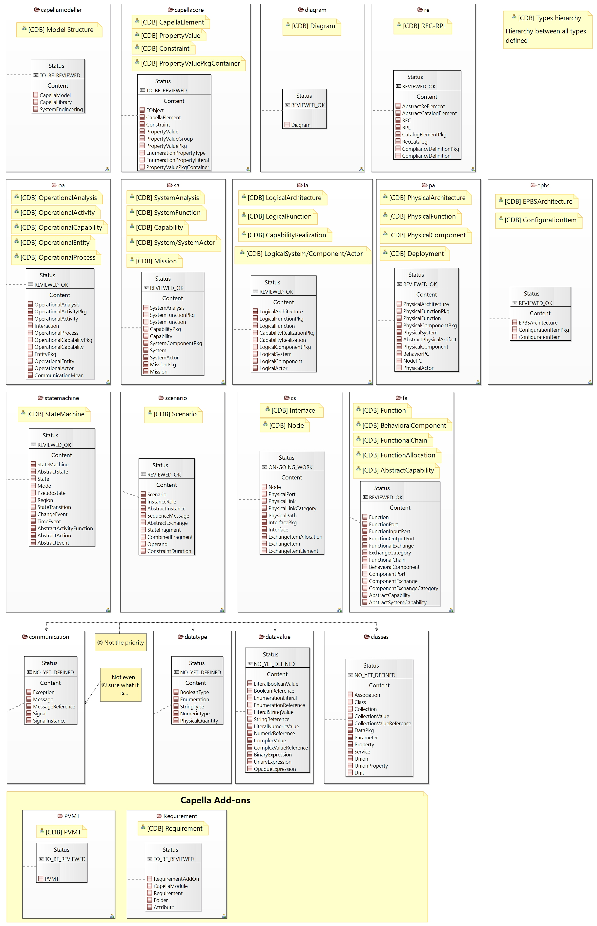

# [Package] capellamodeller

Diagrams:

Here are the diagrams of representing the elements introduced in this package:

[CDB] Model Structure:

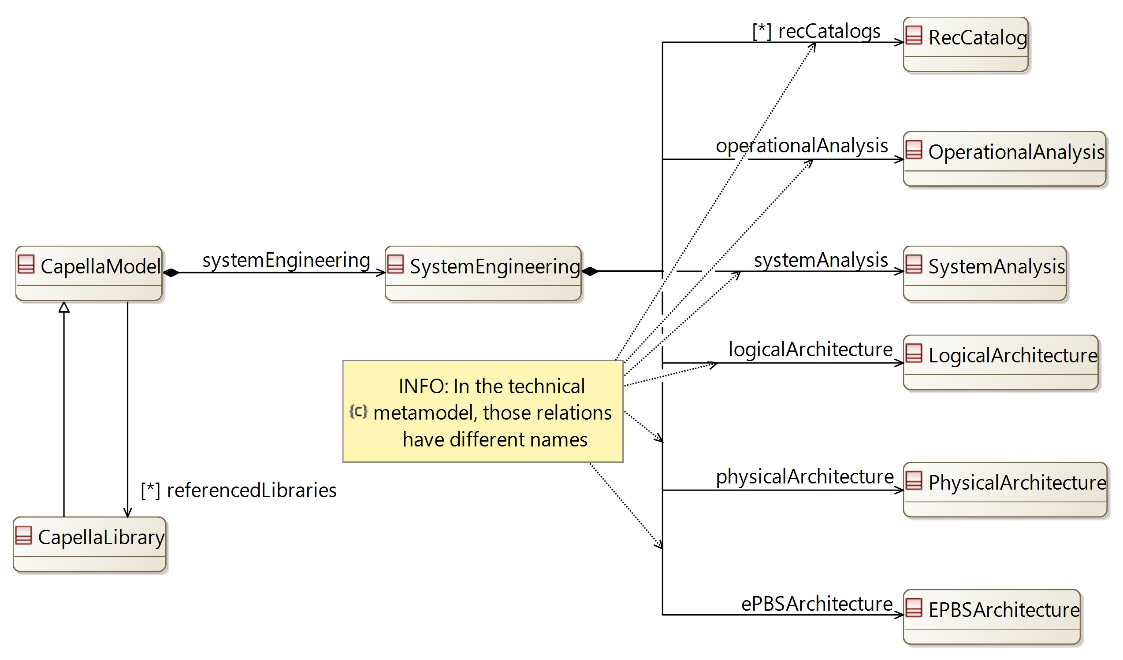

## [Type] CapellaModel

Description:

A Capella model. Used to defined the content of a model, and how to read a model

Direct super types:

*No direct super type*

Direct sub-types:

* **CapellaLibrary**

Possible parent elements:

*No possible parent defined*

Attributes:

*No attribute defined*

Relations:

|  |  |  |  |  |
| --- | --- | --- | --- | --- |
| **Ref. name** | **Kind** | **Card.** | **Target Type** | **Defined on** |
| systemEngineering | COMPOSITION | [1 1] | **SystemEngineering** | *defined on type* |
| referencedLibraries | ASSOCIATION | [0 *] | **CapellaLibrary** | *defined on type* |
| allDiagrams | ASSOCIATION | [0 *] | **Diagram** | *defined on type* |

Methods:

|  |  |  |  |
| --- | --- | --- | --- |
| **Method** | **Description** | **IN Param** | **Result** |
| getDiagrams |  | diagramType: String | diags: Diagram |

## [Type] CapellaLibrary

Description:

A Capella Library. A library is a model which can be referenced by other models in order to reuse its content

Direct super types:

* **CapellaModel**

Direct sub-types:

*No direct sub-type*

Possible parent elements:

*No possible parent defined*

Attributes:

*No attribute defined*

Relations:

|  |  |  |  |  |
| --- | --- | --- | --- | --- |
| **Ref. name** | **Kind** | **Card.** | **Target Type** | **Defined on** |
| systemEngineering | COMPOSITION | [1 1] | **SystemEngineering** | **CapellaModel** |
| referencedLibraries | ASSOCIATION | [0 *] | **CapellaLibrary** | **CapellaModel** |
| allDiagrams | ASSOCIATION | [0 *] | **Diagram** | **CapellaModel** |

Methods:

*No method defined*

## [Type] SystemEngineering

Description:

The main element in the definition of a Capella model. Contains the perspectives of the Arcadia methodology

Direct super types:

* **PropertyValuePkgContainer**

Direct sub-types:

*No direct sub-type*

Possible parent elements:

* CapellaModel
* CapellaLibrary

Attributes:

|  |  |  |
| --- | --- | --- |
| **Attribute name** | **Attribute type** | **Defined on** |
| id | String | **CapellaElement** |
| sid | String | **CapellaElement** |
| name | String | **CapellaElement** |
| summary | String | **CapellaElement** |
| description | String | **CapellaElement** |
| status | **Status** | **CapellaElement** |
| review | String | **CapellaElement** |
| visibleInDocumentation | Boolean | **CapellaElement** |
| visibleForTraceability | Boolean | **CapellaElement** |

Relations:

|  |  |  |  |  |
| --- | --- | --- | --- | --- |
| **Ref. name** | **Kind** | **Card.** | **Target Type** | **Defined on** |
| ownedDiagrams | COMPOSITION | [0 *] | **Diagram** | **EObject** |
| elementOfInterestForDiagrams | ASSOCIATION | [0 *] | **Diagram** | **EObject** |
| contextualElementForDiagrams | ASSOCIATION | [0 *] | **Diagram** | **EObject** |
| representingDiagrams | ASSOCIATION | [0 *] | **Diagram** | **EObject** |
| ownedConstraints | COMPOSITION | [0 *] | **Constraint** | **CapellaElement** |
| constraints | ASSOCIATION | [0 *] | **Constraint** | **CapellaElement** |
| ownedPropertyValues | COMPOSITION | [0 *] | **PropertyValue** | **CapellaElement** |
| appliedPropertyValues | ASSOCIATION | [0 *] | **PropertyValue** | **CapellaElement** |
| ownedPropertyValueGroups | COMPOSITION | [0 *] | **PropertyValueGroup** | **CapellaElement** |
| appliedPropertyValueGroups | ASSOCIATION | [0 *] | **PropertyValueGroup** | **CapellaElement** |
| ownedEnumerationPropertyTypes | COMPOSITION | [0 *] | **EnumerationPropertyType** | **CapellaElement** |
| ownedPropertyValuePkgs | COMPOSITION | [0 *] | **PropertyValuePkg** | **PropertyValuePkgContainer** |
| recCatalogs | COMPOSITION | [0 *] | **RecCatalog** | *defined on type* |
| operationalAnalysis | COMPOSITION | [1 1] | **OperationalAnalysis** | *defined on type* |
| systemAnalysis | COMPOSITION | [1 1] | **SystemAnalysis** | *defined on type* |
| logicalArchitecture | COMPOSITION | [1 1] | **LogicalArchitecture** | *defined on type* |
| physicalArchitecture | COMPOSITION | [1 1] | **PhysicalArchitecture** | *defined on type* |
| ePBSArchitecture | COMPOSITION | [1 1] | **EPBSArchitecture** | *defined on type* |

Methods:

*No method defined*

# [Package] capellacore

Diagrams:

Here are the diagrams of representing the elements introduced in this package:

[CDB] CapellaElement:

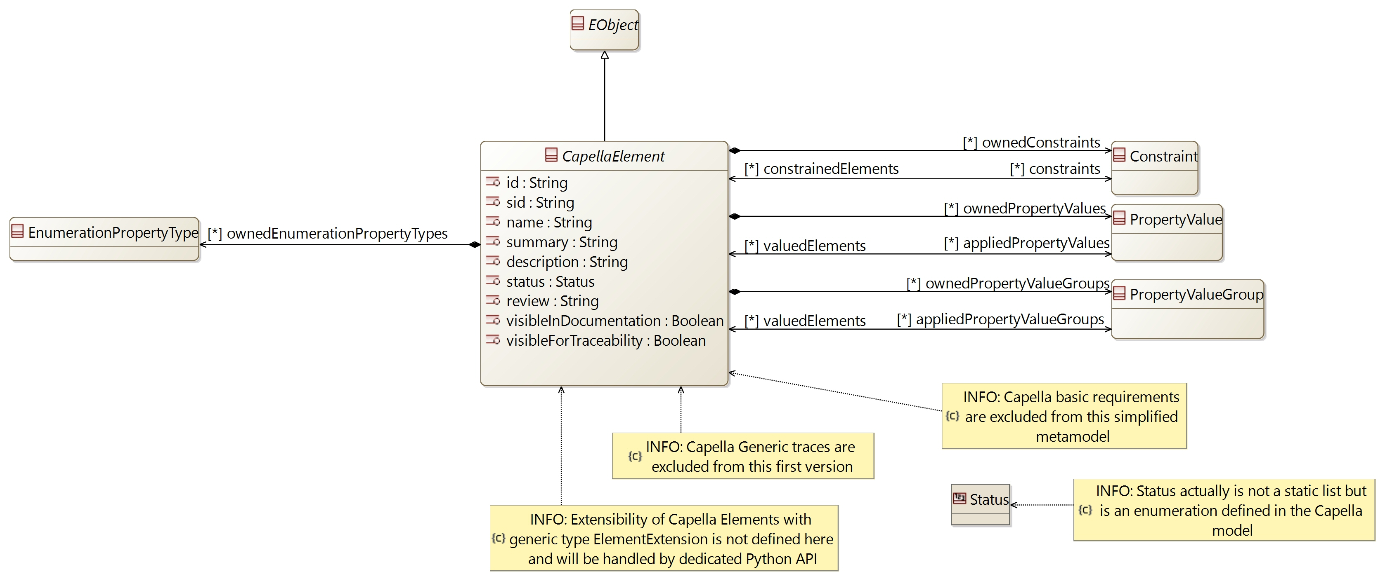

[CDB] Constraint:

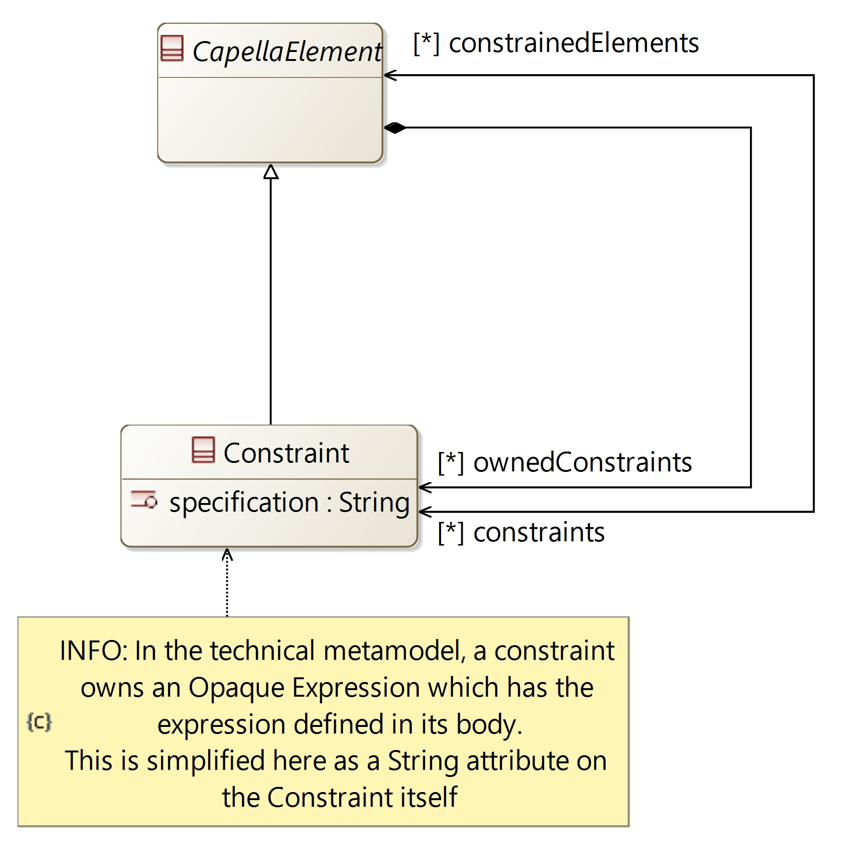

[CDB] PropertyValue:

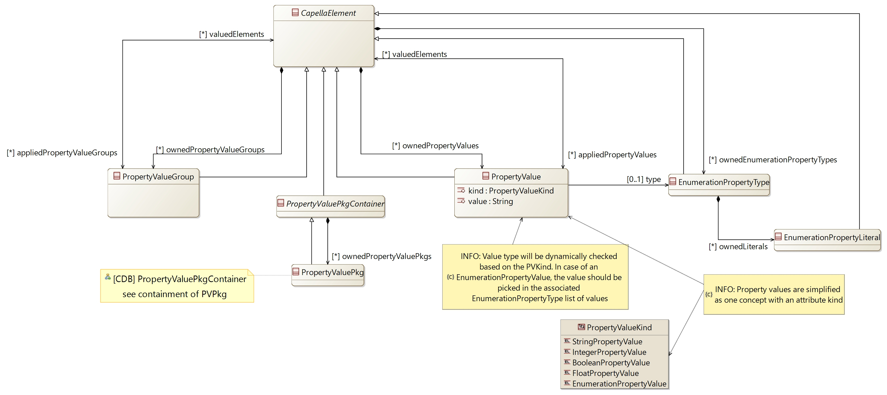

[CDB] PropertyValuePkgContainer:

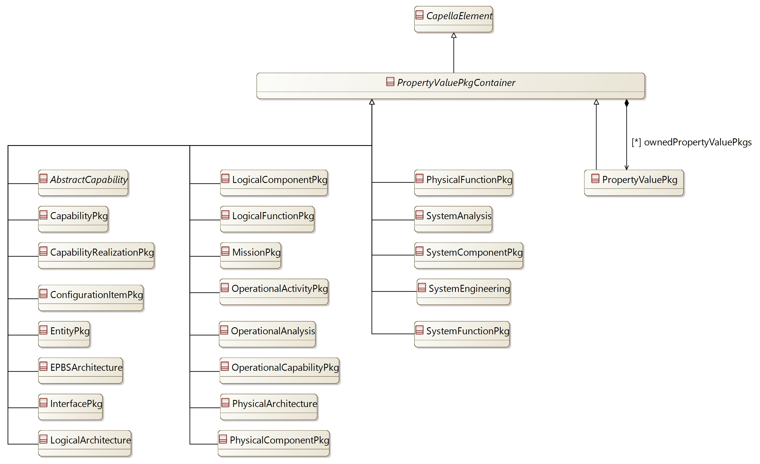

## [Type] EObject [Abstract]

Description:

A generic object. Defines generic relations which are available for all elements

Direct super types:

*No direct super type*

Direct sub-types:

* **CapellaElement**
* **AbstractReElement**
* **CapellaModule**
* **Requirement**
* **Attribute**

Possible parent elements:

*No possible parent defined*

Attributes:

*No attribute defined*

Relations:

|  |  |  |  |  |
| --- | --- | --- | --- | --- |
| **Ref. name** | **Kind** | **Card.** | **Target Type** | **Defined on** |
| ownedDiagrams | COMPOSITION | [0 *] | **Diagram** | *defined on type* |
| elementOfInterestForDiagrams | ASSOCIATION | [0 *] | **Diagram** | *defined on type* |
| contextualElementForDiagrams | ASSOCIATION | [0 *] | **Diagram** | *defined on type* |
| representingDiagrams | ASSOCIATION | [0 *] | **Diagram** | *defined on type* |

Methods:

*No method defined*

## [Type] CapellaElement [Abstract]

Description:

A generic Capella model Element. Used to define generic attributes and relations inherited by most Capella elements

Direct super types:

* **EObject**

Direct sub-types:

* **Constraint**
* **PropertyValue**
* **PropertyValueGroup**
* **EnumerationPropertyType**
* **EnumerationPropertyLiteral**
* **PropertyValuePkgContainer**
* **OperationalProcess**
* **OperationalActor**
* **CommunicationMean**
* **Mission**
* **PhysicalSystem**
* **AbstractPhysicalArtifact**
* **NodePC**
* **ConfigurationItem**
* **StateMachine**
* **AbstractState**
* **Region**
* **StateTransition**
* **AbstractActivityFunction**
* **AbstractEvent**
* **Scenario**
* **InstanceRole**
* **SequenceMessage**
* **StateFragment**
* **CombinedFragment**
* **Operand**
* **ConstraintDuration**
* **PhysicalLinkCategory**
* **PhysicalPath**
* **Interface**
* **ExchangeItemAllocation**
* **ExchangeItem**
* **ExchangeItemElement**
* **FunctionPort**
* **ExchangeCategory**
* **FunctionalChain**
* **BehavioralComponent**
* **ComponentPort**
* **ComponentExchange**
* **ComponentExchangeCategory**

Possible parent elements:

*No possible parent defined*

Attributes:

|  |  |  |
| --- | --- | --- |
| **Attribute name** | **Attribute type** | **Defined on** |
| id | String | *defined on type* |
| sid | String | *defined on type* |
| name | String | *defined on type* |
| summary | String | *defined on type* |
| description | String | *defined on type* |
| status | **Status** | *defined on type* |
| review | String | *defined on type* |
| visibleInDocumentation | Boolean | *defined on type* |
| visibleForTraceability | Boolean | *defined on type* |

Relations:

|  |  |  |  |  |
| --- | --- | --- | --- | --- |
| **Ref. name** | **Kind** | **Card.** | **Target Type** | **Defined on** |
| ownedDiagrams | COMPOSITION | [0 *] | **Diagram** | **EObject** |
| elementOfInterestForDiagrams | ASSOCIATION | [0 *] | **Diagram** | **EObject** |
| contextualElementForDiagrams | ASSOCIATION | [0 *] | **Diagram** | **EObject** |
| representingDiagrams | ASSOCIATION | [0 *] | **Diagram** | **EObject** |
| ownedConstraints | COMPOSITION | [0 *] | **Constraint** | *defined on type* |
| constraints | ASSOCIATION | [0 *] | **Constraint** | *defined on type* |
| ownedPropertyValues | COMPOSITION | [0 *] | **PropertyValue** | *defined on type* |
| appliedPropertyValues | ASSOCIATION | [0 *] | **PropertyValue** | *defined on type* |
| ownedPropertyValueGroups | COMPOSITION | [0 *] | **PropertyValueGroup** | *defined on type* |
| appliedPropertyValueGroups | ASSOCIATION | [0 *] | **PropertyValueGroup** | *defined on type* |
| ownedEnumerationPropertyTypes | COMPOSITION | [0 *] | **EnumerationPropertyType** | *defined on type* |

Methods:

*No method defined*

## [Type] Constraint

Description:

A generic constraint which can be defined on Capella elements

Direct super types:

* **CapellaElement**

Direct sub-types:

*No direct sub-type*

Possible parent elements:

* SystemEngineering
* Constraint
* PropertyValue
* PropertyValueGroup
* PropertyValuePkg
* EnumerationPropertyType
* EnumerationPropertyLiteral
* OperationalAnalysis
* OperationalActivityPkg
* OperationalActivity
* Interaction
* OperationalProcess
* OperationalCapabilityPkg
* OperationalCapability
* EntityPkg
* OperationalEntity
* OperationalActor
* CommunicationMean
* SystemAnalysis
* SystemFunctionPkg
* SystemFunction
* CapabilityPkg
* Capability
* SystemComponentPkg
* System
* SystemActor
* MissionPkg
* Mission
* LogicalArchitecture
* LogicalFunctionPkg
* LogicalFunction
* CapabilityRealizationPkg
* CapabilityRealization
* LogicalComponentPkg
* LogicalSystem
* LogicalComponent
* LogicalActor
* PhysicalArchitecture
* PhysicalFunctionPkg
* PhysicalFunction
* PhysicalComponentPkg
* PhysicalSystem
* BehaviorPC
* NodePC
* PhysicalActor
* EPBSArchitecture
* ConfigurationItemPkg
* ConfigurationItem
* StateMachine
* State
* Mode
* Pseudostate
* Region
* StateTransition
* ChangeEvent
* TimeEvent
* Scenario
* InstanceRole
* SequenceMessage
* StateFragment
* CombinedFragment
* Operand
* ConstraintDuration
* PhysicalPort
* PhysicalLink
* PhysicalLinkCategory
* PhysicalPath
* InterfacePkg
* Interface
* ExchangeItemAllocation
* ExchangeItem
* ExchangeItemElement
* FunctionInputPort
* FunctionOutputPort
* FunctionalExchange
* ExchangeCategory
* FunctionalChain
* ComponentPort
* ComponentExchange
* ComponentExchangeCategory

Attributes:

|  |  |  |
| --- | --- | --- |
| **Attribute name** | **Attribute type** | **Defined on** |
| id | String | **CapellaElement** |
| sid | String | **CapellaElement** |
| name | String | **CapellaElement** |
| summary | String | **CapellaElement** |
| description | String | **CapellaElement** |
| status | **Status** | **CapellaElement** |
| review | String | **CapellaElement** |
| visibleInDocumentation | Boolean | **CapellaElement** |
| visibleForTraceability | Boolean | **CapellaElement** |
| specification | String | *defined on type* |

Relations:

|  |  |  |  |  |
| --- | --- | --- | --- | --- |
| **Ref. name** | **Kind** | **Card.** | **Target Type** | **Defined on** |
| ownedDiagrams | COMPOSITION | [0 *] | **Diagram** | **EObject** |
| elementOfInterestForDiagrams | ASSOCIATION | [0 *] | **Diagram** | **EObject** |
| contextualElementForDiagrams | ASSOCIATION | [0 *] | **Diagram** | **EObject** |
| representingDiagrams | ASSOCIATION | [0 *] | **Diagram** | **EObject** |
| ownedConstraints | COMPOSITION | [0 *] | **Constraint** | **CapellaElement** |
| constraints | ASSOCIATION | [0 *] | **Constraint** | **CapellaElement** |
| ownedPropertyValues | COMPOSITION | [0 *] | **PropertyValue** | **CapellaElement** |
| appliedPropertyValues | ASSOCIATION | [0 *] | **PropertyValue** | **CapellaElement** |
| ownedPropertyValueGroups | COMPOSITION | [0 *] | **PropertyValueGroup** | **CapellaElement** |
| appliedPropertyValueGroups | ASSOCIATION | [0 *] | **PropertyValueGroup** | **CapellaElement** |
| ownedEnumerationPropertyTypes | COMPOSITION | [0 *] | **EnumerationPropertyType** | **CapellaElement** |
| constrainedElements | ASSOCIATION | [0 *] | **CapellaElement** | *defined on type* |

Methods:

*No method defined*

## [Type] PropertyValue

Description:

A generic property with a name and value which can be added to Capella elements

Direct super types:

* **CapellaElement**

Direct sub-types:

*No direct sub-type*

Possible parent elements:

* SystemEngineering
* Constraint
* PropertyValue
* PropertyValueGroup
* PropertyValuePkg
* EnumerationPropertyType
* EnumerationPropertyLiteral
* OperationalAnalysis
* OperationalActivityPkg
* OperationalActivity
* Interaction
* OperationalProcess
* OperationalCapabilityPkg
* OperationalCapability
* EntityPkg
* OperationalEntity
* OperationalActor
* CommunicationMean
* SystemAnalysis
* SystemFunctionPkg
* SystemFunction
* CapabilityPkg
* Capability
* SystemComponentPkg
* System
* SystemActor
* MissionPkg
* Mission
* LogicalArchitecture
* LogicalFunctionPkg
* LogicalFunction
* CapabilityRealizationPkg
* CapabilityRealization
* LogicalComponentPkg
* LogicalSystem
* LogicalComponent
* LogicalActor
* PhysicalArchitecture
* PhysicalFunctionPkg
* PhysicalFunction
* PhysicalComponentPkg
* PhysicalSystem
* BehaviorPC
* NodePC
* PhysicalActor
* EPBSArchitecture
* ConfigurationItemPkg
* ConfigurationItem
* StateMachine
* State
* Mode
* Pseudostate
* Region
* StateTransition
* ChangeEvent
* TimeEvent
* Scenario
* InstanceRole
* SequenceMessage
* StateFragment
* CombinedFragment
* Operand
* ConstraintDuration
* PhysicalPort
* PhysicalLink
* PhysicalLinkCategory
* PhysicalPath
* InterfacePkg
* Interface
* ExchangeItemAllocation
* ExchangeItem
* ExchangeItemElement
* FunctionInputPort
* FunctionOutputPort
* FunctionalExchange
* ExchangeCategory
* FunctionalChain
* ComponentPort
* ComponentExchange
* ComponentExchangeCategory

Attributes:

|  |  |  |
| --- | --- | --- |
| **Attribute name** | **Attribute type** | **Defined on** |
| id | String | **CapellaElement** |
| sid | String | **CapellaElement** |
| name | String | **CapellaElement** |
| summary | String | **CapellaElement** |
| description | String | **CapellaElement** |
| status | **Status** | **CapellaElement** |
| review | String | **CapellaElement** |
| visibleInDocumentation | Boolean | **CapellaElement** |
| visibleForTraceability | Boolean | **CapellaElement** |
| kind | **PropertyValueKind** | *defined on type* |
| value | String | *defined on type* |

Relations:

|  |  |  |  |  |
| --- | --- | --- | --- | --- |
| **Ref. name** | **Kind** | **Card.** | **Target Type** | **Defined on** |
| ownedDiagrams | COMPOSITION | [0 *] | **Diagram** | **EObject** |
| elementOfInterestForDiagrams | ASSOCIATION | [0 *] | **Diagram** | **EObject** |
| contextualElementForDiagrams | ASSOCIATION | [0 *] | **Diagram** | **EObject** |
| representingDiagrams | ASSOCIATION | [0 *] | **Diagram** | **EObject** |
| ownedConstraints | COMPOSITION | [0 *] | **Constraint** | **CapellaElement** |
| constraints | ASSOCIATION | [0 *] | **Constraint** | **CapellaElement** |
| ownedPropertyValues | COMPOSITION | [0 *] | **PropertyValue** | **CapellaElement** |
| appliedPropertyValues | ASSOCIATION | [0 *] | **PropertyValue** | **CapellaElement** |
| ownedPropertyValueGroups | COMPOSITION | [0 *] | **PropertyValueGroup** | **CapellaElement** |
| appliedPropertyValueGroups | ASSOCIATION | [0 *] | **PropertyValueGroup** | **CapellaElement** |
| ownedEnumerationPropertyTypes | COMPOSITION | [0 *] | **EnumerationPropertyType** | **CapellaElement** |
| valuedElements | ASSOCIATION | [0 *] | **CapellaElement** | *defined on type* |
| type | ASSOCIATION | [0 1] | **EnumerationPropertyType** | *defined on type* |

Methods:

*No method defined*

## [Type] PropertyValueGroup

Description:

A group which can contain several PropertyValue and be applied to CapellaElements

Direct super types:

* **CapellaElement**

Direct sub-types:

*No direct sub-type*

Possible parent elements:

* SystemEngineering
* Constraint
* PropertyValue
* PropertyValueGroup
* PropertyValuePkg
* EnumerationPropertyType
* EnumerationPropertyLiteral
* OperationalAnalysis
* OperationalActivityPkg
* OperationalActivity
* Interaction
* OperationalProcess
* OperationalCapabilityPkg
* OperationalCapability
* EntityPkg
* OperationalEntity
* OperationalActor
* CommunicationMean
* SystemAnalysis
* SystemFunctionPkg
* SystemFunction
* CapabilityPkg
* Capability
* SystemComponentPkg
* System
* SystemActor
* MissionPkg
* Mission
* LogicalArchitecture
* LogicalFunctionPkg
* LogicalFunction
* CapabilityRealizationPkg
* CapabilityRealization
* LogicalComponentPkg
* LogicalSystem
* LogicalComponent
* LogicalActor
* PhysicalArchitecture
* PhysicalFunctionPkg
* PhysicalFunction
* PhysicalComponentPkg
* PhysicalSystem
* BehaviorPC
* NodePC
* PhysicalActor
* EPBSArchitecture
* ConfigurationItemPkg
* ConfigurationItem
* StateMachine
* State
* Mode
* Pseudostate
* Region
* StateTransition
* ChangeEvent
* TimeEvent
* Scenario
* InstanceRole
* SequenceMessage
* StateFragment
* CombinedFragment
* Operand
* ConstraintDuration
* PhysicalPort
* PhysicalLink
* PhysicalLinkCategory
* PhysicalPath
* InterfacePkg
* Interface
* ExchangeItemAllocation
* ExchangeItem
* ExchangeItemElement
* FunctionInputPort
* FunctionOutputPort
* FunctionalExchange
* ExchangeCategory
* FunctionalChain
* ComponentPort
* ComponentExchange
* ComponentExchangeCategory

Attributes:

|  |  |  |
| --- | --- | --- |
| **Attribute name** | **Attribute type** | **Defined on** |
| id | String | **CapellaElement** |
| sid | String | **CapellaElement** |
| name | String | **CapellaElement** |
| summary | String | **CapellaElement** |
| description | String | **CapellaElement** |
| status | **Status** | **CapellaElement** |
| review | String | **CapellaElement** |
| visibleInDocumentation | Boolean | **CapellaElement** |
| visibleForTraceability | Boolean | **CapellaElement** |

Relations:

|  |  |  |  |  |
| --- | --- | --- | --- | --- |
| **Ref. name** | **Kind** | **Card.** | **Target Type** | **Defined on** |
| ownedDiagrams | COMPOSITION | [0 *] | **Diagram** | **EObject** |
| elementOfInterestForDiagrams | ASSOCIATION | [0 *] | **Diagram** | **EObject** |
| contextualElementForDiagrams | ASSOCIATION | [0 *] | **Diagram** | **EObject** |
| representingDiagrams | ASSOCIATION | [0 *] | **Diagram** | **EObject** |
| ownedConstraints | COMPOSITION | [0 *] | **Constraint** | **CapellaElement** |
| constraints | ASSOCIATION | [0 *] | **Constraint** | **CapellaElement** |
| ownedPropertyValues | COMPOSITION | [0 *] | **PropertyValue** | **CapellaElement** |
| appliedPropertyValues | ASSOCIATION | [0 *] | **PropertyValue** | **CapellaElement** |
| ownedPropertyValueGroups | COMPOSITION | [0 *] | **PropertyValueGroup** | **CapellaElement** |
| appliedPropertyValueGroups | ASSOCIATION | [0 *] | **PropertyValueGroup** | **CapellaElement** |
| ownedEnumerationPropertyTypes | COMPOSITION | [0 *] | **EnumerationPropertyType** | **CapellaElement** |
| valuedElements | ASSOCIATION | [0 *] | **CapellaElement** | *defined on type* |

Methods:

*No method defined*

## [Type] PropertyValuePkg

Description:

A package to contain PropertyValues and/or PropertyValueGroups

Direct super types:

* **PropertyValuePkgContainer**

Direct sub-types:

*No direct sub-type*

Possible parent elements:

* SystemEngineering
* PropertyValuePkg
* OperationalAnalysis
* OperationalActivityPkg
* OperationalCapabilityPkg
* OperationalCapability
* EntityPkg
* SystemAnalysis
* SystemFunctionPkg
* CapabilityPkg
* Capability
* SystemComponentPkg
* MissionPkg
* LogicalArchitecture
* LogicalFunctionPkg
* CapabilityRealizationPkg
* CapabilityRealization
* LogicalComponentPkg
* PhysicalArchitecture
* PhysicalFunctionPkg
* PhysicalComponentPkg
* EPBSArchitecture
* ConfigurationItemPkg
* InterfacePkg

Attributes:

|  |  |  |
| --- | --- | --- |
| **Attribute name** | **Attribute type** | **Defined on** |
| id | String | **CapellaElement** |
| sid | String | **CapellaElement** |
| name | String | **CapellaElement** |
| summary | String | **CapellaElement** |
| description | String | **CapellaElement** |
| status | **Status** | **CapellaElement** |
| review | String | **CapellaElement** |
| visibleInDocumentation | Boolean | **CapellaElement** |
| visibleForTraceability | Boolean | **CapellaElement** |

Relations:

|  |  |  |  |  |
| --- | --- | --- | --- | --- |
| **Ref. name** | **Kind** | **Card.** | **Target Type** | **Defined on** |
| ownedDiagrams | COMPOSITION | [0 *] | **Diagram** | **EObject** |
| elementOfInterestForDiagrams | ASSOCIATION | [0 *] | **Diagram** | **EObject** |
| contextualElementForDiagrams | ASSOCIATION | [0 *] | **Diagram** | **EObject** |
| representingDiagrams | ASSOCIATION | [0 *] | **Diagram** | **EObject** |
| ownedConstraints | COMPOSITION | [0 *] | **Constraint** | **CapellaElement** |
| constraints | ASSOCIATION | [0 *] | **Constraint** | **CapellaElement** |
| ownedPropertyValues | COMPOSITION | [0 *] | **PropertyValue** | **CapellaElement** |
| appliedPropertyValues | ASSOCIATION | [0 *] | **PropertyValue** | **CapellaElement** |
| ownedPropertyValueGroups | COMPOSITION | [0 *] | **PropertyValueGroup** | **CapellaElement** |
| appliedPropertyValueGroups | ASSOCIATION | [0 *] | **PropertyValueGroup** | **CapellaElement** |
| ownedEnumerationPropertyTypes | COMPOSITION | [0 *] | **EnumerationPropertyType** | **CapellaElement** |
| ownedPropertyValuePkgs | COMPOSITION | [0 *] | **PropertyValuePkg** | **PropertyValuePkgContainer** |

Methods:

*No method defined*

## [Type] EnumerationPropertyType

Description:

The definition of an Enumeration to type a PropertyValue

Direct super types:

* **CapellaElement**

Direct sub-types:

*No direct sub-type*

Possible parent elements:

* SystemEngineering
* Constraint
* PropertyValue
* PropertyValueGroup
* PropertyValuePkg
* EnumerationPropertyType
* EnumerationPropertyLiteral
* OperationalAnalysis
* OperationalActivityPkg
* OperationalActivity
* Interaction
* OperationalProcess
* OperationalCapabilityPkg
* OperationalCapability
* EntityPkg
* OperationalEntity
* OperationalActor
* CommunicationMean
* SystemAnalysis
* SystemFunctionPkg
* SystemFunction
* CapabilityPkg
* Capability
* SystemComponentPkg
* System
* SystemActor
* MissionPkg
* Mission
* LogicalArchitecture
* LogicalFunctionPkg
* LogicalFunction
* CapabilityRealizationPkg
* CapabilityRealization
* LogicalComponentPkg
* LogicalSystem
* LogicalComponent
* LogicalActor
* PhysicalArchitecture
* PhysicalFunctionPkg
* PhysicalFunction
* PhysicalComponentPkg
* PhysicalSystem
* BehaviorPC
* NodePC
* PhysicalActor
* EPBSArchitecture
* ConfigurationItemPkg
* ConfigurationItem
* StateMachine
* State
* Mode
* Pseudostate
* Region
* StateTransition
* ChangeEvent
* TimeEvent
* Scenario
* InstanceRole
* SequenceMessage
* StateFragment
* CombinedFragment
* Operand
* ConstraintDuration
* PhysicalPort
* PhysicalLink
* PhysicalLinkCategory
* PhysicalPath
* InterfacePkg
* Interface
* ExchangeItemAllocation
* ExchangeItem
* ExchangeItemElement
* FunctionInputPort
* FunctionOutputPort
* FunctionalExchange
* ExchangeCategory
* FunctionalChain
* ComponentPort
* ComponentExchange
* ComponentExchangeCategory

Attributes:

|  |  |  |
| --- | --- | --- |
| **Attribute name** | **Attribute type** | **Defined on** |
| id | String | **CapellaElement** |
| sid | String | **CapellaElement** |
| name | String | **CapellaElement** |
| summary | String | **CapellaElement** |
| description | String | **CapellaElement** |
| status | **Status** | **CapellaElement** |
| review | String | **CapellaElement** |
| visibleInDocumentation | Boolean | **CapellaElement** |
| visibleForTraceability | Boolean | **CapellaElement** |

Relations:

|  |  |  |  |  |
| --- | --- | --- | --- | --- |
| **Ref. name** | **Kind** | **Card.** | **Target Type** | **Defined on** |
| ownedDiagrams | COMPOSITION | [0 *] | **Diagram** | **EObject** |
| elementOfInterestForDiagrams | ASSOCIATION | [0 *] | **Diagram** | **EObject** |
| contextualElementForDiagrams | ASSOCIATION | [0 *] | **Diagram** | **EObject** |
| representingDiagrams | ASSOCIATION | [0 *] | **Diagram** | **EObject** |
| ownedConstraints | COMPOSITION | [0 *] | **Constraint** | **CapellaElement** |
| constraints | ASSOCIATION | [0 *] | **Constraint** | **CapellaElement** |
| ownedPropertyValues | COMPOSITION | [0 *] | **PropertyValue** | **CapellaElement** |
| appliedPropertyValues | ASSOCIATION | [0 *] | **PropertyValue** | **CapellaElement** |
| ownedPropertyValueGroups | COMPOSITION | [0 *] | **PropertyValueGroup** | **CapellaElement** |
| appliedPropertyValueGroups | ASSOCIATION | [0 *] | **PropertyValueGroup** | **CapellaElement** |
| ownedEnumerationPropertyTypes | COMPOSITION | [0 *] | **EnumerationPropertyType** | **CapellaElement** |
| ownedLiterals | COMPOSITION | [0 *] | **EnumerationPropertyLiteral** | *defined on type* |

Methods:

*No method defined*

## [Type] EnumerationPropertyLiteral

Description:

A value defined in an EnumerationPropertyType

Direct super types:

* **CapellaElement**

Direct sub-types:

*No direct sub-type*

Possible parent elements:

* EnumerationPropertyType

Attributes:

|  |  |  |
| --- | --- | --- |
| **Attribute name** | **Attribute type** | **Defined on** |
| id | String | **CapellaElement** |
| sid | String | **CapellaElement** |
| name | String | **CapellaElement** |
| summary | String | **CapellaElement** |
| description | String | **CapellaElement** |
| status | **Status** | **CapellaElement** |
| review | String | **CapellaElement** |
| visibleInDocumentation | Boolean | **CapellaElement** |
| visibleForTraceability | Boolean | **CapellaElement** |

Relations:

|  |  |  |  |  |
| --- | --- | --- | --- | --- |
| **Ref. name** | **Kind** | **Card.** | **Target Type** | **Defined on** |
| ownedDiagrams | COMPOSITION | [0 *] | **Diagram** | **EObject** |
| elementOfInterestForDiagrams | ASSOCIATION | [0 *] | **Diagram** | **EObject** |
| contextualElementForDiagrams | ASSOCIATION | [0 *] | **Diagram** | **EObject** |
| representingDiagrams | ASSOCIATION | [0 *] | **Diagram** | **EObject** |
| ownedConstraints | COMPOSITION | [0 *] | **Constraint** | **CapellaElement** |
| constraints | ASSOCIATION | [0 *] | **Constraint** | **CapellaElement** |
| ownedPropertyValues | COMPOSITION | [0 *] | **PropertyValue** | **CapellaElement** |
| appliedPropertyValues | ASSOCIATION | [0 *] | **PropertyValue** | **CapellaElement** |
| ownedPropertyValueGroups | COMPOSITION | [0 *] | **PropertyValueGroup** | **CapellaElement** |
| appliedPropertyValueGroups | ASSOCIATION | [0 *] | **PropertyValueGroup** | **CapellaElement** |
| ownedEnumerationPropertyTypes | COMPOSITION | [0 *] | **EnumerationPropertyType** | **CapellaElement** |

Methods:

*No method defined*

## [Type] PropertyValuePkgContainer [Abstract]

Description:

An abstract type to define all elements which can contain PropertyValuePkg

Direct super types:

* **CapellaElement**

Direct sub-types:

* **SystemEngineering**
* **PropertyValuePkg**
* **OperationalAnalysis**
* **OperationalActivityPkg**
* **OperationalCapabilityPkg**
* **EntityPkg**
* **SystemAnalysis**
* **SystemFunctionPkg**
* **CapabilityPkg**
* **SystemComponentPkg**
* **MissionPkg**
* **LogicalArchitecture**
* **LogicalFunctionPkg**
* **CapabilityRealizationPkg**
* **LogicalComponentPkg**
* **PhysicalArchitecture**
* **PhysicalFunctionPkg**
* **PhysicalComponentPkg**
* **EPBSArchitecture**
* **ConfigurationItemPkg**
* **InterfacePkg**
* **AbstractCapability**

Possible parent elements:

*No possible parent defined*

Attributes:

|  |  |  |
| --- | --- | --- |
| **Attribute name** | **Attribute type** | **Defined on** |
| id | String | **CapellaElement** |
| sid | String | **CapellaElement** |
| name | String | **CapellaElement** |
| summary | String | **CapellaElement** |
| description | String | **CapellaElement** |
| status | **Status** | **CapellaElement** |
| review | String | **CapellaElement** |
| visibleInDocumentation | Boolean | **CapellaElement** |
| visibleForTraceability | Boolean | **CapellaElement** |

Relations:

|  |  |  |  |  |
| --- | --- | --- | --- | --- |
| **Ref. name** | **Kind** | **Card.** | **Target Type** | **Defined on** |
| ownedDiagrams | COMPOSITION | [0 *] | **Diagram** | **EObject** |
| elementOfInterestForDiagrams | ASSOCIATION | [0 *] | **Diagram** | **EObject** |
| contextualElementForDiagrams | ASSOCIATION | [0 *] | **Diagram** | **EObject** |
| representingDiagrams | ASSOCIATION | [0 *] | **Diagram** | **EObject** |
| ownedConstraints | COMPOSITION | [0 *] | **Constraint** | **CapellaElement** |
| constraints | ASSOCIATION | [0 *] | **Constraint** | **CapellaElement** |
| ownedPropertyValues | COMPOSITION | [0 *] | **PropertyValue** | **CapellaElement** |
| appliedPropertyValues | ASSOCIATION | [0 *] | **PropertyValue** | **CapellaElement** |
| ownedPropertyValueGroups | COMPOSITION | [0 *] | **PropertyValueGroup** | **CapellaElement** |
| appliedPropertyValueGroups | ASSOCIATION | [0 *] | **PropertyValueGroup** | **CapellaElement** |
| ownedEnumerationPropertyTypes | COMPOSITION | [0 *] | **EnumerationPropertyType** | **CapellaElement** |
| ownedPropertyValuePkgs | COMPOSITION | [0 *] | **PropertyValuePkg** | *defined on type* |

Methods:

*No method defined*

## [Enumeration] Status

List of values:

*No value defined*

Used by:

* **SystemEngineering**
* **CapellaElement**
* **Constraint**
* **PropertyValue**
* **PropertyValueGroup**
* **PropertyValuePkg**
* **EnumerationPropertyType**
* **EnumerationPropertyLiteral**
* **PropertyValuePkgContainer**
* **Diagram**
* **OperationalAnalysis**
* **OperationalActivityPkg**
* **OperationalActivity**
* **Interaction**
* **OperationalProcess**
* **OperationalCapabilityPkg**
* **OperationalCapability**
* **EntityPkg**
* **OperationalEntity**
* **OperationalActor**
* **CommunicationMean**
* **SystemAnalysis**
* **SystemFunctionPkg**
* **SystemFunction**
* **CapabilityPkg**
* **Capability**
* **SystemComponentPkg**
* **System**
* **SystemActor**
* **MissionPkg**
* **Mission**
* **LogicalArchitecture**
* **LogicalFunctionPkg**
* **LogicalFunction**
* **CapabilityRealizationPkg**
* **CapabilityRealization**
* **LogicalComponentPkg**
* **LogicalSystem**
* **LogicalComponent**
* **LogicalActor**
* **PhysicalArchitecture**
* **PhysicalFunctionPkg**
* **PhysicalFunction**
* **PhysicalComponentPkg**
* **PhysicalSystem**
* **AbstractPhysicalArtifact**
* **PhysicalComponent**
* **BehaviorPC**
* **NodePC**
* **PhysicalActor**
* **EPBSArchitecture**
* **ConfigurationItemPkg**
* **ConfigurationItem**
* **StateMachine**
* **AbstractState**
* **State**
* **Mode**
* **Pseudostate**
* **Region**
* **StateTransition**
* **ChangeEvent**
* **TimeEvent**
* **AbstractActivityFunction**
* **AbstractEvent**
* **Scenario**
* **InstanceRole**
* **SequenceMessage**
* **StateFragment**
* **CombinedFragment**
* **Operand**
* **ConstraintDuration**
* **PhysicalPort**
* **PhysicalLink**
* **PhysicalLinkCategory**
* **PhysicalPath**
* **InterfacePkg**
* **Interface**
* **ExchangeItemAllocation**
* **ExchangeItem**
* **ExchangeItemElement**
* **Function**
* **FunctionPort**
* **FunctionInputPort**
* **FunctionOutputPort**
* **FunctionalExchange**
* **ExchangeCategory**
* **FunctionalChain**
* **BehavioralComponent**
* **ComponentPort**
* **ComponentExchange**
* **ComponentExchangeCategory**
* **AbstractCapability**
* **AbstractSystemCapability**

## [Enumeration] PropertyValueKind

List of values:

* StringPropertyValue
* IntegerPropertyValue
* BooleanPropertyValue
* FloatPropertyValue
* EnumerationPropertyValue

Used by:

* **PropertyValue**

## [Enumeration] VisibilityKind

List of values:

* UNSET
* PUBLIC
* PROTECTED
* PRIVATE
* PACKAGE

Used by:

* **Interface**

# [Package] diagram

Diagrams:

Here are the diagrams of representing the elements introduced in this package:

[CDB] Diagram:

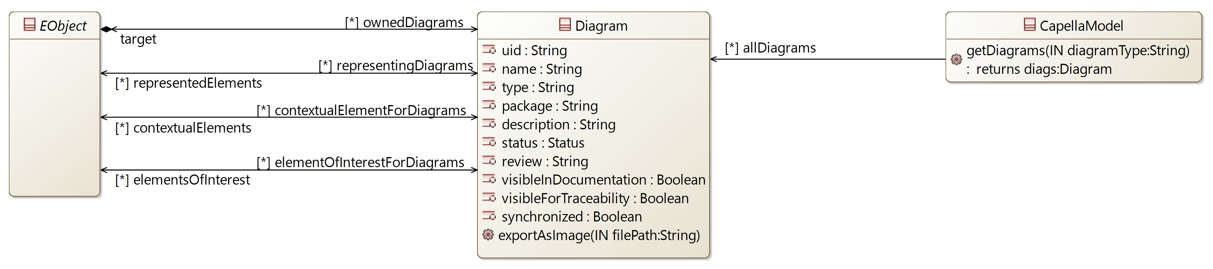

## [Type] Diagram

Description:

A generic Capella diagram

Direct super types:

*No direct super type*

Direct sub-types:

*No direct sub-type*

Possible parent elements:

* SystemEngineering
* Constraint
* PropertyValue
* PropertyValueGroup
* PropertyValuePkg
* EnumerationPropertyType
* EnumerationPropertyLiteral
* REC
* RPL
* CatalogElementPkg
* RecCatalog
* CompliancyDefinitionPkg
* CompliancyDefinition
* OperationalAnalysis
* OperationalActivityPkg
* OperationalActivity
* Interaction
* OperationalProcess
* OperationalCapabilityPkg
* OperationalCapability
* EntityPkg
* OperationalEntity
* OperationalActor
* CommunicationMean
* SystemAnalysis
* SystemFunctionPkg
* SystemFunction
* CapabilityPkg
* Capability
* SystemComponentPkg
* System
* SystemActor
* MissionPkg
* Mission
* LogicalArchitecture
* LogicalFunctionPkg
* LogicalFunction
* CapabilityRealizationPkg
* CapabilityRealization
* LogicalComponentPkg
* LogicalSystem
* LogicalComponent
* LogicalActor
* PhysicalArchitecture
* PhysicalFunctionPkg
* PhysicalFunction
* PhysicalComponentPkg
* PhysicalSystem
* BehaviorPC
* NodePC
* PhysicalActor
* EPBSArchitecture
* ConfigurationItemPkg
* ConfigurationItem
* StateMachine
* State
* Mode
* Pseudostate
* Region
* StateTransition
* ChangeEvent
* TimeEvent
* Scenario
* InstanceRole
* SequenceMessage
* StateFragment
* CombinedFragment
* Operand
* ConstraintDuration
* PhysicalPort
* PhysicalLink
* PhysicalLinkCategory
* PhysicalPath
* InterfacePkg
* Interface
* ExchangeItemAllocation
* ExchangeItem
* ExchangeItemElement
* FunctionInputPort
* FunctionOutputPort
* FunctionalExchange
* ExchangeCategory
* FunctionalChain
* ComponentPort
* ComponentExchange
* ComponentExchangeCategory
* CapellaModule
* Requirement
* Folder
* Attribute

Attributes:

|  |  |  |
| --- | --- | --- |
| **Attribute name** | **Attribute type** | **Defined on** |
| uid | String | *defined on type* |
| name | String | *defined on type* |
| type | String | *defined on type* |
| package | String | *defined on type* |
| description | String | *defined on type* |
| status | **Status** | *defined on type* |
| review | String | *defined on type* |
| visibleInDocumentation | Boolean | *defined on type* |
| visibleForTraceability | Boolean | *defined on type* |
| synchronized | Boolean | *defined on type* |

Relations:

|  |  |  |  |  |
| --- | --- | --- | --- | --- |
| **Ref. name** | **Kind** | **Card.** | **Target Type** | **Defined on** |
| target | ASSOCIATION | [1 1] | **EObject** | *defined on type* |
| representedElements | ASSOCIATION | [0 *] | **EObject** | *defined on type* |
| contextualElements | ASSOCIATION | [0 *] | **EObject** | *defined on type* |
| elementsOfInterest | ASSOCIATION | [0 *] | **EObject** | *defined on type* |

Methods:

|  |  |  |  |
| --- | --- | --- | --- |
| **Method** | **Description** | **IN Param** | **Result** |
| exportAsImage |  | filePath: String |  |

# [Package] re

Diagrams:

Here are the diagrams of representing the elements introduced in this package:

[CDB] REC-RPL:

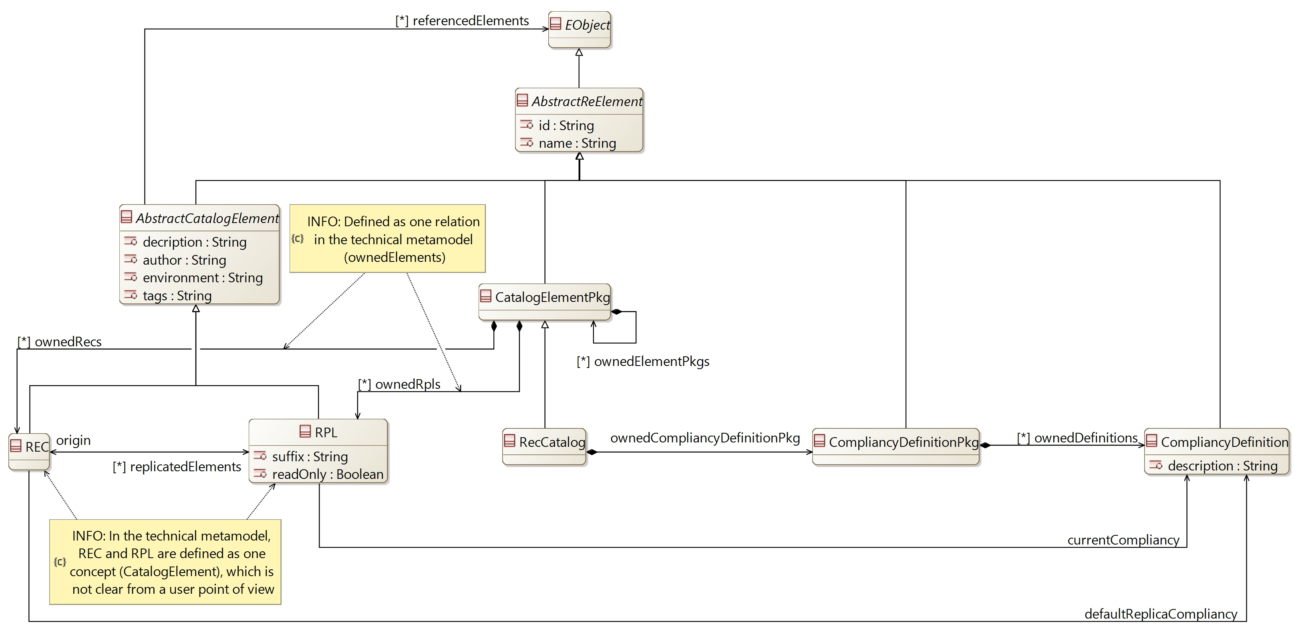

## [Type] AbstractReElement [Abstract]

Description:

An abstract type to define the generic attributes of REC / RPL and packages elements

Direct super types:

* **EObject**

Direct sub-types:

* **AbstractCatalogElement**
* **CatalogElementPkg**
* **CompliancyDefinitionPkg**
* **CompliancyDefinition**

Possible parent elements:

*No possible parent defined*

Attributes:

|  |  |  |
| --- | --- | --- |
| **Attribute name** | **Attribute type** | **Defined on** |
| id | String | *defined on type* |
| name | String | *defined on type* |

Relations:

|  |  |  |  |  |
| --- | --- | --- | --- | --- |
| **Ref. name** | **Kind** | **Card.** | **Target Type** | **Defined on** |
| ownedDiagrams | COMPOSITION | [0 *] | **Diagram** | **EObject** |
| elementOfInterestForDiagrams | ASSOCIATION | [0 *] | **Diagram** | **EObject** |
| contextualElementForDiagrams | ASSOCIATION | [0 *] | **Diagram** | **EObject** |
| representingDiagrams | ASSOCIATION | [0 *] | **Diagram** | **EObject** |

Methods:

*No method defined*

## [Type] AbstractCatalogElement [Abstract]

Description:

An abstract type to define the generic attributes and relations of REC / RPL elements

Direct super types:

* **AbstractReElement**

Direct sub-types:

* **REC**
* **RPL**

Possible parent elements:

*No possible parent defined*

Attributes:

|  |  |  |
| --- | --- | --- |
| **Attribute name** | **Attribute type** | **Defined on** |
| id | String | **AbstractReElement** |
| name | String | **AbstractReElement** |
| decription | String | *defined on type* |
| author | String | *defined on type* |
| environment | String | *defined on type* |
| tags | String | *defined on type* |

Relations:

|  |  |  |  |  |
| --- | --- | --- | --- | --- |
| **Ref. name** | **Kind** | **Card.** | **Target Type** | **Defined on** |
| ownedDiagrams | COMPOSITION | [0 *] | **Diagram** | **EObject** |
| elementOfInterestForDiagrams | ASSOCIATION | [0 *] | **Diagram** | **EObject** |
| contextualElementForDiagrams | ASSOCIATION | [0 *] | **Diagram** | **EObject** |
| representingDiagrams | ASSOCIATION | [0 *] | **Diagram** | **EObject** |
| referencedElements | ASSOCIATION | [0 *] | **EObject** | *defined on type* |

Methods:

*No method defined*

## [Type] REC

Description:

A Record element is the definition of a set of elements to be replicated together

Direct super types:

* **AbstractCatalogElement**

Direct sub-types:

*No direct sub-type*

Possible parent elements:

* CatalogElementPkg
* RecCatalog

Attributes:

|  |  |  |
| --- | --- | --- |
| **Attribute name** | **Attribute type** | **Defined on** |
| id | String | **AbstractReElement** |
| name | String | **AbstractReElement** |
| decription | String | **AbstractCatalogElement** |
| author | String | **AbstractCatalogElement** |
| environment | String | **AbstractCatalogElement** |
| tags | String | **AbstractCatalogElement** |

Relations:

|  |  |  |  |  |
| --- | --- | --- | --- | --- |
| **Ref. name** | **Kind** | **Card.** | **Target Type** | **Defined on** |
| ownedDiagrams | COMPOSITION | [0 *] | **Diagram** | **EObject** |
| elementOfInterestForDiagrams | ASSOCIATION | [0 *] | **Diagram** | **EObject** |
| contextualElementForDiagrams | ASSOCIATION | [0 *] | **Diagram** | **EObject** |
| representingDiagrams | ASSOCIATION | [0 *] | **Diagram** | **EObject** |
| referencedElements | ASSOCIATION | [0 *] | **EObject** | **AbstractCatalogElement** |
| defaultReplicaCompliancy | ASSOCIATION | [1 1] | **CompliancyDefinition** | *defined on type* |
| replicatedElements | ASSOCIATION | [0 *] | **RPL** | *defined on type* |

Methods:

*No method defined*

## [Type] RPL

Description:

A replay element is the instantiation of a record element

Direct super types:

* **AbstractCatalogElement**

Direct sub-types:

*No direct sub-type*

Possible parent elements:

* CatalogElementPkg
* RecCatalog

Attributes:

|  |  |  |
| --- | --- | --- |
| **Attribute name** | **Attribute type** | **Defined on** |
| id | String | **AbstractReElement** |
| name | String | **AbstractReElement** |
| decription | String | **AbstractCatalogElement** |
| author | String | **AbstractCatalogElement** |
| environment | String | **AbstractCatalogElement** |
| tags | String | **AbstractCatalogElement** |
| suffix | String | *defined on type* |
| readOnly | Boolean | *defined on type* |

Relations:

|  |  |  |  |  |
| --- | --- | --- | --- | --- |
| **Ref. name** | **Kind** | **Card.** | **Target Type** | **Defined on** |
| ownedDiagrams | COMPOSITION | [0 *] | **Diagram** | **EObject** |
| elementOfInterestForDiagrams | ASSOCIATION | [0 *] | **Diagram** | **EObject** |
| contextualElementForDiagrams | ASSOCIATION | [0 *] | **Diagram** | **EObject** |
| representingDiagrams | ASSOCIATION | [0 *] | **Diagram** | **EObject** |
| referencedElements | ASSOCIATION | [0 *] | **EObject** | **AbstractCatalogElement** |
| origin | ASSOCIATION | [1 1] | **REC** | *defined on type* |
| currentCompliancy | ASSOCIATION | [1 1] | **CompliancyDefinition** | *defined on type* |

Methods:

*No method defined*

## [Type] CatalogElementPkg

Description:

A package to structure the definition of REC / RPL elements

Direct super types:

* **AbstractReElement**

Direct sub-types:

* **RecCatalog**

Possible parent elements:

* CatalogElementPkg
* RecCatalog

Attributes:

|  |  |  |
| --- | --- | --- |
| **Attribute name** | **Attribute type** | **Defined on** |
| id | String | **AbstractReElement** |
| name | String | **AbstractReElement** |

Relations:

|  |  |  |  |  |
| --- | --- | --- | --- | --- |
| **Ref. name** | **Kind** | **Card.** | **Target Type** | **Defined on** |
| ownedDiagrams | COMPOSITION | [0 *] | **Diagram** | **EObject** |
| elementOfInterestForDiagrams | ASSOCIATION | [0 *] | **Diagram** | **EObject** |
| contextualElementForDiagrams | ASSOCIATION | [0 *] | **Diagram** | **EObject** |
| representingDiagrams | ASSOCIATION | [0 *] | **Diagram** | **EObject** |
| ownedElementPkgs | COMPOSITION | [0 *] | **CatalogElementPkg** | *defined on type* |
| ownedRecs | COMPOSITION | [0 *] | **REC** | *defined on type* |
| ownedRpls | COMPOSITION | [0 *] | **RPL** | *defined on type* |

Methods:

*No method defined*

## [Type] RecCatalog

Description:

The root package which contains the REC / RPL definitions

Direct super types:

* **CatalogElementPkg**

Direct sub-types:

*No direct sub-type*

Possible parent elements:

* SystemEngineering
* CatalogElementPkg
* RecCatalog

Attributes:

|  |  |  |
| --- | --- | --- |
| **Attribute name** | **Attribute type** | **Defined on** |
| id | String | **AbstractReElement** |
| name | String | **AbstractReElement** |

Relations:

|  |  |  |  |  |
| --- | --- | --- | --- | --- |
| **Ref. name** | **Kind** | **Card.** | **Target Type** | **Defined on** |
| ownedDiagrams | COMPOSITION | [0 *] | **Diagram** | **EObject** |
| elementOfInterestForDiagrams | ASSOCIATION | [0 *] | **Diagram** | **EObject** |
| contextualElementForDiagrams | ASSOCIATION | [0 *] | **Diagram** | **EObject** |
| representingDiagrams | ASSOCIATION | [0 *] | **Diagram** | **EObject** |
| ownedElementPkgs | COMPOSITION | [0 *] | **CatalogElementPkg** | **CatalogElementPkg** |
| ownedRecs | COMPOSITION | [0 *] | **REC** | **CatalogElementPkg** |
| ownedRpls | COMPOSITION | [0 *] | **RPL** | **CatalogElementPkg** |
| ownedCompliancyDefinitionPkg | COMPOSITION | [1 1] | **CompliancyDefinitionPkg** | *defined on type* |

Methods:

*No method defined*

## [Type] CompliancyDefinitionPkg

Description:

A package to contain CompliancyDefinitions

Direct super types:

* **AbstractReElement**

Direct sub-types:

*No direct sub-type*

Possible parent elements:

* RecCatalog

Attributes:

|  |  |  |
| --- | --- | --- |
| **Attribute name** | **Attribute type** | **Defined on** |
| id | String | **AbstractReElement** |
| name | String | **AbstractReElement** |

Relations:

|  |  |  |  |  |
| --- | --- | --- | --- | --- |
| **Ref. name** | **Kind** | **Card.** | **Target Type** | **Defined on** |
| ownedDiagrams | COMPOSITION | [0 *] | **Diagram** | **EObject** |
| elementOfInterestForDiagrams | ASSOCIATION | [0 *] | **Diagram** | **EObject** |
| contextualElementForDiagrams | ASSOCIATION | [0 *] | **Diagram** | **EObject** |
| representingDiagrams | ASSOCIATION | [0 *] | **Diagram** | **EObject** |
| ownedDefinitions | COMPOSITION | [0 *] | **CompliancyDefinition** | *defined on type* |

Methods:

*No method defined*

## [Type] CompliancyDefinition

Description:

The type of compliancy which have to be respected by the RPL regarding its REC definition. Default list of compliancies is:

* BLACK_BOX
* CONSTRAINT_REUSE
* INHERITANCY_REUSE

Direct super types:

* **AbstractReElement**

Direct sub-types:

*No direct sub-type*

Possible parent elements:

* CompliancyDefinitionPkg

Attributes:

|  |  |  |
| --- | --- | --- |
| **Attribute name** | **Attribute type** | **Defined on** |
| id | String | **AbstractReElement** |
| name | String | **AbstractReElement** |
| description | String | *defined on type* |

Relations:

|  |  |  |  |  |
| --- | --- | --- | --- | --- |
| **Ref. name** | **Kind** | **Card.** | **Target Type** | **Defined on** |
| ownedDiagrams | COMPOSITION | [0 *] | **Diagram** | **EObject** |
| elementOfInterestForDiagrams | ASSOCIATION | [0 *] | **Diagram** | **EObject** |
| contextualElementForDiagrams | ASSOCIATION | [0 *] | **Diagram** | **EObject** |
| representingDiagrams | ASSOCIATION | [0 *] | **Diagram** | **EObject** |

Methods:

*No method defined*

# [Package] oa

Diagrams:

Here are the diagrams of representing the elements introduced in this package:

[CDB] OperationalActivity:

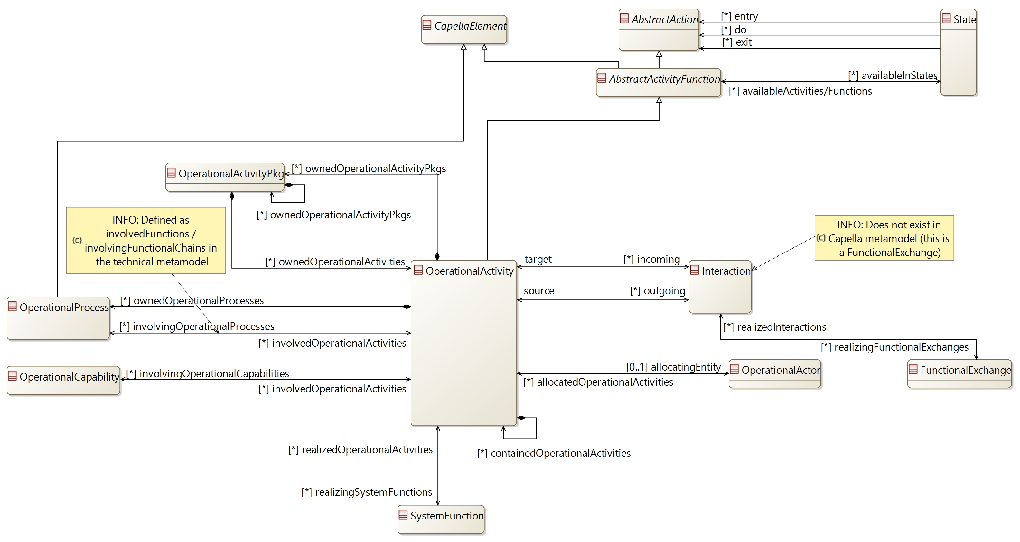

[CDB] OperationalEntity:

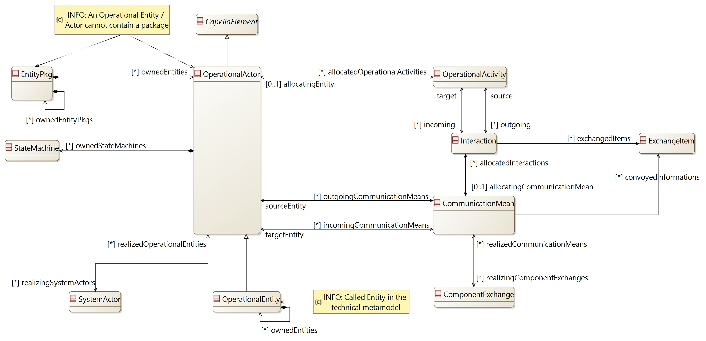

[CDB] OperationalAnalysis:

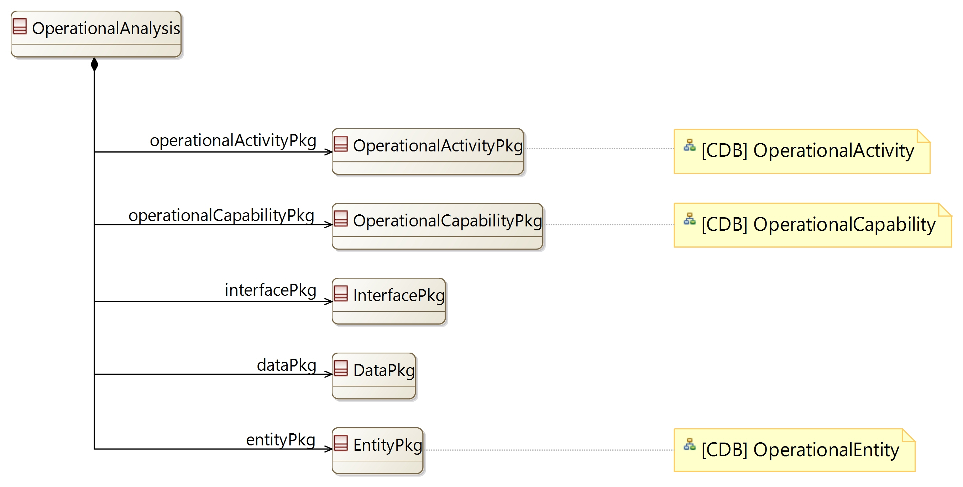

[CDB] OperationalCapability:

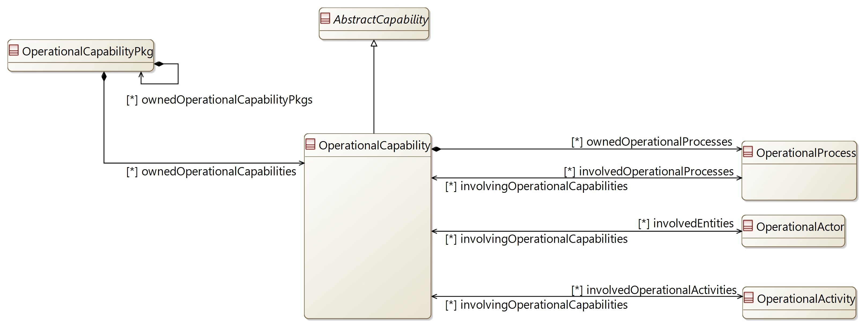

[CDB] OperationalProcess:

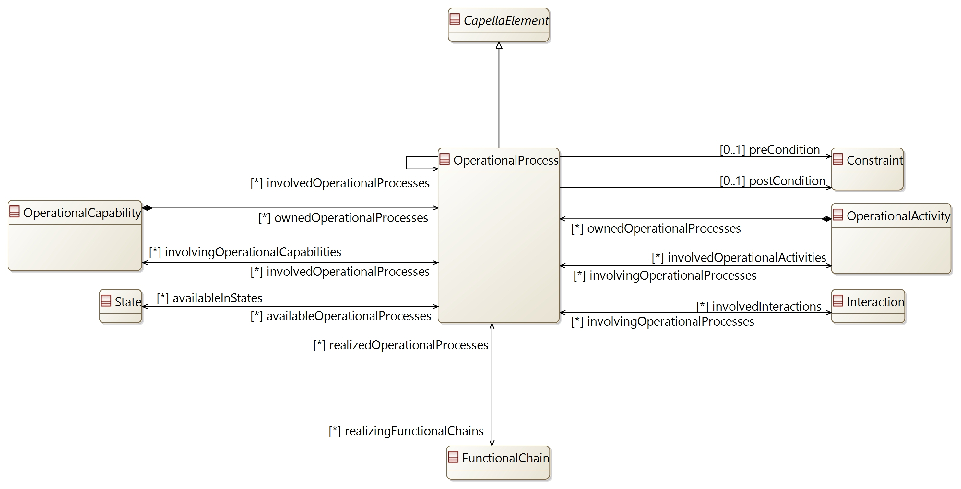

## [Type] OperationalAnalysis

Description:

The element containing all definitions from the Operational Analysis.

The Operational Analysis aims at defining what the users of the system need to accomplish

Direct super types:

* **PropertyValuePkgContainer**

Direct sub-types:

*No direct sub-type*

Possible parent elements:

* SystemEngineering

Attributes:

|  |  |  |
| --- | --- | --- |
| **Attribute name** | **Attribute type** | **Defined on** |
| id | String | **CapellaElement** |
| sid | String | **CapellaElement** |
| name | String | **CapellaElement** |
| summary | String | **CapellaElement** |
| description | String | **CapellaElement** |
| status | **Status** | **CapellaElement** |
| review | String | **CapellaElement** |
| visibleInDocumentation | Boolean | **CapellaElement** |
| visibleForTraceability | Boolean | **CapellaElement** |

Relations:

|  |  |  |  |  |
| --- | --- | --- | --- | --- |
| **Ref. name** | **Kind** | **Card.** | **Target Type** | **Defined on** |
| ownedDiagrams | COMPOSITION | [0 *] | **Diagram** | **EObject** |
| elementOfInterestForDiagrams | ASSOCIATION | [0 *] | **Diagram** | **EObject** |
| contextualElementForDiagrams | ASSOCIATION | [0 *] | **Diagram** | **EObject** |
| representingDiagrams | ASSOCIATION | [0 *] | **Diagram** | **EObject** |
| ownedConstraints | COMPOSITION | [0 *] | **Constraint** | **CapellaElement** |
| constraints | ASSOCIATION | [0 *] | **Constraint** | **CapellaElement** |
| ownedPropertyValues | COMPOSITION | [0 *] | **PropertyValue** | **CapellaElement** |
| appliedPropertyValues | ASSOCIATION | [0 *] | **PropertyValue** | **CapellaElement** |
| ownedPropertyValueGroups | COMPOSITION | [0 *] | **PropertyValueGroup** | **CapellaElement** |
| appliedPropertyValueGroups | ASSOCIATION | [0 *] | **PropertyValueGroup** | **CapellaElement** |
| ownedEnumerationPropertyTypes | COMPOSITION | [0 *] | **EnumerationPropertyType** | **CapellaElement** |
| ownedPropertyValuePkgs | COMPOSITION | [0 *] | **PropertyValuePkg** | **PropertyValuePkgContainer** |
| operationalActivityPkg | COMPOSITION | [1 1] | **OperationalActivityPkg** | *defined on type* |
| operationalCapabilityPkg | COMPOSITION | [1 1] | **OperationalCapabilityPkg** | *defined on type* |
| interfacePkg | COMPOSITION | [1 1] | **InterfacePkg** | *defined on type* |
| dataPkg | COMPOSITION | [1 1] | **DataPkg** | *defined on type* |
| entityPkg | COMPOSITION | [1 1] | **EntityPkg** | *defined on type* |

Methods:

*No method defined*

## [Type] OperationalActivityPkg

Description:

A package to contain OperationalActivity

Direct super types:

* **PropertyValuePkgContainer**

Direct sub-types:

*No direct sub-type*

Possible parent elements:

* OperationalAnalysis
* OperationalActivityPkg
* OperationalActivity

Attributes:

|  |  |  |
| --- | --- | --- |
| **Attribute name** | **Attribute type** | **Defined on** |
| id | String | **CapellaElement** |
| sid | String | **CapellaElement** |
| name | String | **CapellaElement** |
| summary | String | **CapellaElement** |
| description | String | **CapellaElement** |
| status | **Status** | **CapellaElement** |
| review | String | **CapellaElement** |
| visibleInDocumentation | Boolean | **CapellaElement** |
| visibleForTraceability | Boolean | **CapellaElement** |

Relations:

|  |  |  |  |  |
| --- | --- | --- | --- | --- |
| **Ref. name** | **Kind** | **Card.** | **Target Type** | **Defined on** |
| ownedDiagrams | COMPOSITION | [0 *] | **Diagram** | **EObject** |
| elementOfInterestForDiagrams | ASSOCIATION | [0 *] | **Diagram** | **EObject** |
| contextualElementForDiagrams | ASSOCIATION | [0 *] | **Diagram** | **EObject** |
| representingDiagrams | ASSOCIATION | [0 *] | **Diagram** | **EObject** |
| ownedConstraints | COMPOSITION | [0 *] | **Constraint** | **CapellaElement** |
| constraints | ASSOCIATION | [0 *] | **Constraint** | **CapellaElement** |
| ownedPropertyValues | COMPOSITION | [0 *] | **PropertyValue** | **CapellaElement** |
| appliedPropertyValues | ASSOCIATION | [0 *] | **PropertyValue** | **CapellaElement** |
| ownedPropertyValueGroups | COMPOSITION | [0 *] | **PropertyValueGroup** | **CapellaElement** |
| appliedPropertyValueGroups | ASSOCIATION | [0 *] | **PropertyValueGroup** | **CapellaElement** |
| ownedEnumerationPropertyTypes | COMPOSITION | [0 *] | **EnumerationPropertyType** | **CapellaElement** |
| ownedPropertyValuePkgs | COMPOSITION | [0 *] | **PropertyValuePkg** | **PropertyValuePkgContainer** |
| ownedOperationalActivityPkgs | COMPOSITION | [0 *] | **OperationalActivityPkg** | *defined on type* |
| ownedOperationalActivities | COMPOSITION | [0 *] | **OperationalActivity** | *defined on type* |

Methods:

*No method defined*

## [Type] OperationalActivity

Description:

Process step or action/operation/service performed by an Operational entity / actor and likely to influence the system definition or usage. Implementing operational activities generally produces elements of interactions expected by other activities

Direct super types:

* **AbstractActivityFunction**

Direct sub-types:

*No direct sub-type*

Possible parent elements:

* OperationalActivityPkg
* OperationalActivity

Attributes:

|  |  |  |
| --- | --- | --- |
| **Attribute name** | **Attribute type** | **Defined on** |
| id | String | **CapellaElement** |
| sid | String | **CapellaElement** |
| name | String | **CapellaElement** |
| summary | String | **CapellaElement** |
| description | String | **CapellaElement** |
| status | **Status** | **CapellaElement** |
| review | String | **CapellaElement** |
| visibleInDocumentation | Boolean | **CapellaElement** |
| visibleForTraceability | Boolean | **CapellaElement** |

Relations:

|  |  |  |  |  |
| --- | --- | --- | --- | --- |
| **Ref. name** | **Kind** | **Card.** | **Target Type** | **Defined on** |
| ownedDiagrams | COMPOSITION | [0 *] | **Diagram** | **EObject** |
| elementOfInterestForDiagrams | ASSOCIATION | [0 *] | **Diagram** | **EObject** |
| contextualElementForDiagrams | ASSOCIATION | [0 *] | **Diagram** | **EObject** |
| representingDiagrams | ASSOCIATION | [0 *] | **Diagram** | **EObject** |
| ownedConstraints | COMPOSITION | [0 *] | **Constraint** | **CapellaElement** |
| constraints | ASSOCIATION | [0 *] | **Constraint** | **CapellaElement** |
| ownedPropertyValues | COMPOSITION | [0 *] | **PropertyValue** | **CapellaElement** |
| appliedPropertyValues | ASSOCIATION | [0 *] | **PropertyValue** | **CapellaElement** |
| ownedPropertyValueGroups | COMPOSITION | [0 *] | **PropertyValueGroup** | **CapellaElement** |
| appliedPropertyValueGroups | ASSOCIATION | [0 *] | **PropertyValueGroup** | **CapellaElement** |
| ownedEnumerationPropertyTypes | COMPOSITION | [0 *] | **EnumerationPropertyType** | **CapellaElement** |
| availableInStates | ASSOCIATION | [0 *] | **State** | **AbstractActivityFunction** |
| containedOperationalActivities | COMPOSITION | [0 *] | **OperationalActivity** | *defined on type* |
| ownedOperationalActivityPkgs | COMPOSITION | [0 *] | **OperationalActivityPkg** | *defined on type* |
| incoming | ASSOCIATION | [0 *] | **Interaction** | *defined on type* |
| outgoing | ASSOCIATION | [0 *] | **Interaction** | *defined on type* |
| allocatingEntity | ASSOCIATION | [0 1] | **OperationalActor** | *defined on type* |
| ownedOperationalProcesses | COMPOSITION | [0 *] | **OperationalProcess** | *defined on type* |
| involvingOperationalProcesses | ASSOCIATION | [0 *] | **OperationalProcess** | *defined on type* |
| involvingOperationalCapabilities | ASSOCIATION | [0 *] | **OperationalCapability** | *defined on type* |
| realizingSystemFunctions | ASSOCIATION | [0 *] | **SystemFunction** | *defined on type* |

Methods:

*No method defined*

## [Type] Interaction

Description:

Oriented dependency between Operational Activities

Direct super types:

* **AbstractEvent**

Direct sub-types:

*No direct sub-type*

Possible parent elements:

*No possible parent defined*

Attributes:

|  |  |  |
| --- | --- | --- |
| **Attribute name** | **Attribute type** | **Defined on** |
| id | String | **CapellaElement** |
| sid | String | **CapellaElement** |
| name | String | **CapellaElement** |
| summary | String | **CapellaElement** |
| description | String | **CapellaElement** |
| status | **Status** | **CapellaElement** |
| review | String | **CapellaElement** |
| visibleInDocumentation | Boolean | **CapellaElement** |
| visibleForTraceability | Boolean | **CapellaElement** |

Relations:

|  |  |  |  |  |
| --- | --- | --- | --- | --- |
| **Ref. name** | **Kind** | **Card.** | **Target Type** | **Defined on** |
| ownedDiagrams | COMPOSITION | [0 *] | **Diagram** | **EObject** |
| elementOfInterestForDiagrams | ASSOCIATION | [0 *] | **Diagram** | **EObject** |
| contextualElementForDiagrams | ASSOCIATION | [0 *] | **Diagram** | **EObject** |
| representingDiagrams | ASSOCIATION | [0 *] | **Diagram** | **EObject** |
| ownedConstraints | COMPOSITION | [0 *] | **Constraint** | **CapellaElement** |
| constraints | ASSOCIATION | [0 *] | **Constraint** | **CapellaElement** |
| ownedPropertyValues | COMPOSITION | [0 *] | **PropertyValue** | **CapellaElement** |
| appliedPropertyValues | ASSOCIATION | [0 *] | **PropertyValue** | **CapellaElement** |
| ownedPropertyValueGroups | COMPOSITION | [0 *] | **PropertyValueGroup** | **CapellaElement** |
| appliedPropertyValueGroups | ASSOCIATION | [0 *] | **PropertyValueGroup** | **CapellaElement** |
| ownedEnumerationPropertyTypes | COMPOSITION | [0 *] | **EnumerationPropertyType** | **CapellaElement** |
| source | ASSOCIATION | [1 1] | **OperationalActivity** | *defined on type* |
| target | ASSOCIATION | [1 1] | **OperationalActivity** | *defined on type* |
| allocatingCommunicationMean | ASSOCIATION | [0 1] | **CommunicationMean** | *defined on type* |
| involvingOperationalProcesses | ASSOCIATION | [0 *] | **OperationalProcess** | *defined on type* |
| exchangedItems | ASSOCIATION | [0 *] | **ExchangeItem** | *defined on type* |
| realizingFunctionalExchanges | ASSOCIATION | [0 *] | **FunctionalExchange** | *defined on type* |

Methods:

*No method defined*

## [Type] OperationalProcess

Description:

An operational process is used to describe a particular context for performing operational activities to contribute to one or more operational capabilities

Direct super types:

* **CapellaElement**

Direct sub-types:

*No direct sub-type*

Possible parent elements:

* OperationalActivity
* OperationalCapability

Attributes:

|  |  |  |
| --- | --- | --- |
| **Attribute name** | **Attribute type** | **Defined on** |
| id | String | **CapellaElement** |
| sid | String | **CapellaElement** |
| name | String | **CapellaElement** |
| summary | String | **CapellaElement** |
| description | String | **CapellaElement** |
| status | **Status** | **CapellaElement** |
| review | String | **CapellaElement** |
| visibleInDocumentation | Boolean | **CapellaElement** |
| visibleForTraceability | Boolean | **CapellaElement** |

Relations:

|  |  |  |  |  |
| --- | --- | --- | --- | --- |
| **Ref. name** | **Kind** | **Card.** | **Target Type** | **Defined on** |
| ownedDiagrams | COMPOSITION | [0 *] | **Diagram** | **EObject** |
| elementOfInterestForDiagrams | ASSOCIATION | [0 *] | **Diagram** | **EObject** |
| contextualElementForDiagrams | ASSOCIATION | [0 *] | **Diagram** | **EObject** |
| representingDiagrams | ASSOCIATION | [0 *] | **Diagram** | **EObject** |
| ownedConstraints | COMPOSITION | [0 *] | **Constraint** | **CapellaElement** |
| constraints | ASSOCIATION | [0 *] | **Constraint** | **CapellaElement** |
| ownedPropertyValues | COMPOSITION | [0 *] | **PropertyValue** | **CapellaElement** |
| appliedPropertyValues | ASSOCIATION | [0 *] | **PropertyValue** | **CapellaElement** |
| ownedPropertyValueGroups | COMPOSITION | [0 *] | **PropertyValueGroup** | **CapellaElement** |
| appliedPropertyValueGroups | ASSOCIATION | [0 *] | **PropertyValueGroup** | **CapellaElement** |
| ownedEnumerationPropertyTypes | COMPOSITION | [0 *] | **EnumerationPropertyType** | **CapellaElement** |
| involvedOperationalActivities | ASSOCIATION | [0 *] | **OperationalActivity** | *defined on type* |
| involvedInteractions | ASSOCIATION | [0 *] | **Interaction** | *defined on type* |
| involvedOperationalProcesses | ASSOCIATION | [0 *] | **OperationalProcess** | *defined on type* |
| preCondition | ASSOCIATION | [0 1] | **Constraint** | *defined on type* |
| postCondition | ASSOCIATION | [0 1] | **Constraint** | *defined on type* |
| availableInStates | ASSOCIATION | [0 *] | **State** | *defined on type* |
| involvingOperationalCapabilities | ASSOCIATION | [0 *] | **OperationalCapability** | *defined on type* |
| realizingFunctionalChains | ASSOCIATION | [0 *] | **FunctionalChain** | *defined on type* |

Methods:

*No method defined*

## [Type] OperationalCapabilityPkg

Description:

A package to contain OperationalCapabilities

Direct super types:

* **PropertyValuePkgContainer**

Direct sub-types:

*No direct sub-type*

Possible parent elements:

* OperationalAnalysis
* OperationalCapabilityPkg

Attributes:

|  |  |  |
| --- | --- | --- |
| **Attribute name** | **Attribute type** | **Defined on** |
| id | String | **CapellaElement** |
| sid | String | **CapellaElement** |
| name | String | **CapellaElement** |
| summary | String | **CapellaElement** |
| description | String | **CapellaElement** |
| status | **Status** | **CapellaElement** |
| review | String | **CapellaElement** |
| visibleInDocumentation | Boolean | **CapellaElement** |
| visibleForTraceability | Boolean | **CapellaElement** |

Relations:

|  |  |  |  |  |
| --- | --- | --- | --- | --- |
| **Ref. name** | **Kind** | **Card.** | **Target Type** | **Defined on** |
| ownedDiagrams | COMPOSITION | [0 *] | **Diagram** | **EObject** |
| elementOfInterestForDiagrams | ASSOCIATION | [0 *] | **Diagram** | **EObject** |
| contextualElementForDiagrams | ASSOCIATION | [0 *] | **Diagram** | **EObject** |
| representingDiagrams | ASSOCIATION | [0 *] | **Diagram** | **EObject** |
| ownedConstraints | COMPOSITION | [0 *] | **Constraint** | **CapellaElement** |
| constraints | ASSOCIATION | [0 *] | **Constraint** | **CapellaElement** |
| ownedPropertyValues | COMPOSITION | [0 *] | **PropertyValue** | **CapellaElement** |
| appliedPropertyValues | ASSOCIATION | [0 *] | **PropertyValue** | **CapellaElement** |
| ownedPropertyValueGroups | COMPOSITION | [0 *] | **PropertyValueGroup** | **CapellaElement** |
| appliedPropertyValueGroups | ASSOCIATION | [0 *] | **PropertyValueGroup** | **CapellaElement** |
| ownedEnumerationPropertyTypes | COMPOSITION | [0 *] | **EnumerationPropertyType** | **CapellaElement** |
| ownedPropertyValuePkgs | COMPOSITION | [0 *] | **PropertyValuePkg** | **PropertyValuePkgContainer** |
| ownedOperationalCapabilityPkgs | COMPOSITION | [0 *] | **OperationalCapabilityPkg** | *defined on type* |
| ownedOperationalCapabilities | COMPOSITION | [0 *] | **OperationalCapability** | *defined on type* |

Methods:

*No method defined*

## [Type] OperationalCapability

Description:

An operational capability is an ability, expected of one or more operational entities / actors. An operational capability is characterized by a set of operational processes and scenarios

Direct super types:

* **AbstractCapability**

Direct sub-types:

*No direct sub-type*

Possible parent elements:

* OperationalCapabilityPkg

Attributes:

|  |  |  |
| --- | --- | --- |
| **Attribute name** | **Attribute type** | **Defined on** |
| id | String | **CapellaElement** |
| sid | String | **CapellaElement** |
| name | String | **CapellaElement** |
| summary | String | **CapellaElement** |
| description | String | **CapellaElement** |
| status | **Status** | **CapellaElement** |
| review | String | **CapellaElement** |
| visibleInDocumentation | Boolean | **CapellaElement** |
| visibleForTraceability | Boolean | **CapellaElement** |

Relations:

|  |  |  |  |  |
| --- | --- | --- | --- | --- |
| **Ref. name** | **Kind** | **Card.** | **Target Type** | **Defined on** |
| ownedDiagrams | COMPOSITION | [0 *] | **Diagram** | **EObject** |
| elementOfInterestForDiagrams | ASSOCIATION | [0 *] | **Diagram** | **EObject** |
| contextualElementForDiagrams | ASSOCIATION | [0 *] | **Diagram** | **EObject** |
| representingDiagrams | ASSOCIATION | [0 *] | **Diagram** | **EObject** |
| ownedConstraints | COMPOSITION | [0 *] | **Constraint** | **CapellaElement** |
| constraints | ASSOCIATION | [0 *] | **Constraint** | **CapellaElement** |
| ownedPropertyValues | COMPOSITION | [0 *] | **PropertyValue** | **CapellaElement** |
| appliedPropertyValues | ASSOCIATION | [0 *] | **PropertyValue** | **CapellaElement** |
| ownedPropertyValueGroups | COMPOSITION | [0 *] | **PropertyValueGroup** | **CapellaElement** |
| appliedPropertyValueGroups | ASSOCIATION | [0 *] | **PropertyValueGroup** | **CapellaElement** |
| ownedEnumerationPropertyTypes | COMPOSITION | [0 *] | **EnumerationPropertyType** | **CapellaElement** |
| ownedPropertyValuePkgs | COMPOSITION | [0 *] | **PropertyValuePkg** | **PropertyValuePkgContainer** |
| preCondition | ASSOCIATION | [1 1] | **Constraint** | **AbstractCapability** |
| postCondition | ASSOCIATION | [1 1] | **Constraint** | **AbstractCapability** |
| ownedScenarios | COMPOSITION | [0 *] | **Scenario** | **AbstractCapability** |
| super | ASSOCIATION | [0 *] | **AbstractCapability** | **AbstractCapability** |
| sub | ASSOCIATION | [0 *] | **AbstractCapability** | **AbstractCapability** |
| includedCapabilities | ASSOCIATION | [0 *] | **AbstractCapability** | **AbstractCapability** |
| includingCapabilities | ASSOCIATION | [0 *] | **AbstractCapability** | **AbstractCapability** |
| extendedCapabilities | ASSOCIATION | [0 *] | **AbstractCapability** | **AbstractCapability** |
| extendingCapabilities | ASSOCIATION | [0 *] | **AbstractCapability** | **AbstractCapability** |
| availableInStates | ASSOCIATION | [0 *] | **State** | **AbstractCapability** |
| ownedOperationalProcesses | COMPOSITION | [0 *] | **OperationalProcess** | *defined on type* |
| involvedOperationalProcesses | ASSOCIATION | [0 *] | **OperationalProcess** | *defined on type* |
| involvedOperationalActivities | ASSOCIATION | [0 *] | **OperationalActivity** | *defined on type* |
| involvedEntities | ASSOCIATION | [0 *] | **OperationalActor** | *defined on type* |
| realizingCapabilities | ASSOCIATION | [0 *] | **Capability** | *defined on type* |

Methods:

*No method defined*

## [Type] EntityPkg

Description:

A package to define Operational entities / actors

Direct super types:

* **PropertyValuePkgContainer**

Direct sub-types:

*No direct sub-type*

Possible parent elements:

* OperationalAnalysis
* EntityPkg

Attributes:

|  |  |  |
| --- | --- | --- |
| **Attribute name** | **Attribute type** | **Defined on** |
| id | String | **CapellaElement** |
| sid | String | **CapellaElement** |
| name | String | **CapellaElement** |
| summary | String | **CapellaElement** |
| description | String | **CapellaElement** |
| status | **Status** | **CapellaElement** |
| review | String | **CapellaElement** |
| visibleInDocumentation | Boolean | **CapellaElement** |
| visibleForTraceability | Boolean | **CapellaElement** |

Relations:

|  |  |  |  |  |
| --- | --- | --- | --- | --- |
| **Ref. name** | **Kind** | **Card.** | **Target Type** | **Defined on** |
| ownedDiagrams | COMPOSITION | [0 *] | **Diagram** | **EObject** |
| elementOfInterestForDiagrams | ASSOCIATION | [0 *] | **Diagram** | **EObject** |
| contextualElementForDiagrams | ASSOCIATION | [0 *] | **Diagram** | **EObject** |
| representingDiagrams | ASSOCIATION | [0 *] | **Diagram** | **EObject** |
| ownedConstraints | COMPOSITION | [0 *] | **Constraint** | **CapellaElement** |
| constraints | ASSOCIATION | [0 *] | **Constraint** | **CapellaElement** |
| ownedPropertyValues | COMPOSITION | [0 *] | **PropertyValue** | **CapellaElement** |
| appliedPropertyValues | ASSOCIATION | [0 *] | **PropertyValue** | **CapellaElement** |
| ownedPropertyValueGroups | COMPOSITION | [0 *] | **PropertyValueGroup** | **CapellaElement** |
| appliedPropertyValueGroups | ASSOCIATION | [0 *] | **PropertyValueGroup** | **CapellaElement** |
| ownedEnumerationPropertyTypes | COMPOSITION | [0 *] | **EnumerationPropertyType** | **CapellaElement** |
| ownedPropertyValuePkgs | COMPOSITION | [0 *] | **PropertyValuePkg** | **PropertyValuePkgContainer** |
| ownedEntityPkgs | COMPOSITION | [0 *] | **EntityPkg** | *defined on type* |
| ownedEntities | COMPOSITION | [0 *] | **OperationalActor** | *defined on type* |

Methods:

*No method defined*

## [Type] OperationalEntity

Description:

An Operational Entity is a real world entity (other system, device, group or organisation…) carrying Operational Activities to which the system is likely to contribute

Direct super types:

* **OperationalActor**

Direct sub-types:

*No direct sub-type*

Possible parent elements:

* EntityPkg
* OperationalEntity

Attributes:

|  |  |  |
| --- | --- | --- |
| **Attribute name** | **Attribute type** | **Defined on** |
| id | String | **CapellaElement** |
| sid | String | **CapellaElement** |
| name | String | **CapellaElement** |
| summary | String | **CapellaElement** |
| description | String | **CapellaElement** |
| status | **Status** | **CapellaElement** |
| review | String | **CapellaElement** |
| visibleInDocumentation | Boolean | **CapellaElement** |
| visibleForTraceability | Boolean | **CapellaElement** |

Relations:

|  |  |  |  |  |
| --- | --- | --- | --- | --- |
| **Ref. name** | **Kind** | **Card.** | **Target Type** | **Defined on** |
| ownedDiagrams | COMPOSITION | [0 *] | **Diagram** | **EObject** |
| elementOfInterestForDiagrams | ASSOCIATION | [0 *] | **Diagram** | **EObject** |
| contextualElementForDiagrams | ASSOCIATION | [0 *] | **Diagram** | **EObject** |
| representingDiagrams | ASSOCIATION | [0 *] | **Diagram** | **EObject** |
| ownedConstraints | COMPOSITION | [0 *] | **Constraint** | **CapellaElement** |
| constraints | ASSOCIATION | [0 *] | **Constraint** | **CapellaElement** |
| ownedPropertyValues | COMPOSITION | [0 *] | **PropertyValue** | **CapellaElement** |
| appliedPropertyValues | ASSOCIATION | [0 *] | **PropertyValue** | **CapellaElement** |
| ownedPropertyValueGroups | COMPOSITION | [0 *] | **PropertyValueGroup** | **CapellaElement** |
| appliedPropertyValueGroups | ASSOCIATION | [0 *] | **PropertyValueGroup** | **CapellaElement** |
| ownedEnumerationPropertyTypes | COMPOSITION | [0 *] | **EnumerationPropertyType** | **CapellaElement** |
| incomingCommunicationMeans | ASSOCIATION | [0 *] | **CommunicationMean** | **OperationalActor** |
| outgoingCommunicationMeans | ASSOCIATION | [0 *] | **CommunicationMean** | **OperationalActor** |
| allocatedOperationalActivities | ASSOCIATION | [0 *] | **OperationalActivity** | **OperationalActor** |
| involvingOperationalCapabilities | ASSOCIATION | [0 *] | **OperationalCapability** | **OperationalActor** |
| ownedStateMachines | COMPOSITION | [0 *] | **StateMachine** | **OperationalActor** |
| realizingSystemActors | ASSOCIATION | [0 *] | **SystemActor** | **OperationalActor** |
| ownedEntities | COMPOSITION | [0 *] | **OperationalEntity** | *defined on type* |

Methods:

*No method defined*

## [Type] OperationalActor

Description:

An Operational Actor is a kind of Operational Entity, usually human. It cannot be broken down

Direct super types:

* **CapellaElement**

Direct sub-types:

* **OperationalEntity**

Possible parent elements:

* EntityPkg

Attributes:

|  |  |  |
| --- | --- | --- |
| **Attribute name** | **Attribute type** | **Defined on** |
| id | String | **CapellaElement** |
| sid | String | **CapellaElement** |
| name | String | **CapellaElement** |
| summary | String | **CapellaElement** |
| description | String | **CapellaElement** |
| status | **Status** | **CapellaElement** |
| review | String | **CapellaElement** |
| visibleInDocumentation | Boolean | **CapellaElement** |
| visibleForTraceability | Boolean | **CapellaElement** |

Relations:

|  |  |  |  |  |
| --- | --- | --- | --- | --- |
| **Ref. name** | **Kind** | **Card.** | **Target Type** | **Defined on** |
| ownedDiagrams | COMPOSITION | [0 *] | **Diagram** | **EObject** |
| elementOfInterestForDiagrams | ASSOCIATION | [0 *] | **Diagram** | **EObject** |
| contextualElementForDiagrams | ASSOCIATION | [0 *] | **Diagram** | **EObject** |
| representingDiagrams | ASSOCIATION | [0 *] | **Diagram** | **EObject** |
| ownedConstraints | COMPOSITION | [0 *] | **Constraint** | **CapellaElement** |
| constraints | ASSOCIATION | [0 *] | **Constraint** | **CapellaElement** |
| ownedPropertyValues | COMPOSITION | [0 *] | **PropertyValue** | **CapellaElement** |
| appliedPropertyValues | ASSOCIATION | [0 *] | **PropertyValue** | **CapellaElement** |
| ownedPropertyValueGroups | COMPOSITION | [0 *] | **PropertyValueGroup** | **CapellaElement** |
| appliedPropertyValueGroups | ASSOCIATION | [0 *] | **PropertyValueGroup** | **CapellaElement** |
| ownedEnumerationPropertyTypes | COMPOSITION | [0 *] | **EnumerationPropertyType** | **CapellaElement** |
| incomingCommunicationMeans | ASSOCIATION | [0 *] | **CommunicationMean** | *defined on type* |
| outgoingCommunicationMeans | ASSOCIATION | [0 *] | **CommunicationMean** | *defined on type* |
| allocatedOperationalActivities | ASSOCIATION | [0 *] | **OperationalActivity** | *defined on type* |
| involvingOperationalCapabilities | ASSOCIATION | [0 *] | **OperationalCapability** | *defined on type* |
| ownedStateMachines | COMPOSITION | [0 *] | **StateMachine** | *defined on type* |
| realizingSystemActors | ASSOCIATION | [0 *] | **SystemActor** | *defined on type* |

Methods:

*No method defined*

## [Type] CommunicationMean

Description:

Describes the media between the Operational Entities / Actors to support the Operational Interactions

Direct super types:

* **CapellaElement**

Direct sub-types:

*No direct sub-type*

Possible parent elements:

*No possible parent defined*

Attributes:

|  |  |  |
| --- | --- | --- |
| **Attribute name** | **Attribute type** | **Defined on** |
| id | String | **CapellaElement** |
| sid | String | **CapellaElement** |
| name | String | **CapellaElement** |
| summary | String | **CapellaElement** |
| description | String | **CapellaElement** |
| status | **Status** | **CapellaElement** |
| review | String | **CapellaElement** |
| visibleInDocumentation | Boolean | **CapellaElement** |
| visibleForTraceability | Boolean | **CapellaElement** |

Relations:

|  |  |  |  |  |
| --- | --- | --- | --- | --- |
| **Ref. name** | **Kind** | **Card.** | **Target Type** | **Defined on** |
| ownedDiagrams | COMPOSITION | [0 *] | **Diagram** | **EObject** |
| elementOfInterestForDiagrams | ASSOCIATION | [0 *] | **Diagram** | **EObject** |
| contextualElementForDiagrams | ASSOCIATION | [0 *] | **Diagram** | **EObject** |
| representingDiagrams | ASSOCIATION | [0 *] | **Diagram** | **EObject** |
| ownedConstraints | COMPOSITION | [0 *] | **Constraint** | **CapellaElement** |
| constraints | ASSOCIATION | [0 *] | **Constraint** | **CapellaElement** |
| ownedPropertyValues | COMPOSITION | [0 *] | **PropertyValue** | **CapellaElement** |
| appliedPropertyValues | ASSOCIATION | [0 *] | **PropertyValue** | **CapellaElement** |
| ownedPropertyValueGroups | COMPOSITION | [0 *] | **PropertyValueGroup** | **CapellaElement** |
| appliedPropertyValueGroups | ASSOCIATION | [0 *] | **PropertyValueGroup** | **CapellaElement** |
| ownedEnumerationPropertyTypes | COMPOSITION | [0 *] | **EnumerationPropertyType** | **CapellaElement** |
| sourceEntity | ASSOCIATION | [1 1] | **OperationalActor** | *defined on type* |
| targetEntity | ASSOCIATION | [1 1] | **OperationalActor** | *defined on type* |
| allocatedInteractions | ASSOCIATION | [0 *] | **Interaction** | *defined on type* |
| convoyedInformations | ASSOCIATION | [0 *] | **ExchangeItem** | *defined on type* |
| realizingComponentExchanges | ASSOCIATION | [0 *] | **ComponentExchange** | *defined on type* |

Methods:

*No method defined*

# [Package] sa

Diagrams:

Here are the diagrams of representing the elements introduced in this package:

[CDB] SystemAnalysis:

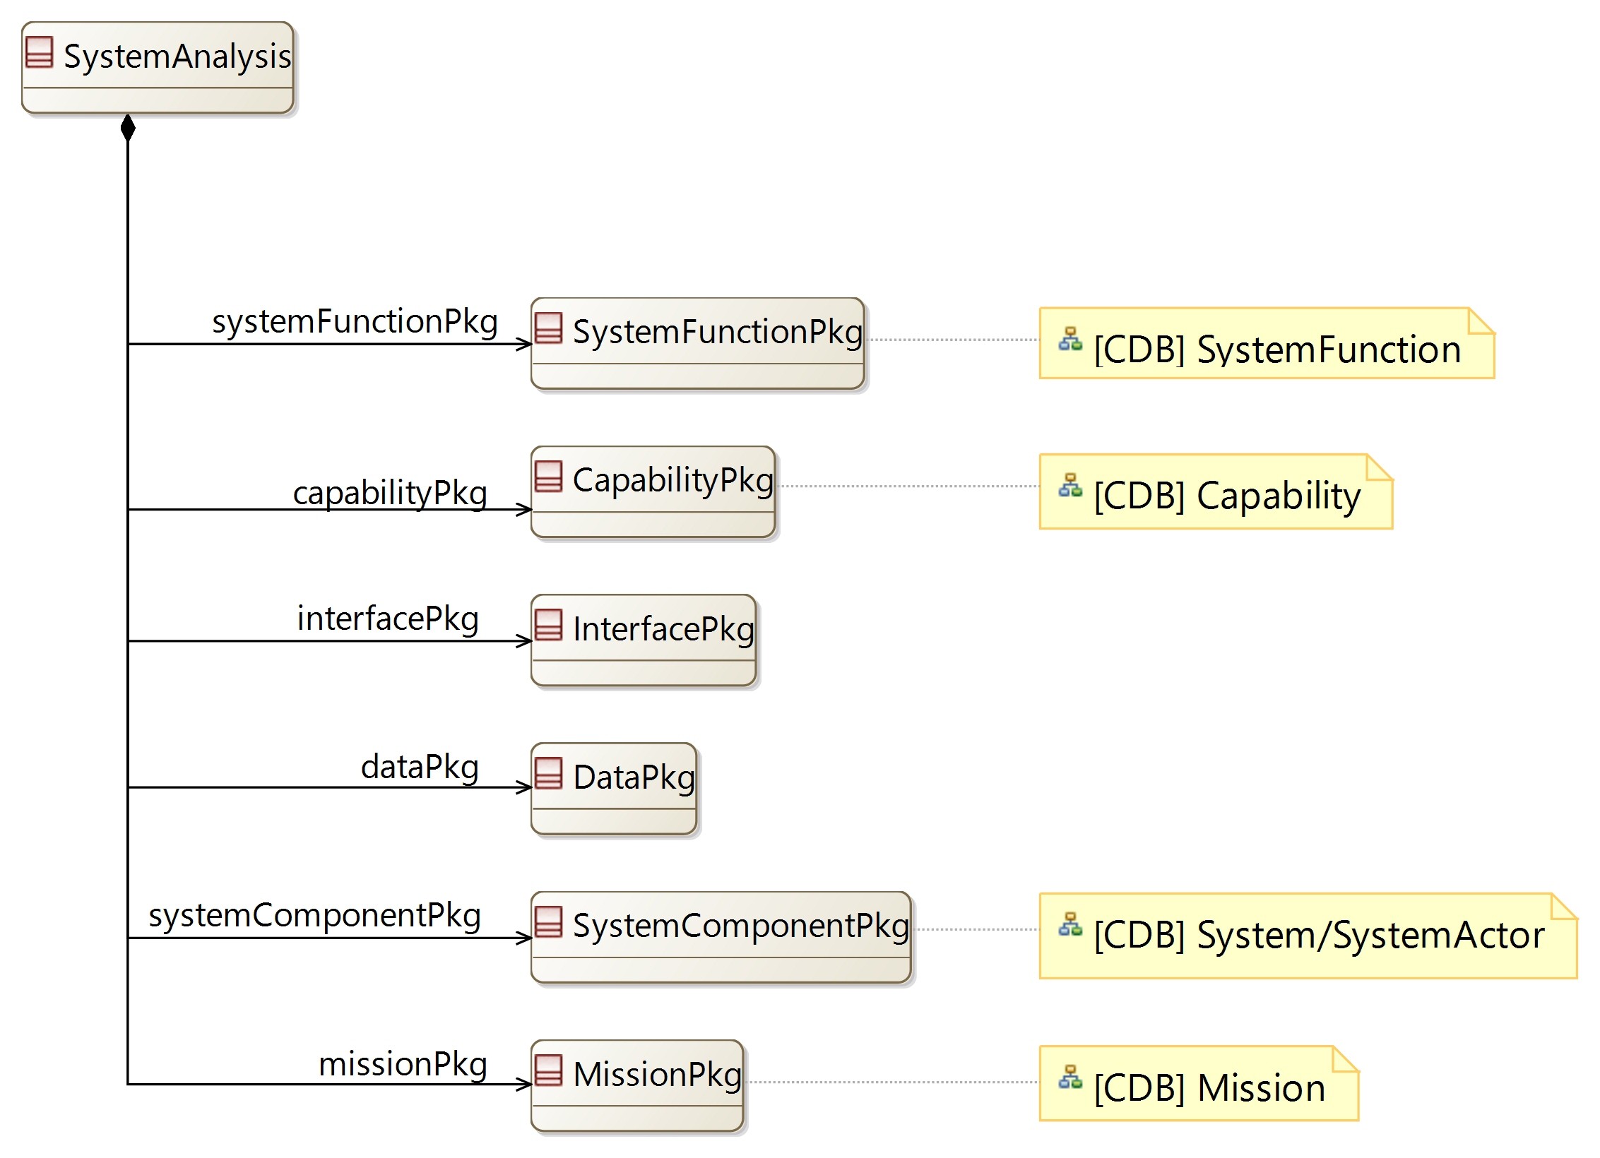

[CDB] SystemFunction:

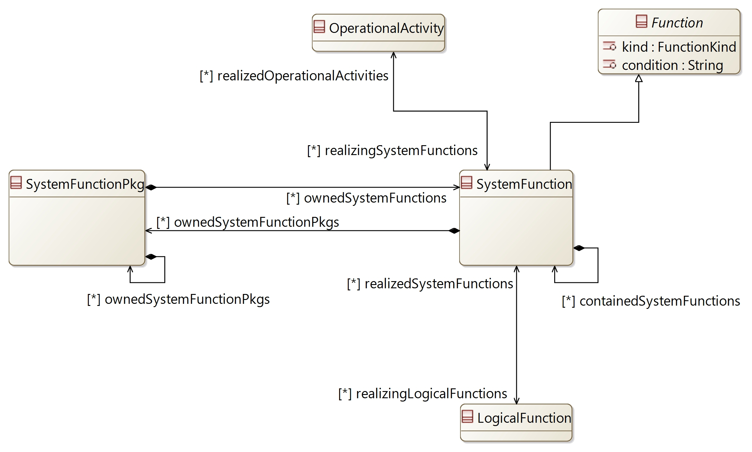

[CDB] Capability:

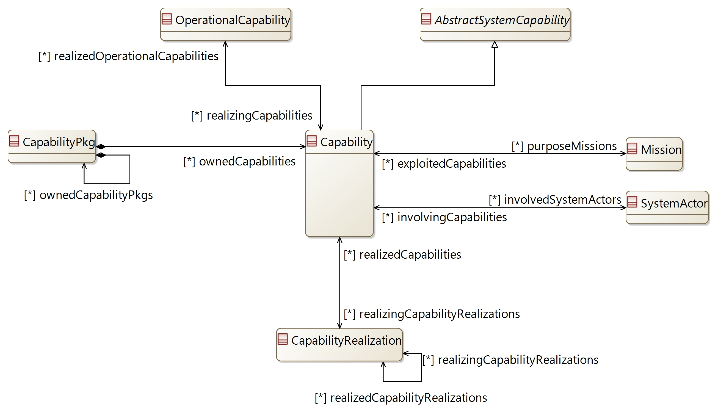

[CDB] Mission:

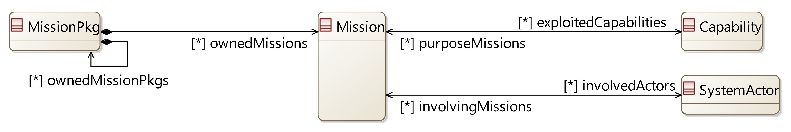

[CDB] System/SystemActor:

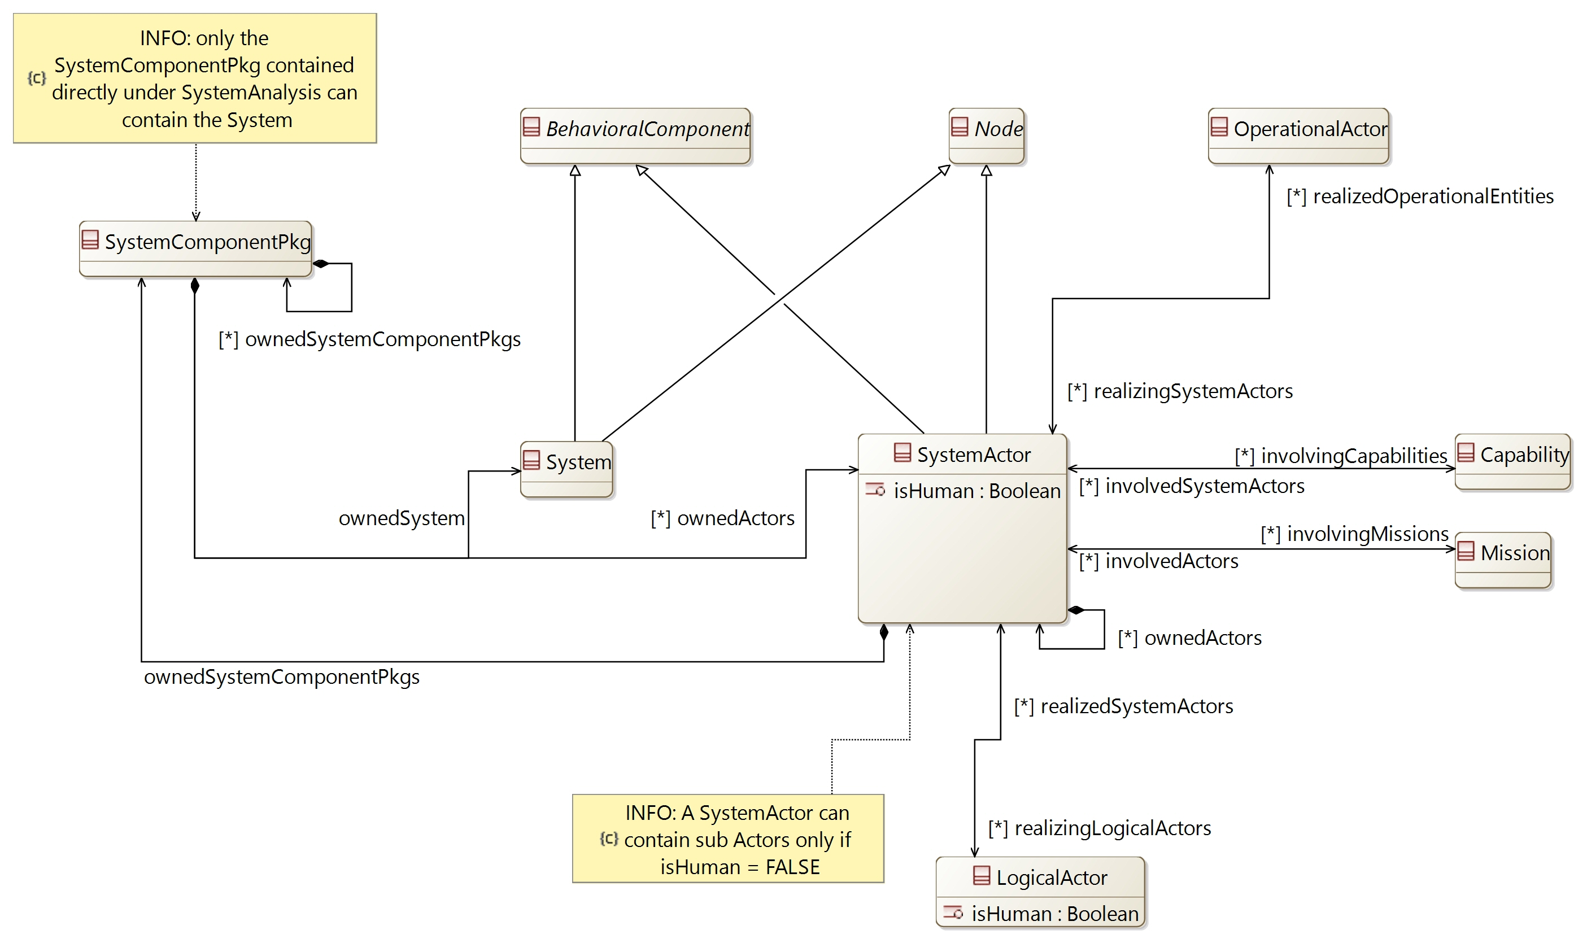

## [Type] SystemAnalysis

Description:

The element containing all definitions from the System Analysis.

The System Analysis aims at defining what the system has to accomplish for the users

Direct super types:

* **PropertyValuePkgContainer**

Direct sub-types:

*No direct sub-type*

Possible parent elements:

* SystemEngineering

Attributes:

|  |  |  |
| --- | --- | --- |
| **Attribute name** | **Attribute type** | **Defined on** |
| id | String | **CapellaElement** |
| sid | String | **CapellaElement** |
| name | String | **CapellaElement** |
| summary | String | **CapellaElement** |
| description | String | **CapellaElement** |
| status | **Status** | **CapellaElement** |
| review | String | **CapellaElement** |
| visibleInDocumentation | Boolean | **CapellaElement** |
| visibleForTraceability | Boolean | **CapellaElement** |

Relations:

|  |  |  |  |  |
| --- | --- | --- | --- | --- |
| **Ref. name** | **Kind** | **Card.** | **Target Type** | **Defined on** |
| ownedDiagrams | COMPOSITION | [0 *] | **Diagram** | **EObject** |
| elementOfInterestForDiagrams | ASSOCIATION | [0 *] | **Diagram** | **EObject** |
| contextualElementForDiagrams | ASSOCIATION | [0 *] | **Diagram** | **EObject** |
| representingDiagrams | ASSOCIATION | [0 *] | **Diagram** | **EObject** |
| ownedConstraints | COMPOSITION | [0 *] | **Constraint** | **CapellaElement** |
| constraints | ASSOCIATION | [0 *] | **Constraint** | **CapellaElement** |
| ownedPropertyValues | COMPOSITION | [0 *] | **PropertyValue** | **CapellaElement** |
| appliedPropertyValues | ASSOCIATION | [0 *] | **PropertyValue** | **CapellaElement** |
| ownedPropertyValueGroups | COMPOSITION | [0 *] | **PropertyValueGroup** | **CapellaElement** |
| appliedPropertyValueGroups | ASSOCIATION | [0 *] | **PropertyValueGroup** | **CapellaElement** |
| ownedEnumerationPropertyTypes | COMPOSITION | [0 *] | **EnumerationPropertyType** | **CapellaElement** |
| ownedPropertyValuePkgs | COMPOSITION | [0 *] | **PropertyValuePkg** | **PropertyValuePkgContainer** |
| systemFunctionPkg | COMPOSITION | [1 1] | **SystemFunctionPkg** | *defined on type* |
| capabilityPkg | COMPOSITION | [1 1] | **CapabilityPkg** | *defined on type* |
| interfacePkg | COMPOSITION | [1 1] | **InterfacePkg** | *defined on type* |
| dataPkg | COMPOSITION | [1 1] | **DataPkg** | *defined on type* |
| systemComponentPkg | COMPOSITION | [1 1] | **SystemComponentPkg** | *defined on type* |
| missionPkg | COMPOSITION | [1 1] | **MissionPkg** | *defined on type* |

Methods:

*No method defined*

## [Type] SystemFunctionPkg

Description:

A package to contain SystemFunctions

Direct super types:

* **PropertyValuePkgContainer**

Direct sub-types:

*No direct sub-type*

Possible parent elements:

* SystemAnalysis
* SystemFunctionPkg
* SystemFunction

Attributes:

|  |  |  |
| --- | --- | --- |
| **Attribute name** | **Attribute type** | **Defined on** |
| id | String | **CapellaElement** |
| sid | String | **CapellaElement** |
| name | String | **CapellaElement** |
| summary | String | **CapellaElement** |
| description | String | **CapellaElement** |
| status | **Status** | **CapellaElement** |
| review | String | **CapellaElement** |
| visibleInDocumentation | Boolean | **CapellaElement** |
| visibleForTraceability | Boolean | **CapellaElement** |

Relations:

|  |  |  |  |  |
| --- | --- | --- | --- | --- |
| **Ref. name** | **Kind** | **Card.** | **Target Type** | **Defined on** |
| ownedDiagrams | COMPOSITION | [0 *] | **Diagram** | **EObject** |
| elementOfInterestForDiagrams | ASSOCIATION | [0 *] | **Diagram** | **EObject** |
| contextualElementForDiagrams | ASSOCIATION | [0 *] | **Diagram** | **EObject** |
| representingDiagrams | ASSOCIATION | [0 *] | **Diagram** | **EObject** |
| ownedConstraints | COMPOSITION | [0 *] | **Constraint** | **CapellaElement** |
| constraints | ASSOCIATION | [0 *] | **Constraint** | **CapellaElement** |
| ownedPropertyValues | COMPOSITION | [0 *] | **PropertyValue** | **CapellaElement** |
| appliedPropertyValues | ASSOCIATION | [0 *] | **PropertyValue** | **CapellaElement** |
| ownedPropertyValueGroups | COMPOSITION | [0 *] | **PropertyValueGroup** | **CapellaElement** |
| appliedPropertyValueGroups | ASSOCIATION | [0 *] | **PropertyValueGroup** | **CapellaElement** |
| ownedEnumerationPropertyTypes | COMPOSITION | [0 *] | **EnumerationPropertyType** | **CapellaElement** |
| ownedPropertyValuePkgs | COMPOSITION | [0 *] | **PropertyValuePkg** | **PropertyValuePkgContainer** |
| ownedSystemFunctionPkgs | COMPOSITION | [0 *] | **SystemFunctionPkg** | *defined on type* |
| ownedSystemFunctions | COMPOSITION | [0 *] | **SystemFunction** | *defined on type* |

Methods:

*No method defined*

## [Type] SystemFunction

Description:

The definition of a Function in the System Analysis

Direct super types:

* **Function**

Direct sub-types:

*No direct sub-type*

Possible parent elements:

* SystemFunctionPkg
* SystemFunction

Attributes:

|  |  |  |
| --- | --- | --- |
| **Attribute name** | **Attribute type** | **Defined on** |
| id | String | **CapellaElement** |
| sid | String | **CapellaElement** |
| name | String | **CapellaElement** |
| summary | String | **CapellaElement** |
| description | String | **CapellaElement** |
| status | **Status** | **CapellaElement** |
| review | String | **CapellaElement** |
| visibleInDocumentation | Boolean | **CapellaElement** |
| visibleForTraceability | Boolean | **CapellaElement** |
| kind | **FunctionKind** | **Function** |
| condition | String | **Function** |

Relations:

|  |  |  |  |  |
| --- | --- | --- | --- | --- |
| **Ref. name** | **Kind** | **Card.** | **Target Type** | **Defined on** |
| ownedDiagrams | COMPOSITION | [0 *] | **Diagram** | **EObject** |
| elementOfInterestForDiagrams | ASSOCIATION | [0 *] | **Diagram** | **EObject** |
| contextualElementForDiagrams | ASSOCIATION | [0 *] | **Diagram** | **EObject** |
| representingDiagrams | ASSOCIATION | [0 *] | **Diagram** | **EObject** |
| ownedConstraints | COMPOSITION | [0 *] | **Constraint** | **CapellaElement** |
| constraints | ASSOCIATION | [0 *] | **Constraint** | **CapellaElement** |
| ownedPropertyValues | COMPOSITION | [0 *] | **PropertyValue** | **CapellaElement** |
| appliedPropertyValues | ASSOCIATION | [0 *] | **PropertyValue** | **CapellaElement** |
| ownedPropertyValueGroups | COMPOSITION | [0 *] | **PropertyValueGroup** | **CapellaElement** |
| appliedPropertyValueGroups | ASSOCIATION | [0 *] | **PropertyValueGroup** | **CapellaElement** |
| ownedEnumerationPropertyTypes | COMPOSITION | [0 *] | **EnumerationPropertyType** | **CapellaElement** |
| availableInStates | ASSOCIATION | [0 *] | **State** | **AbstractActivityFunction** |
| inputs | COMPOSITION | [0 *] | **FunctionInputPort** | **Function** |
| outputs | COMPOSITION | [0 *] | **FunctionOutputPort** | **Function** |
| incoming | ASSOCIATION | [0 *] | **FunctionalExchange** | **Function** |
| outgoing | ASSOCIATION | [0 *] | **FunctionalExchange** | **Function** |
| allocatingComponent | ASSOCIATION | [0 1] | **BehavioralComponent** | **Function** |
| ownedFunctionalChains | COMPOSITION | [0 *] | **FunctionalChain** | **Function** |
| involvingFunctionalChains | ASSOCIATION | [0 *] | **FunctionalChain** | **Function** |
| involvingCapabilities | ASSOCIATION | [0 *] | **AbstractSystemCapability** | **Function** |
| containedSystemFunctions | COMPOSITION | [0 *] | **SystemFunction** | *defined on type* |
| ownedSystemFunctionPkgs | COMPOSITION | [0 *] | **SystemFunctionPkg** | *defined on type* |
| realizedOperationalActivities | ASSOCIATION | [0 *] | **OperationalActivity** | *defined on type* |
| realizingLogicalFunctions | ASSOCIATION | [0 *] | **LogicalFunction** | *defined on type* |

Methods:

*No method defined*

## [Type] CapabilityPkg

Description:

A package to contain Capabilities

Direct super types:

* **PropertyValuePkgContainer**

Direct sub-types:

*No direct sub-type*

Possible parent elements:

* SystemAnalysis
* CapabilityPkg

Attributes:

|  |  |  |
| --- | --- | --- |
| **Attribute name** | **Attribute type** | **Defined on** |
| id | String | **CapellaElement** |
| sid | String | **CapellaElement** |
| name | String | **CapellaElement** |
| summary | String | **CapellaElement** |
| description | String | **CapellaElement** |
| status | **Status** | **CapellaElement** |
| review | String | **CapellaElement** |
| visibleInDocumentation | Boolean | **CapellaElement** |
| visibleForTraceability | Boolean | **CapellaElement** |

Relations:

|  |  |  |  |  |
| --- | --- | --- | --- | --- |
| **Ref. name** | **Kind** | **Card.** | **Target Type** | **Defined on** |
| ownedDiagrams | COMPOSITION | [0 *] | **Diagram** | **EObject** |
| elementOfInterestForDiagrams | ASSOCIATION | [0 *] | **Diagram** | **EObject** |
| contextualElementForDiagrams | ASSOCIATION | [0 *] | **Diagram** | **EObject** |
| representingDiagrams | ASSOCIATION | [0 *] | **Diagram** | **EObject** |
| ownedConstraints | COMPOSITION | [0 *] | **Constraint** | **CapellaElement** |
| constraints | ASSOCIATION | [0 *] | **Constraint** | **CapellaElement** |
| ownedPropertyValues | COMPOSITION | [0 *] | **PropertyValue** | **CapellaElement** |
| appliedPropertyValues | ASSOCIATION | [0 *] | **PropertyValue** | **CapellaElement** |
| ownedPropertyValueGroups | COMPOSITION | [0 *] | **PropertyValueGroup** | **CapellaElement** |
| appliedPropertyValueGroups | ASSOCIATION | [0 *] | **PropertyValueGroup** | **CapellaElement** |
| ownedEnumerationPropertyTypes | COMPOSITION | [0 *] | **EnumerationPropertyType** | **CapellaElement** |
| ownedPropertyValuePkgs | COMPOSITION | [0 *] | **PropertyValuePkg** | **PropertyValuePkgContainer** |
| ownedCapabilityPkgs | COMPOSITION | [0 *] | **CapabilityPkg** | *defined on type* |
| ownedCapabilities | COMPOSITION | [0 *] | **Capability** | *defined on type* |

Methods:

*No method defined*

## [Type] Capability

Description:

The ability of the system to supply a service contributing to fulfilling one or more Missions. A Capability represents a system usage context. It is characterized by a set of Functional Chains and Scenarios it references.

Direct super types:

* **AbstractSystemCapability**

Direct sub-types:

*No direct sub-type*

Possible parent elements:

* CapabilityPkg

Attributes:

|  |  |  |
| --- | --- | --- |
| **Attribute name** | **Attribute type** | **Defined on** |
| id | String | **CapellaElement** |
| sid | String | **CapellaElement** |
| name | String | **CapellaElement** |
| summary | String | **CapellaElement** |
| description | String | **CapellaElement** |
| status | **Status** | **CapellaElement** |
| review | String | **CapellaElement** |
| visibleInDocumentation | Boolean | **CapellaElement** |
| visibleForTraceability | Boolean | **CapellaElement** |

Relations:

|  |  |  |  |  |
| --- | --- | --- | --- | --- |
| **Ref. name** | **Kind** | **Card.** | **Target Type** | **Defined on** |
| ownedDiagrams | COMPOSITION | [0 *] | **Diagram** | **EObject** |
| elementOfInterestForDiagrams | ASSOCIATION | [0 *] | **Diagram** | **EObject** |
| contextualElementForDiagrams | ASSOCIATION | [0 *] | **Diagram** | **EObject** |
| representingDiagrams | ASSOCIATION | [0 *] | **Diagram** | **EObject** |
| ownedConstraints | COMPOSITION | [0 *] | **Constraint** | **CapellaElement** |
| constraints | ASSOCIATION | [0 *] | **Constraint** | **CapellaElement** |
| ownedPropertyValues | COMPOSITION | [0 *] | **PropertyValue** | **CapellaElement** |
| appliedPropertyValues | ASSOCIATION | [0 *] | **PropertyValue** | **CapellaElement** |
| ownedPropertyValueGroups | COMPOSITION | [0 *] | **PropertyValueGroup** | **CapellaElement** |
| appliedPropertyValueGroups | ASSOCIATION | [0 *] | **PropertyValueGroup** | **CapellaElement** |
| ownedEnumerationPropertyTypes | COMPOSITION | [0 *] | **EnumerationPropertyType** | **CapellaElement** |
| ownedPropertyValuePkgs | COMPOSITION | [0 *] | **PropertyValuePkg** | **PropertyValuePkgContainer** |
| preCondition | ASSOCIATION | [1 1] | **Constraint** | **AbstractCapability** |
| postCondition | ASSOCIATION | [1 1] | **Constraint** | **AbstractCapability** |
| ownedScenarios | COMPOSITION | [0 *] | **Scenario** | **AbstractCapability** |
| super | ASSOCIATION | [0 *] | **AbstractCapability** | **AbstractCapability** |
| sub | ASSOCIATION | [0 *] | **AbstractCapability** | **AbstractCapability** |
| includedCapabilities | ASSOCIATION | [0 *] | **AbstractCapability** | **AbstractCapability** |
| includingCapabilities | ASSOCIATION | [0 *] | **AbstractCapability** | **AbstractCapability** |
| extendedCapabilities | ASSOCIATION | [0 *] | **AbstractCapability** | **AbstractCapability** |
| extendingCapabilities | ASSOCIATION | [0 *] | **AbstractCapability** | **AbstractCapability** |
| availableInStates | ASSOCIATION | [0 *] | **State** | **AbstractCapability** |
| ownedFunctionalChains | COMPOSITION | [0 *] | **FunctionalChain** | **AbstractSystemCapability** |
| involvedFunctionalChains | ASSOCIATION | [0 *] | **FunctionalChain** | **AbstractSystemCapability** |
| involvedFunctions | ASSOCIATION | [0 *] | **Function** | **AbstractSystemCapability** |
| purposeMissions | ASSOCIATION | [0 *] | **Mission** | *defined on type* |
| realizedOperationalCapabilities | ASSOCIATION | [0 *] | **OperationalCapability** | *defined on type* |
| realizingCapabilityRealizations | ASSOCIATION | [0 *] | **CapabilityRealization** | *defined on type* |
| involvedSystemActors | ASSOCIATION | [0 *] | **SystemActor** | *defined on type* |

Methods:

*No method defined*

## [Type] SystemComponentPkg

Description:

A package to contain the System and the Actors

Direct super types:

* **PropertyValuePkgContainer**

Direct sub-types:

*No direct sub-type*

Possible parent elements:

* SystemAnalysis
* SystemComponentPkg
* SystemActor

Attributes:

|  |  |  |
| --- | --- | --- |
| **Attribute name** | **Attribute type** | **Defined on** |
| id | String | **CapellaElement** |
| sid | String | **CapellaElement** |
| name | String | **CapellaElement** |
| summary | String | **CapellaElement** |
| description | String | **CapellaElement** |
| status | **Status** | **CapellaElement** |
| review | String | **CapellaElement** |
| visibleInDocumentation | Boolean | **CapellaElement** |
| visibleForTraceability | Boolean | **CapellaElement** |

Relations:

|  |  |  |  |  |
| --- | --- | --- | --- | --- |
| **Ref. name** | **Kind** | **Card.** | **Target Type** | **Defined on** |
| ownedDiagrams | COMPOSITION | [0 *] | **Diagram** | **EObject** |
| elementOfInterestForDiagrams | ASSOCIATION | [0 *] | **Diagram** | **EObject** |
| contextualElementForDiagrams | ASSOCIATION | [0 *] | **Diagram** | **EObject** |
| representingDiagrams | ASSOCIATION | [0 *] | **Diagram** | **EObject** |
| ownedConstraints | COMPOSITION | [0 *] | **Constraint** | **CapellaElement** |
| constraints | ASSOCIATION | [0 *] | **Constraint** | **CapellaElement** |
| ownedPropertyValues | COMPOSITION | [0 *] | **PropertyValue** | **CapellaElement** |
| appliedPropertyValues | ASSOCIATION | [0 *] | **PropertyValue** | **CapellaElement** |
| ownedPropertyValueGroups | COMPOSITION | [0 *] | **PropertyValueGroup** | **CapellaElement** |
| appliedPropertyValueGroups | ASSOCIATION | [0 *] | **PropertyValueGroup** | **CapellaElement** |
| ownedEnumerationPropertyTypes | COMPOSITION | [0 *] | **EnumerationPropertyType** | **CapellaElement** |
| ownedPropertyValuePkgs | COMPOSITION | [0 *] | **PropertyValuePkg** | **PropertyValuePkgContainer** |
| ownedSystemComponentPkgs | COMPOSITION | [0 *] | **SystemComponentPkg** | *defined on type* |
| ownedSystem | COMPOSITION | [1 1] | **System** | *defined on type* |
| ownedActors | COMPOSITION | [0 *] | **SystemActor** | *defined on type* |

Methods:

*No method defined*

## [Type] System

Description:

Set of elements functioning as a whole, responding to customer and user demand and needs

The System defined in the SystemAnalysis is seen as a black box

Direct super types:

* **BehavioralComponent**
* **Node**

Direct sub-types:

*No direct sub-type*

Possible parent elements:

* SystemComponentPkg

Attributes:

|  |  |  |
| --- | --- | --- |
| **Attribute name** | **Attribute type** | **Defined on** |
| id | String | **CapellaElement** |
| sid | String | **CapellaElement** |
| name | String | **CapellaElement** |
| summary | String | **CapellaElement** |
| description | String | **CapellaElement** |
| status | **Status** | **CapellaElement** |
| review | String | **CapellaElement** |
| visibleInDocumentation | Boolean | **CapellaElement** |
| visibleForTraceability | Boolean | **CapellaElement** |

Relations:

|  |  |  |  |  |
| --- | --- | --- | --- | --- |
| **Ref. name** | **Kind** | **Card.** | **Target Type** | **Defined on** |
| ownedDiagrams | COMPOSITION | [0 *] | **Diagram** | **EObject** |
| elementOfInterestForDiagrams | ASSOCIATION | [0 *] | **Diagram** | **EObject** |
| contextualElementForDiagrams | ASSOCIATION | [0 *] | **Diagram** | **EObject** |
| representingDiagrams | ASSOCIATION | [0 *] | **Diagram** | **EObject** |
| ownedConstraints | COMPOSITION | [0 *] | **Constraint** | **CapellaElement** |
| constraints | ASSOCIATION | [0 *] | **Constraint** | **CapellaElement** |
| ownedPropertyValues | COMPOSITION | [0 *] | **PropertyValue** | **CapellaElement** |
| appliedPropertyValues | ASSOCIATION | [0 *] | **PropertyValue** | **CapellaElement** |
| ownedPropertyValueGroups | COMPOSITION | [0 *] | **PropertyValueGroup** | **CapellaElement** |
| appliedPropertyValueGroups | ASSOCIATION | [0 *] | **PropertyValueGroup** | **CapellaElement** |
| ownedEnumerationPropertyTypes | COMPOSITION | [0 *] | **EnumerationPropertyType** | **CapellaElement** |
| containedComponentPorts | COMPOSITION | [0 *] | **ComponentPort** | **BehavioralComponent** |
| incomingComponentExchanges | ASSOCIATION | [0 *] | **ComponentExchange** | **BehavioralComponent** |
| outgoingComponentExchanges | ASSOCIATION | [0 *] | **ComponentExchange** | **BehavioralComponent** |
| inoutComponentExchanges | ASSOCIATION | [0 *] | **ComponentExchange** | **BehavioralComponent** |
| allocatedFunctions | ASSOCIATION | [0 *] | **Function** | **BehavioralComponent** |
| usedInterfaces | ASSOCIATION | [0 *] | **Interface** | **BehavioralComponent** |
| implementedInterfaces | ASSOCIATION | [0 *] | **Interface** | **BehavioralComponent** |
| ownedStateMachines | COMPOSITION | [0 *] | **StateMachine** | **BehavioralComponent** |
| containedPhysicalPorts | COMPOSITION | [0 *] | **PhysicalPort** | **Node** |
| physicalLinks | ASSOCIATION | [0 *] | **PhysicalLink** | **Node** |
| involvingPhysicalPaths | ASSOCIATION | [0 *] | **PhysicalPath** | **Node** |
| ownedStateMachines | COMPOSITION | [0 *] | **StateMachine** | **Node** |

Methods:

*No method defined*

## [Type] SystemActor

Description:

Entity (human or not) that is external to the System (in term of responsibility), interacting with it, via its interfaces

Direct super types:

* **BehavioralComponent**
* **Node**

Direct sub-types:

*No direct sub-type*

Possible parent elements:

* SystemComponentPkg
* SystemActor

Attributes:

|  |  |  |
| --- | --- | --- |
| **Attribute name** | **Attribute type** | **Defined on** |
| id | String | **CapellaElement** |
| sid | String | **CapellaElement** |
| name | String | **CapellaElement** |
| summary | String | **CapellaElement** |
| description | String | **CapellaElement** |
| status | **Status** | **CapellaElement** |
| review | String | **CapellaElement** |
| visibleInDocumentation | Boolean | **CapellaElement** |
| visibleForTraceability | Boolean | **CapellaElement** |
| isHuman | Boolean | *defined on type* |

Relations:

|  |  |  |  |  |
| --- | --- | --- | --- | --- |
| **Ref. name** | **Kind** | **Card.** | **Target Type** | **Defined on** |
| ownedDiagrams | COMPOSITION | [0 *] | **Diagram** | **EObject** |
| elementOfInterestForDiagrams | ASSOCIATION | [0 *] | **Diagram** | **EObject** |
| contextualElementForDiagrams | ASSOCIATION | [0 *] | **Diagram** | **EObject** |
| representingDiagrams | ASSOCIATION | [0 *] | **Diagram** | **EObject** |
| ownedConstraints | COMPOSITION | [0 *] | **Constraint** | **CapellaElement** |
| constraints | ASSOCIATION | [0 *] | **Constraint** | **CapellaElement** |
| ownedPropertyValues | COMPOSITION | [0 *] | **PropertyValue** | **CapellaElement** |
| appliedPropertyValues | ASSOCIATION | [0 *] | **PropertyValue** | **CapellaElement** |
| ownedPropertyValueGroups | COMPOSITION | [0 *] | **PropertyValueGroup** | **CapellaElement** |
| appliedPropertyValueGroups | ASSOCIATION | [0 *] | **PropertyValueGroup** | **CapellaElement** |
| ownedEnumerationPropertyTypes | COMPOSITION | [0 *] | **EnumerationPropertyType** | **CapellaElement** |
| containedComponentPorts | COMPOSITION | [0 *] | **ComponentPort** | **BehavioralComponent** |
| incomingComponentExchanges | ASSOCIATION | [0 *] | **ComponentExchange** | **BehavioralComponent** |
| outgoingComponentExchanges | ASSOCIATION | [0 *] | **ComponentExchange** | **BehavioralComponent** |
| inoutComponentExchanges | ASSOCIATION | [0 *] | **ComponentExchange** | **BehavioralComponent** |
| allocatedFunctions | ASSOCIATION | [0 *] | **Function** | **BehavioralComponent** |
| usedInterfaces | ASSOCIATION | [0 *] | **Interface** | **BehavioralComponent** |
| implementedInterfaces | ASSOCIATION | [0 *] | **Interface** | **BehavioralComponent** |
| ownedStateMachines | COMPOSITION | [0 *] | **StateMachine** | **BehavioralComponent** |
| containedPhysicalPorts | COMPOSITION | [0 *] | **PhysicalPort** | **Node** |
| physicalLinks | ASSOCIATION | [0 *] | **PhysicalLink** | **Node** |
| involvingPhysicalPaths | ASSOCIATION | [0 *] | **PhysicalPath** | **Node** |
| ownedStateMachines | COMPOSITION | [0 *] | **StateMachine** | **Node** |
| ownedActors | COMPOSITION | [0 *] | **SystemActor** | *defined on type* |
| ownedSystemComponentPkgs | COMPOSITION | [1 1] | **SystemComponentPkg** | *defined on type* |
| involvingMissions | ASSOCIATION | [0 *] | **Mission** | *defined on type* |
| realizedOperationalEntities | ASSOCIATION | [0 *] | **OperationalActor** | *defined on type* |
| involvingCapabilities | ASSOCIATION | [0 *] | **Capability** | *defined on type* |
| realizingLogicalActors | ASSOCIATION | [0 *] | **LogicalActor** | *defined on type* |

Methods:

*No method defined*

## [Type] MissionPkg

Description:

A package to contain Missions

Direct super types:

* **PropertyValuePkgContainer**

Direct sub-types:

*No direct sub-type*

Possible parent elements:

* SystemAnalysis
* MissionPkg

Attributes:

|  |  |  |
| --- | --- | --- |
| **Attribute name** | **Attribute type** | **Defined on** |
| id | String | **CapellaElement** |
| sid | String | **CapellaElement** |
| name | String | **CapellaElement** |
| summary | String | **CapellaElement** |
| description | String | **CapellaElement** |
| status | **Status** | **CapellaElement** |
| review | String | **CapellaElement** |
| visibleInDocumentation | Boolean | **CapellaElement** |
| visibleForTraceability | Boolean | **CapellaElement** |

Relations:

|  |  |  |  |  |
| --- | --- | --- | --- | --- |
| **Ref. name** | **Kind** | **Card.** | **Target Type** | **Defined on** |
| ownedDiagrams | COMPOSITION | [0 *] | **Diagram** | **EObject** |
| elementOfInterestForDiagrams | ASSOCIATION | [0 *] | **Diagram** | **EObject** |
| contextualElementForDiagrams | ASSOCIATION | [0 *] | **Diagram** | **EObject** |
| representingDiagrams | ASSOCIATION | [0 *] | **Diagram** | **EObject** |
| ownedConstraints | COMPOSITION | [0 *] | **Constraint** | **CapellaElement** |
| constraints | ASSOCIATION | [0 *] | **Constraint** | **CapellaElement** |
| ownedPropertyValues | COMPOSITION | [0 *] | **PropertyValue** | **CapellaElement** |
| appliedPropertyValues | ASSOCIATION | [0 *] | **PropertyValue** | **CapellaElement** |
| ownedPropertyValueGroups | COMPOSITION | [0 *] | **PropertyValueGroup** | **CapellaElement** |
| appliedPropertyValueGroups | ASSOCIATION | [0 *] | **PropertyValueGroup** | **CapellaElement** |
| ownedEnumerationPropertyTypes | COMPOSITION | [0 *] | **EnumerationPropertyType** | **CapellaElement** |
| ownedPropertyValuePkgs | COMPOSITION | [0 *] | **PropertyValuePkg** | **PropertyValuePkgContainer** |
| ownedMissionPkgs | COMPOSITION | [0 *] | **MissionPkg** | *defined on type* |
| ownedMissions | COMPOSITION | [0 *] | **Mission** | *defined on type* |

Methods:

*No method defined*

## [Type] Mission

Description:

High-level goal to which the System should contribute. To be fulfilled, a Mission should use a number of system Functions regrouped within one or more Capabilities

Direct super types:

* **CapellaElement**

Direct sub-types:

*No direct sub-type*

Possible parent elements:

* MissionPkg

Attributes:

|  |  |  |
| --- | --- | --- |
| **Attribute name** | **Attribute type** | **Defined on** |
| id | String | **CapellaElement** |
| sid | String | **CapellaElement** |
| name | String | **CapellaElement** |
| summary | String | **CapellaElement** |
| description | String | **CapellaElement** |
| status | **Status** | **CapellaElement** |
| review | String | **CapellaElement** |
| visibleInDocumentation | Boolean | **CapellaElement** |
| visibleForTraceability | Boolean | **CapellaElement** |

Relations:

|  |  |  |  |  |
| --- | --- | --- | --- | --- |
| **Ref. name** | **Kind** | **Card.** | **Target Type** | **Defined on** |
| ownedDiagrams | COMPOSITION | [0 *] | **Diagram** | **EObject** |
| elementOfInterestForDiagrams | ASSOCIATION | [0 *] | **Diagram** | **EObject** |
| contextualElementForDiagrams | ASSOCIATION | [0 *] | **Diagram** | **EObject** |
| representingDiagrams | ASSOCIATION | [0 *] | **Diagram** | **EObject** |
| ownedConstraints | COMPOSITION | [0 *] | **Constraint** | **CapellaElement** |
| constraints | ASSOCIATION | [0 *] | **Constraint** | **CapellaElement** |
| ownedPropertyValues | COMPOSITION | [0 *] | **PropertyValue** | **CapellaElement** |
| appliedPropertyValues | ASSOCIATION | [0 *] | **PropertyValue** | **CapellaElement** |
| ownedPropertyValueGroups | COMPOSITION | [0 *] | **PropertyValueGroup** | **CapellaElement** |
| appliedPropertyValueGroups | ASSOCIATION | [0 *] | **PropertyValueGroup** | **CapellaElement** |
| ownedEnumerationPropertyTypes | COMPOSITION | [0 *] | **EnumerationPropertyType** | **CapellaElement** |
| exploitedCapabilities | ASSOCIATION | [0 *] | **Capability** | *defined on type* |
| involvedActors | ASSOCIATION | [0 *] | **SystemActor** | *defined on type* |

Methods:

*No method defined*

# [Package] la

Diagrams:

Here are the diagrams of representing the elements introduced in this package:

[CDB] LogicalArchitecture:

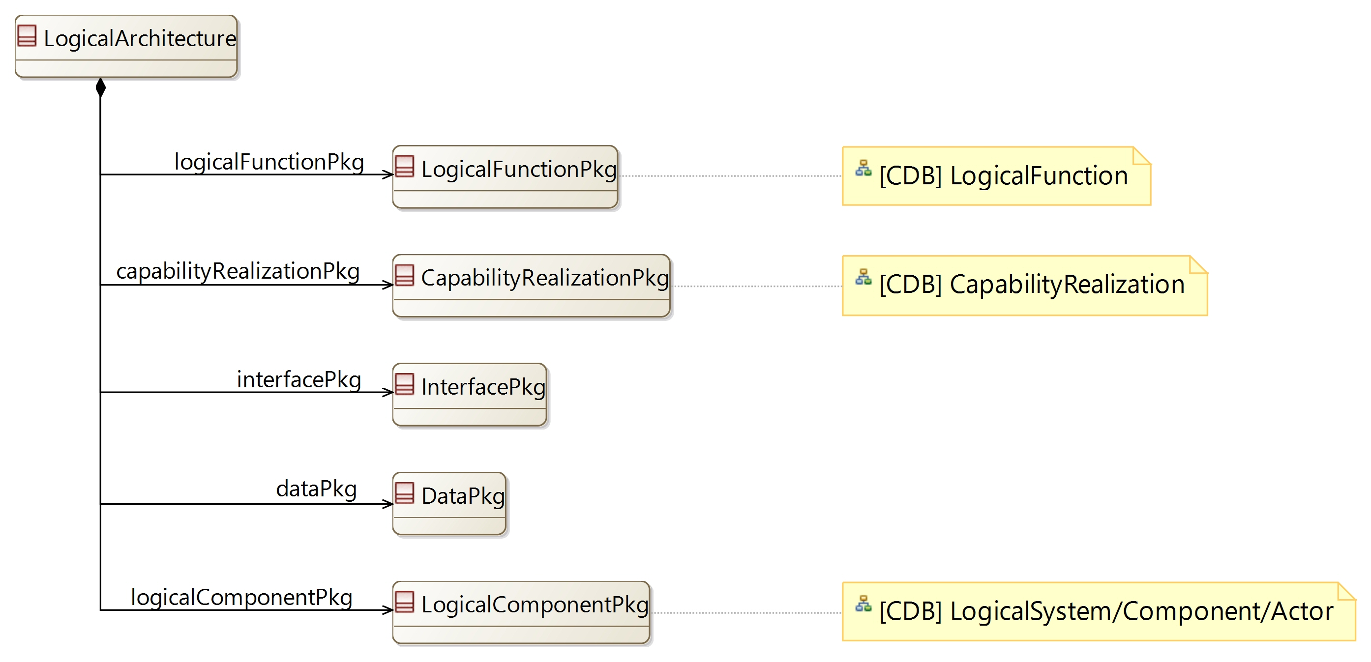

[CDB] LogicalFunction:

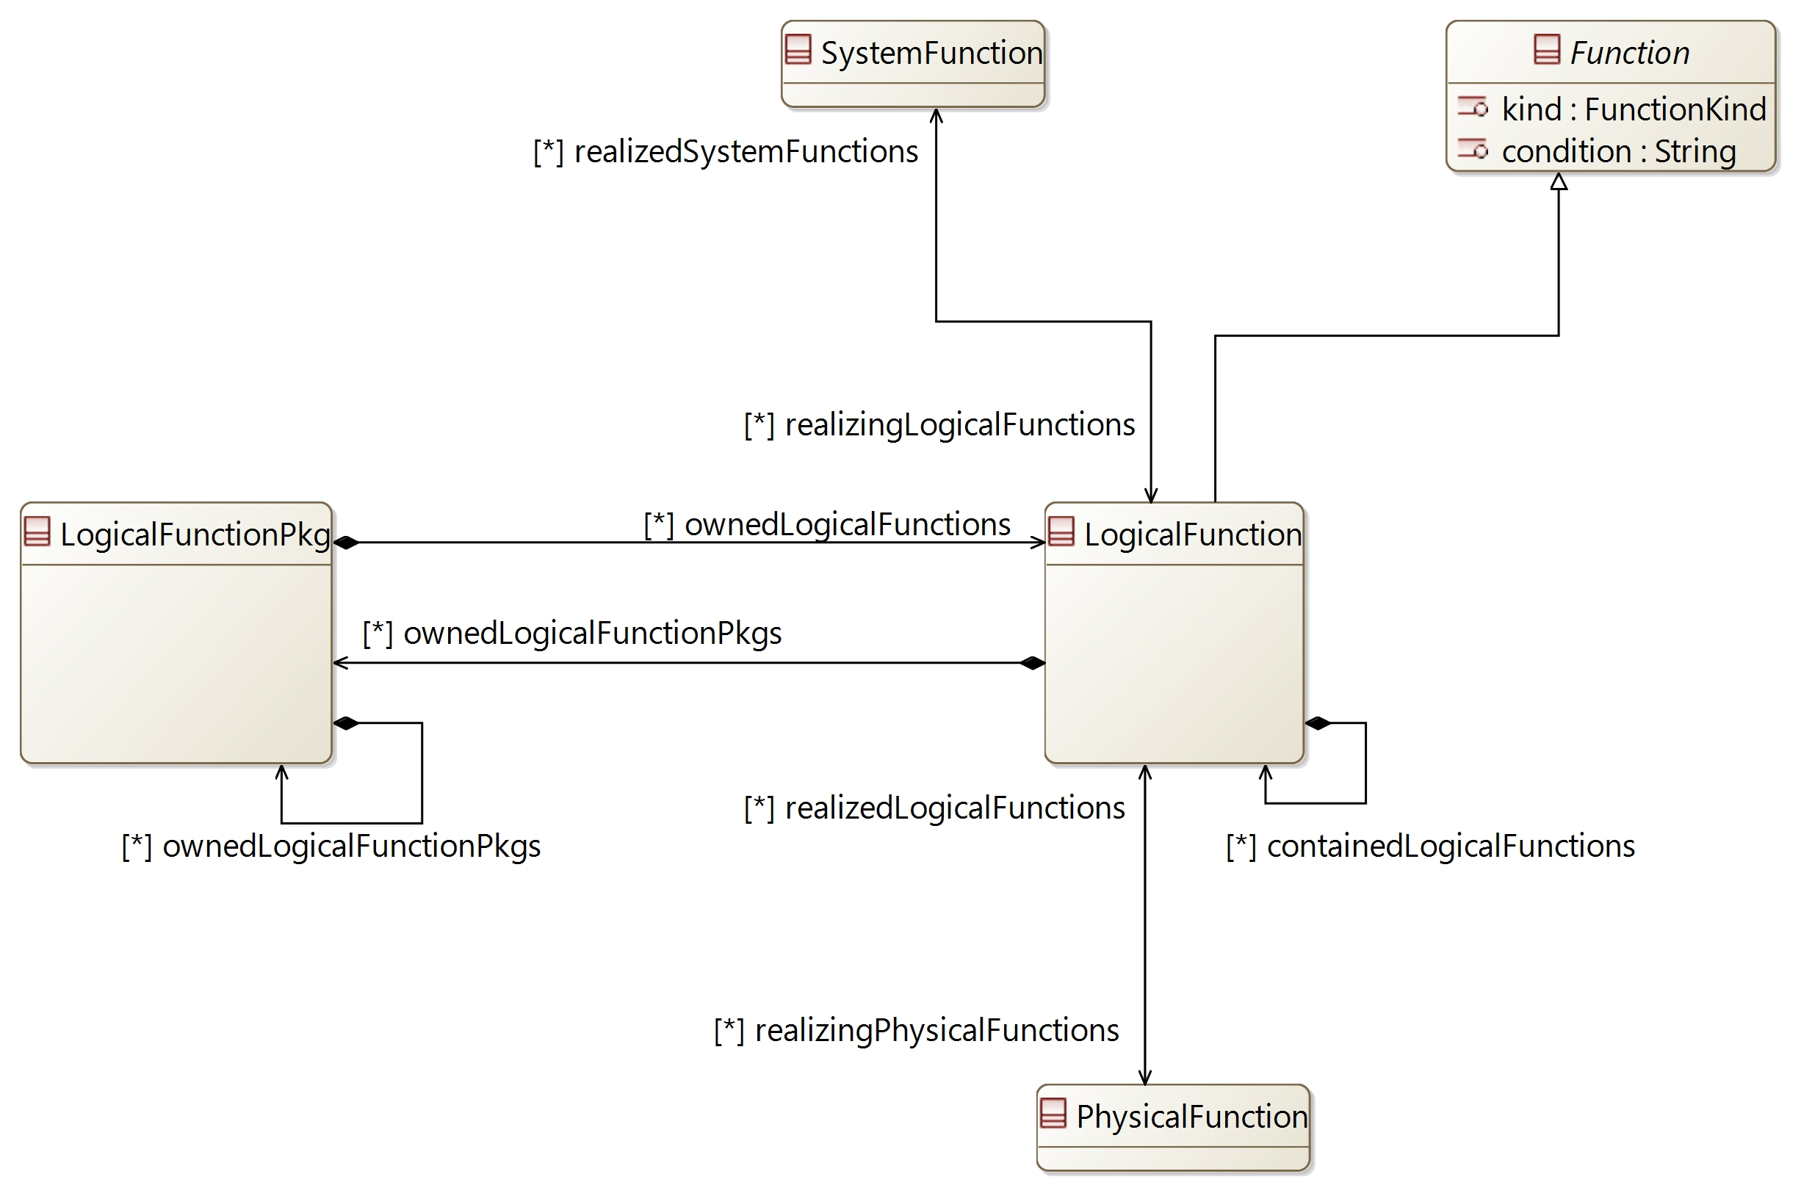

[CDB] CapabilityRealization:

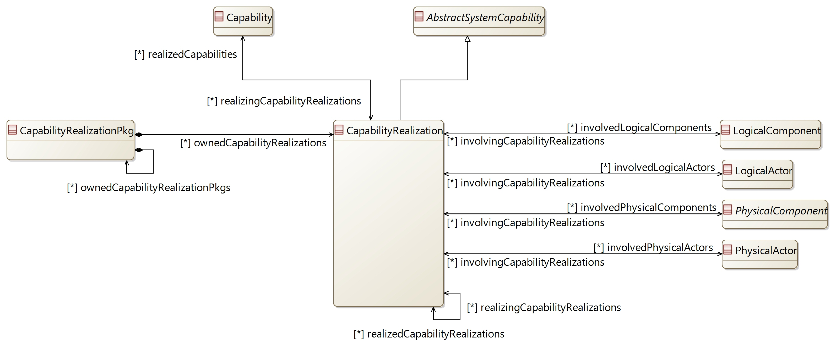

[CDB] LogicalSystem/Component/Actor:

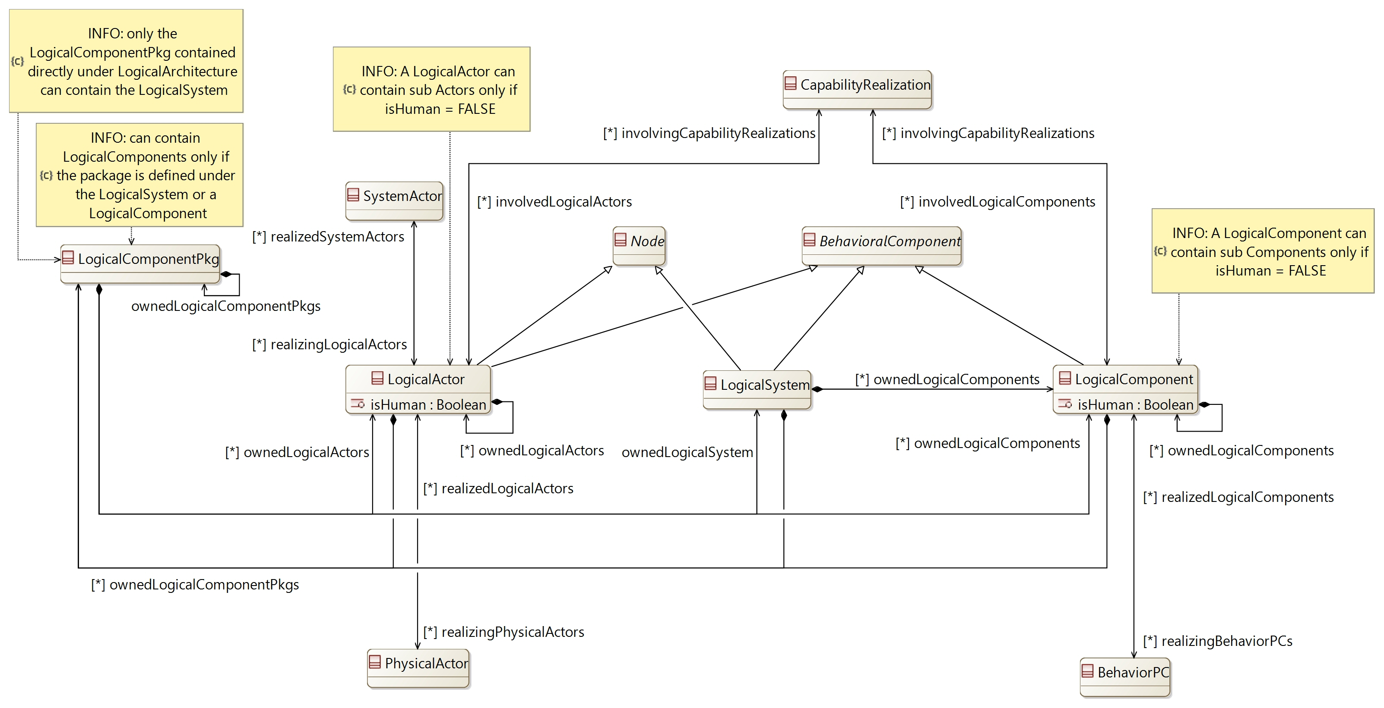

## [Type] LogicalArchitecture

Description:

The element containing all definitions from the Logical Architecture.

The Logical Architecture (or conceptual solution) aims at defining how the system will work in order to fulfil expectations

Direct super types:

* **PropertyValuePkgContainer**

Direct sub-types:

*No direct sub-type*

Possible parent elements:

* SystemEngineering

Attributes:

|  |  |  |
| --- | --- | --- |
| **Attribute name** | **Attribute type** | **Defined on** |
| id | String | **CapellaElement** |
| sid | String | **CapellaElement** |
| name | String | **CapellaElement** |
| summary | String | **CapellaElement** |
| description | String | **CapellaElement** |
| status | **Status** | **CapellaElement** |
| review | String | **CapellaElement** |
| visibleInDocumentation | Boolean | **CapellaElement** |
| visibleForTraceability | Boolean | **CapellaElement** |

Relations:

|  |  |  |  |  |
| --- | --- | --- | --- | --- |
| **Ref. name** | **Kind** | **Card.** | **Target Type** | **Defined on** |
| ownedDiagrams | COMPOSITION | [0 *] | **Diagram** | **EObject** |
| elementOfInterestForDiagrams | ASSOCIATION | [0 *] | **Diagram** | **EObject** |
| contextualElementForDiagrams | ASSOCIATION | [0 *] | **Diagram** | **EObject** |
| representingDiagrams | ASSOCIATION | [0 *] | **Diagram** | **EObject** |
| ownedConstraints | COMPOSITION | [0 *] | **Constraint** | **CapellaElement** |
| constraints | ASSOCIATION | [0 *] | **Constraint** | **CapellaElement** |
| ownedPropertyValues | COMPOSITION | [0 *] | **PropertyValue** | **CapellaElement** |
| appliedPropertyValues | ASSOCIATION | [0 *] | **PropertyValue** | **CapellaElement** |
| ownedPropertyValueGroups | COMPOSITION | [0 *] | **PropertyValueGroup** | **CapellaElement** |
| appliedPropertyValueGroups | ASSOCIATION | [0 *] | **PropertyValueGroup** | **CapellaElement** |
| ownedEnumerationPropertyTypes | COMPOSITION | [0 *] | **EnumerationPropertyType** | **CapellaElement** |
| ownedPropertyValuePkgs | COMPOSITION | [0 *] | **PropertyValuePkg** | **PropertyValuePkgContainer** |
| logicalFunctionPkg | COMPOSITION | [1 1] | **LogicalFunctionPkg** | *defined on type* |
| capabilityRealizationPkg | COMPOSITION | [1 1] | **CapabilityRealizationPkg** | *defined on type* |
| interfacePkg | COMPOSITION | [1 1] | **InterfacePkg** | *defined on type* |
| dataPkg | COMPOSITION | [1 1] | **DataPkg** | *defined on type* |
| logicalComponentPkg | COMPOSITION | [1 1] | **LogicalComponentPkg** | *defined on type* |

Methods:

*No method defined*

## [Type] LogicalFunctionPkg

Description:

A package to contain LogicalFunctions

Direct super types:

* **PropertyValuePkgContainer**

Direct sub-types:

*No direct sub-type*

Possible parent elements:

* LogicalArchitecture
* LogicalFunctionPkg
* LogicalFunction

Attributes:

|  |  |  |
| --- | --- | --- |
| **Attribute name** | **Attribute type** | **Defined on** |
| id | String | **CapellaElement** |
| sid | String | **CapellaElement** |
| name | String | **CapellaElement** |
| summary | String | **CapellaElement** |
| description | String | **CapellaElement** |
| status | **Status** | **CapellaElement** |
| review | String | **CapellaElement** |
| visibleInDocumentation | Boolean | **CapellaElement** |
| visibleForTraceability | Boolean | **CapellaElement** |

Relations:

|  |  |  |  |  |
| --- | --- | --- | --- | --- |
| **Ref. name** | **Kind** | **Card.** | **Target Type** | **Defined on** |
| ownedDiagrams | COMPOSITION | [0 *] | **Diagram** | **EObject** |
| elementOfInterestForDiagrams | ASSOCIATION | [0 *] | **Diagram** | **EObject** |
| contextualElementForDiagrams | ASSOCIATION | [0 *] | **Diagram** | **EObject** |
| representingDiagrams | ASSOCIATION | [0 *] | **Diagram** | **EObject** |
| ownedConstraints | COMPOSITION | [0 *] | **Constraint** | **CapellaElement** |
| constraints | ASSOCIATION | [0 *] | **Constraint** | **CapellaElement** |
| ownedPropertyValues | COMPOSITION | [0 *] | **PropertyValue** | **CapellaElement** |
| appliedPropertyValues | ASSOCIATION | [0 *] | **PropertyValue** | **CapellaElement** |
| ownedPropertyValueGroups | COMPOSITION | [0 *] | **PropertyValueGroup** | **CapellaElement** |
| appliedPropertyValueGroups | ASSOCIATION | [0 *] | **PropertyValueGroup** | **CapellaElement** |
| ownedEnumerationPropertyTypes | COMPOSITION | [0 *] | **EnumerationPropertyType** | **CapellaElement** |
| ownedPropertyValuePkgs | COMPOSITION | [0 *] | **PropertyValuePkg** | **PropertyValuePkgContainer** |
| ownedLogicalFunctionPkgs | COMPOSITION | [0 *] | **LogicalFunctionPkg** | *defined on type* |
| ownedLogicalFunctions | COMPOSITION | [0 *] | **LogicalFunction** | *defined on type* |

Methods:

*No method defined*

## [Type] LogicalFunction

Description:

The definition of a Function in the Logical Architecture

Direct super types:

* **Function**

Direct sub-types:

*No direct sub-type*

Possible parent elements:

* LogicalFunctionPkg
* LogicalFunction

Attributes:

|  |  |  |
| --- | --- | --- |
| **Attribute name** | **Attribute type** | **Defined on** |
| id | String | **CapellaElement** |
| sid | String | **CapellaElement** |
| name | String | **CapellaElement** |
| summary | String | **CapellaElement** |
| description | String | **CapellaElement** |
| status | **Status** | **CapellaElement** |
| review | String | **CapellaElement** |
| visibleInDocumentation | Boolean | **CapellaElement** |
| visibleForTraceability | Boolean | **CapellaElement** |
| kind | **FunctionKind** | **Function** |
| condition | String | **Function** |

Relations:

|  |  |  |  |  |
| --- | --- | --- | --- | --- |
| **Ref. name** | **Kind** | **Card.** | **Target Type** | **Defined on** |
| ownedDiagrams | COMPOSITION | [0 *] | **Diagram** | **EObject** |
| elementOfInterestForDiagrams | ASSOCIATION | [0 *] | **Diagram** | **EObject** |
| contextualElementForDiagrams | ASSOCIATION | [0 *] | **Diagram** | **EObject** |
| representingDiagrams | ASSOCIATION | [0 *] | **Diagram** | **EObject** |
| ownedConstraints | COMPOSITION | [0 *] | **Constraint** | **CapellaElement** |
| constraints | ASSOCIATION | [0 *] | **Constraint** | **CapellaElement** |
| ownedPropertyValues | COMPOSITION | [0 *] | **PropertyValue** | **CapellaElement** |
| appliedPropertyValues | ASSOCIATION | [0 *] | **PropertyValue** | **CapellaElement** |
| ownedPropertyValueGroups | COMPOSITION | [0 *] | **PropertyValueGroup** | **CapellaElement** |
| appliedPropertyValueGroups | ASSOCIATION | [0 *] | **PropertyValueGroup** | **CapellaElement** |
| ownedEnumerationPropertyTypes | COMPOSITION | [0 *] | **EnumerationPropertyType** | **CapellaElement** |
| availableInStates | ASSOCIATION | [0 *] | **State** | **AbstractActivityFunction** |
| inputs | COMPOSITION | [0 *] | **FunctionInputPort** | **Function** |
| outputs | COMPOSITION | [0 *] | **FunctionOutputPort** | **Function** |
| incoming | ASSOCIATION | [0 *] | **FunctionalExchange** | **Function** |
| outgoing | ASSOCIATION | [0 *] | **FunctionalExchange** | **Function** |
| allocatingComponent | ASSOCIATION | [0 1] | **BehavioralComponent** | **Function** |
| ownedFunctionalChains | COMPOSITION | [0 *] | **FunctionalChain** | **Function** |
| involvingFunctionalChains | ASSOCIATION | [0 *] | **FunctionalChain** | **Function** |
| involvingCapabilities | ASSOCIATION | [0 *] | **AbstractSystemCapability** | **Function** |
| containedLogicalFunctions | COMPOSITION | [0 *] | **LogicalFunction** | *defined on type* |
| ownedLogicalFunctionPkgs | COMPOSITION | [0 *] | **LogicalFunctionPkg** | *defined on type* |
| realizedSystemFunctions | ASSOCIATION | [0 *] | **SystemFunction** | *defined on type* |
| realizingPhysicalFunctions | ASSOCIATION | [0 *] | **PhysicalFunction** | *defined on type* |

Methods:

*No method defined*

## [Type] CapabilityRealizationPkg

Description:

A package to contain CapabilityRealizations

Direct super types:

* **PropertyValuePkgContainer**

Direct sub-types:

*No direct sub-type*

Possible parent elements:

* LogicalArchitecture
* CapabilityRealizationPkg
* PhysicalArchitecture
* EPBSArchitecture

Attributes:

|  |  |  |
| --- | --- | --- |
| **Attribute name** | **Attribute type** | **Defined on** |
| id | String | **CapellaElement** |
| sid | String | **CapellaElement** |
| name | String | **CapellaElement** |
| summary | String | **CapellaElement** |
| description | String | **CapellaElement** |
| status | **Status** | **CapellaElement** |
| review | String | **CapellaElement** |
| visibleInDocumentation | Boolean | **CapellaElement** |
| visibleForTraceability | Boolean | **CapellaElement** |

Relations:

|  |  |  |  |  |
| --- | --- | --- | --- | --- |
| **Ref. name** | **Kind** | **Card.** | **Target Type** | **Defined on** |
| ownedDiagrams | COMPOSITION | [0 *] | **Diagram** | **EObject** |
| elementOfInterestForDiagrams | ASSOCIATION | [0 *] | **Diagram** | **EObject** |
| contextualElementForDiagrams | ASSOCIATION | [0 *] | **Diagram** | **EObject** |
| representingDiagrams | ASSOCIATION | [0 *] | **Diagram** | **EObject** |
| ownedConstraints | COMPOSITION | [0 *] | **Constraint** | **CapellaElement** |
| constraints | ASSOCIATION | [0 *] | **Constraint** | **CapellaElement** |
| ownedPropertyValues | COMPOSITION | [0 *] | **PropertyValue** | **CapellaElement** |
| appliedPropertyValues | ASSOCIATION | [0 *] | **PropertyValue** | **CapellaElement** |
| ownedPropertyValueGroups | COMPOSITION | [0 *] | **PropertyValueGroup** | **CapellaElement** |
| appliedPropertyValueGroups | ASSOCIATION | [0 *] | **PropertyValueGroup** | **CapellaElement** |
| ownedEnumerationPropertyTypes | COMPOSITION | [0 *] | **EnumerationPropertyType** | **CapellaElement** |
| ownedPropertyValuePkgs | COMPOSITION | [0 *] | **PropertyValuePkg** | **PropertyValuePkgContainer** |
| ownedCapabilityRealizationPkgs | COMPOSITION | [0 *] | **CapabilityRealizationPkg** | *defined on type* |
| ownedCapabilityRealizations | COMPOSITION | [0 *] | **CapabilityRealization** | *defined on type* |

Methods:

*No method defined*

## [Type] CapabilityRealization

Description:

The implementation of the system Capabilities in Logical Architecture and Physical Architecture

Direct super types:

* **AbstractSystemCapability**

Direct sub-types:

*No direct sub-type*

Possible parent elements:

* CapabilityRealizationPkg

Attributes:

|  |  |  |
| --- | --- | --- |
| **Attribute name** | **Attribute type** | **Defined on** |
| id | String | **CapellaElement** |
| sid | String | **CapellaElement** |
| name | String | **CapellaElement** |
| summary | String | **CapellaElement** |
| description | String | **CapellaElement** |
| status | **Status** | **CapellaElement** |
| review | String | **CapellaElement** |
| visibleInDocumentation | Boolean | **CapellaElement** |
| visibleForTraceability | Boolean | **CapellaElement** |

Relations:

|  |  |  |  |  |
| --- | --- | --- | --- | --- |
| **Ref. name** | **Kind** | **Card.** | **Target Type** | **Defined on** |
| ownedDiagrams | COMPOSITION | [0 *] | **Diagram** | **EObject** |
| elementOfInterestForDiagrams | ASSOCIATION | [0 *] | **Diagram** | **EObject** |
| contextualElementForDiagrams | ASSOCIATION | [0 *] | **Diagram** | **EObject** |
| representingDiagrams | ASSOCIATION | [0 *] | **Diagram** | **EObject** |
| ownedConstraints | COMPOSITION | [0 *] | **Constraint** | **CapellaElement** |
| constraints | ASSOCIATION | [0 *] | **Constraint** | **CapellaElement** |
| ownedPropertyValues | COMPOSITION | [0 *] | **PropertyValue** | **CapellaElement** |
| appliedPropertyValues | ASSOCIATION | [0 *] | **PropertyValue** | **CapellaElement** |
| ownedPropertyValueGroups | COMPOSITION | [0 *] | **PropertyValueGroup** | **CapellaElement** |
| appliedPropertyValueGroups | ASSOCIATION | [0 *] | **PropertyValueGroup** | **CapellaElement** |
| ownedEnumerationPropertyTypes | COMPOSITION | [0 *] | **EnumerationPropertyType** | **CapellaElement** |
| ownedPropertyValuePkgs | COMPOSITION | [0 *] | **PropertyValuePkg** | **PropertyValuePkgContainer** |
| preCondition | ASSOCIATION | [1 1] | **Constraint** | **AbstractCapability** |
| postCondition | ASSOCIATION | [1 1] | **Constraint** | **AbstractCapability** |
| ownedScenarios | COMPOSITION | [0 *] | **Scenario** | **AbstractCapability** |
| super | ASSOCIATION | [0 *] | **AbstractCapability** | **AbstractCapability** |
| sub | ASSOCIATION | [0 *] | **AbstractCapability** | **AbstractCapability** |
| includedCapabilities | ASSOCIATION | [0 *] | **AbstractCapability** | **AbstractCapability** |
| includingCapabilities | ASSOCIATION | [0 *] | **AbstractCapability** | **AbstractCapability** |
| extendedCapabilities | ASSOCIATION | [0 *] | **AbstractCapability** | **AbstractCapability** |
| extendingCapabilities | ASSOCIATION | [0 *] | **AbstractCapability** | **AbstractCapability** |
| availableInStates | ASSOCIATION | [0 *] | **State** | **AbstractCapability** |
| ownedFunctionalChains | COMPOSITION | [0 *] | **FunctionalChain** | **AbstractSystemCapability** |
| involvedFunctionalChains | ASSOCIATION | [0 *] | **FunctionalChain** | **AbstractSystemCapability** |
| involvedFunctions | ASSOCIATION | [0 *] | **Function** | **AbstractSystemCapability** |
| realizedCapabilities | ASSOCIATION | [0 *] | **Capability** | *defined on type* |
| realizedCapabilityRealizations | ASSOCIATION | [0 *] | **CapabilityRealization** | *defined on type* |
| realizingCapabilityRealizations | ASSOCIATION | [0 *] | **CapabilityRealization** | *defined on type* |
| involvedLogicalActors | ASSOCIATION | [0 *] | **LogicalActor** | *defined on type* |
| involvedLogicalComponents | ASSOCIATION | [0 *] | **LogicalComponent** | *defined on type* |
| involvedPhysicalComponents | ASSOCIATION | [0 *] | **PhysicalComponent** | *defined on type* |
| involvedPhysicalActors | ASSOCIATION | [0 *] | **PhysicalActor** | *defined on type* |

Methods:

*No method defined*

## [Type] LogicalComponentPkg

Description:

A package to contain the LogicalSystem, LogicalComponents and LogicalActors

Direct super types:

* **PropertyValuePkgContainer**

Direct sub-types:

*No direct sub-type*

Possible parent elements:

* LogicalArchitecture
* LogicalComponentPkg
* LogicalSystem
* LogicalComponent
* LogicalActor

Attributes:

|  |  |  |
| --- | --- | --- |
| **Attribute name** | **Attribute type** | **Defined on** |
| id | String | **CapellaElement** |
| sid | String | **CapellaElement** |
| name | String | **CapellaElement** |
| summary | String | **CapellaElement** |
| description | String | **CapellaElement** |
| status | **Status** | **CapellaElement** |
| review | String | **CapellaElement** |
| visibleInDocumentation | Boolean | **CapellaElement** |
| visibleForTraceability | Boolean | **CapellaElement** |

Relations:

|  |  |  |  |  |
| --- | --- | --- | --- | --- |
| **Ref. name** | **Kind** | **Card.** | **Target Type** | **Defined on** |
| ownedDiagrams | COMPOSITION | [0 *] | **Diagram** | **EObject** |
| elementOfInterestForDiagrams | ASSOCIATION | [0 *] | **Diagram** | **EObject** |
| contextualElementForDiagrams | ASSOCIATION | [0 *] | **Diagram** | **EObject** |
| representingDiagrams | ASSOCIATION | [0 *] | **Diagram** | **EObject** |
| ownedConstraints | COMPOSITION | [0 *] | **Constraint** | **CapellaElement** |
| constraints | ASSOCIATION | [0 *] | **Constraint** | **CapellaElement** |
| ownedPropertyValues | COMPOSITION | [0 *] | **PropertyValue** | **CapellaElement** |
| appliedPropertyValues | ASSOCIATION | [0 *] | **PropertyValue** | **CapellaElement** |
| ownedPropertyValueGroups | COMPOSITION | [0 *] | **PropertyValueGroup** | **CapellaElement** |
| appliedPropertyValueGroups | ASSOCIATION | [0 *] | **PropertyValueGroup** | **CapellaElement** |
| ownedEnumerationPropertyTypes | COMPOSITION | [0 *] | **EnumerationPropertyType** | **CapellaElement** |
| ownedPropertyValuePkgs | COMPOSITION | [0 *] | **PropertyValuePkg** | **PropertyValuePkgContainer** |
| ownedLogicalComponentPkgs | COMPOSITION | [1 1] | **LogicalComponentPkg** | *defined on type* |
| ownedLogicalSystem | COMPOSITION | [1 1] | **LogicalSystem** | *defined on type* |
| ownedLogicalActors | COMPOSITION | [0 *] | **LogicalActor** | *defined on type* |
| ownedLogicalComponents | COMPOSITION | [0 *] | **LogicalComponent** | *defined on type* |

Methods:

*No method defined*

## [Type] LogicalSystem

Description:

The definition of the system in Logical Architecture

Direct super types:

* **BehavioralComponent**
* **Node**

Direct sub-types:

*No direct sub-type*

Possible parent elements:

* LogicalComponentPkg

Attributes:

|  |  |  |
| --- | --- | --- |
| **Attribute name** | **Attribute type** | **Defined on** |
| id | String | **CapellaElement** |
| sid | String | **CapellaElement** |
| name | String | **CapellaElement** |
| summary | String | **CapellaElement** |
| description | String | **CapellaElement** |
| status | **Status** | **CapellaElement** |
| review | String | **CapellaElement** |
| visibleInDocumentation | Boolean | **CapellaElement** |
| visibleForTraceability | Boolean | **CapellaElement** |

Relations:

|  |  |  |  |  |
| --- | --- | --- | --- | --- |
| **Ref. name** | **Kind** | **Card.** | **Target Type** | **Defined on** |
| ownedDiagrams | COMPOSITION | [0 *] | **Diagram** | **EObject** |
| elementOfInterestForDiagrams | ASSOCIATION | [0 *] | **Diagram** | **EObject** |
| contextualElementForDiagrams | ASSOCIATION | [0 *] | **Diagram** | **EObject** |
| representingDiagrams | ASSOCIATION | [0 *] | **Diagram** | **EObject** |
| ownedConstraints | COMPOSITION | [0 *] | **Constraint** | **CapellaElement** |
| constraints | ASSOCIATION | [0 *] | **Constraint** | **CapellaElement** |
| ownedPropertyValues | COMPOSITION | [0 *] | **PropertyValue** | **CapellaElement** |
| appliedPropertyValues | ASSOCIATION | [0 *] | **PropertyValue** | **CapellaElement** |
| ownedPropertyValueGroups | COMPOSITION | [0 *] | **PropertyValueGroup** | **CapellaElement** |
| appliedPropertyValueGroups | ASSOCIATION | [0 *] | **PropertyValueGroup** | **CapellaElement** |
| ownedEnumerationPropertyTypes | COMPOSITION | [0 *] | **EnumerationPropertyType** | **CapellaElement** |
| containedComponentPorts | COMPOSITION | [0 *] | **ComponentPort** | **BehavioralComponent** |
| incomingComponentExchanges | ASSOCIATION | [0 *] | **ComponentExchange** | **BehavioralComponent** |
| outgoingComponentExchanges | ASSOCIATION | [0 *] | **ComponentExchange** | **BehavioralComponent** |
| inoutComponentExchanges | ASSOCIATION | [0 *] | **ComponentExchange** | **BehavioralComponent** |
| allocatedFunctions | ASSOCIATION | [0 *] | **Function** | **BehavioralComponent** |
| usedInterfaces | ASSOCIATION | [0 *] | **Interface** | **BehavioralComponent** |
| implementedInterfaces | ASSOCIATION | [0 *] | **Interface** | **BehavioralComponent** |
| ownedStateMachines | COMPOSITION | [0 *] | **StateMachine** | **BehavioralComponent** |
| containedPhysicalPorts | COMPOSITION | [0 *] | **PhysicalPort** | **Node** |
| physicalLinks | ASSOCIATION | [0 *] | **PhysicalLink** | **Node** |
| involvingPhysicalPaths | ASSOCIATION | [0 *] | **PhysicalPath** | **Node** |
| ownedStateMachines | COMPOSITION | [0 *] | **StateMachine** | **Node** |
| ownedLogicalComponents | COMPOSITION | [0 *] | **LogicalComponent** | *defined on type* |
| ownedLogicalComponentPkgs | COMPOSITION | [0 *] | **LogicalComponentPkg** | *defined on type* |

Methods:

*No method defined*

## [Type] LogicalComponent

Description:

Logical Components are the artefacts enabling a notional decomposition of the system as a "white box", independently from any technological solutions, but dealing with major system decomposition constraints

Logical components are identified according to logical abstractions (i.e. functional grouping, logical interfaces)

Direct super types:

* **BehavioralComponent**

Direct sub-types:

*No direct sub-type*

Possible parent elements:

* LogicalComponentPkg
* LogicalSystem
* LogicalComponent

Attributes:

|  |  |  |
| --- | --- | --- |
| **Attribute name** | **Attribute type** | **Defined on** |
| id | String | **CapellaElement** |
| sid | String | **CapellaElement** |
| name | String | **CapellaElement** |
| summary | String | **CapellaElement** |
| description | String | **CapellaElement** |
| status | **Status** | **CapellaElement** |
| review | String | **CapellaElement** |
| visibleInDocumentation | Boolean | **CapellaElement** |
| visibleForTraceability | Boolean | **CapellaElement** |
| isHuman | Boolean | *defined on type* |

Relations:

|  |  |  |  |  |
| --- | --- | --- | --- | --- |
| **Ref. name** | **Kind** | **Card.** | **Target Type** | **Defined on** |
| ownedDiagrams | COMPOSITION | [0 *] | **Diagram** | **EObject** |
| elementOfInterestForDiagrams | ASSOCIATION | [0 *] | **Diagram** | **EObject** |
| contextualElementForDiagrams | ASSOCIATION | [0 *] | **Diagram** | **EObject** |
| representingDiagrams | ASSOCIATION | [0 *] | **Diagram** | **EObject** |
| ownedConstraints | COMPOSITION | [0 *] | **Constraint** | **CapellaElement** |
| constraints | ASSOCIATION | [0 *] | **Constraint** | **CapellaElement** |
| ownedPropertyValues | COMPOSITION | [0 *] | **PropertyValue** | **CapellaElement** |
| appliedPropertyValues | ASSOCIATION | [0 *] | **PropertyValue** | **CapellaElement** |
| ownedPropertyValueGroups | COMPOSITION | [0 *] | **PropertyValueGroup** | **CapellaElement** |
| appliedPropertyValueGroups | ASSOCIATION | [0 *] | **PropertyValueGroup** | **CapellaElement** |
| ownedEnumerationPropertyTypes | COMPOSITION | [0 *] | **EnumerationPropertyType** | **CapellaElement** |
| containedComponentPorts | COMPOSITION | [0 *] | **ComponentPort** | **BehavioralComponent** |
| incomingComponentExchanges | ASSOCIATION | [0 *] | **ComponentExchange** | **BehavioralComponent** |
| outgoingComponentExchanges | ASSOCIATION | [0 *] | **ComponentExchange** | **BehavioralComponent** |
| inoutComponentExchanges | ASSOCIATION | [0 *] | **ComponentExchange** | **BehavioralComponent** |
| allocatedFunctions | ASSOCIATION | [0 *] | **Function** | **BehavioralComponent** |
| usedInterfaces | ASSOCIATION | [0 *] | **Interface** | **BehavioralComponent** |
| implementedInterfaces | ASSOCIATION | [0 *] | **Interface** | **BehavioralComponent** |
| ownedStateMachines | COMPOSITION | [0 *] | **StateMachine** | **BehavioralComponent** |
| ownedLogicalComponents | COMPOSITION | [0 *] | **LogicalComponent** | *defined on type* |
| ownedLogicalComponentPkgs | COMPOSITION | [0 *] | **LogicalComponentPkg** | *defined on type* |
| realizingBehaviorPCs | ASSOCIATION | [0 *] | **BehaviorPC** | *defined on type* |
| involvingCapabilityRealizations | ASSOCIATION | [0 *] | **CapabilityRealization** | *defined on type* |

Methods:

*No method defined*

## [Type] LogicalActor

Description:

An external Actor defined in the Logical Architecture

Direct super types:

* **BehavioralComponent**
* **Node**

Direct sub-types:

*No direct sub-type*

Possible parent elements:

* LogicalComponentPkg
* LogicalActor

Attributes:

|  |  |  |
| --- | --- | --- |
| **Attribute name** | **Attribute type** | **Defined on** |
| id | String | **CapellaElement** |
| sid | String | **CapellaElement** |
| name | String | **CapellaElement** |
| summary | String | **CapellaElement** |
| description | String | **CapellaElement** |
| status | **Status** | **CapellaElement** |
| review | String | **CapellaElement** |
| visibleInDocumentation | Boolean | **CapellaElement** |
| visibleForTraceability | Boolean | **CapellaElement** |
| isHuman | Boolean | *defined on type* |

Relations:

|  |  |  |  |  |
| --- | --- | --- | --- | --- |
| **Ref. name** | **Kind** | **Card.** | **Target Type** | **Defined on** |
| ownedDiagrams | COMPOSITION | [0 *] | **Diagram** | **EObject** |
| elementOfInterestForDiagrams | ASSOCIATION | [0 *] | **Diagram** | **EObject** |
| contextualElementForDiagrams | ASSOCIATION | [0 *] | **Diagram** | **EObject** |
| representingDiagrams | ASSOCIATION | [0 *] | **Diagram** | **EObject** |
| ownedConstraints | COMPOSITION | [0 *] | **Constraint** | **CapellaElement** |
| constraints | ASSOCIATION | [0 *] | **Constraint** | **CapellaElement** |
| ownedPropertyValues | COMPOSITION | [0 *] | **PropertyValue** | **CapellaElement** |
| appliedPropertyValues | ASSOCIATION | [0 *] | **PropertyValue** | **CapellaElement** |
| ownedPropertyValueGroups | COMPOSITION | [0 *] | **PropertyValueGroup** | **CapellaElement** |
| appliedPropertyValueGroups | ASSOCIATION | [0 *] | **PropertyValueGroup** | **CapellaElement** |
| ownedEnumerationPropertyTypes | COMPOSITION | [0 *] | **EnumerationPropertyType** | **CapellaElement** |
| containedComponentPorts | COMPOSITION | [0 *] | **ComponentPort** | **BehavioralComponent** |
| incomingComponentExchanges | ASSOCIATION | [0 *] | **ComponentExchange** | **BehavioralComponent** |
| outgoingComponentExchanges | ASSOCIATION | [0 *] | **ComponentExchange** | **BehavioralComponent** |
| inoutComponentExchanges | ASSOCIATION | [0 *] | **ComponentExchange** | **BehavioralComponent** |
| allocatedFunctions | ASSOCIATION | [0 *] | **Function** | **BehavioralComponent** |
| usedInterfaces | ASSOCIATION | [0 *] | **Interface** | **BehavioralComponent** |
| implementedInterfaces | ASSOCIATION | [0 *] | **Interface** | **BehavioralComponent** |
| ownedStateMachines | COMPOSITION | [0 *] | **StateMachine** | **BehavioralComponent** |
| containedPhysicalPorts | COMPOSITION | [0 *] | **PhysicalPort** | **Node** |
| physicalLinks | ASSOCIATION | [0 *] | **PhysicalLink** | **Node** |
| involvingPhysicalPaths | ASSOCIATION | [0 *] | **PhysicalPath** | **Node** |
| ownedStateMachines | COMPOSITION | [0 *] | **StateMachine** | **Node** |
| ownedLogicalActors | COMPOSITION | [0 *] | **LogicalActor** | *defined on type* |
| ownedLogicalComponentPkgs | COMPOSITION | [0 *] | **LogicalComponentPkg** | *defined on type* |
| realizedSystemActors | ASSOCIATION | [0 *] | **SystemActor** | *defined on type* |
| realizingPhysicalActors | ASSOCIATION | [0 *] | **PhysicalActor** | *defined on type* |
| involvingCapabilityRealizations | ASSOCIATION | [0 *] | **CapabilityRealization** | *defined on type* |

Methods:

*No method defined*

# [Package] pa

Diagrams:

Here are the diagrams of representing the elements introduced in this package:

[CDB] PhysicalComponent:

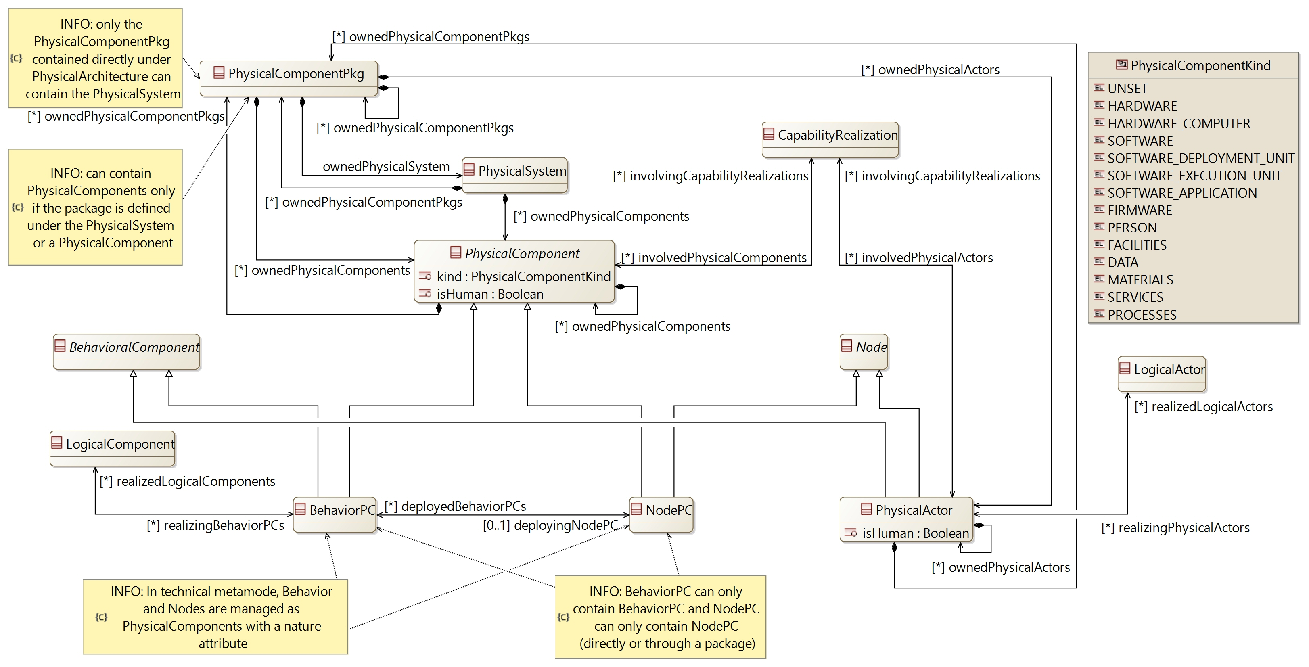

[CDB] PhysicalArchitecture:

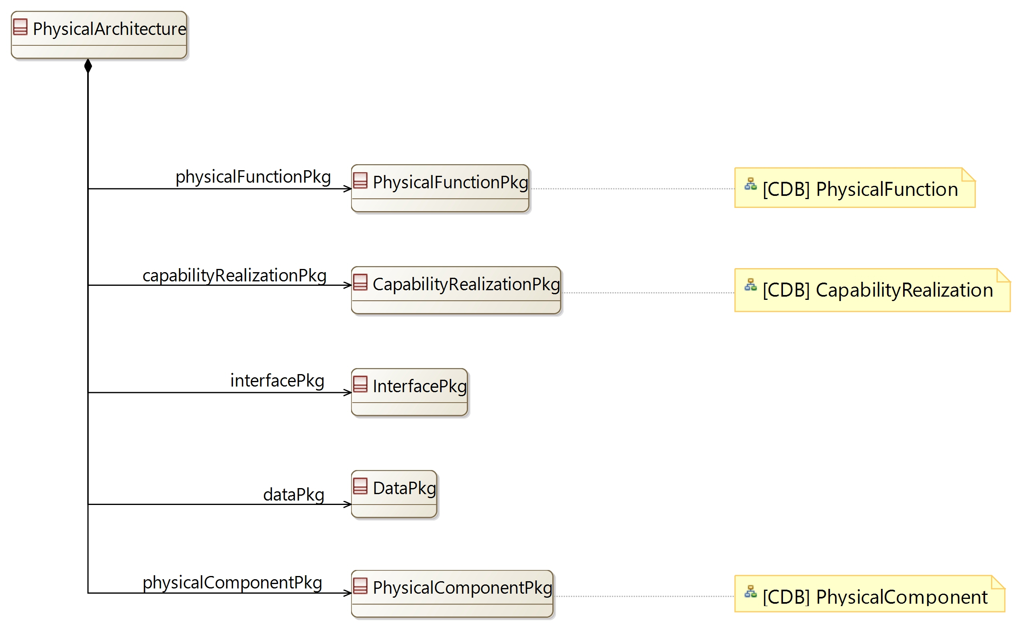

[CDB] PhysicalFunction:

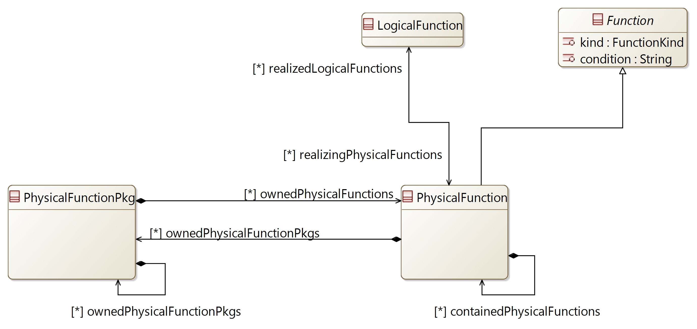

[CDB] Deployment:

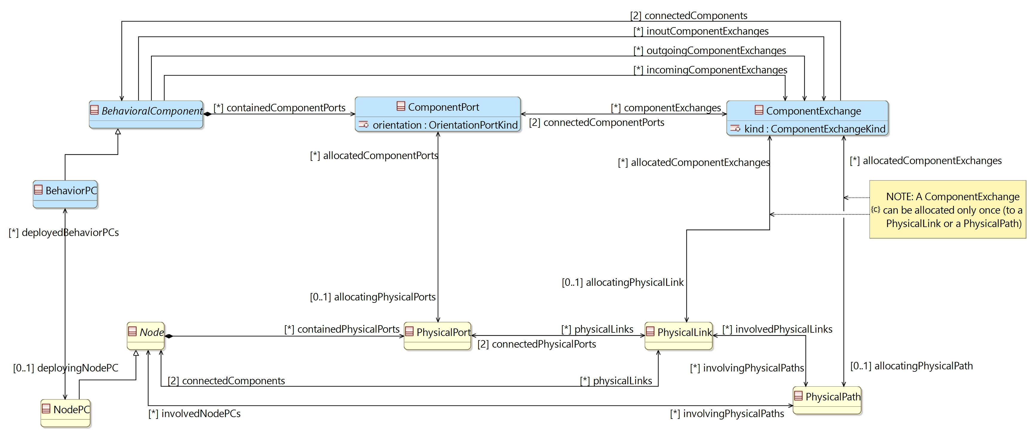

## [Type] PhysicalArchitecture

Description:

The element containing all definitions from the Physical Architecture.

The Physical Architecture (or finalized solution) aims at defining how the system will be developed and built

Direct super types:

* **PropertyValuePkgContainer**

Direct sub-types:

*No direct sub-type*

Possible parent elements:

* SystemEngineering

Attributes:

|  |  |  |
| --- | --- | --- |
| **Attribute name** | **Attribute type** | **Defined on** |
| id | String | **CapellaElement** |
| sid | String | **CapellaElement** |
| name | String | **CapellaElement** |
| summary | String | **CapellaElement** |
| description | String | **CapellaElement** |
| status | **Status** | **CapellaElement** |
| review | String | **CapellaElement** |
| visibleInDocumentation | Boolean | **CapellaElement** |
| visibleForTraceability | Boolean | **CapellaElement** |

Relations:

|  |  |  |  |  |
| --- | --- | --- | --- | --- |
| **Ref. name** | **Kind** | **Card.** | **Target Type** | **Defined on** |
| ownedDiagrams | COMPOSITION | [0 *] | **Diagram** | **EObject** |
| elementOfInterestForDiagrams | ASSOCIATION | [0 *] | **Diagram** | **EObject** |
| contextualElementForDiagrams | ASSOCIATION | [0 *] | **Diagram** | **EObject** |
| representingDiagrams | ASSOCIATION | [0 *] | **Diagram** | **EObject** |
| ownedConstraints | COMPOSITION | [0 *] | **Constraint** | **CapellaElement** |
| constraints | ASSOCIATION | [0 *] | **Constraint** | **CapellaElement** |
| ownedPropertyValues | COMPOSITION | [0 *] | **PropertyValue** | **CapellaElement** |
| appliedPropertyValues | ASSOCIATION | [0 *] | **PropertyValue** | **CapellaElement** |
| ownedPropertyValueGroups | COMPOSITION | [0 *] | **PropertyValueGroup** | **CapellaElement** |
| appliedPropertyValueGroups | ASSOCIATION | [0 *] | **PropertyValueGroup** | **CapellaElement** |
| ownedEnumerationPropertyTypes | COMPOSITION | [0 *] | **EnumerationPropertyType** | **CapellaElement** |
| ownedPropertyValuePkgs | COMPOSITION | [0 *] | **PropertyValuePkg** | **PropertyValuePkgContainer** |
| physicalFunctionPkg | COMPOSITION | [1 1] | **PhysicalFunctionPkg** | *defined on type* |
| capabilityRealizationPkg | COMPOSITION | [1 1] | **CapabilityRealizationPkg** | *defined on type* |
| interfacePkg | COMPOSITION | [1 1] | **InterfacePkg** | *defined on type* |
| dataPkg | COMPOSITION | [1 1] | **DataPkg** | *defined on type* |
| physicalComponentPkg | COMPOSITION | [1 1] | **PhysicalComponentPkg** | *defined on type* |

Methods:

*No method defined*

## [Type] PhysicalFunctionPkg

Description:

A package to contain PhysicalFunctions

Direct super types:

* **PropertyValuePkgContainer**

Direct sub-types:

*No direct sub-type*

Possible parent elements:

* PhysicalArchitecture
* PhysicalFunctionPkg
* PhysicalFunction

Attributes:

|  |  |  |
| --- | --- | --- |
| **Attribute name** | **Attribute type** | **Defined on** |
| id | String | **CapellaElement** |
| sid | String | **CapellaElement** |
| name | String | **CapellaElement** |
| summary | String | **CapellaElement** |
| description | String | **CapellaElement** |
| status | **Status** | **CapellaElement** |
| review | String | **CapellaElement** |
| visibleInDocumentation | Boolean | **CapellaElement** |
| visibleForTraceability | Boolean | **CapellaElement** |

Relations:

|  |  |  |  |  |
| --- | --- | --- | --- | --- |
| **Ref. name** | **Kind** | **Card.** | **Target Type** | **Defined on** |
| ownedDiagrams | COMPOSITION | [0 *] | **Diagram** | **EObject** |
| elementOfInterestForDiagrams | ASSOCIATION | [0 *] | **Diagram** | **EObject** |
| contextualElementForDiagrams | ASSOCIATION | [0 *] | **Diagram** | **EObject** |
| representingDiagrams | ASSOCIATION | [0 *] | **Diagram** | **EObject** |
| ownedConstraints | COMPOSITION | [0 *] | **Constraint** | **CapellaElement** |
| constraints | ASSOCIATION | [0 *] | **Constraint** | **CapellaElement** |
| ownedPropertyValues | COMPOSITION | [0 *] | **PropertyValue** | **CapellaElement** |
| appliedPropertyValues | ASSOCIATION | [0 *] | **PropertyValue** | **CapellaElement** |
| ownedPropertyValueGroups | COMPOSITION | [0 *] | **PropertyValueGroup** | **CapellaElement** |
| appliedPropertyValueGroups | ASSOCIATION | [0 *] | **PropertyValueGroup** | **CapellaElement** |
| ownedEnumerationPropertyTypes | COMPOSITION | [0 *] | **EnumerationPropertyType** | **CapellaElement** |
| ownedPropertyValuePkgs | COMPOSITION | [0 *] | **PropertyValuePkg** | **PropertyValuePkgContainer** |
| ownedPhysicalFunctionPkgs | COMPOSITION | [0 *] | **PhysicalFunctionPkg** | *defined on type* |
| ownedPhysicalFunctions | COMPOSITION | [0 *] | **PhysicalFunction** | *defined on type* |

Methods:

*No method defined*

## [Type] PhysicalFunction

Description:

The definition of a Function in the Physical Architecture

Direct super types:

* **Function**

Direct sub-types:

*No direct sub-type*

Possible parent elements:

* PhysicalFunctionPkg
* PhysicalFunction

Attributes:

|  |  |  |
| --- | --- | --- |
| **Attribute name** | **Attribute type** | **Defined on** |
| id | String | **CapellaElement** |
| sid | String | **CapellaElement** |
| name | String | **CapellaElement** |
| summary | String | **CapellaElement** |
| description | String | **CapellaElement** |
| status | **Status** | **CapellaElement** |
| review | String | **CapellaElement** |
| visibleInDocumentation | Boolean | **CapellaElement** |
| visibleForTraceability | Boolean | **CapellaElement** |
| kind | **FunctionKind** | **Function** |
| condition | String | **Function** |

Relations:

|  |  |  |  |  |
| --- | --- | --- | --- | --- |
| **Ref. name** | **Kind** | **Card.** | **Target Type** | **Defined on** |
| ownedDiagrams | COMPOSITION | [0 *] | **Diagram** | **EObject** |
| elementOfInterestForDiagrams | ASSOCIATION | [0 *] | **Diagram** | **EObject** |
| contextualElementForDiagrams | ASSOCIATION | [0 *] | **Diagram** | **EObject** |
| representingDiagrams | ASSOCIATION | [0 *] | **Diagram** | **EObject** |
| ownedConstraints | COMPOSITION | [0 *] | **Constraint** | **CapellaElement** |
| constraints | ASSOCIATION | [0 *] | **Constraint** | **CapellaElement** |
| ownedPropertyValues | COMPOSITION | [0 *] | **PropertyValue** | **CapellaElement** |
| appliedPropertyValues | ASSOCIATION | [0 *] | **PropertyValue** | **CapellaElement** |
| ownedPropertyValueGroups | COMPOSITION | [0 *] | **PropertyValueGroup** | **CapellaElement** |
| appliedPropertyValueGroups | ASSOCIATION | [0 *] | **PropertyValueGroup** | **CapellaElement** |
| ownedEnumerationPropertyTypes | COMPOSITION | [0 *] | **EnumerationPropertyType** | **CapellaElement** |
| availableInStates | ASSOCIATION | [0 *] | **State** | **AbstractActivityFunction** |
| inputs | COMPOSITION | [0 *] | **FunctionInputPort** | **Function** |
| outputs | COMPOSITION | [0 *] | **FunctionOutputPort** | **Function** |
| incoming | ASSOCIATION | [0 *] | **FunctionalExchange** | **Function** |
| outgoing | ASSOCIATION | [0 *] | **FunctionalExchange** | **Function** |
| allocatingComponent | ASSOCIATION | [0 1] | **BehavioralComponent** | **Function** |
| ownedFunctionalChains | COMPOSITION | [0 *] | **FunctionalChain** | **Function** |
| involvingFunctionalChains | ASSOCIATION | [0 *] | **FunctionalChain** | **Function** |
| involvingCapabilities | ASSOCIATION | [0 *] | **AbstractSystemCapability** | **Function** |
| containedPhysicalFunctions | COMPOSITION | [0 *] | **PhysicalFunction** | *defined on type* |
| ownedPhysicalFunctionPkgs | COMPOSITION | [0 *] | **PhysicalFunctionPkg** | *defined on type* |
| realizedLogicalFunctions | ASSOCIATION | [0 *] | **LogicalFunction** | *defined on type* |

Methods:

*No method defined*

## [Type] PhysicalComponentPkg

Description:

A package to contain the PhysicalSystem, PhysicalComponents and PhysicalActors

Direct super types:

* **PropertyValuePkgContainer**

Direct sub-types:

*No direct sub-type*

Possible parent elements:

* PhysicalArchitecture
* PhysicalComponentPkg
* PhysicalSystem
* BehaviorPC
* NodePC
* PhysicalActor

Attributes:

|  |  |  |
| --- | --- | --- |
| **Attribute name** | **Attribute type** | **Defined on** |
| id | String | **CapellaElement** |
| sid | String | **CapellaElement** |
| name | String | **CapellaElement** |
| summary | String | **CapellaElement** |
| description | String | **CapellaElement** |
| status | **Status** | **CapellaElement** |
| review | String | **CapellaElement** |
| visibleInDocumentation | Boolean | **CapellaElement** |
| visibleForTraceability | Boolean | **CapellaElement** |

Relations:

|  |  |  |  |  |
| --- | --- | --- | --- | --- |
| **Ref. name** | **Kind** | **Card.** | **Target Type** | **Defined on** |
| ownedDiagrams | COMPOSITION | [0 *] | **Diagram** | **EObject** |
| elementOfInterestForDiagrams | ASSOCIATION | [0 *] | **Diagram** | **EObject** |
| contextualElementForDiagrams | ASSOCIATION | [0 *] | **Diagram** | **EObject** |
| representingDiagrams | ASSOCIATION | [0 *] | **Diagram** | **EObject** |
| ownedConstraints | COMPOSITION | [0 *] | **Constraint** | **CapellaElement** |
| constraints | ASSOCIATION | [0 *] | **Constraint** | **CapellaElement** |
| ownedPropertyValues | COMPOSITION | [0 *] | **PropertyValue** | **CapellaElement** |
| appliedPropertyValues | ASSOCIATION | [0 *] | **PropertyValue** | **CapellaElement** |
| ownedPropertyValueGroups | COMPOSITION | [0 *] | **PropertyValueGroup** | **CapellaElement** |
| appliedPropertyValueGroups | ASSOCIATION | [0 *] | **PropertyValueGroup** | **CapellaElement** |
| ownedEnumerationPropertyTypes | COMPOSITION | [0 *] | **EnumerationPropertyType** | **CapellaElement** |
| ownedPropertyValuePkgs | COMPOSITION | [0 *] | **PropertyValuePkg** | **PropertyValuePkgContainer** |
| ownedPhysicalComponentPkgs | COMPOSITION | [0 *] | **PhysicalComponentPkg** | *defined on type* |
| ownedPhysicalSystem | COMPOSITION | [1 1] | **PhysicalSystem** | *defined on type* |
| ownedPhysicalActors | COMPOSITION | [0 *] | **PhysicalActor** | *defined on type* |
| ownedPhysicalComponents | COMPOSITION | [0 *] | **PhysicalComponent** | *defined on type* |

Methods:

*No method defined*

## [Type] PhysicalSystem

Description:

The definition of the system in Physical Architecture

Direct super types:

* **CapellaElement**

Direct sub-types:

*No direct sub-type*

Possible parent elements:

* PhysicalComponentPkg

Attributes:

|  |  |  |
| --- | --- | --- |
| **Attribute name** | **Attribute type** | **Defined on** |
| id | String | **CapellaElement** |
| sid | String | **CapellaElement** |
| name | String | **CapellaElement** |
| summary | String | **CapellaElement** |
| description | String | **CapellaElement** |
| status | **Status** | **CapellaElement** |
| review | String | **CapellaElement** |
| visibleInDocumentation | Boolean | **CapellaElement** |
| visibleForTraceability | Boolean | **CapellaElement** |

Relations:

|  |  |  |  |  |
| --- | --- | --- | --- | --- |
| **Ref. name** | **Kind** | **Card.** | **Target Type** | **Defined on** |
| ownedDiagrams | COMPOSITION | [0 *] | **Diagram** | **EObject** |
| elementOfInterestForDiagrams | ASSOCIATION | [0 *] | **Diagram** | **EObject** |
| contextualElementForDiagrams | ASSOCIATION | [0 *] | **Diagram** | **EObject** |
| representingDiagrams | ASSOCIATION | [0 *] | **Diagram** | **EObject** |
| ownedConstraints | COMPOSITION | [0 *] | **Constraint** | **CapellaElement** |
| constraints | ASSOCIATION | [0 *] | **Constraint** | **CapellaElement** |
| ownedPropertyValues | COMPOSITION | [0 *] | **PropertyValue** | **CapellaElement** |
| appliedPropertyValues | ASSOCIATION | [0 *] | **PropertyValue** | **CapellaElement** |
| ownedPropertyValueGroups | COMPOSITION | [0 *] | **PropertyValueGroup** | **CapellaElement** |
| appliedPropertyValueGroups | ASSOCIATION | [0 *] | **PropertyValueGroup** | **CapellaElement** |
| ownedEnumerationPropertyTypes | COMPOSITION | [0 *] | **EnumerationPropertyType** | **CapellaElement** |
| ownedPhysicalComponents | COMPOSITION | [0 *] | **PhysicalComponent** | *defined on type* |
| ownedPhysicalComponentPkgs | COMPOSITION | [0 *] | **PhysicalComponentPkg** | *defined on type* |

Methods:

*No method defined*

## [Type] AbstractPhysicalArtifact [Abstract]

Description:

An abstract type to defined the relation between elements of the Physical Architecture and ConfigurationItems

Direct super types:

* **CapellaElement**

Direct sub-types:

* **PhysicalComponent**
* **PhysicalPort**
* **PhysicalLink**

Possible parent elements:

*No possible parent defined*

Attributes:

|  |  |  |
| --- | --- | --- |
| **Attribute name** | **Attribute type** | **Defined on** |
| id | String | **CapellaElement** |
| sid | String | **CapellaElement** |
| name | String | **CapellaElement** |
| summary | String | **CapellaElement** |
| description | String | **CapellaElement** |
| status | **Status** | **CapellaElement** |
| review | String | **CapellaElement** |
| visibleInDocumentation | Boolean | **CapellaElement** |
| visibleForTraceability | Boolean | **CapellaElement** |

Relations:

|  |  |  |  |  |
| --- | --- | --- | --- | --- |
| **Ref. name** | **Kind** | **Card.** | **Target Type** | **Defined on** |
| ownedDiagrams | COMPOSITION | [0 *] | **Diagram** | **EObject** |
| elementOfInterestForDiagrams | ASSOCIATION | [0 *] | **Diagram** | **EObject** |
| contextualElementForDiagrams | ASSOCIATION | [0 *] | **Diagram** | **EObject** |
| representingDiagrams | ASSOCIATION | [0 *] | **Diagram** | **EObject** |
| ownedConstraints | COMPOSITION | [0 *] | **Constraint** | **CapellaElement** |
| constraints | ASSOCIATION | [0 *] | **Constraint** | **CapellaElement** |
| ownedPropertyValues | COMPOSITION | [0 *] | **PropertyValue** | **CapellaElement** |
| appliedPropertyValues | ASSOCIATION | [0 *] | **PropertyValue** | **CapellaElement** |
| ownedPropertyValueGroups | COMPOSITION | [0 *] | **PropertyValueGroup** | **CapellaElement** |
| appliedPropertyValueGroups | ASSOCIATION | [0 *] | **PropertyValueGroup** | **CapellaElement** |
| ownedEnumerationPropertyTypes | COMPOSITION | [0 *] | **EnumerationPropertyType** | **CapellaElement** |
| allocatorConfigurationItems | ASSOCIATION | [0 *] | **ConfigurationItem** | *defined on type* |

Methods:

*No method defined*

## [Type] PhysicalComponent [Abstract]

Description:

A generic Physical Component which can be either a BehaviorPC or a NodePC

Direct super types:

* **AbstractPhysicalArtifact**

Direct sub-types:

* **BehaviorPC**
* **NodePC**

Possible parent elements:

* PhysicalComponentPkg
* PhysicalSystem
* BehaviorPC
* NodePC

Attributes:

|  |  |  |
| --- | --- | --- |
| **Attribute name** | **Attribute type** | **Defined on** |
| id | String | **CapellaElement** |
| sid | String | **CapellaElement** |
| name | String | **CapellaElement** |
| summary | String | **CapellaElement** |
| description | String | **CapellaElement** |
| status | **Status** | **CapellaElement** |
| review | String | **CapellaElement** |
| visibleInDocumentation | Boolean | **CapellaElement** |
| visibleForTraceability | Boolean | **CapellaElement** |
| kind | **PhysicalComponentKind** | *defined on type* |
| isHuman | Boolean | *defined on type* |

Relations:

|  |  |  |  |  |
| --- | --- | --- | --- | --- |
| **Ref. name** | **Kind** | **Card.** | **Target Type** | **Defined on** |
| ownedDiagrams | COMPOSITION | [0 *] | **Diagram** | **EObject** |
| elementOfInterestForDiagrams | ASSOCIATION | [0 *] | **Diagram** | **EObject** |
| contextualElementForDiagrams | ASSOCIATION | [0 *] | **Diagram** | **EObject** |
| representingDiagrams | ASSOCIATION | [0 *] | **Diagram** | **EObject** |
| ownedConstraints | COMPOSITION | [0 *] | **Constraint** | **CapellaElement** |
| constraints | ASSOCIATION | [0 *] | **Constraint** | **CapellaElement** |
| ownedPropertyValues | COMPOSITION | [0 *] | **PropertyValue** | **CapellaElement** |
| appliedPropertyValues | ASSOCIATION | [0 *] | **PropertyValue** | **CapellaElement** |
| ownedPropertyValueGroups | COMPOSITION | [0 *] | **PropertyValueGroup** | **CapellaElement** |
| appliedPropertyValueGroups | ASSOCIATION | [0 *] | **PropertyValueGroup** | **CapellaElement** |
| ownedEnumerationPropertyTypes | COMPOSITION | [0 *] | **EnumerationPropertyType** | **CapellaElement** |
| allocatorConfigurationItems | ASSOCIATION | [0 *] | **ConfigurationItem** | **AbstractPhysicalArtifact** |
| ownedPhysicalComponents | COMPOSITION | [0 *] | **PhysicalComponent** | *defined on type* |
| ownedPhysicalComponentPkgs | COMPOSITION | [0 *] | **PhysicalComponentPkg** | *defined on type* |
| involvingCapabilityRealizations | ASSOCIATION | [0 *] | **CapabilityRealization** | *defined on type* |

Methods:

*No method defined*

## [Type] BehaviorPC

Description:

System component in charge of implementing / realizing some of the functions devoted to the system

Direct super types:

* **PhysicalComponent**
* **BehavioralComponent**

Direct sub-types:

*No direct sub-type*

Possible parent elements:

* PhysicalComponentPkg
* PhysicalSystem
* BehaviorPC
* NodePC

Attributes:

|  |  |  |
| --- | --- | --- |
| **Attribute name** | **Attribute type** | **Defined on** |
| id | String | **CapellaElement** |
| sid | String | **CapellaElement** |
| name | String | **CapellaElement** |
| summary | String | **CapellaElement** |
| description | String | **CapellaElement** |
| status | **Status** | **CapellaElement** |
| review | String | **CapellaElement** |
| visibleInDocumentation | Boolean | **CapellaElement** |
| visibleForTraceability | Boolean | **CapellaElement** |
| kind | **PhysicalComponentKind** | **PhysicalComponent** |
| isHuman | Boolean | **PhysicalComponent** |

Relations:

|  |  |  |  |  |
| --- | --- | --- | --- | --- |
| **Ref. name** | **Kind** | **Card.** | **Target Type** | **Defined on** |
| ownedDiagrams | COMPOSITION | [0 *] | **Diagram** | **EObject** |
| elementOfInterestForDiagrams | ASSOCIATION | [0 *] | **Diagram** | **EObject** |
| contextualElementForDiagrams | ASSOCIATION | [0 *] | **Diagram** | **EObject** |
| representingDiagrams | ASSOCIATION | [0 *] | **Diagram** | **EObject** |
| ownedConstraints | COMPOSITION | [0 *] | **Constraint** | **CapellaElement** |
| constraints | ASSOCIATION | [0 *] | **Constraint** | **CapellaElement** |
| ownedPropertyValues | COMPOSITION | [0 *] | **PropertyValue** | **CapellaElement** |
| appliedPropertyValues | ASSOCIATION | [0 *] | **PropertyValue** | **CapellaElement** |
| ownedPropertyValueGroups | COMPOSITION | [0 *] | **PropertyValueGroup** | **CapellaElement** |
| appliedPropertyValueGroups | ASSOCIATION | [0 *] | **PropertyValueGroup** | **CapellaElement** |
| ownedEnumerationPropertyTypes | COMPOSITION | [0 *] | **EnumerationPropertyType** | **CapellaElement** |
| allocatorConfigurationItems | ASSOCIATION | [0 *] | **ConfigurationItem** | **AbstractPhysicalArtifact** |
| ownedPhysicalComponents | COMPOSITION | [0 *] | **PhysicalComponent** | **PhysicalComponent** |
| ownedPhysicalComponentPkgs | COMPOSITION | [0 *] | **PhysicalComponentPkg** | **PhysicalComponent** |
| involvingCapabilityRealizations | ASSOCIATION | [0 *] | **CapabilityRealization** | **PhysicalComponent** |
| containedComponentPorts | COMPOSITION | [0 *] | **ComponentPort** | **BehavioralComponent** |
| incomingComponentExchanges | ASSOCIATION | [0 *] | **ComponentExchange** | **BehavioralComponent** |
| outgoingComponentExchanges | ASSOCIATION | [0 *] | **ComponentExchange** | **BehavioralComponent** |
| inoutComponentExchanges | ASSOCIATION | [0 *] | **ComponentExchange** | **BehavioralComponent** |
| allocatedFunctions | ASSOCIATION | [0 *] | **Function** | **BehavioralComponent** |
| usedInterfaces | ASSOCIATION | [0 *] | **Interface** | **BehavioralComponent** |
| implementedInterfaces | ASSOCIATION | [0 *] | **Interface** | **BehavioralComponent** |
| ownedStateMachines | COMPOSITION | [0 *] | **StateMachine** | **BehavioralComponent** |
| deployingNodePC | ASSOCIATION | [0 1] | **NodePC** | *defined on type* |
| realizedLogicalComponents | ASSOCIATION | [0 *] | **LogicalComponent** | *defined on type* |

Methods:

*No method defined*

## [Type] NodePC

Description:

Component hosting a number of behavioral components, providing them with the resource they require to function and to interact with their environment

Direct super types:

* **PhysicalComponent**
* **CapellaElement**
* **Node**

Direct sub-types:

*No direct sub-type*

Possible parent elements:

* PhysicalComponentPkg
* PhysicalSystem
* BehaviorPC
* NodePC

Attributes:

|  |  |  |
| --- | --- | --- |
| **Attribute name** | **Attribute type** | **Defined on** |
| id | String | **CapellaElement** |
| sid | String | **CapellaElement** |
| name | String | **CapellaElement** |
| summary | String | **CapellaElement** |
| description | String | **CapellaElement** |
| status | **Status** | **CapellaElement** |
| review | String | **CapellaElement** |
| visibleInDocumentation | Boolean | **CapellaElement** |
| visibleForTraceability | Boolean | **CapellaElement** |
| kind | **PhysicalComponentKind** | **PhysicalComponent** |
| isHuman | Boolean | **PhysicalComponent** |

Relations:

|  |  |  |  |  |
| --- | --- | --- | --- | --- |
| **Ref. name** | **Kind** | **Card.** | **Target Type** | **Defined on** |
| ownedDiagrams | COMPOSITION | [0 *] | **Diagram** | **EObject** |
| elementOfInterestForDiagrams | ASSOCIATION | [0 *] | **Diagram** | **EObject** |
| contextualElementForDiagrams | ASSOCIATION | [0 *] | **Diagram** | **EObject** |
| representingDiagrams | ASSOCIATION | [0 *] | **Diagram** | **EObject** |
| ownedConstraints | COMPOSITION | [0 *] | **Constraint** | **CapellaElement** |
| constraints | ASSOCIATION | [0 *] | **Constraint** | **CapellaElement** |
| ownedPropertyValues | COMPOSITION | [0 *] | **PropertyValue** | **CapellaElement** |
| appliedPropertyValues | ASSOCIATION | [0 *] | **PropertyValue** | **CapellaElement** |
| ownedPropertyValueGroups | COMPOSITION | [0 *] | **PropertyValueGroup** | **CapellaElement** |
| appliedPropertyValueGroups | ASSOCIATION | [0 *] | **PropertyValueGroup** | **CapellaElement** |
| ownedEnumerationPropertyTypes | COMPOSITION | [0 *] | **EnumerationPropertyType** | **CapellaElement** |
| allocatorConfigurationItems | ASSOCIATION | [0 *] | **ConfigurationItem** | **AbstractPhysicalArtifact** |
| ownedPhysicalComponents | COMPOSITION | [0 *] | **PhysicalComponent** | **PhysicalComponent** |
| ownedPhysicalComponentPkgs | COMPOSITION | [0 *] | **PhysicalComponentPkg** | **PhysicalComponent** |
| involvingCapabilityRealizations | ASSOCIATION | [0 *] | **CapabilityRealization** | **PhysicalComponent** |
| containedPhysicalPorts | COMPOSITION | [0 *] | **PhysicalPort** | **Node** |
| physicalLinks | ASSOCIATION | [0 *] | **PhysicalLink** | **Node** |
| involvingPhysicalPaths | ASSOCIATION | [0 *] | **PhysicalPath** | **Node** |
| ownedStateMachines | COMPOSITION | [0 *] | **StateMachine** | **Node** |
| deployedBehaviorPCs | ASSOCIATION | [0 *] | **BehaviorPC** | *defined on type* |

Methods:

*No method defined*

## [Type] PhysicalActor

Description:

An external Actor defined in the Physical Architecture

Direct super types:

* **BehavioralComponent**
* **Node**

Direct sub-types:

*No direct sub-type*

Possible parent elements:

* PhysicalComponentPkg
* PhysicalActor

Attributes:

|  |  |  |
| --- | --- | --- |
| **Attribute name** | **Attribute type** | **Defined on** |
| id | String | **CapellaElement** |
| sid | String | **CapellaElement** |
| name | String | **CapellaElement** |
| summary | String | **CapellaElement** |
| description | String | **CapellaElement** |
| status | **Status** | **CapellaElement** |
| review | String | **CapellaElement** |
| visibleInDocumentation | Boolean | **CapellaElement** |
| visibleForTraceability | Boolean | **CapellaElement** |
| isHuman | Boolean | *defined on type* |

Relations:

|  |  |  |  |  |
| --- | --- | --- | --- | --- |
| **Ref. name** | **Kind** | **Card.** | **Target Type** | **Defined on** |
| ownedDiagrams | COMPOSITION | [0 *] | **Diagram** | **EObject** |
| elementOfInterestForDiagrams | ASSOCIATION | [0 *] | **Diagram** | **EObject** |
| contextualElementForDiagrams | ASSOCIATION | [0 *] | **Diagram** | **EObject** |
| representingDiagrams | ASSOCIATION | [0 *] | **Diagram** | **EObject** |
| ownedConstraints | COMPOSITION | [0 *] | **Constraint** | **CapellaElement** |
| constraints | ASSOCIATION | [0 *] | **Constraint** | **CapellaElement** |
| ownedPropertyValues | COMPOSITION | [0 *] | **PropertyValue** | **CapellaElement** |
| appliedPropertyValues | ASSOCIATION | [0 *] | **PropertyValue** | **CapellaElement** |
| ownedPropertyValueGroups | COMPOSITION | [0 *] | **PropertyValueGroup** | **CapellaElement** |
| appliedPropertyValueGroups | ASSOCIATION | [0 *] | **PropertyValueGroup** | **CapellaElement** |
| ownedEnumerationPropertyTypes | COMPOSITION | [0 *] | **EnumerationPropertyType** | **CapellaElement** |
| containedComponentPorts | COMPOSITION | [0 *] | **ComponentPort** | **BehavioralComponent** |
| incomingComponentExchanges | ASSOCIATION | [0 *] | **ComponentExchange** | **BehavioralComponent** |
| outgoingComponentExchanges | ASSOCIATION | [0 *] | **ComponentExchange** | **BehavioralComponent** |
| inoutComponentExchanges | ASSOCIATION | [0 *] | **ComponentExchange** | **BehavioralComponent** |
| allocatedFunctions | ASSOCIATION | [0 *] | **Function** | **BehavioralComponent** |
| usedInterfaces | ASSOCIATION | [0 *] | **Interface** | **BehavioralComponent** |
| implementedInterfaces | ASSOCIATION | [0 *] | **Interface** | **BehavioralComponent** |
| ownedStateMachines | COMPOSITION | [0 *] | **StateMachine** | **BehavioralComponent** |
| containedPhysicalPorts | COMPOSITION | [0 *] | **PhysicalPort** | **Node** |
| physicalLinks | ASSOCIATION | [0 *] | **PhysicalLink** | **Node** |
| involvingPhysicalPaths | ASSOCIATION | [0 *] | **PhysicalPath** | **Node** |
| ownedStateMachines | COMPOSITION | [0 *] | **StateMachine** | **Node** |
| ownedPhysicalActors | COMPOSITION | [0 *] | **PhysicalActor** | *defined on type* |
| ownedPhysicalComponentPkgs | COMPOSITION | [0 *] | **PhysicalComponentPkg** | *defined on type* |
| realizedLogicalActors | ASSOCIATION | [0 *] | **LogicalActor** | *defined on type* |
| involvingCapabilityRealizations | ASSOCIATION | [0 *] | **CapabilityRealization** | *defined on type* |

Methods:

*No method defined*

## [Enumeration] PhysicalComponentKind

List of values:

* UNSET
* HARDWARE
* HARDWARE_COMPUTER
* SOFTWARE
* SOFTWARE_DEPLOYMENT_UNIT
* SOFTWARE_EXECUTION_UNIT
* SOFTWARE_APPLICATION
* FIRMWARE
* PERSON
* FACILITIES
* DATA
* MATERIALS
* SERVICES
* PROCESSES

Used by:

* **PhysicalComponent**
* **BehaviorPC**
* **NodePC**

# [Package] epbs

Diagrams:

Here are the diagrams of representing the elements introduced in this package:

[CDB] EPBSArchitecture:

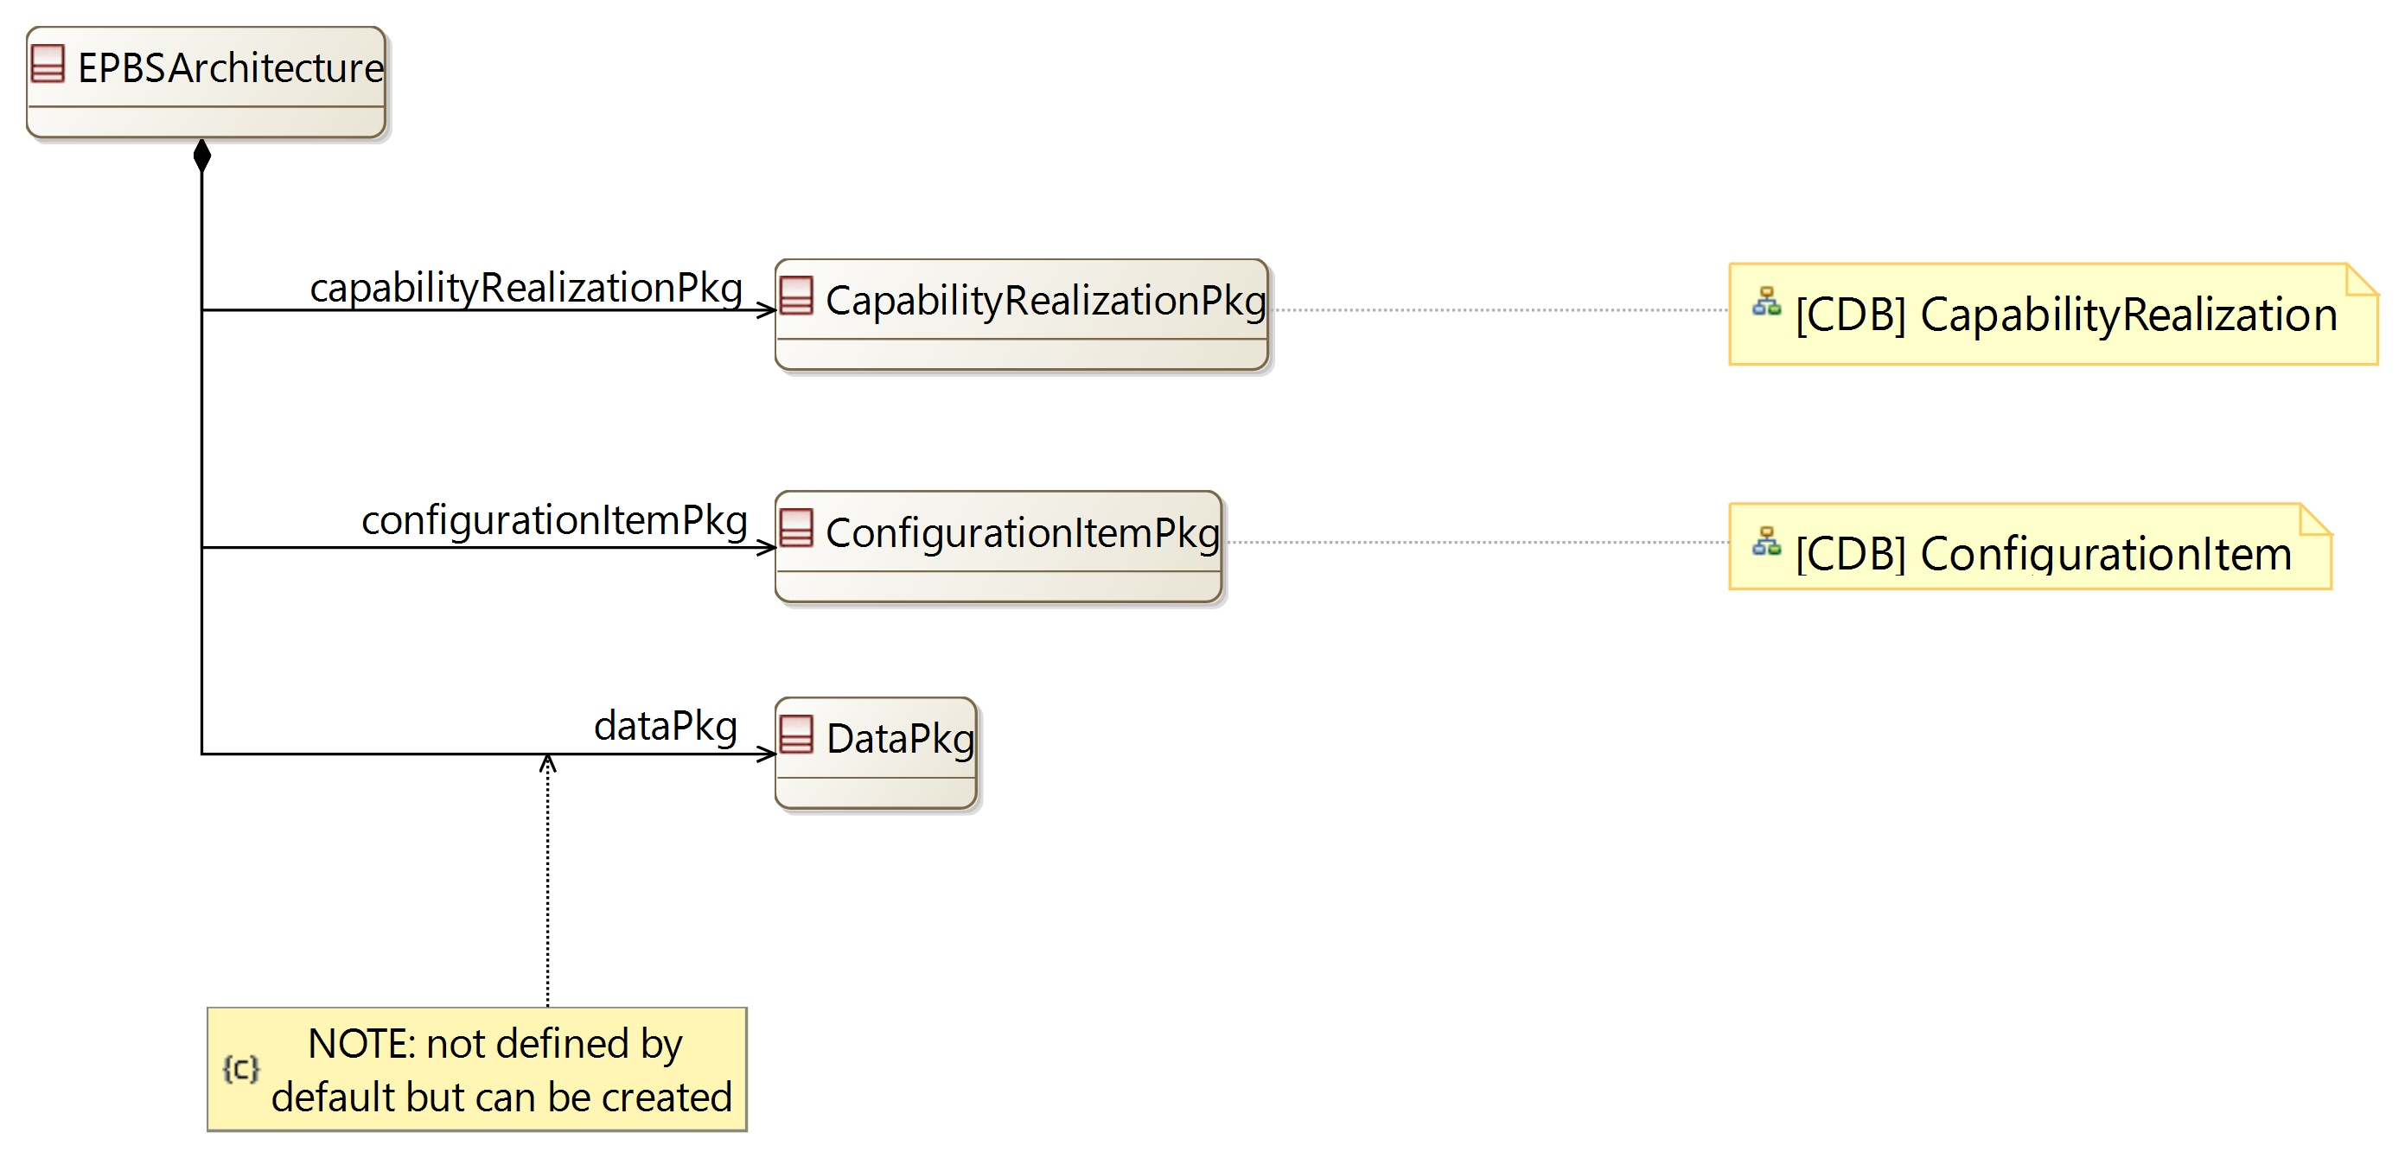

[CDB] ConfigurationItem:

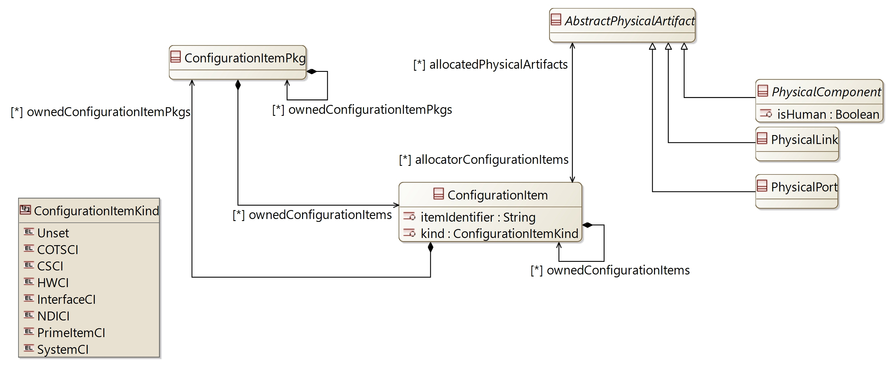

## [Type] EPBSArchitecture

Description:

The element containing all definitions from the End-Product Breakdown Structure.

The End-Product Breakdown Structure aims at defining the construction strategy of the product, taking into account industrial and subcontracting constraints

Direct super types:

* **PropertyValuePkgContainer**

Direct sub-types:

*No direct sub-type*

Possible parent elements:

* SystemEngineering

Attributes:

|  |  |  |
| --- | --- | --- |
| **Attribute name** | **Attribute type** | **Defined on** |
| id | String | **CapellaElement** |
| sid | String | **CapellaElement** |
| name | String | **CapellaElement** |
| summary | String | **CapellaElement** |
| description | String | **CapellaElement** |
| status | **Status** | **CapellaElement** |
| review | String | **CapellaElement** |
| visibleInDocumentation | Boolean | **CapellaElement** |
| visibleForTraceability | Boolean | **CapellaElement** |

Relations:

|  |  |  |  |  |
| --- | --- | --- | --- | --- |
| **Ref. name** | **Kind** | **Card.** | **Target Type** | **Defined on** |
| ownedDiagrams | COMPOSITION | [0 *] | **Diagram** | **EObject** |
| elementOfInterestForDiagrams | ASSOCIATION | [0 *] | **Diagram** | **EObject** |
| contextualElementForDiagrams | ASSOCIATION | [0 *] | **Diagram** | **EObject** |
| representingDiagrams | ASSOCIATION | [0 *] | **Diagram** | **EObject** |
| ownedConstraints | COMPOSITION | [0 *] | **Constraint** | **CapellaElement** |
| constraints | ASSOCIATION | [0 *] | **Constraint** | **CapellaElement** |
| ownedPropertyValues | COMPOSITION | [0 *] | **PropertyValue** | **CapellaElement** |
| appliedPropertyValues | ASSOCIATION | [0 *] | **PropertyValue** | **CapellaElement** |
| ownedPropertyValueGroups | COMPOSITION | [0 *] | **PropertyValueGroup** | **CapellaElement** |
| appliedPropertyValueGroups | ASSOCIATION | [0 *] | **PropertyValueGroup** | **CapellaElement** |
| ownedEnumerationPropertyTypes | COMPOSITION | [0 *] | **EnumerationPropertyType** | **CapellaElement** |
| ownedPropertyValuePkgs | COMPOSITION | [0 *] | **PropertyValuePkg** | **PropertyValuePkgContainer** |
| capabilityRealizationPkg | COMPOSITION | [1 1] | **CapabilityRealizationPkg** | *defined on type* |
| configurationItemPkg | COMPOSITION | [1 1] | **ConfigurationItemPkg** | *defined on type* |
| dataPkg | COMPOSITION | [1 1] | **DataPkg** | *defined on type* |

Methods:

*No method defined*

## [Type] ConfigurationItemPkg

Description:

A package to contain ConfigurationItems

Direct super types:

* **PropertyValuePkgContainer**

Direct sub-types:

*No direct sub-type*

Possible parent elements:

* EPBSArchitecture
* ConfigurationItemPkg
* ConfigurationItem

Attributes:

|  |  |  |
| --- | --- | --- |
| **Attribute name** | **Attribute type** | **Defined on** |
| id | String | **CapellaElement** |
| sid | String | **CapellaElement** |
| name | String | **CapellaElement** |
| summary | String | **CapellaElement** |
| description | String | **CapellaElement** |
| status | **Status** | **CapellaElement** |
| review | String | **CapellaElement** |
| visibleInDocumentation | Boolean | **CapellaElement** |
| visibleForTraceability | Boolean | **CapellaElement** |

Relations:

|  |  |  |  |  |
| --- | --- | --- | --- | --- |
| **Ref. name** | **Kind** | **Card.** | **Target Type** | **Defined on** |
| ownedDiagrams | COMPOSITION | [0 *] | **Diagram** | **EObject** |
| elementOfInterestForDiagrams | ASSOCIATION | [0 *] | **Diagram** | **EObject** |
| contextualElementForDiagrams | ASSOCIATION | [0 *] | **Diagram** | **EObject** |
| representingDiagrams | ASSOCIATION | [0 *] | **Diagram** | **EObject** |
| ownedConstraints | COMPOSITION | [0 *] | **Constraint** | **CapellaElement** |
| constraints | ASSOCIATION | [0 *] | **Constraint** | **CapellaElement** |
| ownedPropertyValues | COMPOSITION | [0 *] | **PropertyValue** | **CapellaElement** |
| appliedPropertyValues | ASSOCIATION | [0 *] | **PropertyValue** | **CapellaElement** |
| ownedPropertyValueGroups | COMPOSITION | [0 *] | **PropertyValueGroup** | **CapellaElement** |
| appliedPropertyValueGroups | ASSOCIATION | [0 *] | **PropertyValueGroup** | **CapellaElement** |
| ownedEnumerationPropertyTypes | COMPOSITION | [0 *] | **EnumerationPropertyType** | **CapellaElement** |
| ownedPropertyValuePkgs | COMPOSITION | [0 *] | **PropertyValuePkg** | **PropertyValuePkgContainer** |
| ownedConfigurationItemPkgs | COMPOSITION | [0 *] | **ConfigurationItemPkg** | *defined on type* |
| ownedConfigurationItems | COMPOSITION | [0 *] | **ConfigurationItem** | *defined on type* |

Methods:

*No method defined*

## [Type] ConfigurationItem

Description:

System part to be acquired or produced, in as many copies as the physical architecture requires

Direct super types:

* **CapellaElement**

Direct sub-types:

*No direct sub-type*

Possible parent elements:

* ConfigurationItemPkg
* ConfigurationItem

Attributes:

|  |  |  |
| --- | --- | --- |
| **Attribute name** | **Attribute type** | **Defined on** |
| id | String | **CapellaElement** |
| sid | String | **CapellaElement** |
| name | String | **CapellaElement** |
| summary | String | **CapellaElement** |
| description | String | **CapellaElement** |
| status | **Status** | **CapellaElement** |
| review | String | **CapellaElement** |
| visibleInDocumentation | Boolean | **CapellaElement** |
| visibleForTraceability | Boolean | **CapellaElement** |
| itemIdentifier | String | *defined on type* |
| kind | **ConfigurationItemKind** | *defined on type* |

Relations:

|  |  |  |  |  |
| --- | --- | --- | --- | --- |
| **Ref. name** | **Kind** | **Card.** | **Target Type** | **Defined on** |
| ownedDiagrams | COMPOSITION | [0 *] | **Diagram** | **EObject** |
| elementOfInterestForDiagrams | ASSOCIATION | [0 *] | **Diagram** | **EObject** |
| contextualElementForDiagrams | ASSOCIATION | [0 *] | **Diagram** | **EObject** |
| representingDiagrams | ASSOCIATION | [0 *] | **Diagram** | **EObject** |
| ownedConstraints | COMPOSITION | [0 *] | **Constraint** | **CapellaElement** |
| constraints | ASSOCIATION | [0 *] | **Constraint** | **CapellaElement** |
| ownedPropertyValues | COMPOSITION | [0 *] | **PropertyValue** | **CapellaElement** |
| appliedPropertyValues | ASSOCIATION | [0 *] | **PropertyValue** | **CapellaElement** |
| ownedPropertyValueGroups | COMPOSITION | [0 *] | **PropertyValueGroup** | **CapellaElement** |
| appliedPropertyValueGroups | ASSOCIATION | [0 *] | **PropertyValueGroup** | **CapellaElement** |
| ownedEnumerationPropertyTypes | COMPOSITION | [0 *] | **EnumerationPropertyType** | **CapellaElement** |
| ownedConfigurationItems | COMPOSITION | [0 *] | **ConfigurationItem** | *defined on type* |
| ownedConfigurationItemPkgs | COMPOSITION | [0 *] | **ConfigurationItemPkg** | *defined on type* |
| allocatedPhysicalArtifacts | ASSOCIATION | [0 *] | **AbstractPhysicalArtifact** | *defined on type* |

Methods:

*No method defined*

## [Enumeration] ConfigurationItemKind

List of values:

* Unset
* COTSCI
* CSCI
* HWCI
* InterfaceCI
* NDICI
* PrimeItemCI
* SystemCI

Used by:

* **ConfigurationItem**

# [Package] statemachine

Diagrams:

Here are the diagrams of representing the elements introduced in this package:

[CDB] StateMachine:

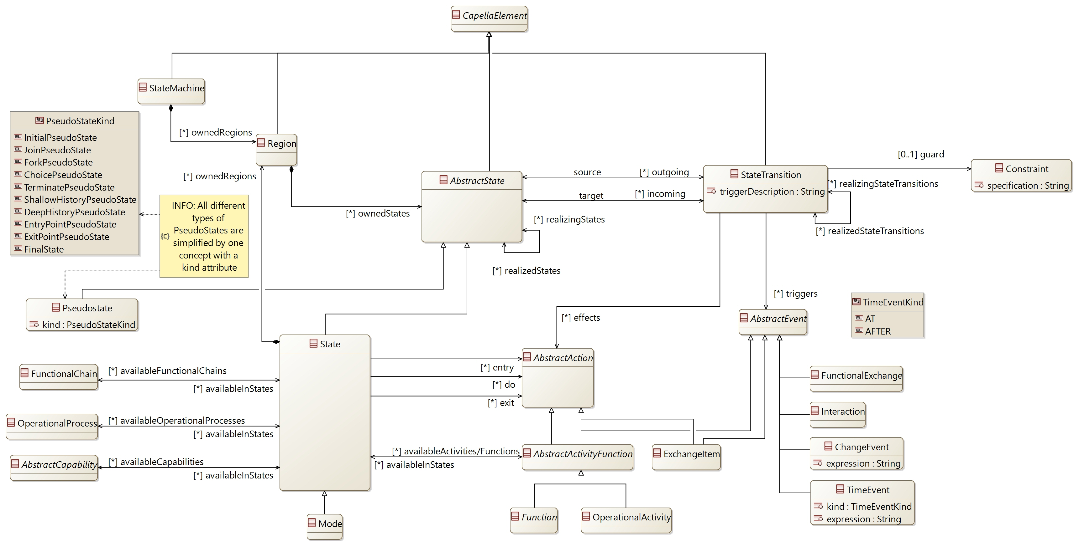

## [Type] StateMachine

Description:

State Machine is a way to define some of the expected behavior of the System, a Component or an external Actor

Direct super types:

* **CapellaElement**

Direct sub-types:

*No direct sub-type*

Possible parent elements:

* OperationalEntity
* OperationalActor
* System
* System
* SystemActor
* SystemActor
* LogicalSystem
* LogicalSystem
* LogicalComponent
* LogicalActor
* LogicalActor
* BehaviorPC
* NodePC
* PhysicalActor
* PhysicalActor

Attributes:

|  |  |  |
| --- | --- | --- |
| **Attribute name** | **Attribute type** | **Defined on** |
| id | String | **CapellaElement** |
| sid | String | **CapellaElement** |
| name | String | **CapellaElement** |
| summary | String | **CapellaElement** |
| description | String | **CapellaElement** |
| status | **Status** | **CapellaElement** |
| review | String | **CapellaElement** |
| visibleInDocumentation | Boolean | **CapellaElement** |
| visibleForTraceability | Boolean | **CapellaElement** |

Relations:

|  |  |  |  |  |
| --- | --- | --- | --- | --- |
| **Ref. name** | **Kind** | **Card.** | **Target Type** | **Defined on** |
| ownedDiagrams | COMPOSITION | [0 *] | **Diagram** | **EObject** |
| elementOfInterestForDiagrams | ASSOCIATION | [0 *] | **Diagram** | **EObject** |
| contextualElementForDiagrams | ASSOCIATION | [0 *] | **Diagram** | **EObject** |
| representingDiagrams | ASSOCIATION | [0 *] | **Diagram** | **EObject** |
| ownedConstraints | COMPOSITION | [0 *] | **Constraint** | **CapellaElement** |
| constraints | ASSOCIATION | [0 *] | **Constraint** | **CapellaElement** |
| ownedPropertyValues | COMPOSITION | [0 *] | **PropertyValue** | **CapellaElement** |
| appliedPropertyValues | ASSOCIATION | [0 *] | **PropertyValue** | **CapellaElement** |
| ownedPropertyValueGroups | COMPOSITION | [0 *] | **PropertyValueGroup** | **CapellaElement** |
| appliedPropertyValueGroups | ASSOCIATION | [0 *] | **PropertyValueGroup** | **CapellaElement** |
| ownedEnumerationPropertyTypes | COMPOSITION | [0 *] | **EnumerationPropertyType** | **CapellaElement** |
| ownedRegions | COMPOSITION | [0 *] | **Region** | *defined on type* |

Methods:

*No method defined*

## [Type] AbstractState [Abstract]

Description:

An abstract type to define the generic relation of modes and states

Direct super types:

* **CapellaElement**

Direct sub-types:

* **State**
* **Pseudostate**

Possible parent elements:

* Region

Attributes:

|  |  |  |
| --- | --- | --- |
| **Attribute name** | **Attribute type** | **Defined on** |
| id | String | **CapellaElement** |
| sid | String | **CapellaElement** |
| name | String | **CapellaElement** |
| summary | String | **CapellaElement** |
| description | String | **CapellaElement** |
| status | **Status** | **CapellaElement** |
| review | String | **CapellaElement** |
| visibleInDocumentation | Boolean | **CapellaElement** |
| visibleForTraceability | Boolean | **CapellaElement** |

Relations:

|  |  |  |  |  |
| --- | --- | --- | --- | --- |
| **Ref. name** | **Kind** | **Card.** | **Target Type** | **Defined on** |
| ownedDiagrams | COMPOSITION | [0 *] | **Diagram** | **EObject** |
| elementOfInterestForDiagrams | ASSOCIATION | [0 *] | **Diagram** | **EObject** |
| contextualElementForDiagrams | ASSOCIATION | [0 *] | **Diagram** | **EObject** |
| representingDiagrams | ASSOCIATION | [0 *] | **Diagram** | **EObject** |
| ownedConstraints | COMPOSITION | [0 *] | **Constraint** | **CapellaElement** |
| constraints | ASSOCIATION | [0 *] | **Constraint** | **CapellaElement** |
| ownedPropertyValues | COMPOSITION | [0 *] | **PropertyValue** | **CapellaElement** |
| appliedPropertyValues | ASSOCIATION | [0 *] | **PropertyValue** | **CapellaElement** |
| ownedPropertyValueGroups | COMPOSITION | [0 *] | **PropertyValueGroup** | **CapellaElement** |
| appliedPropertyValueGroups | ASSOCIATION | [0 *] | **PropertyValueGroup** | **CapellaElement** |
| ownedEnumerationPropertyTypes | COMPOSITION | [0 *] | **EnumerationPropertyType** | **CapellaElement** |
| incoming | ASSOCIATION | [0 *] | **StateTransition** | *defined on type* |
| outgoing | ASSOCIATION | [0 *] | **StateTransition** | *defined on type* |
| realizedStates | ASSOCIATION | [0 *] | **AbstractState** | *defined on type* |
| realizingStates | ASSOCIATION | [0 *] | **AbstractState** | *defined on type* |

Methods:

*No method defined*

## [Type] State

Description:

A State is a context undergone by the system, an actor or a component in specific circumstances (for example imposed by the environment)

Direct super types:

* **AbstractState**

Direct sub-types:

* **Mode**

Possible parent elements:

* Region

Attributes:

|  |  |  |
| --- | --- | --- |
| **Attribute name** | **Attribute type** | **Defined on** |
| id | String | **CapellaElement** |
| sid | String | **CapellaElement** |
| name | String | **CapellaElement** |
| summary | String | **CapellaElement** |
| description | String | **CapellaElement** |
| status | **Status** | **CapellaElement** |
| review | String | **CapellaElement** |
| visibleInDocumentation | Boolean | **CapellaElement** |
| visibleForTraceability | Boolean | **CapellaElement** |

Relations:

|  |  |  |  |  |
| --- | --- | --- | --- | --- |
| **Ref. name** | **Kind** | **Card.** | **Target Type** | **Defined on** |
| ownedDiagrams | COMPOSITION | [0 *] | **Diagram** | **EObject** |
| elementOfInterestForDiagrams | ASSOCIATION | [0 *] | **Diagram** | **EObject** |
| contextualElementForDiagrams | ASSOCIATION | [0 *] | **Diagram** | **EObject** |
| representingDiagrams | ASSOCIATION | [0 *] | **Diagram** | **EObject** |
| ownedConstraints | COMPOSITION | [0 *] | **Constraint** | **CapellaElement** |
| constraints | ASSOCIATION | [0 *] | **Constraint** | **CapellaElement** |
| ownedPropertyValues | COMPOSITION | [0 *] | **PropertyValue** | **CapellaElement** |
| appliedPropertyValues | ASSOCIATION | [0 *] | **PropertyValue** | **CapellaElement** |
| ownedPropertyValueGroups | COMPOSITION | [0 *] | **PropertyValueGroup** | **CapellaElement** |
| appliedPropertyValueGroups | ASSOCIATION | [0 *] | **PropertyValueGroup** | **CapellaElement** |
| ownedEnumerationPropertyTypes | COMPOSITION | [0 *] | **EnumerationPropertyType** | **CapellaElement** |
| incoming | ASSOCIATION | [0 *] | **StateTransition** | **AbstractState** |
| outgoing | ASSOCIATION | [0 *] | **StateTransition** | **AbstractState** |
| realizedStates | ASSOCIATION | [0 *] | **AbstractState** | **AbstractState** |
| realizingStates | ASSOCIATION | [0 *] | **AbstractState** | **AbstractState** |
| ownedRegions | COMPOSITION | [0 *] | **Region** | *defined on type* |
| availableActivities/Functions | ASSOCIATION | [0 *] | **AbstractActivityFunction** | *defined on type* |
| entry | ASSOCIATION | [0 *] | **AbstractAction** | *defined on type* |
| do | ASSOCIATION | [0 *] | **AbstractAction** | *defined on type* |
| exit | ASSOCIATION | [0 *] | **AbstractAction** | *defined on type* |
| availableFunctionalChains | ASSOCIATION | [0 *] | **FunctionalChain** | *defined on type* |
| availableOperationalProcesses | ASSOCIATION | [0 *] | **OperationalProcess** | *defined on type* |
| availableCapabilities | ASSOCIATION | [0 *] | **AbstractCapability** | *defined on type* |

Methods:

*No method defined*

## [Type] Mode

Description:

A Mode is a behavior expected from the system, an Actor or a component in chosen conditions

Direct super types:

* **State**

Direct sub-types:

*No direct sub-type*

Possible parent elements:

* Region

Attributes:

|  |  |  |
| --- | --- | --- |
| **Attribute name** | **Attribute type** | **Defined on** |
| id | String | **CapellaElement** |
| sid | String | **CapellaElement** |
| name | String | **CapellaElement** |
| summary | String | **CapellaElement** |
| description | String | **CapellaElement** |
| status | **Status** | **CapellaElement** |
| review | String | **CapellaElement** |
| visibleInDocumentation | Boolean | **CapellaElement** |
| visibleForTraceability | Boolean | **CapellaElement** |

Relations:

|  |  |  |  |  |
| --- | --- | --- | --- | --- |
| **Ref. name** | **Kind** | **Card.** | **Target Type** | **Defined on** |
| ownedDiagrams | COMPOSITION | [0 *] | **Diagram** | **EObject** |
| elementOfInterestForDiagrams | ASSOCIATION | [0 *] | **Diagram** | **EObject** |
| contextualElementForDiagrams | ASSOCIATION | [0 *] | **Diagram** | **EObject** |
| representingDiagrams | ASSOCIATION | [0 *] | **Diagram** | **EObject** |
| ownedConstraints | COMPOSITION | [0 *] | **Constraint** | **CapellaElement** |
| constraints | ASSOCIATION | [0 *] | **Constraint** | **CapellaElement** |
| ownedPropertyValues | COMPOSITION | [0 *] | **PropertyValue** | **CapellaElement** |
| appliedPropertyValues | ASSOCIATION | [0 *] | **PropertyValue** | **CapellaElement** |
| ownedPropertyValueGroups | COMPOSITION | [0 *] | **PropertyValueGroup** | **CapellaElement** |
| appliedPropertyValueGroups | ASSOCIATION | [0 *] | **PropertyValueGroup** | **CapellaElement** |
| ownedEnumerationPropertyTypes | COMPOSITION | [0 *] | **EnumerationPropertyType** | **CapellaElement** |
| incoming | ASSOCIATION | [0 *] | **StateTransition** | **AbstractState** |
| outgoing | ASSOCIATION | [0 *] | **StateTransition** | **AbstractState** |
| realizedStates | ASSOCIATION | [0 *] | **AbstractState** | **AbstractState** |
| realizingStates | ASSOCIATION | [0 *] | **AbstractState** | **AbstractState** |
| ownedRegions | COMPOSITION | [0 *] | **Region** | **State** |
| availableActivities/Functions | ASSOCIATION | [0 *] | **AbstractActivityFunction** | **State** |
| entry | ASSOCIATION | [0 *] | **AbstractAction** | **State** |
| do | ASSOCIATION | [0 *] | **AbstractAction** | **State** |
| exit | ASSOCIATION | [0 *] | **AbstractAction** | **State** |
| availableFunctionalChains | ASSOCIATION | [0 *] | **FunctionalChain** | **State** |
| availableOperationalProcesses | ASSOCIATION | [0 *] | **OperationalProcess** | **State** |
| availableCapabilities | ASSOCIATION | [0 *] | **AbstractCapability** | **State** |

Methods:

*No method defined*

## [Type] Pseudostate

Description:

A pseudo states are transitive states (meaning they don't remain active). They are used to define entry / exit point of a state machine, and to connect multiple transitions into more complex transition paths

Direct super types:

* **AbstractState**

Direct sub-types:

*No direct sub-type*

Possible parent elements:

* Region

Attributes:

|  |  |  |
| --- | --- | --- |
| **Attribute name** | **Attribute type** | **Defined on** |
| id | String | **CapellaElement** |
| sid | String | **CapellaElement** |
| name | String | **CapellaElement** |
| summary | String | **CapellaElement** |
| description | String | **CapellaElement** |
| status | **Status** | **CapellaElement** |
| review | String | **CapellaElement** |
| visibleInDocumentation | Boolean | **CapellaElement** |
| visibleForTraceability | Boolean | **CapellaElement** |
| kind | **PseudoStateKind** | *defined on type* |

Relations:

|  |  |  |  |  |
| --- | --- | --- | --- | --- |
| **Ref. name** | **Kind** | **Card.** | **Target Type** | **Defined on** |
| ownedDiagrams | COMPOSITION | [0 *] | **Diagram** | **EObject** |
| elementOfInterestForDiagrams | ASSOCIATION | [0 *] | **Diagram** | **EObject** |
| contextualElementForDiagrams | ASSOCIATION | [0 *] | **Diagram** | **EObject** |
| representingDiagrams | ASSOCIATION | [0 *] | **Diagram** | **EObject** |
| ownedConstraints | COMPOSITION | [0 *] | **Constraint** | **CapellaElement** |
| constraints | ASSOCIATION | [0 *] | **Constraint** | **CapellaElement** |
| ownedPropertyValues | COMPOSITION | [0 *] | **PropertyValue** | **CapellaElement** |
| appliedPropertyValues | ASSOCIATION | [0 *] | **PropertyValue** | **CapellaElement** |
| ownedPropertyValueGroups | COMPOSITION | [0 *] | **PropertyValueGroup** | **CapellaElement** |
| appliedPropertyValueGroups | ASSOCIATION | [0 *] | **PropertyValueGroup** | **CapellaElement** |
| ownedEnumerationPropertyTypes | COMPOSITION | [0 *] | **EnumerationPropertyType** | **CapellaElement** |
| incoming | ASSOCIATION | [0 *] | **StateTransition** | **AbstractState** |
| outgoing | ASSOCIATION | [0 *] | **StateTransition** | **AbstractState** |
| realizedStates | ASSOCIATION | [0 *] | **AbstractState** | **AbstractState** |
| realizingStates | ASSOCIATION | [0 *] | **AbstractState** | **AbstractState** |

Methods:

*No method defined*

## [Type] Region

Description:

A region is an orthogonal part of either a composite state or a state machine.

Inside of a region, only one more or state can be active at a time

Direct super types:

* **CapellaElement**

Direct sub-types:

*No direct sub-type*

Possible parent elements:

* StateMachine
* State
* Mode

Attributes:

|  |  |  |
| --- | --- | --- |
| **Attribute name** | **Attribute type** | **Defined on** |
| id | String | **CapellaElement** |
| sid | String | **CapellaElement** |
| name | String | **CapellaElement** |
| summary | String | **CapellaElement** |
| description | String | **CapellaElement** |
| status | **Status** | **CapellaElement** |
| review | String | **CapellaElement** |
| visibleInDocumentation | Boolean | **CapellaElement** |
| visibleForTraceability | Boolean | **CapellaElement** |

Relations:

|  |  |  |  |  |
| --- | --- | --- | --- | --- |
| **Ref. name** | **Kind** | **Card.** | **Target Type** | **Defined on** |
| ownedDiagrams | COMPOSITION | [0 *] | **Diagram** | **EObject** |
| elementOfInterestForDiagrams | ASSOCIATION | [0 *] | **Diagram** | **EObject** |
| contextualElementForDiagrams | ASSOCIATION | [0 *] | **Diagram** | **EObject** |
| representingDiagrams | ASSOCIATION | [0 *] | **Diagram** | **EObject** |
| ownedConstraints | COMPOSITION | [0 *] | **Constraint** | **CapellaElement** |
| constraints | ASSOCIATION | [0 *] | **Constraint** | **CapellaElement** |
| ownedPropertyValues | COMPOSITION | [0 *] | **PropertyValue** | **CapellaElement** |
| appliedPropertyValues | ASSOCIATION | [0 *] | **PropertyValue** | **CapellaElement** |
| ownedPropertyValueGroups | COMPOSITION | [0 *] | **PropertyValueGroup** | **CapellaElement** |
| appliedPropertyValueGroups | ASSOCIATION | [0 *] | **PropertyValueGroup** | **CapellaElement** |
| ownedEnumerationPropertyTypes | COMPOSITION | [0 *] | **EnumerationPropertyType** | **CapellaElement** |
| ownedStates | COMPOSITION | [0 *] | **AbstractState** | *defined on type* |

Methods:

*No method defined*

## [Type] StateTransition

Description:

A possible transition between 2 modes or 2 states

Direct super types:

* **CapellaElement**

Direct sub-types:

*No direct sub-type*

Possible parent elements:

*No possible parent defined*

Attributes:

|  |  |  |
| --- | --- | --- |
| **Attribute name** | **Attribute type** | **Defined on** |
| id | String | **CapellaElement** |
| sid | String | **CapellaElement** |
| name | String | **CapellaElement** |
| summary | String | **CapellaElement** |
| description | String | **CapellaElement** |
| status | **Status** | **CapellaElement** |
| review | String | **CapellaElement** |
| visibleInDocumentation | Boolean | **CapellaElement** |
| visibleForTraceability | Boolean | **CapellaElement** |
| triggerDescription | String | *defined on type* |

Relations:

|  |  |  |  |  |
| --- | --- | --- | --- | --- |
| **Ref. name** | **Kind** | **Card.** | **Target Type** | **Defined on** |
| ownedDiagrams | COMPOSITION | [0 *] | **Diagram** | **EObject** |
| elementOfInterestForDiagrams | ASSOCIATION | [0 *] | **Diagram** | **EObject** |
| contextualElementForDiagrams | ASSOCIATION | [0 *] | **Diagram** | **EObject** |
| representingDiagrams | ASSOCIATION | [0 *] | **Diagram** | **EObject** |
| ownedConstraints | COMPOSITION | [0 *] | **Constraint** | **CapellaElement** |
| constraints | ASSOCIATION | [0 *] | **Constraint** | **CapellaElement** |
| ownedPropertyValues | COMPOSITION | [0 *] | **PropertyValue** | **CapellaElement** |
| appliedPropertyValues | ASSOCIATION | [0 *] | **PropertyValue** | **CapellaElement** |
| ownedPropertyValueGroups | COMPOSITION | [0 *] | **PropertyValueGroup** | **CapellaElement** |
| appliedPropertyValueGroups | ASSOCIATION | [0 *] | **PropertyValueGroup** | **CapellaElement** |
| ownedEnumerationPropertyTypes | COMPOSITION | [0 *] | **EnumerationPropertyType** | **CapellaElement** |
| source | ASSOCIATION | [1 1] | **AbstractState** | *defined on type* |
| target | ASSOCIATION | [1 1] | **AbstractState** | *defined on type* |
| triggers | ASSOCIATION | [0 *] | **AbstractEvent** | *defined on type* |
| guard | ASSOCIATION | [0 1] | **Constraint** | *defined on type* |
| effects | ASSOCIATION | [0 *] | **AbstractAction** | *defined on type* |
| realizedStateTransitions | ASSOCIATION | [0 *] | **StateTransition** | *defined on type* |
| realizingStateTransitions | ASSOCIATION | [0 *] | **StateTransition** | *defined on type* |

Methods:

*No method defined*

## [Type] ChangeEvent

Description:

An event defined by WHEN something occurs

Direct super types:

* **AbstractEvent**

Direct sub-types:

*No direct sub-type*

Possible parent elements:

*No possible parent defined*

Attributes:

|  |  |  |
| --- | --- | --- |
| **Attribute name** | **Attribute type** | **Defined on** |
| id | String | **CapellaElement** |
| sid | String | **CapellaElement** |
| name | String | **CapellaElement** |
| summary | String | **CapellaElement** |
| description | String | **CapellaElement** |
| status | **Status** | **CapellaElement** |
| review | String | **CapellaElement** |
| visibleInDocumentation | Boolean | **CapellaElement** |
| visibleForTraceability | Boolean | **CapellaElement** |
| expression | String | *defined on type* |

Relations:

|  |  |  |  |  |
| --- | --- | --- | --- | --- |
| **Ref. name** | **Kind** | **Card.** | **Target Type** | **Defined on** |
| ownedDiagrams | COMPOSITION | [0 *] | **Diagram** | **EObject** |
| elementOfInterestForDiagrams | ASSOCIATION | [0 *] | **Diagram** | **EObject** |
| contextualElementForDiagrams | ASSOCIATION | [0 *] | **Diagram** | **EObject** |
| representingDiagrams | ASSOCIATION | [0 *] | **Diagram** | **EObject** |
| ownedConstraints | COMPOSITION | [0 *] | **Constraint** | **CapellaElement** |
| constraints | ASSOCIATION | [0 *] | **Constraint** | **CapellaElement** |
| ownedPropertyValues | COMPOSITION | [0 *] | **PropertyValue** | **CapellaElement** |
| appliedPropertyValues | ASSOCIATION | [0 *] | **PropertyValue** | **CapellaElement** |
| ownedPropertyValueGroups | COMPOSITION | [0 *] | **PropertyValueGroup** | **CapellaElement** |
| appliedPropertyValueGroups | ASSOCIATION | [0 *] | **PropertyValueGroup** | **CapellaElement** |
| ownedEnumerationPropertyTypes | COMPOSITION | [0 *] | **EnumerationPropertyType** | **CapellaElement** |

Methods:

*No method defined*

## [Type] TimeEvent

Description:

An event defined by AT a given time, or AFTER a certain time

Direct super types:

* **AbstractEvent**

Direct sub-types:

*No direct sub-type*

Possible parent elements:

*No possible parent defined*

Attributes:

|  |  |  |
| --- | --- | --- |
| **Attribute name** | **Attribute type** | **Defined on** |
| id | String | **CapellaElement** |
| sid | String | **CapellaElement** |
| name | String | **CapellaElement** |
| summary | String | **CapellaElement** |
| description | String | **CapellaElement** |
| status | **Status** | **CapellaElement** |
| review | String | **CapellaElement** |
| visibleInDocumentation | Boolean | **CapellaElement** |
| visibleForTraceability | Boolean | **CapellaElement** |
| kind | **TimeEventKind** | *defined on type* |
| expression | String | *defined on type* |

Relations:

|  |  |  |  |  |
| --- | --- | --- | --- | --- |
| **Ref. name** | **Kind** | **Card.** | **Target Type** | **Defined on** |
| ownedDiagrams | COMPOSITION | [0 *] | **Diagram** | **EObject** |
| elementOfInterestForDiagrams | ASSOCIATION | [0 *] | **Diagram** | **EObject** |
| contextualElementForDiagrams | ASSOCIATION | [0 *] | **Diagram** | **EObject** |
| representingDiagrams | ASSOCIATION | [0 *] | **Diagram** | **EObject** |
| ownedConstraints | COMPOSITION | [0 *] | **Constraint** | **CapellaElement** |
| constraints | ASSOCIATION | [0 *] | **Constraint** | **CapellaElement** |
| ownedPropertyValues | COMPOSITION | [0 *] | **PropertyValue** | **CapellaElement** |
| appliedPropertyValues | ASSOCIATION | [0 *] | **PropertyValue** | **CapellaElement** |
| ownedPropertyValueGroups | COMPOSITION | [0 *] | **PropertyValueGroup** | **CapellaElement** |
| appliedPropertyValueGroups | ASSOCIATION | [0 *] | **PropertyValueGroup** | **CapellaElement** |
| ownedEnumerationPropertyTypes | COMPOSITION | [0 *] | **EnumerationPropertyType** | **CapellaElement** |

Methods:

*No method defined*

## [Type] AbstractActivityFunction [Abstract]

Description:

An abstract type to define the link between mode / state and activity / function (available in states)

Direct super types:

* **CapellaElement**
* **AbstractAction**
* **AbstractEvent**
* **AbstractInstance**

Direct sub-types:

* **OperationalActivity**
* **Function**

Possible parent elements:

*No possible parent defined*

Attributes:

|  |  |  |
| --- | --- | --- |
| **Attribute name** | **Attribute type** | **Defined on** |
| id | String | **CapellaElement** |
| sid | String | **CapellaElement** |
| name | String | **CapellaElement** |
| summary | String | **CapellaElement** |
| description | String | **CapellaElement** |
| status | **Status** | **CapellaElement** |
| review | String | **CapellaElement** |
| visibleInDocumentation | Boolean | **CapellaElement** |
| visibleForTraceability | Boolean | **CapellaElement** |

Relations:

|  |  |  |  |  |
| --- | --- | --- | --- | --- |
| **Ref. name** | **Kind** | **Card.** | **Target Type** | **Defined on** |
| ownedDiagrams | COMPOSITION | [0 *] | **Diagram** | **EObject** |
| elementOfInterestForDiagrams | ASSOCIATION | [0 *] | **Diagram** | **EObject** |
| contextualElementForDiagrams | ASSOCIATION | [0 *] | **Diagram** | **EObject** |
| representingDiagrams | ASSOCIATION | [0 *] | **Diagram** | **EObject** |
| ownedConstraints | COMPOSITION | [0 *] | **Constraint** | **CapellaElement** |
| constraints | ASSOCIATION | [0 *] | **Constraint** | **CapellaElement** |
| ownedPropertyValues | COMPOSITION | [0 *] | **PropertyValue** | **CapellaElement** |
| appliedPropertyValues | ASSOCIATION | [0 *] | **PropertyValue** | **CapellaElement** |
| ownedPropertyValueGroups | COMPOSITION | [0 *] | **PropertyValueGroup** | **CapellaElement** |
| appliedPropertyValueGroups | ASSOCIATION | [0 *] | **PropertyValueGroup** | **CapellaElement** |
| ownedEnumerationPropertyTypes | COMPOSITION | [0 *] | **EnumerationPropertyType** | **CapellaElement** |
| availableInStates | ASSOCIATION | [0 *] | **State** | *defined on type* |

Methods:

*No method defined*

## [Type] AbstractAction [Abstract]

Description:

A generic action which can be triggered by a Mode / State or a StateTransition

Direct super types:

*No direct super type*

Direct sub-types:

* **AbstractActivityFunction**
* **ExchangeItem**

Possible parent elements:

*No possible parent defined*

Attributes:

*No attribute defined*

Relations:

*No relation defined*

Methods:

*No method defined*

## [Type] AbstractEvent [Abstract]

Description:

An generic event which can trigger a transition

Direct super types:

* **CapellaElement**

Direct sub-types:

* **Interaction**
* **ChangeEvent**
* **TimeEvent**
* **AbstractActivityFunction**
* **ExchangeItem**
* **FunctionalExchange**

Possible parent elements:

*No possible parent defined*

Attributes:

|  |  |  |
| --- | --- | --- |
| **Attribute name** | **Attribute type** | **Defined on** |
| id | String | **CapellaElement** |
| sid | String | **CapellaElement** |
| name | String | **CapellaElement** |
| summary | String | **CapellaElement** |
| description | String | **CapellaElement** |
| status | **Status** | **CapellaElement** |
| review | String | **CapellaElement** |
| visibleInDocumentation | Boolean | **CapellaElement** |
| visibleForTraceability | Boolean | **CapellaElement** |

Relations:

|  |  |  |  |  |
| --- | --- | --- | --- | --- |
| **Ref. name** | **Kind** | **Card.** | **Target Type** | **Defined on** |
| ownedDiagrams | COMPOSITION | [0 *] | **Diagram** | **EObject** |
| elementOfInterestForDiagrams | ASSOCIATION | [0 *] | **Diagram** | **EObject** |
| contextualElementForDiagrams | ASSOCIATION | [0 *] | **Diagram** | **EObject** |
| representingDiagrams | ASSOCIATION | [0 *] | **Diagram** | **EObject** |
| ownedConstraints | COMPOSITION | [0 *] | **Constraint** | **CapellaElement** |
| constraints | ASSOCIATION | [0 *] | **Constraint** | **CapellaElement** |
| ownedPropertyValues | COMPOSITION | [0 *] | **PropertyValue** | **CapellaElement** |
| appliedPropertyValues | ASSOCIATION | [0 *] | **PropertyValue** | **CapellaElement** |
| ownedPropertyValueGroups | COMPOSITION | [0 *] | **PropertyValueGroup** | **CapellaElement** |
| appliedPropertyValueGroups | ASSOCIATION | [0 *] | **PropertyValueGroup** | **CapellaElement** |
| ownedEnumerationPropertyTypes | COMPOSITION | [0 *] | **EnumerationPropertyType** | **CapellaElement** |

Methods:

*No method defined*

## [Enumeration] PseudoStateKind

List of values:

* InitialPseudoState
* JoinPseudoState
* ForkPseudoState
* ChoicePseudoState
* TerminatePseudoState
* ShallowHistoryPseudoState
* DeepHistoryPseudoState
* EntryPointPseudoState
* ExitPointPseudoState
* FinalState

Used by:

* **Pseudostate**

## [Enumeration] TimeEventKind

List of values:

* AT
* AFTER

Used by:

* **TimeEvent**

# [Package] scenario

Diagrams:

Here are the diagrams of representing the elements introduced in this package:

[CDB] Scenario:

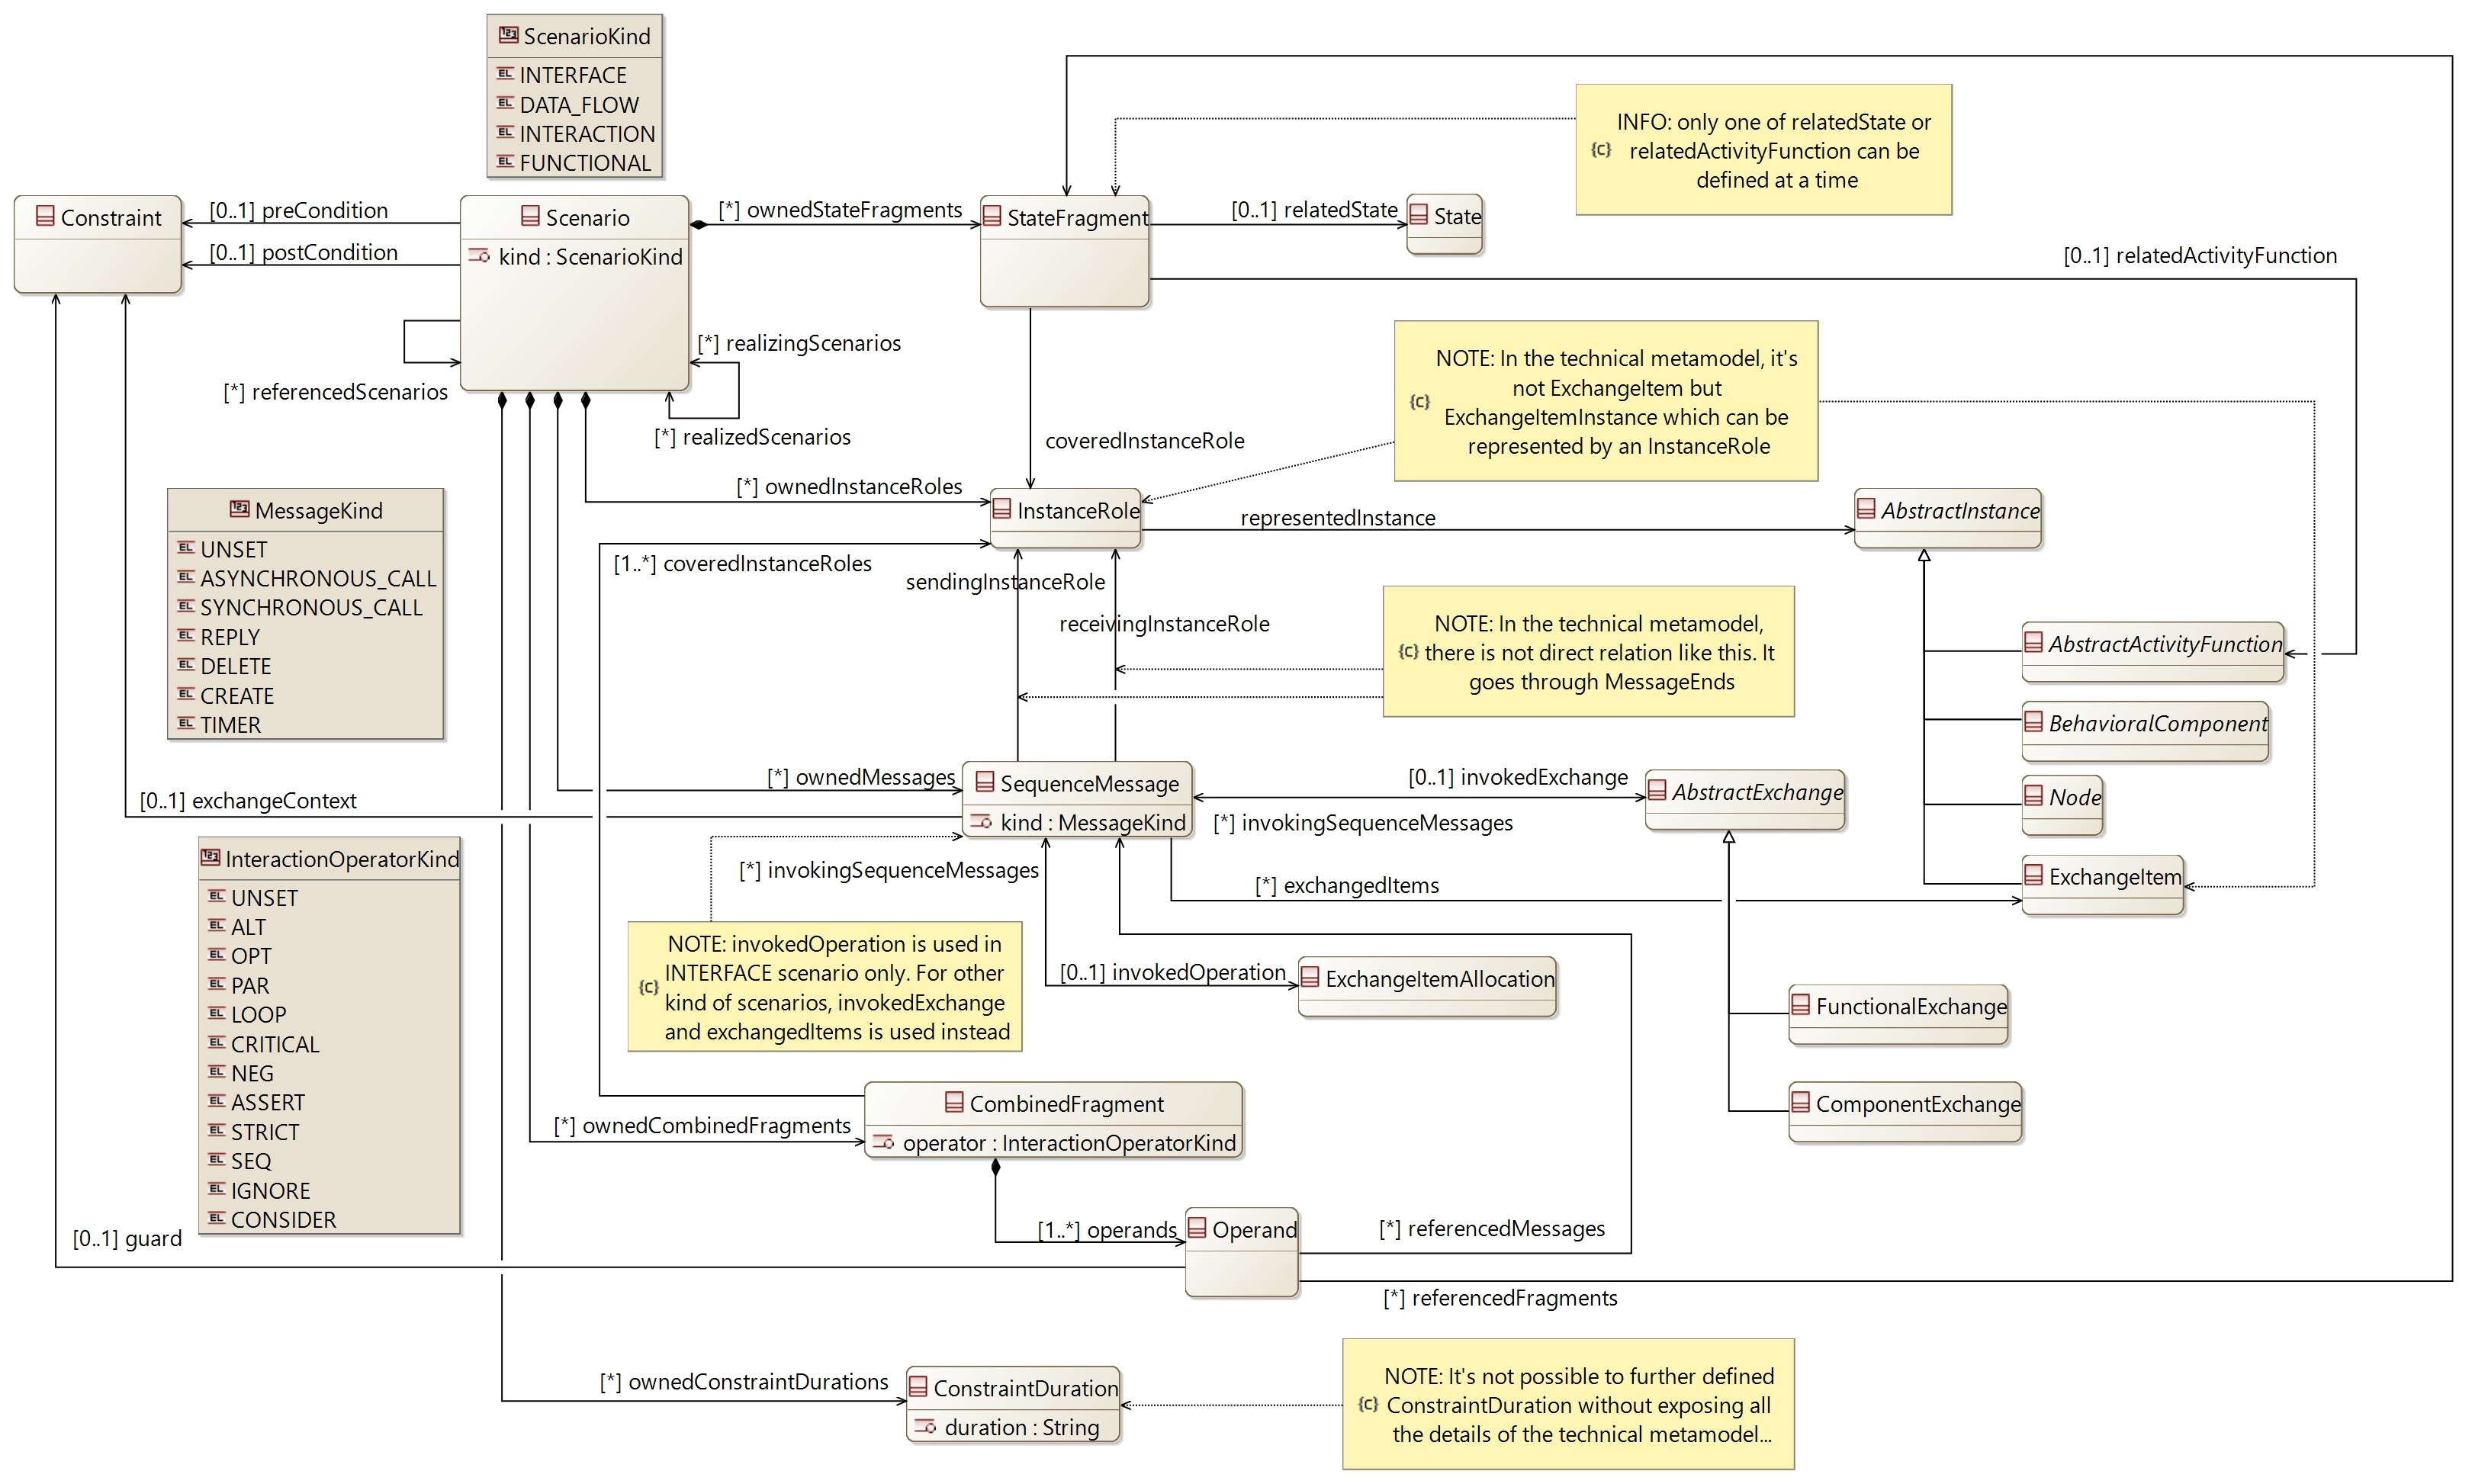

## [Type] Scenario

Description:

A scenario of use of the system defined by a specific sequence

Direct super types:

* **CapellaElement**

Direct sub-types:

*No direct sub-type*

Possible parent elements:

* OperationalCapability
* Capability
* CapabilityRealization

Attributes:

|  |  |  |
| --- | --- | --- |
| **Attribute name** | **Attribute type** | **Defined on** |
| id | String | **CapellaElement** |
| sid | String | **CapellaElement** |
| name | String | **CapellaElement** |
| summary | String | **CapellaElement** |
| description | String | **CapellaElement** |
| status | **Status** | **CapellaElement** |
| review | String | **CapellaElement** |
| visibleInDocumentation | Boolean | **CapellaElement** |
| visibleForTraceability | Boolean | **CapellaElement** |
| kind | **ScenarioKind** | *defined on type* |

Relations:

|  |  |  |  |  |
| --- | --- | --- | --- | --- |
| **Ref. name** | **Kind** | **Card.** | **Target Type** | **Defined on** |
| ownedDiagrams | COMPOSITION | [0 *] | **Diagram** | **EObject** |
| elementOfInterestForDiagrams | ASSOCIATION | [0 *] | **Diagram** | **EObject** |
| contextualElementForDiagrams | ASSOCIATION | [0 *] | **Diagram** | **EObject** |
| representingDiagrams | ASSOCIATION | [0 *] | **Diagram** | **EObject** |
| ownedConstraints | COMPOSITION | [0 *] | **Constraint** | **CapellaElement** |
| constraints | ASSOCIATION | [0 *] | **Constraint** | **CapellaElement** |
| ownedPropertyValues | COMPOSITION | [0 *] | **PropertyValue** | **CapellaElement** |
| appliedPropertyValues | ASSOCIATION | [0 *] | **PropertyValue** | **CapellaElement** |
| ownedPropertyValueGroups | COMPOSITION | [0 *] | **PropertyValueGroup** | **CapellaElement** |
| appliedPropertyValueGroups | ASSOCIATION | [0 *] | **PropertyValueGroup** | **CapellaElement** |
| ownedEnumerationPropertyTypes | COMPOSITION | [0 *] | **EnumerationPropertyType** | **CapellaElement** |
| preCondition | ASSOCIATION | [0 1] | **Constraint** | *defined on type* |
| postCondition | ASSOCIATION | [0 1] | **Constraint** | *defined on type* |
| ownedInstanceRoles | COMPOSITION | [0 *] | **InstanceRole** | *defined on type* |
| ownedMessages | COMPOSITION | [0 *] | **SequenceMessage** | *defined on type* |
| ownedStateFragments | COMPOSITION | [0 *] | **StateFragment** | *defined on type* |
| ownedCombinedFragments | COMPOSITION | [0 *] | **CombinedFragment** | *defined on type* |
| ownedConstraintDurations | COMPOSITION | [0 *] | **ConstraintDuration** | *defined on type* |
| referencedScenarios | ASSOCIATION | [0 *] | **Scenario** | *defined on type* |
| realizedScenarios | ASSOCIATION | [0 *] | **Scenario** | *defined on type* |
| realizingScenarios | ASSOCIATION | [0 *] | **Scenario** | *defined on type* |

Methods:

*No method defined*

## [Type] InstanceRole

Description:

The involvement of an element (function, system, component or actor) in a scenario

Direct super types:

* **CapellaElement**

Direct sub-types:

*No direct sub-type*

Possible parent elements:

* Scenario

Attributes:

|  |  |  |
| --- | --- | --- |
| **Attribute name** | **Attribute type** | **Defined on** |
| id | String | **CapellaElement** |
| sid | String | **CapellaElement** |
| name | String | **CapellaElement** |
| summary | String | **CapellaElement** |
| description | String | **CapellaElement** |
| status | **Status** | **CapellaElement** |
| review | String | **CapellaElement** |
| visibleInDocumentation | Boolean | **CapellaElement** |
| visibleForTraceability | Boolean | **CapellaElement** |

Relations:

|  |  |  |  |  |
| --- | --- | --- | --- | --- |
| **Ref. name** | **Kind** | **Card.** | **Target Type** | **Defined on** |
| ownedDiagrams | COMPOSITION | [0 *] | **Diagram** | **EObject** |
| elementOfInterestForDiagrams | ASSOCIATION | [0 *] | **Diagram** | **EObject** |
| contextualElementForDiagrams | ASSOCIATION | [0 *] | **Diagram** | **EObject** |
| representingDiagrams | ASSOCIATION | [0 *] | **Diagram** | **EObject** |
| ownedConstraints | COMPOSITION | [0 *] | **Constraint** | **CapellaElement** |
| constraints | ASSOCIATION | [0 *] | **Constraint** | **CapellaElement** |
| ownedPropertyValues | COMPOSITION | [0 *] | **PropertyValue** | **CapellaElement** |
| appliedPropertyValues | ASSOCIATION | [0 *] | **PropertyValue** | **CapellaElement** |
| ownedPropertyValueGroups | COMPOSITION | [0 *] | **PropertyValueGroup** | **CapellaElement** |
| appliedPropertyValueGroups | ASSOCIATION | [0 *] | **PropertyValueGroup** | **CapellaElement** |
| ownedEnumerationPropertyTypes | COMPOSITION | [0 *] | **EnumerationPropertyType** | **CapellaElement** |
| representedInstance | ASSOCIATION | [1 1] | **AbstractInstance** | *defined on type* |

Methods:

*No method defined*

## [Type] AbstractInstance [Abstract]

Description:

A generic element which can be involved in a scenario as an InstanceRole

Direct super types:

*No direct super type*

Direct sub-types:

* **AbstractActivityFunction**
* **Node**
* **ExchangeItem**
* **BehavioralComponent**

Possible parent elements:

*No possible parent defined*

Attributes:

*No attribute defined*

Relations:

*No relation defined*

Methods:

*No method defined*

## [Type] SequenceMessage

Description:

An exchange between InstanceRole performed in the frame of a scenario

Direct super types:

* **CapellaElement**

Direct sub-types:

*No direct sub-type*

Possible parent elements:

* Scenario

Attributes:

|  |  |  |
| --- | --- | --- |
| **Attribute name** | **Attribute type** | **Defined on** |
| id | String | **CapellaElement** |
| sid | String | **CapellaElement** |
| name | String | **CapellaElement** |
| summary | String | **CapellaElement** |
| description | String | **CapellaElement** |
| status | **Status** | **CapellaElement** |
| review | String | **CapellaElement** |
| visibleInDocumentation | Boolean | **CapellaElement** |
| visibleForTraceability | Boolean | **CapellaElement** |
| kind | **MessageKind** | *defined on type* |

Relations:

|  |  |  |  |  |
| --- | --- | --- | --- | --- |
| **Ref. name** | **Kind** | **Card.** | **Target Type** | **Defined on** |
| ownedDiagrams | COMPOSITION | [0 *] | **Diagram** | **EObject** |
| elementOfInterestForDiagrams | ASSOCIATION | [0 *] | **Diagram** | **EObject** |
| contextualElementForDiagrams | ASSOCIATION | [0 *] | **Diagram** | **EObject** |
| representingDiagrams | ASSOCIATION | [0 *] | **Diagram** | **EObject** |
| ownedConstraints | COMPOSITION | [0 *] | **Constraint** | **CapellaElement** |
| constraints | ASSOCIATION | [0 *] | **Constraint** | **CapellaElement** |
| ownedPropertyValues | COMPOSITION | [0 *] | **PropertyValue** | **CapellaElement** |
| appliedPropertyValues | ASSOCIATION | [0 *] | **PropertyValue** | **CapellaElement** |
| ownedPropertyValueGroups | COMPOSITION | [0 *] | **PropertyValueGroup** | **CapellaElement** |
| appliedPropertyValueGroups | ASSOCIATION | [0 *] | **PropertyValueGroup** | **CapellaElement** |
| ownedEnumerationPropertyTypes | COMPOSITION | [0 *] | **EnumerationPropertyType** | **CapellaElement** |
| sendingInstanceRole | ASSOCIATION | [1 1] | **InstanceRole** | *defined on type* |
| receivingInstanceRole | ASSOCIATION | [1 1] | **InstanceRole** | *defined on type* |
| invokedExchange | ASSOCIATION | [0 1] | **AbstractExchange** | *defined on type* |
| exchangedItems | ASSOCIATION | [0 *] | **ExchangeItem** | *defined on type* |
| invokedOperation | ASSOCIATION | [0 1] | **ExchangeItemAllocation** | *defined on type* |
| exchangeContext | ASSOCIATION | [0 1] | **Constraint** | *defined on type* |

Methods:

*No method defined*

## [Type] AbstractExchange [Abstract]

Description:

A generic exchange which can be used in a scenario as a sequence message

Direct super types:

*No direct super type*

Direct sub-types:

* **FunctionalExchange**
* **ComponentExchange**

Possible parent elements:

*No possible parent defined*

Attributes:

*No attribute defined*

Relations:

|  |  |  |  |  |
| --- | --- | --- | --- | --- |
| **Ref. name** | **Kind** | **Card.** | **Target Type** | **Defined on** |
| invokingSequenceMessages | ASSOCIATION | [0 *] | **SequenceMessage** | *defined on type* |

Methods:

*No method defined*

## [Type] StateFragment

Description:

The call of a function or mode / state by an InstanceRole in the context of a scenario

Direct super types:

* **CapellaElement**

Direct sub-types:

*No direct sub-type*

Possible parent elements:

* Scenario

Attributes:

|  |  |  |
| --- | --- | --- |
| **Attribute name** | **Attribute type** | **Defined on** |
| id | String | **CapellaElement** |
| sid | String | **CapellaElement** |
| name | String | **CapellaElement** |
| summary | String | **CapellaElement** |
| description | String | **CapellaElement** |
| status | **Status** | **CapellaElement** |
| review | String | **CapellaElement** |
| visibleInDocumentation | Boolean | **CapellaElement** |
| visibleForTraceability | Boolean | **CapellaElement** |

Relations:

|  |  |  |  |  |
| --- | --- | --- | --- | --- |
| **Ref. name** | **Kind** | **Card.** | **Target Type** | **Defined on** |
| ownedDiagrams | COMPOSITION | [0 *] | **Diagram** | **EObject** |
| elementOfInterestForDiagrams | ASSOCIATION | [0 *] | **Diagram** | **EObject** |
| contextualElementForDiagrams | ASSOCIATION | [0 *] | **Diagram** | **EObject** |
| representingDiagrams | ASSOCIATION | [0 *] | **Diagram** | **EObject** |
| ownedConstraints | COMPOSITION | [0 *] | **Constraint** | **CapellaElement** |
| constraints | ASSOCIATION | [0 *] | **Constraint** | **CapellaElement** |
| ownedPropertyValues | COMPOSITION | [0 *] | **PropertyValue** | **CapellaElement** |
| appliedPropertyValues | ASSOCIATION | [0 *] | **PropertyValue** | **CapellaElement** |
| ownedPropertyValueGroups | COMPOSITION | [0 *] | **PropertyValueGroup** | **CapellaElement** |
| appliedPropertyValueGroups | ASSOCIATION | [0 *] | **PropertyValueGroup** | **CapellaElement** |
| ownedEnumerationPropertyTypes | COMPOSITION | [0 *] | **EnumerationPropertyType** | **CapellaElement** |
| coveredInstanceRole | ASSOCIATION | [1 1] | **InstanceRole** | *defined on type* |
| relatedState | ASSOCIATION | [0 1] | **State** | *defined on type* |
| relatedActivityFunction | ASSOCIATION | [0 1] | **AbstractActivityFunction** | *defined on type* |

Methods:

*No method defined*

## [Type] CombinedFragment

Description:

The identification of a specific operator (ALT, OPT, LOOP...) in the sequence of a scenario

Direct super types:

* **CapellaElement**

Direct sub-types:

*No direct sub-type*

Possible parent elements:

* Scenario

Attributes:

|  |  |  |
| --- | --- | --- |
| **Attribute name** | **Attribute type** | **Defined on** |
| id | String | **CapellaElement** |
| sid | String | **CapellaElement** |
| name | String | **CapellaElement** |
| summary | String | **CapellaElement** |
| description | String | **CapellaElement** |
| status | **Status** | **CapellaElement** |
| review | String | **CapellaElement** |
| visibleInDocumentation | Boolean | **CapellaElement** |
| visibleForTraceability | Boolean | **CapellaElement** |
| operator | **InteractionOperatorKind** | *defined on type* |

Relations:

|  |  |  |  |  |
| --- | --- | --- | --- | --- |
| **Ref. name** | **Kind** | **Card.** | **Target Type** | **Defined on** |
| ownedDiagrams | COMPOSITION | [0 *] | **Diagram** | **EObject** |
| elementOfInterestForDiagrams | ASSOCIATION | [0 *] | **Diagram** | **EObject** |
| contextualElementForDiagrams | ASSOCIATION | [0 *] | **Diagram** | **EObject** |
| representingDiagrams | ASSOCIATION | [0 *] | **Diagram** | **EObject** |
| ownedConstraints | COMPOSITION | [0 *] | **Constraint** | **CapellaElement** |
| constraints | ASSOCIATION | [0 *] | **Constraint** | **CapellaElement** |
| ownedPropertyValues | COMPOSITION | [0 *] | **PropertyValue** | **CapellaElement** |
| appliedPropertyValues | ASSOCIATION | [0 *] | **PropertyValue** | **CapellaElement** |
| ownedPropertyValueGroups | COMPOSITION | [0 *] | **PropertyValueGroup** | **CapellaElement** |
| appliedPropertyValueGroups | ASSOCIATION | [0 *] | **PropertyValueGroup** | **CapellaElement** |
| ownedEnumerationPropertyTypes | COMPOSITION | [0 *] | **EnumerationPropertyType** | **CapellaElement** |
| operands | COMPOSITION | [1 *] | **Operand** | *defined on type* |
| coveredInstanceRoles | ASSOCIATION | [1 *] | **InstanceRole** | *defined on type* |

Methods:

*No method defined*

## [Type] Operand

Description:

A specific "region" in a Combined Fragment

For example, an ALTERNATIVE contains one operand for each of the alternative conditions

Direct super types:

* **CapellaElement**

Direct sub-types:

*No direct sub-type*

Possible parent elements:

* CombinedFragment

Attributes:

|  |  |  |
| --- | --- | --- |
| **Attribute name** | **Attribute type** | **Defined on** |
| id | String | **CapellaElement** |
| sid | String | **CapellaElement** |
| name | String | **CapellaElement** |
| summary | String | **CapellaElement** |
| description | String | **CapellaElement** |
| status | **Status** | **CapellaElement** |
| review | String | **CapellaElement** |
| visibleInDocumentation | Boolean | **CapellaElement** |
| visibleForTraceability | Boolean | **CapellaElement** |

Relations:

|  |  |  |  |  |
| --- | --- | --- | --- | --- |
| **Ref. name** | **Kind** | **Card.** | **Target Type** | **Defined on** |
| ownedDiagrams | COMPOSITION | [0 *] | **Diagram** | **EObject** |
| elementOfInterestForDiagrams | ASSOCIATION | [0 *] | **Diagram** | **EObject** |
| contextualElementForDiagrams | ASSOCIATION | [0 *] | **Diagram** | **EObject** |
| representingDiagrams | ASSOCIATION | [0 *] | **Diagram** | **EObject** |
| ownedConstraints | COMPOSITION | [0 *] | **Constraint** | **CapellaElement** |
| constraints | ASSOCIATION | [0 *] | **Constraint** | **CapellaElement** |
| ownedPropertyValues | COMPOSITION | [0 *] | **PropertyValue** | **CapellaElement** |
| appliedPropertyValues | ASSOCIATION | [0 *] | **PropertyValue** | **CapellaElement** |
| ownedPropertyValueGroups | COMPOSITION | [0 *] | **PropertyValueGroup** | **CapellaElement** |
| appliedPropertyValueGroups | ASSOCIATION | [0 *] | **PropertyValueGroup** | **CapellaElement** |
| ownedEnumerationPropertyTypes | COMPOSITION | [0 *] | **EnumerationPropertyType** | **CapellaElement** |
| guard | ASSOCIATION | [0 1] | **Constraint** | *defined on type* |
| referencedMessages | ASSOCIATION | [0 *] | **SequenceMessage** | *defined on type* |
| referencedFragments | ASSOCIATION | [0 *] | **StateFragment** | *defined on type* |

Methods:

*No method defined*

## [Type] ConstraintDuration

Description:

A constraint about the execution time of a scenario defined between 2 points

Direct super types:

* **CapellaElement**

Direct sub-types:

*No direct sub-type*

Possible parent elements:

* Scenario

Attributes:

|  |  |  |
| --- | --- | --- |
| **Attribute name** | **Attribute type** | **Defined on** |
| id | String | **CapellaElement** |
| sid | String | **CapellaElement** |
| name | String | **CapellaElement** |
| summary | String | **CapellaElement** |
| description | String | **CapellaElement** |
| status | **Status** | **CapellaElement** |
| review | String | **CapellaElement** |
| visibleInDocumentation | Boolean | **CapellaElement** |
| visibleForTraceability | Boolean | **CapellaElement** |
| duration | String | *defined on type* |

Relations:

|  |  |  |  |  |
| --- | --- | --- | --- | --- |
| **Ref. name** | **Kind** | **Card.** | **Target Type** | **Defined on** |
| ownedDiagrams | COMPOSITION | [0 *] | **Diagram** | **EObject** |
| elementOfInterestForDiagrams | ASSOCIATION | [0 *] | **Diagram** | **EObject** |
| contextualElementForDiagrams | ASSOCIATION | [0 *] | **Diagram** | **EObject** |
| representingDiagrams | ASSOCIATION | [0 *] | **Diagram** | **EObject** |
| ownedConstraints | COMPOSITION | [0 *] | **Constraint** | **CapellaElement** |
| constraints | ASSOCIATION | [0 *] | **Constraint** | **CapellaElement** |
| ownedPropertyValues | COMPOSITION | [0 *] | **PropertyValue** | **CapellaElement** |
| appliedPropertyValues | ASSOCIATION | [0 *] | **PropertyValue** | **CapellaElement** |
| ownedPropertyValueGroups | COMPOSITION | [0 *] | **PropertyValueGroup** | **CapellaElement** |
| appliedPropertyValueGroups | ASSOCIATION | [0 *] | **PropertyValueGroup** | **CapellaElement** |
| ownedEnumerationPropertyTypes | COMPOSITION | [0 *] | **EnumerationPropertyType** | **CapellaElement** |

Methods:

*No method defined*

## [Enumeration] ScenarioKind

List of values:

* INTERFACE
* DATA_FLOW
* INTERACTION
* FUNCTIONAL

Used by:

* **Scenario**

## [Enumeration] MessageKind

List of values:

* UNSET
* ASYNCHRONOUS_CALL
* SYNCHRONOUS_CALL
* REPLY
* DELETE
* CREATE
* TIMER

Used by:

* **SequenceMessage**

## [Enumeration] InteractionOperatorKind

List of values:

* UNSET
* ALT
* OPT
* PAR
* LOOP
* CRITICAL
* NEG
* ASSERT
* STRICT
* SEQ
* IGNORE
* CONSIDER

Used by:

* **CombinedFragment**

# [Package] cs

Diagrams:

Here are the diagrams of representing the elements introduced in this package:

[CDB] Interface:

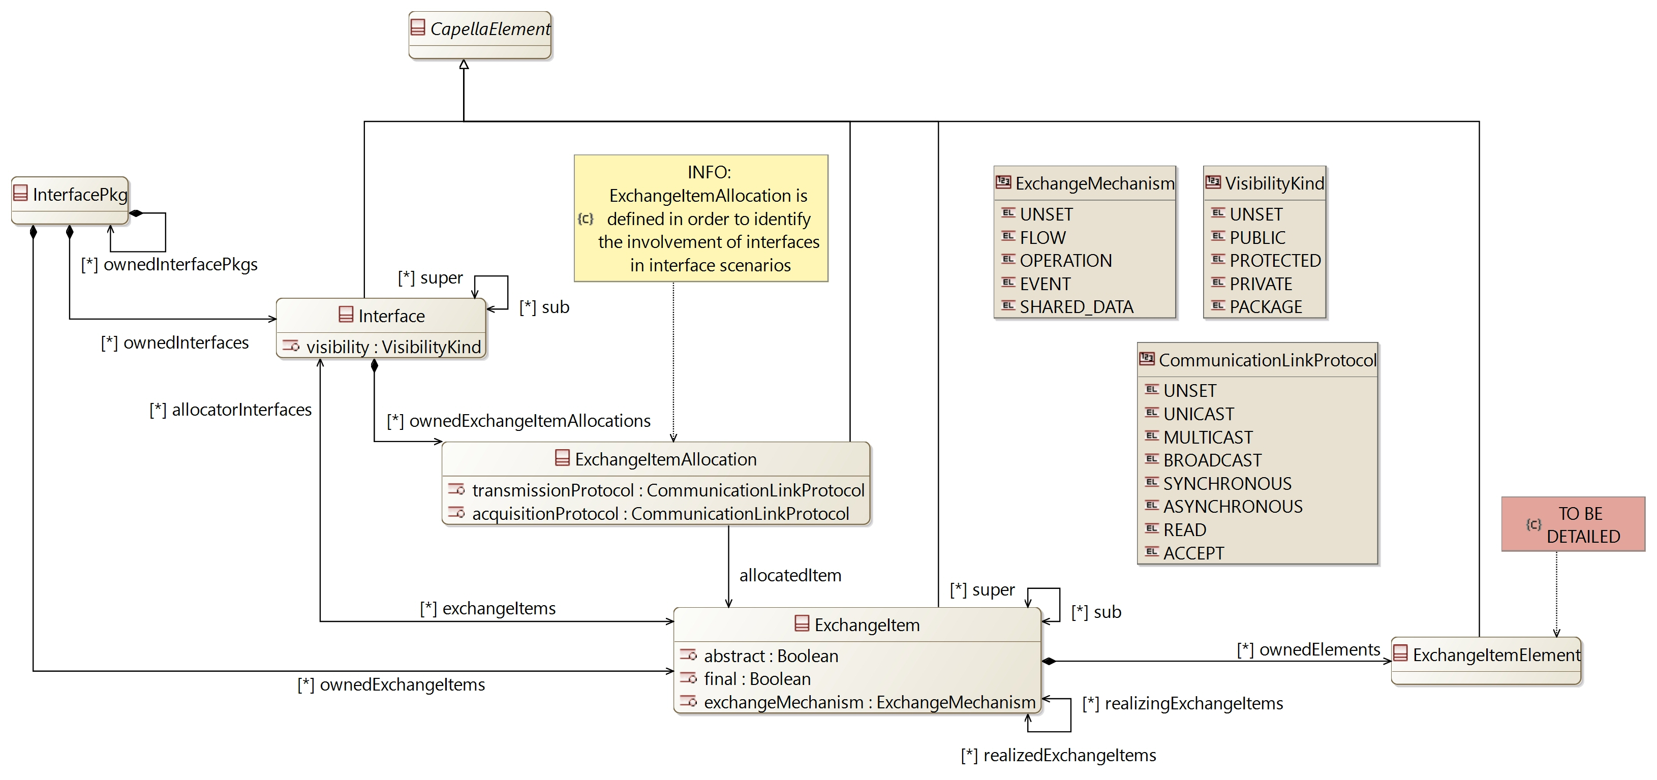

[CDB] Node:

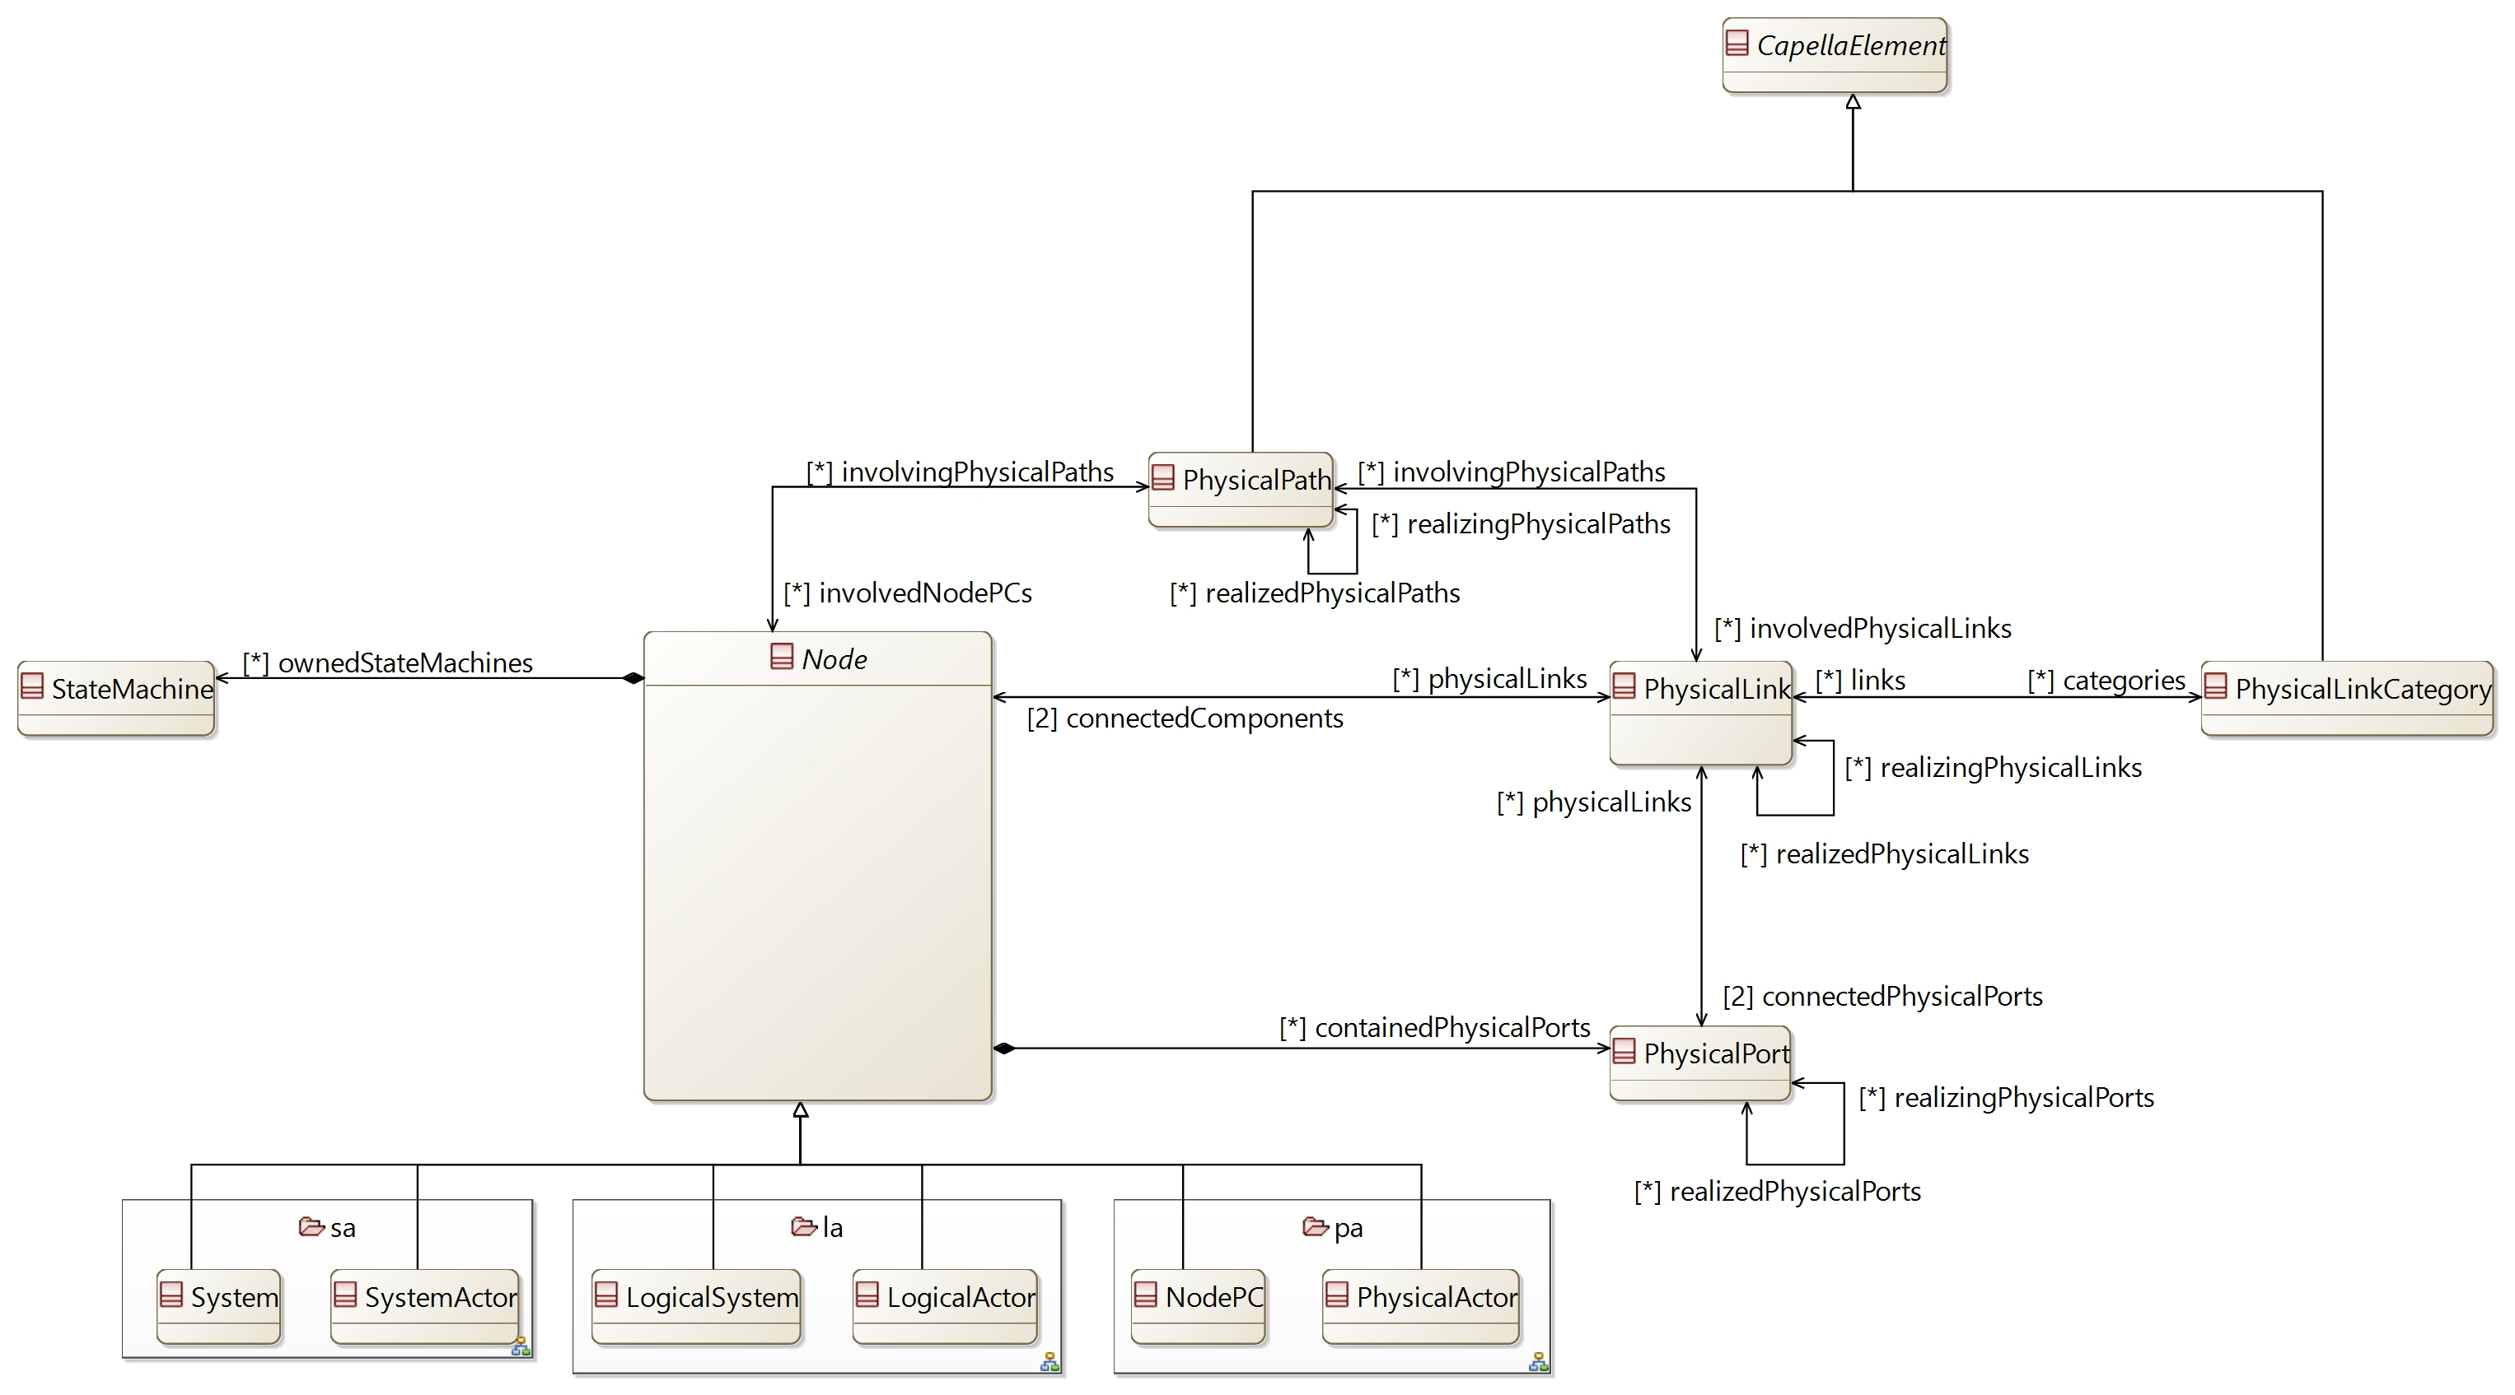

## [Type] Node [Abstract]

Description:

An abstract type defining the generic relation of a Node (implementation ressource) element

Direct super types:

* **AbstractInstance**

Direct sub-types:

* **System**
* **SystemActor**
* **LogicalSystem**
* **LogicalActor**
* **NodePC**
* **PhysicalActor**

Possible parent elements:

*No possible parent defined*

Attributes:

*No attribute defined*

Relations:

|  |  |  |  |  |
| --- | --- | --- | --- | --- |
| **Ref. name** | **Kind** | **Card.** | **Target Type** | **Defined on** |
| containedPhysicalPorts | COMPOSITION | [0 *] | **PhysicalPort** | *defined on type* |
| physicalLinks | ASSOCIATION | [0 *] | **PhysicalLink** | *defined on type* |
| involvingPhysicalPaths | ASSOCIATION | [0 *] | **PhysicalPath** | *defined on type* |
| ownedStateMachines | COMPOSITION | [0 *] | **StateMachine** | *defined on type* |

Methods:

*No method defined*

## [Type] PhysicalPort

Description:

A port on a Node component defining a physical interaction point

Direct super types:

* **AbstractPhysicalArtifact**

Direct sub-types:

*No direct sub-type*

Possible parent elements:

* System
* SystemActor
* LogicalSystem
* LogicalActor
* NodePC
* PhysicalActor

Attributes:

|  |  |  |
| --- | --- | --- |
| **Attribute name** | **Attribute type** | **Defined on** |
| id | String | **CapellaElement** |
| sid | String | **CapellaElement** |
| name | String | **CapellaElement** |
| summary | String | **CapellaElement** |
| description | String | **CapellaElement** |
| status | **Status** | **CapellaElement** |
| review | String | **CapellaElement** |
| visibleInDocumentation | Boolean | **CapellaElement** |
| visibleForTraceability | Boolean | **CapellaElement** |

Relations:

|  |  |  |  |  |
| --- | --- | --- | --- | --- |
| **Ref. name** | **Kind** | **Card.** | **Target Type** | **Defined on** |
| ownedDiagrams | COMPOSITION | [0 *] | **Diagram** | **EObject** |
| elementOfInterestForDiagrams | ASSOCIATION | [0 *] | **Diagram** | **EObject** |
| contextualElementForDiagrams | ASSOCIATION | [0 *] | **Diagram** | **EObject** |
| representingDiagrams | ASSOCIATION | [0 *] | **Diagram** | **EObject** |
| ownedConstraints | COMPOSITION | [0 *] | **Constraint** | **CapellaElement** |
| constraints | ASSOCIATION | [0 *] | **Constraint** | **CapellaElement** |
| ownedPropertyValues | COMPOSITION | [0 *] | **PropertyValue** | **CapellaElement** |
| appliedPropertyValues | ASSOCIATION | [0 *] | **PropertyValue** | **CapellaElement** |
| ownedPropertyValueGroups | COMPOSITION | [0 *] | **PropertyValueGroup** | **CapellaElement** |
| appliedPropertyValueGroups | ASSOCIATION | [0 *] | **PropertyValueGroup** | **CapellaElement** |
| ownedEnumerationPropertyTypes | COMPOSITION | [0 *] | **EnumerationPropertyType** | **CapellaElement** |
| allocatorConfigurationItems | ASSOCIATION | [0 *] | **ConfigurationItem** | **AbstractPhysicalArtifact** |
| physicalLinks | ASSOCIATION | [0 *] | **PhysicalLink** | *defined on type* |
| allocatedComponentPorts | ASSOCIATION | [0 *] | **ComponentPort** | *defined on type* |
| realizedPhysicalPorts | ASSOCIATION | [0 *] | **PhysicalPort** | *defined on type* |
| realizingPhysicalPorts | ASSOCIATION | [0 *] | **PhysicalPort** | *defined on type* |

Methods:

*No method defined*

## [Type] PhysicalLink

Description:

Means of communication, transport or routing between two Node components, used as a support for behavioral exchanges

Direct super types:

* **AbstractPhysicalArtifact**

Direct sub-types:

*No direct sub-type*

Possible parent elements:

*No possible parent defined*

Attributes:

|  |  |  |
| --- | --- | --- |
| **Attribute name** | **Attribute type** | **Defined on** |
| id | String | **CapellaElement** |
| sid | String | **CapellaElement** |
| name | String | **CapellaElement** |
| summary | String | **CapellaElement** |
| description | String | **CapellaElement** |
| status | **Status** | **CapellaElement** |
| review | String | **CapellaElement** |
| visibleInDocumentation | Boolean | **CapellaElement** |
| visibleForTraceability | Boolean | **CapellaElement** |

Relations:

|  |  |  |  |  |
| --- | --- | --- | --- | --- |
| **Ref. name** | **Kind** | **Card.** | **Target Type** | **Defined on** |
| ownedDiagrams | COMPOSITION | [0 *] | **Diagram** | **EObject** |
| elementOfInterestForDiagrams | ASSOCIATION | [0 *] | **Diagram** | **EObject** |
| contextualElementForDiagrams | ASSOCIATION | [0 *] | **Diagram** | **EObject** |
| representingDiagrams | ASSOCIATION | [0 *] | **Diagram** | **EObject** |
| ownedConstraints | COMPOSITION | [0 *] | **Constraint** | **CapellaElement** |
| constraints | ASSOCIATION | [0 *] | **Constraint** | **CapellaElement** |
| ownedPropertyValues | COMPOSITION | [0 *] | **PropertyValue** | **CapellaElement** |
| appliedPropertyValues | ASSOCIATION | [0 *] | **PropertyValue** | **CapellaElement** |
| ownedPropertyValueGroups | COMPOSITION | [0 *] | **PropertyValueGroup** | **CapellaElement** |
| appliedPropertyValueGroups | ASSOCIATION | [0 *] | **PropertyValueGroup** | **CapellaElement** |
| ownedEnumerationPropertyTypes | COMPOSITION | [0 *] | **EnumerationPropertyType** | **CapellaElement** |
| allocatorConfigurationItems | ASSOCIATION | [0 *] | **ConfigurationItem** | **AbstractPhysicalArtifact** |
| connectedPhysicalPorts | ASSOCIATION | [2 2] | **PhysicalPort** | *defined on type* |
| categories | ASSOCIATION | [0 *] | **PhysicalLinkCategory** | *defined on type* |
| involvingPhysicalPaths | ASSOCIATION | [0 *] | **PhysicalPath** | *defined on type* |
| connectedComponents | ASSOCIATION | [2 2] | **Node** | *defined on type* |
| allocatedComponentExchanges | ASSOCIATION | [0 *] | **ComponentExchange** | *defined on type* |
| realizedPhysicalLinks | ASSOCIATION | [0 *] | **PhysicalLink** | *defined on type* |
| realizingPhysicalLinks | ASSOCIATION | [0 *] | **PhysicalLink** | *defined on type* |

Methods:

*No method defined*

## [Type] PhysicalLinkCategory

Description:

A regroupement of PhysicalLinks for graphical simplification of diagrams

Direct super types:

* **CapellaElement**

Direct sub-types:

*No direct sub-type*

Possible parent elements:

*No possible parent defined*

Attributes:

|  |  |  |
| --- | --- | --- |
| **Attribute name** | **Attribute type** | **Defined on** |
| id | String | **CapellaElement** |
| sid | String | **CapellaElement** |
| name | String | **CapellaElement** |
| summary | String | **CapellaElement** |
| description | String | **CapellaElement** |
| status | **Status** | **CapellaElement** |
| review | String | **CapellaElement** |
| visibleInDocumentation | Boolean | **CapellaElement** |
| visibleForTraceability | Boolean | **CapellaElement** |

Relations:

|  |  |  |  |  |
| --- | --- | --- | --- | --- |
| **Ref. name** | **Kind** | **Card.** | **Target Type** | **Defined on** |
| ownedDiagrams | COMPOSITION | [0 *] | **Diagram** | **EObject** |
| elementOfInterestForDiagrams | ASSOCIATION | [0 *] | **Diagram** | **EObject** |
| contextualElementForDiagrams | ASSOCIATION | [0 *] | **Diagram** | **EObject** |
| representingDiagrams | ASSOCIATION | [0 *] | **Diagram** | **EObject** |
| ownedConstraints | COMPOSITION | [0 *] | **Constraint** | **CapellaElement** |
| constraints | ASSOCIATION | [0 *] | **Constraint** | **CapellaElement** |
| ownedPropertyValues | COMPOSITION | [0 *] | **PropertyValue** | **CapellaElement** |
| appliedPropertyValues | ASSOCIATION | [0 *] | **PropertyValue** | **CapellaElement** |
| ownedPropertyValueGroups | COMPOSITION | [0 *] | **PropertyValueGroup** | **CapellaElement** |
| appliedPropertyValueGroups | ASSOCIATION | [0 *] | **PropertyValueGroup** | **CapellaElement** |
| ownedEnumerationPropertyTypes | COMPOSITION | [0 *] | **EnumerationPropertyType** | **CapellaElement** |
| links | ASSOCIATION | [0 *] | **PhysicalLink** | *defined on type* |

Methods:

*No method defined*

## [Type] PhysicalPath

Description:

Set of Physical Links defining a continuous path likely to route one or more behavioral exchanges

Direct super types:

* **CapellaElement**

Direct sub-types:

*No direct sub-type*

Possible parent elements:

*No possible parent defined*

Attributes:

|  |  |  |
| --- | --- | --- |
| **Attribute name** | **Attribute type** | **Defined on** |
| id | String | **CapellaElement** |
| sid | String | **CapellaElement** |
| name | String | **CapellaElement** |
| summary | String | **CapellaElement** |
| description | String | **CapellaElement** |
| status | **Status** | **CapellaElement** |
| review | String | **CapellaElement** |
| visibleInDocumentation | Boolean | **CapellaElement** |
| visibleForTraceability | Boolean | **CapellaElement** |

Relations:

|  |  |  |  |  |
| --- | --- | --- | --- | --- |
| **Ref. name** | **Kind** | **Card.** | **Target Type** | **Defined on** |
| ownedDiagrams | COMPOSITION | [0 *] | **Diagram** | **EObject** |
| elementOfInterestForDiagrams | ASSOCIATION | [0 *] | **Diagram** | **EObject** |
| contextualElementForDiagrams | ASSOCIATION | [0 *] | **Diagram** | **EObject** |
| representingDiagrams | ASSOCIATION | [0 *] | **Diagram** | **EObject** |
| ownedConstraints | COMPOSITION | [0 *] | **Constraint** | **CapellaElement** |
| constraints | ASSOCIATION | [0 *] | **Constraint** | **CapellaElement** |
| ownedPropertyValues | COMPOSITION | [0 *] | **PropertyValue** | **CapellaElement** |
| appliedPropertyValues | ASSOCIATION | [0 *] | **PropertyValue** | **CapellaElement** |
| ownedPropertyValueGroups | COMPOSITION | [0 *] | **PropertyValueGroup** | **CapellaElement** |
| appliedPropertyValueGroups | ASSOCIATION | [0 *] | **PropertyValueGroup** | **CapellaElement** |
| ownedEnumerationPropertyTypes | COMPOSITION | [0 *] | **EnumerationPropertyType** | **CapellaElement** |
| involvedPhysicalLinks | ASSOCIATION | [0 *] | **PhysicalLink** | *defined on type* |
| involvedNodePCs | ASSOCIATION | [0 *] | **Node** | *defined on type* |
| allocatedComponentExchanges | ASSOCIATION | [0 *] | **ComponentExchange** | *defined on type* |
| realizedPhysicalPaths | ASSOCIATION | [0 *] | **PhysicalPath** | *defined on type* |
| realizingPhysicalPaths | ASSOCIATION | [0 *] | **PhysicalPath** | *defined on type* |

Methods:

*No method defined*

## [Type] InterfacePkg

Description:

A package to contain Interfaces

Direct super types:

* **PropertyValuePkgContainer**

Direct sub-types:

*No direct sub-type*

Possible parent elements:

* OperationalAnalysis
* SystemAnalysis
* LogicalArchitecture
* PhysicalArchitecture
* InterfacePkg

Attributes:

|  |  |  |
| --- | --- | --- |
| **Attribute name** | **Attribute type** | **Defined on** |
| id | String | **CapellaElement** |
| sid | String | **CapellaElement** |
| name | String | **CapellaElement** |
| summary | String | **CapellaElement** |
| description | String | **CapellaElement** |
| status | **Status** | **CapellaElement** |
| review | String | **CapellaElement** |
| visibleInDocumentation | Boolean | **CapellaElement** |
| visibleForTraceability | Boolean | **CapellaElement** |

Relations:

|  |  |  |  |  |
| --- | --- | --- | --- | --- |
| **Ref. name** | **Kind** | **Card.** | **Target Type** | **Defined on** |
| ownedDiagrams | COMPOSITION | [0 *] | **Diagram** | **EObject** |
| elementOfInterestForDiagrams | ASSOCIATION | [0 *] | **Diagram** | **EObject** |
| contextualElementForDiagrams | ASSOCIATION | [0 *] | **Diagram** | **EObject** |
| representingDiagrams | ASSOCIATION | [0 *] | **Diagram** | **EObject** |
| ownedConstraints | COMPOSITION | [0 *] | **Constraint** | **CapellaElement** |
| constraints | ASSOCIATION | [0 *] | **Constraint** | **CapellaElement** |
| ownedPropertyValues | COMPOSITION | [0 *] | **PropertyValue** | **CapellaElement** |
| appliedPropertyValues | ASSOCIATION | [0 *] | **PropertyValue** | **CapellaElement** |
| ownedPropertyValueGroups | COMPOSITION | [0 *] | **PropertyValueGroup** | **CapellaElement** |
| appliedPropertyValueGroups | ASSOCIATION | [0 *] | **PropertyValueGroup** | **CapellaElement** |
| ownedEnumerationPropertyTypes | COMPOSITION | [0 *] | **EnumerationPropertyType** | **CapellaElement** |
| ownedPropertyValuePkgs | COMPOSITION | [0 *] | **PropertyValuePkg** | **PropertyValuePkgContainer** |
| ownedInterfacePkgs | COMPOSITION | [0 *] | **InterfacePkg** | *defined on type* |
| ownedInterfaces | COMPOSITION | [0 *] | **Interface** | *defined on type* |
| ownedExchangeItems | COMPOSITION | [0 *] | **ExchangeItem** | *defined on type* |

Methods:

*No method defined*

## [Type] Interface

Description:

The definition of ExchangeItems which can be send / received by a ComponentPort

Direct super types:

* **CapellaElement**

Direct sub-types:

*No direct sub-type*

Possible parent elements:

* InterfacePkg

Attributes:

|  |  |  |
| --- | --- | --- |
| **Attribute name** | **Attribute type** | **Defined on** |
| id | String | **CapellaElement** |
| sid | String | **CapellaElement** |
| name | String | **CapellaElement** |
| summary | String | **CapellaElement** |
| description | String | **CapellaElement** |
| status | **Status** | **CapellaElement** |
| review | String | **CapellaElement** |
| visibleInDocumentation | Boolean | **CapellaElement** |
| visibleForTraceability | Boolean | **CapellaElement** |
| visibility | **VisibilityKind** | *defined on type* |

Relations:

|  |  |  |  |  |
| --- | --- | --- | --- | --- |
| **Ref. name** | **Kind** | **Card.** | **Target Type** | **Defined on** |
| ownedDiagrams | COMPOSITION | [0 *] | **Diagram** | **EObject** |
| elementOfInterestForDiagrams | ASSOCIATION | [0 *] | **Diagram** | **EObject** |
| contextualElementForDiagrams | ASSOCIATION | [0 *] | **Diagram** | **EObject** |
| representingDiagrams | ASSOCIATION | [0 *] | **Diagram** | **EObject** |
| ownedConstraints | COMPOSITION | [0 *] | **Constraint** | **CapellaElement** |
| constraints | ASSOCIATION | [0 *] | **Constraint** | **CapellaElement** |
| ownedPropertyValues | COMPOSITION | [0 *] | **PropertyValue** | **CapellaElement** |
| appliedPropertyValues | ASSOCIATION | [0 *] | **PropertyValue** | **CapellaElement** |
| ownedPropertyValueGroups | COMPOSITION | [0 *] | **PropertyValueGroup** | **CapellaElement** |
| appliedPropertyValueGroups | ASSOCIATION | [0 *] | **PropertyValueGroup** | **CapellaElement** |
| ownedEnumerationPropertyTypes | COMPOSITION | [0 *] | **EnumerationPropertyType** | **CapellaElement** |
| ownedExchangeItemAllocations | COMPOSITION | [0 *] | **ExchangeItemAllocation** | *defined on type* |
| exchangeItems | ASSOCIATION | [0 *] | **ExchangeItem** | *defined on type* |
| providingComponentPorts | ASSOCIATION | [0 *] | **ComponentPort** | *defined on type* |
| requiringComponentPorts | ASSOCIATION | [0 *] | **ComponentPort** | *defined on type* |
| userComponents | ASSOCIATION | [0 *] | **BehavioralComponent** | *defined on type* |
| implementorComponents | ASSOCIATION | [0 *] | **BehavioralComponent** | *defined on type* |
| super | ASSOCIATION | [0 *] | **Interface** | *defined on type* |
| sub | ASSOCIATION | [0 *] | **Interface** | *defined on type* |

Methods:

*No method defined*

## [Type] ExchangeItemAllocation

Description:

The involvement of an ExchangeItem by an Interface.

Mainly used for the involvement of ExchangeItems in Interface Scenarios based on the definition of Interfaces between components

Direct super types:

* **CapellaElement**

Direct sub-types:

*No direct sub-type*

Possible parent elements:

* Interface

Attributes:

|  |  |  |
| --- | --- | --- |
| **Attribute name** | **Attribute type** | **Defined on** |
| id | String | **CapellaElement** |
| sid | String | **CapellaElement** |
| name | String | **CapellaElement** |
| summary | String | **CapellaElement** |
| description | String | **CapellaElement** |
| status | **Status** | **CapellaElement** |
| review | String | **CapellaElement** |
| visibleInDocumentation | Boolean | **CapellaElement** |
| visibleForTraceability | Boolean | **CapellaElement** |
| transmissionProtocol | **CommunicationLinkProtocol** | *defined on type* |
| acquisitionProtocol | **CommunicationLinkProtocol** | *defined on type* |

Relations:

|  |  |  |  |  |
| --- | --- | --- | --- | --- |
| **Ref. name** | **Kind** | **Card.** | **Target Type** | **Defined on** |
| ownedDiagrams | COMPOSITION | [0 *] | **Diagram** | **EObject** |
| elementOfInterestForDiagrams | ASSOCIATION | [0 *] | **Diagram** | **EObject** |
| contextualElementForDiagrams | ASSOCIATION | [0 *] | **Diagram** | **EObject** |
| representingDiagrams | ASSOCIATION | [0 *] | **Diagram** | **EObject** |
| ownedConstraints | COMPOSITION | [0 *] | **Constraint** | **CapellaElement** |
| constraints | ASSOCIATION | [0 *] | **Constraint** | **CapellaElement** |
| ownedPropertyValues | COMPOSITION | [0 *] | **PropertyValue** | **CapellaElement** |
| appliedPropertyValues | ASSOCIATION | [0 *] | **PropertyValue** | **CapellaElement** |
| ownedPropertyValueGroups | COMPOSITION | [0 *] | **PropertyValueGroup** | **CapellaElement** |
| appliedPropertyValueGroups | ASSOCIATION | [0 *] | **PropertyValueGroup** | **CapellaElement** |
| ownedEnumerationPropertyTypes | COMPOSITION | [0 *] | **EnumerationPropertyType** | **CapellaElement** |
| allocatedItem | ASSOCIATION | [1 1] | **ExchangeItem** | *defined on type* |
| invokingSequenceMessages | ASSOCIATION | [0 *] | **SequenceMessage** | *defined on type* |

Methods:

*No method defined*

## [Type] ExchangeItem

Description:

Ordered set of references to elements carried together during an interaction or exchange between functions, components and actors. The elements are carried simultaneously, in the same conditions, with the same non-functional properties. The “elements” are called data

Direct super types:

* **CapellaElement**
* **AbstractAction**
* **AbstractEvent**
* **AbstractInstance**

Direct sub-types:

*No direct sub-type*

Possible parent elements:

* InterfacePkg

Attributes:

|  |  |  |
| --- | --- | --- |
| **Attribute name** | **Attribute type** | **Defined on** |
| id | String | **CapellaElement** |
| sid | String | **CapellaElement** |
| name | String | **CapellaElement** |
| summary | String | **CapellaElement** |
| description | String | **CapellaElement** |
| status | **Status** | **CapellaElement** |
| review | String | **CapellaElement** |
| visibleInDocumentation | Boolean | **CapellaElement** |
| visibleForTraceability | Boolean | **CapellaElement** |
| abstract | Boolean | *defined on type* |
| final | Boolean | *defined on type* |
| exchangeMechanism | **ExchangeMechanism** | *defined on type* |

Relations:

|  |  |  |  |  |
| --- | --- | --- | --- | --- |
| **Ref. name** | **Kind** | **Card.** | **Target Type** | **Defined on** |
| ownedDiagrams | COMPOSITION | [0 *] | **Diagram** | **EObject** |
| elementOfInterestForDiagrams | ASSOCIATION | [0 *] | **Diagram** | **EObject** |
| contextualElementForDiagrams | ASSOCIATION | [0 *] | **Diagram** | **EObject** |
| representingDiagrams | ASSOCIATION | [0 *] | **Diagram** | **EObject** |
| ownedConstraints | COMPOSITION | [0 *] | **Constraint** | **CapellaElement** |
| constraints | ASSOCIATION | [0 *] | **Constraint** | **CapellaElement** |
| ownedPropertyValues | COMPOSITION | [0 *] | **PropertyValue** | **CapellaElement** |
| appliedPropertyValues | ASSOCIATION | [0 *] | **PropertyValue** | **CapellaElement** |
| ownedPropertyValueGroups | COMPOSITION | [0 *] | **PropertyValueGroup** | **CapellaElement** |
| appliedPropertyValueGroups | ASSOCIATION | [0 *] | **PropertyValueGroup** | **CapellaElement** |
| ownedEnumerationPropertyTypes | COMPOSITION | [0 *] | **EnumerationPropertyType** | **CapellaElement** |
| ownedElements | COMPOSITION | [0 *] | **ExchangeItemElement** | *defined on type* |
| allocatorInterfaces | ASSOCIATION | [0 *] | **Interface** | *defined on type* |
| super | ASSOCIATION | [0 *] | **ExchangeItem** | *defined on type* |
| sub | ASSOCIATION | [0 *] | **ExchangeItem** | *defined on type* |
| realizedExchangeItems | ASSOCIATION | [0 *] | **ExchangeItem** | *defined on type* |
| realizingExchangeItems | ASSOCIATION | [0 *] | **ExchangeItem** | *defined on type* |

Methods:

*No method defined*

## [Type] ExchangeItemElement

Description:

A part of the information contained by an ExchangeItem

Direct super types:

* **CapellaElement**

Direct sub-types:

*No direct sub-type*

Possible parent elements:

* ExchangeItem

Attributes:

|  |  |  |
| --- | --- | --- |
| **Attribute name** | **Attribute type** | **Defined on** |
| id | String | **CapellaElement** |
| sid | String | **CapellaElement** |
| name | String | **CapellaElement** |
| summary | String | **CapellaElement** |
| description | String | **CapellaElement** |
| status | **Status** | **CapellaElement** |
| review | String | **CapellaElement** |
| visibleInDocumentation | Boolean | **CapellaElement** |
| visibleForTraceability | Boolean | **CapellaElement** |

Relations:

|  |  |  |  |  |
| --- | --- | --- | --- | --- |
| **Ref. name** | **Kind** | **Card.** | **Target Type** | **Defined on** |
| ownedDiagrams | COMPOSITION | [0 *] | **Diagram** | **EObject** |
| elementOfInterestForDiagrams | ASSOCIATION | [0 *] | **Diagram** | **EObject** |
| contextualElementForDiagrams | ASSOCIATION | [0 *] | **Diagram** | **EObject** |
| representingDiagrams | ASSOCIATION | [0 *] | **Diagram** | **EObject** |
| ownedConstraints | COMPOSITION | [0 *] | **Constraint** | **CapellaElement** |
| constraints | ASSOCIATION | [0 *] | **Constraint** | **CapellaElement** |
| ownedPropertyValues | COMPOSITION | [0 *] | **PropertyValue** | **CapellaElement** |
| appliedPropertyValues | ASSOCIATION | [0 *] | **PropertyValue** | **CapellaElement** |
| ownedPropertyValueGroups | COMPOSITION | [0 *] | **PropertyValueGroup** | **CapellaElement** |
| appliedPropertyValueGroups | ASSOCIATION | [0 *] | **PropertyValueGroup** | **CapellaElement** |
| ownedEnumerationPropertyTypes | COMPOSITION | [0 *] | **EnumerationPropertyType** | **CapellaElement** |

Methods:

*No method defined*

## [Enumeration] ExchangeMechanism

List of values:

* UNSET
* FLOW
* OPERATION
* EVENT
* SHARED_DATA

Used by:

* **ExchangeItem**

## [Enumeration] CommunicationLinkProtocol

List of values:

* UNSET
* UNICAST
* MULTICAST
* BROADCAST
* SYNCHRONOUS
* ASYNCHRONOUS
* READ
* ACCEPT

Used by:

* **ExchangeItemAllocation**

# [Package] fa

Diagrams:

Here are the diagrams of representing the elements introduced in this package:

[CDB] Function:

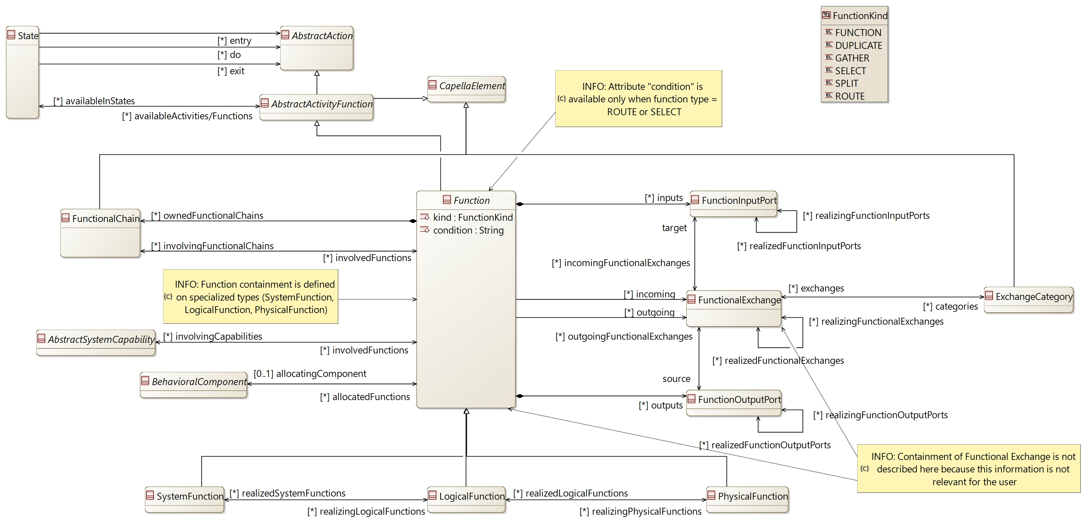

[CDB] BehavioralComponent:

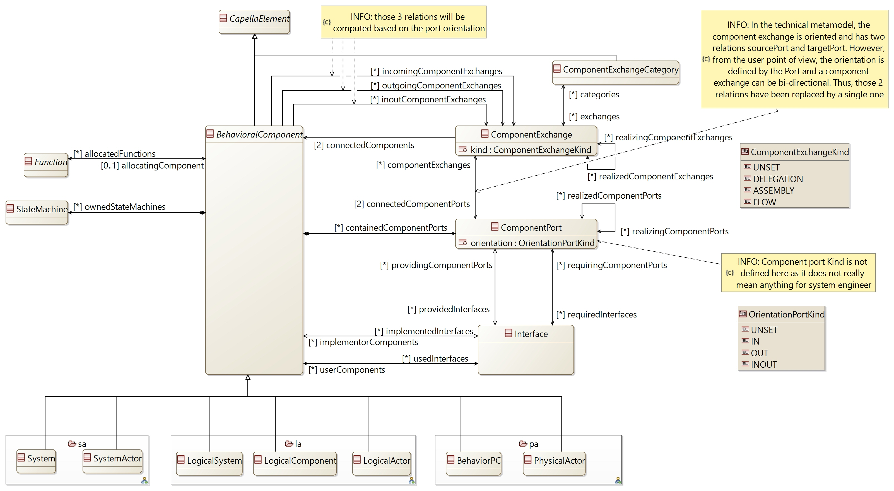

[CDB] FunctionalChain:

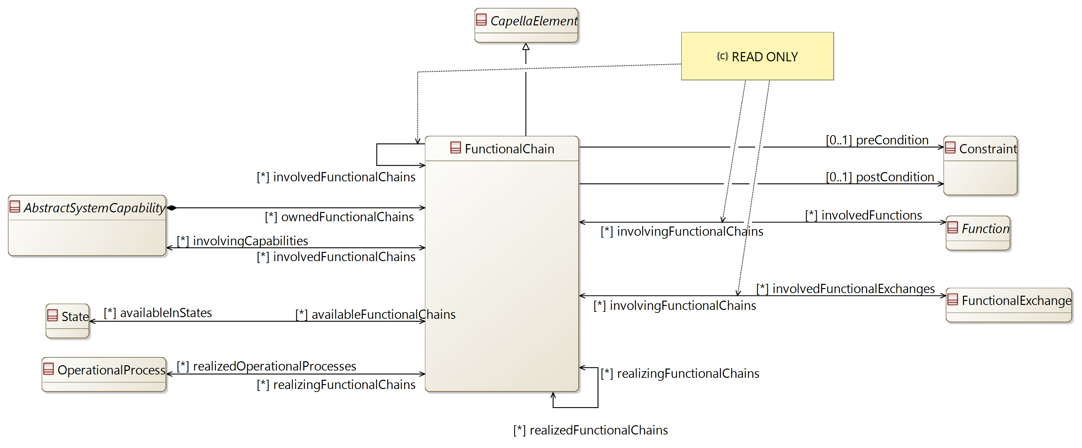

[CDB] FunctionAllocation:

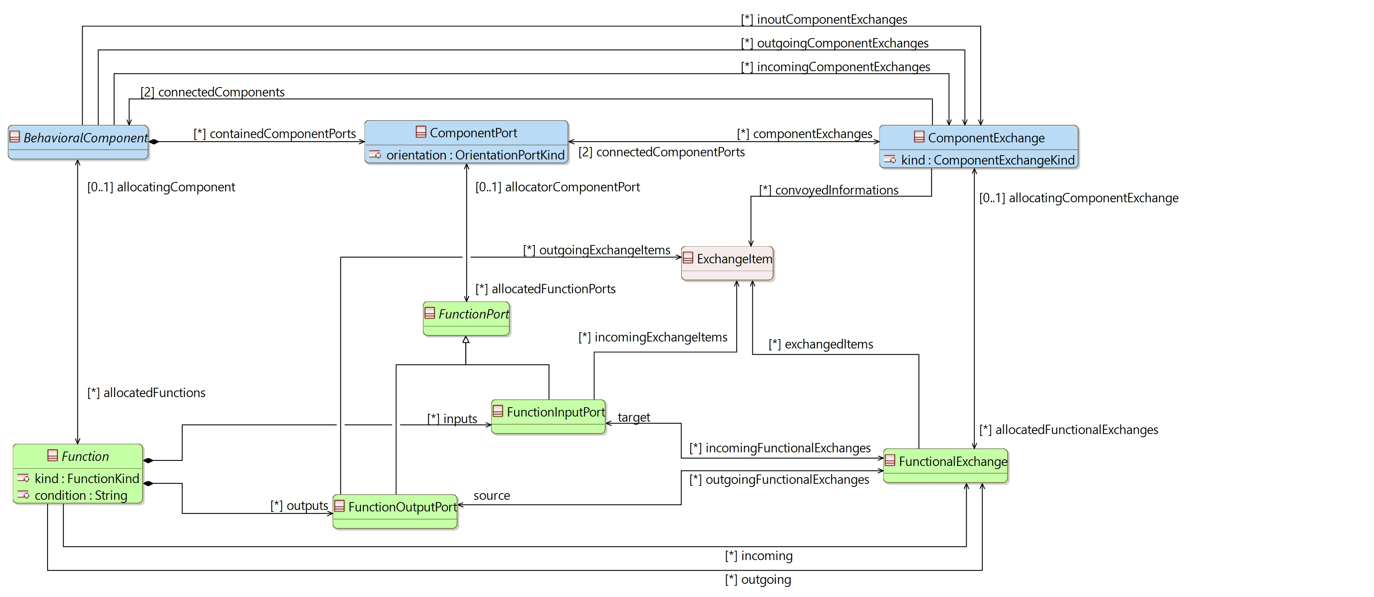

[CDB] AbstractCapability:

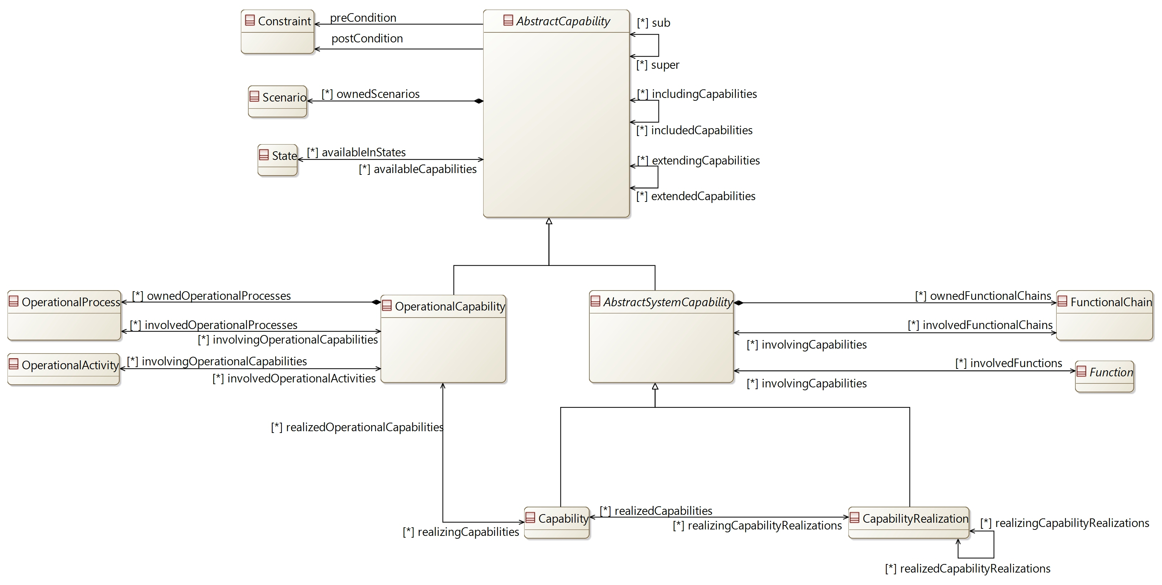

## [Type] Function [Abstract]

Description:

Action performed by the System, an Actor or a component, in order to realize a Capability

Direct super types:

* **AbstractActivityFunction**

Direct sub-types:

* **SystemFunction**
* **LogicalFunction**
* **PhysicalFunction**

Possible parent elements:

*No possible parent defined*

Attributes:

|  |  |  |
| --- | --- | --- |
| **Attribute name** | **Attribute type** | **Defined on** |
| id | String | **CapellaElement** |
| sid | String | **CapellaElement** |
| name | String | **CapellaElement** |
| summary | String | **CapellaElement** |
| description | String | **CapellaElement** |
| status | **Status** | **CapellaElement** |
| review | String | **CapellaElement** |
| visibleInDocumentation | Boolean | **CapellaElement** |
| visibleForTraceability | Boolean | **CapellaElement** |
| kind | **FunctionKind** | *defined on type* |
| condition | String | *defined on type* |

Relations:

|  |  |  |  |  |
| --- | --- | --- | --- | --- |
| **Ref. name** | **Kind** | **Card.** | **Target Type** | **Defined on** |
| ownedDiagrams | COMPOSITION | [0 *] | **Diagram** | **EObject** |
| elementOfInterestForDiagrams | ASSOCIATION | [0 *] | **Diagram** | **EObject** |
| contextualElementForDiagrams | ASSOCIATION | [0 *] | **Diagram** | **EObject** |
| representingDiagrams | ASSOCIATION | [0 *] | **Diagram** | **EObject** |
| ownedConstraints | COMPOSITION | [0 *] | **Constraint** | **CapellaElement** |
| constraints | ASSOCIATION | [0 *] | **Constraint** | **CapellaElement** |
| ownedPropertyValues | COMPOSITION | [0 *] | **PropertyValue** | **CapellaElement** |
| appliedPropertyValues | ASSOCIATION | [0 *] | **PropertyValue** | **CapellaElement** |
| ownedPropertyValueGroups | COMPOSITION | [0 *] | **PropertyValueGroup** | **CapellaElement** |
| appliedPropertyValueGroups | ASSOCIATION | [0 *] | **PropertyValueGroup** | **CapellaElement** |
| ownedEnumerationPropertyTypes | COMPOSITION | [0 *] | **EnumerationPropertyType** | **CapellaElement** |
| availableInStates | ASSOCIATION | [0 *] | **State** | **AbstractActivityFunction** |
| inputs | COMPOSITION | [0 *] | **FunctionInputPort** | *defined on type* |
| outputs | COMPOSITION | [0 *] | **FunctionOutputPort** | *defined on type* |
| incoming | ASSOCIATION | [0 *] | **FunctionalExchange** | *defined on type* |
| outgoing | ASSOCIATION | [0 *] | **FunctionalExchange** | *defined on type* |
| allocatingComponent | ASSOCIATION | [0 1] | **BehavioralComponent** | *defined on type* |
| ownedFunctionalChains | COMPOSITION | [0 *] | **FunctionalChain** | *defined on type* |
| involvingFunctionalChains | ASSOCIATION | [0 *] | **FunctionalChain** | *defined on type* |
| involvingCapabilities | ASSOCIATION | [0 *] | **AbstractSystemCapability** | *defined on type* |

Methods:

*No method defined*

## [Type] FunctionPort [Abstract]

Description:

An generic FunctionPort to define the allocation with ComponentPorts

A Function Port specify what a Function is capable of producing or is requiring

Direct super types:

* **CapellaElement**

Direct sub-types:

* **FunctionInputPort**
* **FunctionOutputPort**

Possible parent elements:

*No possible parent defined*

Attributes:

|  |  |  |
| --- | --- | --- |
| **Attribute name** | **Attribute type** | **Defined on** |
| id | String | **CapellaElement** |
| sid | String | **CapellaElement** |
| name | String | **CapellaElement** |
| summary | String | **CapellaElement** |
| description | String | **CapellaElement** |
| status | **Status** | **CapellaElement** |
| review | String | **CapellaElement** |
| visibleInDocumentation | Boolean | **CapellaElement** |
| visibleForTraceability | Boolean | **CapellaElement** |

Relations:

|  |  |  |  |  |
| --- | --- | --- | --- | --- |
| **Ref. name** | **Kind** | **Card.** | **Target Type** | **Defined on** |
| ownedDiagrams | COMPOSITION | [0 *] | **Diagram** | **EObject** |
| elementOfInterestForDiagrams | ASSOCIATION | [0 *] | **Diagram** | **EObject** |
| contextualElementForDiagrams | ASSOCIATION | [0 *] | **Diagram** | **EObject** |
| representingDiagrams | ASSOCIATION | [0 *] | **Diagram** | **EObject** |
| ownedConstraints | COMPOSITION | [0 *] | **Constraint** | **CapellaElement** |
| constraints | ASSOCIATION | [0 *] | **Constraint** | **CapellaElement** |
| ownedPropertyValues | COMPOSITION | [0 *] | **PropertyValue** | **CapellaElement** |
| appliedPropertyValues | ASSOCIATION | [0 *] | **PropertyValue** | **CapellaElement** |
| ownedPropertyValueGroups | COMPOSITION | [0 *] | **PropertyValueGroup** | **CapellaElement** |
| appliedPropertyValueGroups | ASSOCIATION | [0 *] | **PropertyValueGroup** | **CapellaElement** |
| ownedEnumerationPropertyTypes | COMPOSITION | [0 *] | **EnumerationPropertyType** | **CapellaElement** |
| allocatorComponentPort | ASSOCIATION | [0 1] | **ComponentPort** | *defined on type* |

Methods:

*No method defined*

## [Type] FunctionInputPort

Description:

An FunctionInputPort defines what a Function is requiring

Direct super types:

* **FunctionPort**

Direct sub-types:

*No direct sub-type*

Possible parent elements:

* SystemFunction
* LogicalFunction
* PhysicalFunction

Attributes:

|  |  |  |
| --- | --- | --- |
| **Attribute name** | **Attribute type** | **Defined on** |
| id | String | **CapellaElement** |
| sid | String | **CapellaElement** |
| name | String | **CapellaElement** |
| summary | String | **CapellaElement** |
| description | String | **CapellaElement** |
| status | **Status** | **CapellaElement** |
| review | String | **CapellaElement** |
| visibleInDocumentation | Boolean | **CapellaElement** |
| visibleForTraceability | Boolean | **CapellaElement** |

Relations:

|  |  |  |  |  |
| --- | --- | --- | --- | --- |
| **Ref. name** | **Kind** | **Card.** | **Target Type** | **Defined on** |
| ownedDiagrams | COMPOSITION | [0 *] | **Diagram** | **EObject** |
| elementOfInterestForDiagrams | ASSOCIATION | [0 *] | **Diagram** | **EObject** |
| contextualElementForDiagrams | ASSOCIATION | [0 *] | **Diagram** | **EObject** |
| representingDiagrams | ASSOCIATION | [0 *] | **Diagram** | **EObject** |
| ownedConstraints | COMPOSITION | [0 *] | **Constraint** | **CapellaElement** |
| constraints | ASSOCIATION | [0 *] | **Constraint** | **CapellaElement** |
| ownedPropertyValues | COMPOSITION | [0 *] | **PropertyValue** | **CapellaElement** |
| appliedPropertyValues | ASSOCIATION | [0 *] | **PropertyValue** | **CapellaElement** |
| ownedPropertyValueGroups | COMPOSITION | [0 *] | **PropertyValueGroup** | **CapellaElement** |
| appliedPropertyValueGroups | ASSOCIATION | [0 *] | **PropertyValueGroup** | **CapellaElement** |
| ownedEnumerationPropertyTypes | COMPOSITION | [0 *] | **EnumerationPropertyType** | **CapellaElement** |
| allocatorComponentPort | ASSOCIATION | [0 1] | **ComponentPort** | **FunctionPort** |
| incomingFunctionalExchanges | ASSOCIATION | [0 *] | **FunctionalExchange** | *defined on type* |
| incomingExchangeItems | ASSOCIATION | [0 *] | **ExchangeItem** | *defined on type* |
| realizedFunctionInputPorts | ASSOCIATION | [0 *] | **FunctionInputPort** | *defined on type* |
| realizingFunctionInputPorts | ASSOCIATION | [0 *] | **FunctionInputPort** | *defined on type* |

Methods:

*No method defined*

## [Type] FunctionOutputPort

Description:

A FunctionOutputPort defines what a Function is capable of producing

Direct super types:

* **FunctionPort**

Direct sub-types:

*No direct sub-type*

Possible parent elements:

* SystemFunction
* LogicalFunction
* PhysicalFunction

Attributes:

|  |  |  |
| --- | --- | --- |
| **Attribute name** | **Attribute type** | **Defined on** |
| id | String | **CapellaElement** |
| sid | String | **CapellaElement** |
| name | String | **CapellaElement** |
| summary | String | **CapellaElement** |
| description | String | **CapellaElement** |
| status | **Status** | **CapellaElement** |
| review | String | **CapellaElement** |
| visibleInDocumentation | Boolean | **CapellaElement** |
| visibleForTraceability | Boolean | **CapellaElement** |

Relations:

|  |  |  |  |  |
| --- | --- | --- | --- | --- |
| **Ref. name** | **Kind** | **Card.** | **Target Type** | **Defined on** |
| ownedDiagrams | COMPOSITION | [0 *] | **Diagram** | **EObject** |
| elementOfInterestForDiagrams | ASSOCIATION | [0 *] | **Diagram** | **EObject** |
| contextualElementForDiagrams | ASSOCIATION | [0 *] | **Diagram** | **EObject** |
| representingDiagrams | ASSOCIATION | [0 *] | **Diagram** | **EObject** |
| ownedConstraints | COMPOSITION | [0 *] | **Constraint** | **CapellaElement** |
| constraints | ASSOCIATION | [0 *] | **Constraint** | **CapellaElement** |
| ownedPropertyValues | COMPOSITION | [0 *] | **PropertyValue** | **CapellaElement** |
| appliedPropertyValues | ASSOCIATION | [0 *] | **PropertyValue** | **CapellaElement** |
| ownedPropertyValueGroups | COMPOSITION | [0 *] | **PropertyValueGroup** | **CapellaElement** |
| appliedPropertyValueGroups | ASSOCIATION | [0 *] | **PropertyValueGroup** | **CapellaElement** |
| ownedEnumerationPropertyTypes | COMPOSITION | [0 *] | **EnumerationPropertyType** | **CapellaElement** |
| allocatorComponentPort | ASSOCIATION | [0 1] | **ComponentPort** | **FunctionPort** |
| outgoingFunctionalExchanges | ASSOCIATION | [0 *] | **FunctionalExchange** | *defined on type* |
| outgoingExchangeItems | ASSOCIATION | [0 *] | **ExchangeItem** | *defined on type* |
| realizedFunctionOutputPorts | ASSOCIATION | [0 *] | **FunctionOutputPort** | *defined on type* |
| realizingFunctionOutputPorts | ASSOCIATION | [0 *] | **FunctionOutputPort** | *defined on type* |

Methods:

*No method defined*

## [Type] FunctionalExchange

Description:

A functional exchange represents a dependency between a source function and a target one. Exchanges connect Function Ports, which specify what a Function is capable of producing or is requiring.

Direct super types:

* **AbstractEvent**
* **AbstractExchange**

Direct sub-types:

*No direct sub-type*

Possible parent elements:

*No possible parent defined*

Attributes:

|  |  |  |
| --- | --- | --- |
| **Attribute name** | **Attribute type** | **Defined on** |
| id | String | **CapellaElement** |
| sid | String | **CapellaElement** |
| name | String | **CapellaElement** |
| summary | String | **CapellaElement** |
| description | String | **CapellaElement** |
| status | **Status** | **CapellaElement** |
| review | String | **CapellaElement** |
| visibleInDocumentation | Boolean | **CapellaElement** |
| visibleForTraceability | Boolean | **CapellaElement** |

Relations:

|  |  |  |  |  |
| --- | --- | --- | --- | --- |
| **Ref. name** | **Kind** | **Card.** | **Target Type** | **Defined on** |
| ownedDiagrams | COMPOSITION | [0 *] | **Diagram** | **EObject** |
| elementOfInterestForDiagrams | ASSOCIATION | [0 *] | **Diagram** | **EObject** |
| contextualElementForDiagrams | ASSOCIATION | [0 *] | **Diagram** | **EObject** |
| representingDiagrams | ASSOCIATION | [0 *] | **Diagram** | **EObject** |
| ownedConstraints | COMPOSITION | [0 *] | **Constraint** | **CapellaElement** |
| constraints | ASSOCIATION | [0 *] | **Constraint** | **CapellaElement** |
| ownedPropertyValues | COMPOSITION | [0 *] | **PropertyValue** | **CapellaElement** |
| appliedPropertyValues | ASSOCIATION | [0 *] | **PropertyValue** | **CapellaElement** |
| ownedPropertyValueGroups | COMPOSITION | [0 *] | **PropertyValueGroup** | **CapellaElement** |
| appliedPropertyValueGroups | ASSOCIATION | [0 *] | **PropertyValueGroup** | **CapellaElement** |
| ownedEnumerationPropertyTypes | COMPOSITION | [0 *] | **EnumerationPropertyType** | **CapellaElement** |
| invokingSequenceMessages | ASSOCIATION | [0 *] | **SequenceMessage** | **AbstractExchange** |
| source | ASSOCIATION | [1 1] | **FunctionOutputPort** | *defined on type* |
| target | ASSOCIATION | [1 1] | **FunctionInputPort** | *defined on type* |
| exchangedItems | ASSOCIATION | [0 *] | **ExchangeItem** | *defined on type* |
| involvingFunctionalChains | ASSOCIATION | [0 *] | **FunctionalChain** | *defined on type* |
| categories | ASSOCIATION | [0 *] | **ExchangeCategory** | *defined on type* |
| allocatingComponentExchange | ASSOCIATION | [0 1] | **ComponentExchange** | *defined on type* |
| realizedFunctionalExchanges | ASSOCIATION | [0 *] | **FunctionalExchange** | *defined on type* |
| realizingFunctionalExchanges | ASSOCIATION | [0 *] | **FunctionalExchange** | *defined on type* |
| realizedInteractions | ASSOCIATION | [0 *] | **Interaction** | *defined on type* |

Methods:

*No method defined*

## [Type] ExchangeCategory

Description:

A regroupement of FunctionalExchanges for graphical simplification of diagrams

Direct super types:

* **CapellaElement**

Direct sub-types:

*No direct sub-type*

Possible parent elements:

*No possible parent defined*

Attributes:

|  |  |  |
| --- | --- | --- |
| **Attribute name** | **Attribute type** | **Defined on** |
| id | String | **CapellaElement** |
| sid | String | **CapellaElement** |
| name | String | **CapellaElement** |
| summary | String | **CapellaElement** |
| description | String | **CapellaElement** |
| status | **Status** | **CapellaElement** |
| review | String | **CapellaElement** |
| visibleInDocumentation | Boolean | **CapellaElement** |
| visibleForTraceability | Boolean | **CapellaElement** |

Relations:

|  |  |  |  |  |
| --- | --- | --- | --- | --- |
| **Ref. name** | **Kind** | **Card.** | **Target Type** | **Defined on** |
| ownedDiagrams | COMPOSITION | [0 *] | **Diagram** | **EObject** |
| elementOfInterestForDiagrams | ASSOCIATION | [0 *] | **Diagram** | **EObject** |
| contextualElementForDiagrams | ASSOCIATION | [0 *] | **Diagram** | **EObject** |
| representingDiagrams | ASSOCIATION | [0 *] | **Diagram** | **EObject** |
| ownedConstraints | COMPOSITION | [0 *] | **Constraint** | **CapellaElement** |
| constraints | ASSOCIATION | [0 *] | **Constraint** | **CapellaElement** |
| ownedPropertyValues | COMPOSITION | [0 *] | **PropertyValue** | **CapellaElement** |
| appliedPropertyValues | ASSOCIATION | [0 *] | **PropertyValue** | **CapellaElement** |
| ownedPropertyValueGroups | COMPOSITION | [0 *] | **PropertyValueGroup** | **CapellaElement** |
| appliedPropertyValueGroups | ASSOCIATION | [0 *] | **PropertyValueGroup** | **CapellaElement** |
| ownedEnumerationPropertyTypes | COMPOSITION | [0 *] | **EnumerationPropertyType** | **CapellaElement** |
| exchanges | ASSOCIATION | [0 *] | **FunctionalExchange** | *defined on type* |

Methods:

*No method defined*

## [Type] FunctionalChain

Description:

Describe the system behaviour in a particular usage context with references towards Functions and Functional Exchanges

Direct super types:

* **CapellaElement**

Direct sub-types:

*No direct sub-type*

Possible parent elements:

* SystemFunction
* Capability
* LogicalFunction
* CapabilityRealization
* PhysicalFunction

Attributes:

|  |  |  |
| --- | --- | --- |
| **Attribute name** | **Attribute type** | **Defined on** |
| id | String | **CapellaElement** |
| sid | String | **CapellaElement** |
| name | String | **CapellaElement** |
| summary | String | **CapellaElement** |
| description | String | **CapellaElement** |
| status | **Status** | **CapellaElement** |
| review | String | **CapellaElement** |
| visibleInDocumentation | Boolean | **CapellaElement** |
| visibleForTraceability | Boolean | **CapellaElement** |

Relations:

|  |  |  |  |  |
| --- | --- | --- | --- | --- |
| **Ref. name** | **Kind** | **Card.** | **Target Type** | **Defined on** |
| ownedDiagrams | COMPOSITION | [0 *] | **Diagram** | **EObject** |
| elementOfInterestForDiagrams | ASSOCIATION | [0 *] | **Diagram** | **EObject** |
| contextualElementForDiagrams | ASSOCIATION | [0 *] | **Diagram** | **EObject** |
| representingDiagrams | ASSOCIATION | [0 *] | **Diagram** | **EObject** |
| ownedConstraints | COMPOSITION | [0 *] | **Constraint** | **CapellaElement** |
| constraints | ASSOCIATION | [0 *] | **Constraint** | **CapellaElement** |
| ownedPropertyValues | COMPOSITION | [0 *] | **PropertyValue** | **CapellaElement** |
| appliedPropertyValues | ASSOCIATION | [0 *] | **PropertyValue** | **CapellaElement** |
| ownedPropertyValueGroups | COMPOSITION | [0 *] | **PropertyValueGroup** | **CapellaElement** |
| appliedPropertyValueGroups | ASSOCIATION | [0 *] | **PropertyValueGroup** | **CapellaElement** |
| ownedEnumerationPropertyTypes | COMPOSITION | [0 *] | **EnumerationPropertyType** | **CapellaElement** |
| preCondition | ASSOCIATION | [0 1] | **Constraint** | *defined on type* |
| postCondition | ASSOCIATION | [0 1] | **Constraint** | *defined on type* |
| involvedFunctions | ASSOCIATION | [0 *] | **Function** | *defined on type* |
| involvedFunctionalExchanges | ASSOCIATION | [0 *] | **FunctionalExchange** | *defined on type* |
| involvedFunctionalChains | ASSOCIATION | [0 *] | **FunctionalChain** | *defined on type* |
| involvingCapabilities | ASSOCIATION | [0 *] | **AbstractSystemCapability** | *defined on type* |
| availableInStates | ASSOCIATION | [0 *] | **State** | *defined on type* |
| realizedOperationalProcesses | ASSOCIATION | [0 *] | **OperationalProcess** | *defined on type* |
| realizedFunctionalChains | ASSOCIATION | [0 *] | **FunctionalChain** | *defined on type* |
| realizingFunctionalChains | ASSOCIATION | [0 *] | **FunctionalChain** | *defined on type* |

Methods:

*No method defined*

## [Type] BehavioralComponent [Abstract]

Description:

An abstract type to define the generic relation of behavioral elements

Direct super types:

* **CapellaElement**
* **AbstractInstance**

Direct sub-types:

* **System**
* **SystemActor**
* **LogicalSystem**
* **LogicalComponent**
* **LogicalActor**
* **BehaviorPC**
* **PhysicalActor**

Possible parent elements:

*No possible parent defined*

Attributes:

|  |  |  |
| --- | --- | --- |
| **Attribute name** | **Attribute type** | **Defined on** |
| id | String | **CapellaElement** |
| sid | String | **CapellaElement** |
| name | String | **CapellaElement** |
| summary | String | **CapellaElement** |
| description | String | **CapellaElement** |
| status | **Status** | **CapellaElement** |
| review | String | **CapellaElement** |
| visibleInDocumentation | Boolean | **CapellaElement** |
| visibleForTraceability | Boolean | **CapellaElement** |

Relations:

|  |  |  |  |  |
| --- | --- | --- | --- | --- |
| **Ref. name** | **Kind** | **Card.** | **Target Type** | **Defined on** |
| ownedDiagrams | COMPOSITION | [0 *] | **Diagram** | **EObject** |
| elementOfInterestForDiagrams | ASSOCIATION | [0 *] | **Diagram** | **EObject** |
| contextualElementForDiagrams | ASSOCIATION | [0 *] | **Diagram** | **EObject** |
| representingDiagrams | ASSOCIATION | [0 *] | **Diagram** | **EObject** |
| ownedConstraints | COMPOSITION | [0 *] | **Constraint** | **CapellaElement** |
| constraints | ASSOCIATION | [0 *] | **Constraint** | **CapellaElement** |
| ownedPropertyValues | COMPOSITION | [0 *] | **PropertyValue** | **CapellaElement** |
| appliedPropertyValues | ASSOCIATION | [0 *] | **PropertyValue** | **CapellaElement** |
| ownedPropertyValueGroups | COMPOSITION | [0 *] | **PropertyValueGroup** | **CapellaElement** |
| appliedPropertyValueGroups | ASSOCIATION | [0 *] | **PropertyValueGroup** | **CapellaElement** |
| ownedEnumerationPropertyTypes | COMPOSITION | [0 *] | **EnumerationPropertyType** | **CapellaElement** |
| containedComponentPorts | COMPOSITION | [0 *] | **ComponentPort** | *defined on type* |
| incomingComponentExchanges | ASSOCIATION | [0 *] | **ComponentExchange** | *defined on type* |
| outgoingComponentExchanges | ASSOCIATION | [0 *] | **ComponentExchange** | *defined on type* |
| inoutComponentExchanges | ASSOCIATION | [0 *] | **ComponentExchange** | *defined on type* |
| allocatedFunctions | ASSOCIATION | [0 *] | **Function** | *defined on type* |
| usedInterfaces | ASSOCIATION | [0 *] | **Interface** | *defined on type* |
| implementedInterfaces | ASSOCIATION | [0 *] | **Interface** | *defined on type* |
| ownedStateMachines | COMPOSITION | [0 *] | **StateMachine** | *defined on type* |

Methods:

*No method defined*

## [Type] ComponentPort

Description:

A port on a BehavioralComponent defining a logical interaction point

Direct super types:

* **CapellaElement**

Direct sub-types:

*No direct sub-type*

Possible parent elements:

* System
* SystemActor
* LogicalSystem
* LogicalComponent
* LogicalActor
* BehaviorPC
* PhysicalActor

Attributes:

|  |  |  |
| --- | --- | --- |
| **Attribute name** | **Attribute type** | **Defined on** |
| id | String | **CapellaElement** |
| sid | String | **CapellaElement** |
| name | String | **CapellaElement** |
| summary | String | **CapellaElement** |
| description | String | **CapellaElement** |
| status | **Status** | **CapellaElement** |
| review | String | **CapellaElement** |
| visibleInDocumentation | Boolean | **CapellaElement** |
| visibleForTraceability | Boolean | **CapellaElement** |
| orientation | **OrientationPortKind** | *defined on type* |

Relations:

|  |  |  |  |  |
| --- | --- | --- | --- | --- |
| **Ref. name** | **Kind** | **Card.** | **Target Type** | **Defined on** |
| ownedDiagrams | COMPOSITION | [0 *] | **Diagram** | **EObject** |
| elementOfInterestForDiagrams | ASSOCIATION | [0 *] | **Diagram** | **EObject** |
| contextualElementForDiagrams | ASSOCIATION | [0 *] | **Diagram** | **EObject** |
| representingDiagrams | ASSOCIATION | [0 *] | **Diagram** | **EObject** |
| ownedConstraints | COMPOSITION | [0 *] | **Constraint** | **CapellaElement** |
| constraints | ASSOCIATION | [0 *] | **Constraint** | **CapellaElement** |
| ownedPropertyValues | COMPOSITION | [0 *] | **PropertyValue** | **CapellaElement** |
| appliedPropertyValues | ASSOCIATION | [0 *] | **PropertyValue** | **CapellaElement** |
| ownedPropertyValueGroups | COMPOSITION | [0 *] | **PropertyValueGroup** | **CapellaElement** |
| appliedPropertyValueGroups | ASSOCIATION | [0 *] | **PropertyValueGroup** | **CapellaElement** |
| ownedEnumerationPropertyTypes | COMPOSITION | [0 *] | **EnumerationPropertyType** | **CapellaElement** |
| componentExchanges | ASSOCIATION | [0 *] | **ComponentExchange** | *defined on type* |
| allocatedFunctionPorts | ASSOCIATION | [0 *] | **FunctionPort** | *defined on type* |
| providedInterfaces | ASSOCIATION | [0 *] | **Interface** | *defined on type* |
| requiredInterfaces | ASSOCIATION | [0 *] | **Interface** | *defined on type* |
| allocatingPhysicalPorts | ASSOCIATION | [0 1] | **PhysicalPort** | *defined on type* |
| realizedComponentPorts | ASSOCIATION | [0 *] | **ComponentPort** | *defined on type* |
| realizingComponentPorts | ASSOCIATION | [0 *] | **ComponentPort** | *defined on type* |

Methods:

*No method defined*

## [Type] ComponentExchange

Description:

Represent the interactions between Logical / Behavioral Components. Exchanges connects Component Ports.

Direct super types:

* **CapellaElement**
* **AbstractExchange**

Direct sub-types:

*No direct sub-type*

Possible parent elements:

*No possible parent defined*

Attributes:

|  |  |  |
| --- | --- | --- |
| **Attribute name** | **Attribute type** | **Defined on** |
| id | String | **CapellaElement** |
| sid | String | **CapellaElement** |
| name | String | **CapellaElement** |
| summary | String | **CapellaElement** |
| description | String | **CapellaElement** |
| status | **Status** | **CapellaElement** |
| review | String | **CapellaElement** |
| visibleInDocumentation | Boolean | **CapellaElement** |
| visibleForTraceability | Boolean | **CapellaElement** |
| kind | **ComponentExchangeKind** | *defined on type* |

Relations:

|  |  |  |  |  |
| --- | --- | --- | --- | --- |
| **Ref. name** | **Kind** | **Card.** | **Target Type** | **Defined on** |
| ownedDiagrams | COMPOSITION | [0 *] | **Diagram** | **EObject** |
| elementOfInterestForDiagrams | ASSOCIATION | [0 *] | **Diagram** | **EObject** |
| contextualElementForDiagrams | ASSOCIATION | [0 *] | **Diagram** | **EObject** |
| representingDiagrams | ASSOCIATION | [0 *] | **Diagram** | **EObject** |
| ownedConstraints | COMPOSITION | [0 *] | **Constraint** | **CapellaElement** |
| constraints | ASSOCIATION | [0 *] | **Constraint** | **CapellaElement** |
| ownedPropertyValues | COMPOSITION | [0 *] | **PropertyValue** | **CapellaElement** |
| appliedPropertyValues | ASSOCIATION | [0 *] | **PropertyValue** | **CapellaElement** |
| ownedPropertyValueGroups | COMPOSITION | [0 *] | **PropertyValueGroup** | **CapellaElement** |
| appliedPropertyValueGroups | ASSOCIATION | [0 *] | **PropertyValueGroup** | **CapellaElement** |
| ownedEnumerationPropertyTypes | COMPOSITION | [0 *] | **EnumerationPropertyType** | **CapellaElement** |
| invokingSequenceMessages | ASSOCIATION | [0 *] | **SequenceMessage** | **AbstractExchange** |
| connectedComponentPorts | ASSOCIATION | [2 2] | **ComponentPort** | *defined on type* |
| connectedComponents | ASSOCIATION | [2 2] | **BehavioralComponent** | *defined on type* |
| categories | ASSOCIATION | [0 *] | **ComponentExchangeCategory** | *defined on type* |
| allocatedFunctionalExchanges | ASSOCIATION | [0 *] | **FunctionalExchange** | *defined on type* |
| convoyedInformations | ASSOCIATION | [0 *] | **ExchangeItem** | *defined on type* |
| allocatingPhysicalLink | ASSOCIATION | [0 1] | **PhysicalLink** | *defined on type* |
| allocatingPhysicalPath | ASSOCIATION | [0 1] | **PhysicalPath** | *defined on type* |
| realizedCommunicationMeans | ASSOCIATION | [0 *] | **CommunicationMean** | *defined on type* |
| realizedComponentExchanges | ASSOCIATION | [0 *] | **ComponentExchange** | *defined on type* |
| realizingComponentExchanges | ASSOCIATION | [0 *] | **ComponentExchange** | *defined on type* |

Methods:

*No method defined*

## [Type] ComponentExchangeCategory

Description:

A regroupement of ComponentExchanges for graphical simplification of diagrams

Direct super types:

* **CapellaElement**

Direct sub-types:

*No direct sub-type*

Possible parent elements:

*No possible parent defined*

Attributes:

|  |  |  |
| --- | --- | --- |
| **Attribute name** | **Attribute type** | **Defined on** |
| id | String | **CapellaElement** |
| sid | String | **CapellaElement** |
| name | String | **CapellaElement** |
| summary | String | **CapellaElement** |
| description | String | **CapellaElement** |
| status | **Status** | **CapellaElement** |
| review | String | **CapellaElement** |
| visibleInDocumentation | Boolean | **CapellaElement** |
| visibleForTraceability | Boolean | **CapellaElement** |

Relations:

|  |  |  |  |  |
| --- | --- | --- | --- | --- |
| **Ref. name** | **Kind** | **Card.** | **Target Type** | **Defined on** |
| ownedDiagrams | COMPOSITION | [0 *] | **Diagram** | **EObject** |
| elementOfInterestForDiagrams | ASSOCIATION | [0 *] | **Diagram** | **EObject** |
| contextualElementForDiagrams | ASSOCIATION | [0 *] | **Diagram** | **EObject** |
| representingDiagrams | ASSOCIATION | [0 *] | **Diagram** | **EObject** |
| ownedConstraints | COMPOSITION | [0 *] | **Constraint** | **CapellaElement** |
| constraints | ASSOCIATION | [0 *] | **Constraint** | **CapellaElement** |
| ownedPropertyValues | COMPOSITION | [0 *] | **PropertyValue** | **CapellaElement** |
| appliedPropertyValues | ASSOCIATION | [0 *] | **PropertyValue** | **CapellaElement** |
| ownedPropertyValueGroups | COMPOSITION | [0 *] | **PropertyValueGroup** | **CapellaElement** |
| appliedPropertyValueGroups | ASSOCIATION | [0 *] | **PropertyValueGroup** | **CapellaElement** |
| ownedEnumerationPropertyTypes | COMPOSITION | [0 *] | **EnumerationPropertyType** | **CapellaElement** |
| exchanges | ASSOCIATION | [0 *] | **ComponentExchange** | *defined on type* |

Methods:

*No method defined*

## [Type] AbstractCapability [Abstract]

Description:

An abstract type to define the generic relations of all capabilities (operational and system)

Direct super types:

* **PropertyValuePkgContainer**

Direct sub-types:

* **OperationalCapability**
* **AbstractSystemCapability**

Possible parent elements:

*No possible parent defined*

Attributes:

|  |  |  |
| --- | --- | --- |
| **Attribute name** | **Attribute type** | **Defined on** |
| id | String | **CapellaElement** |
| sid | String | **CapellaElement** |
| name | String | **CapellaElement** |
| summary | String | **CapellaElement** |
| description | String | **CapellaElement** |
| status | **Status** | **CapellaElement** |
| review | String | **CapellaElement** |
| visibleInDocumentation | Boolean | **CapellaElement** |
| visibleForTraceability | Boolean | **CapellaElement** |

Relations:

|  |  |  |  |  |
| --- | --- | --- | --- | --- |
| **Ref. name** | **Kind** | **Card.** | **Target Type** | **Defined on** |
| ownedDiagrams | COMPOSITION | [0 *] | **Diagram** | **EObject** |
| elementOfInterestForDiagrams | ASSOCIATION | [0 *] | **Diagram** | **EObject** |
| contextualElementForDiagrams | ASSOCIATION | [0 *] | **Diagram** | **EObject** |
| representingDiagrams | ASSOCIATION | [0 *] | **Diagram** | **EObject** |
| ownedConstraints | COMPOSITION | [0 *] | **Constraint** | **CapellaElement** |
| constraints | ASSOCIATION | [0 *] | **Constraint** | **CapellaElement** |
| ownedPropertyValues | COMPOSITION | [0 *] | **PropertyValue** | **CapellaElement** |
| appliedPropertyValues | ASSOCIATION | [0 *] | **PropertyValue** | **CapellaElement** |
| ownedPropertyValueGroups | COMPOSITION | [0 *] | **PropertyValueGroup** | **CapellaElement** |
| appliedPropertyValueGroups | ASSOCIATION | [0 *] | **PropertyValueGroup** | **CapellaElement** |
| ownedEnumerationPropertyTypes | COMPOSITION | [0 *] | **EnumerationPropertyType** | **CapellaElement** |
| ownedPropertyValuePkgs | COMPOSITION | [0 *] | **PropertyValuePkg** | **PropertyValuePkgContainer** |
| preCondition | ASSOCIATION | [1 1] | **Constraint** | *defined on type* |
| postCondition | ASSOCIATION | [1 1] | **Constraint** | *defined on type* |
| ownedScenarios | COMPOSITION | [0 *] | **Scenario** | *defined on type* |
| super | ASSOCIATION | [0 *] | **AbstractCapability** | *defined on type* |
| sub | ASSOCIATION | [0 *] | **AbstractCapability** | *defined on type* |
| includedCapabilities | ASSOCIATION | [0 *] | **AbstractCapability** | *defined on type* |
| includingCapabilities | ASSOCIATION | [0 *] | **AbstractCapability** | *defined on type* |
| extendedCapabilities | ASSOCIATION | [0 *] | **AbstractCapability** | *defined on type* |
| extendingCapabilities | ASSOCIATION | [0 *] | **AbstractCapability** | *defined on type* |
| availableInStates | ASSOCIATION | [0 *] | **State** | *defined on type* |

Methods:

*No method defined*

## [Type] AbstractSystemCapability [Abstract]

Description:

An abstract type to define the generic relation of system capabilities (as defined in SA, LA and PA)

Direct super types:

* **AbstractCapability**

Direct sub-types:

* **Capability**
* **CapabilityRealization**

Possible parent elements:

*No possible parent defined*

Attributes:

|  |  |  |
| --- | --- | --- |
| **Attribute name** | **Attribute type** | **Defined on** |
| id | String | **CapellaElement** |
| sid | String | **CapellaElement** |
| name | String | **CapellaElement** |
| summary | String | **CapellaElement** |
| description | String | **CapellaElement** |
| status | **Status** | **CapellaElement** |
| review | String | **CapellaElement** |
| visibleInDocumentation | Boolean | **CapellaElement** |
| visibleForTraceability | Boolean | **CapellaElement** |

Relations:

|  |  |  |  |  |
| --- | --- | --- | --- | --- |
| **Ref. name** | **Kind** | **Card.** | **Target Type** | **Defined on** |
| ownedDiagrams | COMPOSITION | [0 *] | **Diagram** | **EObject** |
| elementOfInterestForDiagrams | ASSOCIATION | [0 *] | **Diagram** | **EObject** |
| contextualElementForDiagrams | ASSOCIATION | [0 *] | **Diagram** | **EObject** |
| representingDiagrams | ASSOCIATION | [0 *] | **Diagram** | **EObject** |
| ownedConstraints | COMPOSITION | [0 *] | **Constraint** | **CapellaElement** |
| constraints | ASSOCIATION | [0 *] | **Constraint** | **CapellaElement** |
| ownedPropertyValues | COMPOSITION | [0 *] | **PropertyValue** | **CapellaElement** |
| appliedPropertyValues | ASSOCIATION | [0 *] | **PropertyValue** | **CapellaElement** |
| ownedPropertyValueGroups | COMPOSITION | [0 *] | **PropertyValueGroup** | **CapellaElement** |
| appliedPropertyValueGroups | ASSOCIATION | [0 *] | **PropertyValueGroup** | **CapellaElement** |
| ownedEnumerationPropertyTypes | COMPOSITION | [0 *] | **EnumerationPropertyType** | **CapellaElement** |
| ownedPropertyValuePkgs | COMPOSITION | [0 *] | **PropertyValuePkg** | **PropertyValuePkgContainer** |
| preCondition | ASSOCIATION | [1 1] | **Constraint** | **AbstractCapability** |
| postCondition | ASSOCIATION | [1 1] | **Constraint** | **AbstractCapability** |
| ownedScenarios | COMPOSITION | [0 *] | **Scenario** | **AbstractCapability** |
| super | ASSOCIATION | [0 *] | **AbstractCapability** | **AbstractCapability** |
| sub | ASSOCIATION | [0 *] | **AbstractCapability** | **AbstractCapability** |
| includedCapabilities | ASSOCIATION | [0 *] | **AbstractCapability** | **AbstractCapability** |
| includingCapabilities | ASSOCIATION | [0 *] | **AbstractCapability** | **AbstractCapability** |
| extendedCapabilities | ASSOCIATION | [0 *] | **AbstractCapability** | **AbstractCapability** |
| extendingCapabilities | ASSOCIATION | [0 *] | **AbstractCapability** | **AbstractCapability** |
| availableInStates | ASSOCIATION | [0 *] | **State** | **AbstractCapability** |
| ownedFunctionalChains | COMPOSITION | [0 *] | **FunctionalChain** | *defined on type* |
| involvedFunctionalChains | ASSOCIATION | [0 *] | **FunctionalChain** | *defined on type* |
| involvedFunctions | ASSOCIATION | [0 *] | **Function** | *defined on type* |

Methods:

*No method defined*

## [Enumeration] FunctionKind

List of values:

* FUNCTION
* DUPLICATE
* GATHER
* SELECT
* SPLIT
* ROUTE

Used by:

* **SystemFunction**
* **LogicalFunction**
* **PhysicalFunction**
* **Function**

## [Enumeration] OrientationPortKind

List of values:

* UNSET
* IN
* OUT
* INOUT

Used by:

* **ComponentPort**

## [Enumeration] ComponentExchangeKind

List of values:

* UNSET
* DELEGATION
* ASSEMBLY
* FLOW

Used by:

* **ComponentExchange**

# [Package] communication

Diagrams:

*No diagram defined for this package*

## [Type] Exception

Description:

*No description*

Direct super types:

*No direct super type*

Direct sub-types:

*No direct sub-type*

Possible parent elements:

*No possible parent defined*

Attributes:

*No attribute defined*

Relations:

*No relation defined*

Methods:

*No method defined*

## [Type] Message

Description:

*No description*

Direct super types:

*No direct super type*

Direct sub-types:

*No direct sub-type*

Possible parent elements:

*No possible parent defined*

Attributes:

*No attribute defined*

Relations:

*No relation defined*

Methods:

*No method defined*

## [Type] MessageReference

Description:

*No description*

Direct super types:

*No direct super type*

Direct sub-types:

*No direct sub-type*

Possible parent elements:

*No possible parent defined*

Attributes:

*No attribute defined*

Relations:

*No relation defined*

Methods:

*No method defined*

## [Type] Signal

Description:

*No description*

Direct super types:

*No direct super type*

Direct sub-types:

*No direct sub-type*

Possible parent elements:

*No possible parent defined*

Attributes:

*No attribute defined*

Relations:

*No relation defined*

Methods:

*No method defined*

## [Type] SignalInstance

Description:

*No description*

Direct super types:

*No direct super type*

Direct sub-types:

*No direct sub-type*

Possible parent elements:

*No possible parent defined*

Attributes:

*No attribute defined*

Relations:

*No relation defined*

Methods:

*No method defined*

# [Package] datavalue

Diagrams:

*No diagram defined for this package*

## [Type] LiteralBooleanValue

Description:

*No description*

Direct super types:

*No direct super type*

Direct sub-types:

*No direct sub-type*

Possible parent elements:

*No possible parent defined*

Attributes:

*No attribute defined*

Relations:

*No relation defined*

Methods:

*No method defined*

## [Type] BooleanReference

Description:

*No description*

Direct super types:

*No direct super type*

Direct sub-types:

*No direct sub-type*

Possible parent elements:

*No possible parent defined*

Attributes:

*No attribute defined*

Relations:

*No relation defined*

Methods:

*No method defined*

## [Type] EnumerationLiteral

Description:

*No description*

Direct super types:

*No direct super type*

Direct sub-types:

*No direct sub-type*

Possible parent elements:

*No possible parent defined*

Attributes:

*No attribute defined*

Relations:

*No relation defined*

Methods:

*No method defined*

## [Type] EnumerationReference

Description:

*No description*

Direct super types:

*No direct super type*

Direct sub-types:

*No direct sub-type*

Possible parent elements:

*No possible parent defined*

Attributes:

*No attribute defined*

Relations:

*No relation defined*

Methods:

*No method defined*

## [Type] LiteralStringValue

Description:

*No description*

Direct super types:

*No direct super type*

Direct sub-types:

*No direct sub-type*

Possible parent elements:

*No possible parent defined*

Attributes:

*No attribute defined*

Relations:

*No relation defined*

Methods:

*No method defined*

## [Type] StringReference

Description:

*No description*

Direct super types:

*No direct super type*

Direct sub-types:

*No direct sub-type*

Possible parent elements:

*No possible parent defined*

Attributes:

*No attribute defined*

Relations:

*No relation defined*

Methods:

*No method defined*

## [Type] LiteralNumericValue

Description:

*No description*

Direct super types:

*No direct super type*

Direct sub-types:

*No direct sub-type*

Possible parent elements:

*No possible parent defined*

Attributes:

*No attribute defined*

Relations:

*No relation defined*

Methods:

*No method defined*

## [Type] NumericReference

Description:

*No description*

Direct super types:

*No direct super type*

Direct sub-types:

*No direct sub-type*

Possible parent elements:

*No possible parent defined*

Attributes:

*No attribute defined*

Relations:

*No relation defined*

Methods:

*No method defined*

## [Type] ComplexValue

Description:

*No description*

Direct super types:

*No direct super type*

Direct sub-types:

*No direct sub-type*

Possible parent elements:

*No possible parent defined*

Attributes:

*No attribute defined*

Relations:

*No relation defined*

Methods:

*No method defined*

## [Type] ComplexValueReference

Description:

*No description*

Direct super types:

*No direct super type*

Direct sub-types:

*No direct sub-type*

Possible parent elements:

*No possible parent defined*

Attributes:

*No attribute defined*

Relations:

*No relation defined*

Methods:

*No method defined*

## [Type] BinaryExpression

Description:

*No description*

Direct super types:

*No direct super type*

Direct sub-types:

*No direct sub-type*

Possible parent elements:

*No possible parent defined*

Attributes:

*No attribute defined*

Relations:

*No relation defined*

Methods:

*No method defined*

## [Type] UnaryExpression

Description:

*No description*

Direct super types:

*No direct super type*

Direct sub-types:

*No direct sub-type*

Possible parent elements:

*No possible parent defined*

Attributes:

*No attribute defined*

Relations:

*No relation defined*

Methods:

*No method defined*

## [Type] OpaqueExpression

Description:

*No description*

Direct super types:

*No direct super type*

Direct sub-types:

*No direct sub-type*

Possible parent elements:

*No possible parent defined*

Attributes:

*No attribute defined*

Relations:

*No relation defined*

Methods:

*No method defined*

# [Package] classes

Diagrams:

*No diagram defined for this package*

## [Type] Association

Description:

*No description*

Direct super types:

*No direct super type*

Direct sub-types:

*No direct sub-type*

Possible parent elements:

*No possible parent defined*

Attributes:

*No attribute defined*

Relations:

*No relation defined*

Methods:

*No method defined*

## [Type] Class

Description:

*No description*

Direct super types:

*No direct super type*

Direct sub-types:

*No direct sub-type*

Possible parent elements:

*No possible parent defined*

Attributes:

*No attribute defined*

Relations:

*No relation defined*

Methods:

*No method defined*

## [Type] Collection

Description:

*No description*

Direct super types:

*No direct super type*

Direct sub-types:

*No direct sub-type*

Possible parent elements:

*No possible parent defined*

Attributes:

*No attribute defined*

Relations:

*No relation defined*

Methods:

*No method defined*

## [Type] CollectionValue

Description:

*No description*

Direct super types:

*No direct super type*

Direct sub-types:

*No direct sub-type*

Possible parent elements:

*No possible parent defined*

Attributes:

*No attribute defined*

Relations:

*No relation defined*

Methods:

*No method defined*

## [Type] CollectionValueReference

Description:

*No description*

Direct super types:

*No direct super type*

Direct sub-types:

*No direct sub-type*

Possible parent elements:

*No possible parent defined*

Attributes:

*No attribute defined*

Relations:

*No relation defined*

Methods:

*No method defined*

## [Type] DataPkg

Description:

*No description*

Direct super types:

*No direct super type*

Direct sub-types:

*No direct sub-type*

Possible parent elements:

* OperationalAnalysis
* SystemAnalysis
* LogicalArchitecture
* PhysicalArchitecture
* EPBSArchitecture

Attributes:

*No attribute defined*

Relations:

*No relation defined*

Methods:

*No method defined*

## [Type] Parameter

Description:

*No description*

Direct super types:

*No direct super type*

Direct sub-types:

*No direct sub-type*

Possible parent elements:

*No possible parent defined*

Attributes:

*No attribute defined*

Relations:

*No relation defined*

Methods:

*No method defined*

## [Type] Property

Description:

*No description*

Direct super types:

*No direct super type*

Direct sub-types:

*No direct sub-type*

Possible parent elements:

*No possible parent defined*

Attributes:

*No attribute defined*

Relations:

*No relation defined*

Methods:

*No method defined*

## [Type] Service

Description:

*No description*

Direct super types:

*No direct super type*

Direct sub-types:

*No direct sub-type*

Possible parent elements:

*No possible parent defined*

Attributes:

*No attribute defined*

Relations:

*No relation defined*

Methods:

*No method defined*

## [Type] Union

Description:

*No description*

Direct super types:

*No direct super type*

Direct sub-types:

*No direct sub-type*

Possible parent elements:

*No possible parent defined*

Attributes:

*No attribute defined*

Relations:

*No relation defined*

Methods:

*No method defined*

## [Type] UnionProperty

Description:

*No description*

Direct super types:

*No direct super type*

Direct sub-types:

*No direct sub-type*

Possible parent elements:

*No possible parent defined*

Attributes:

*No attribute defined*

Relations:

*No relation defined*

Methods:

*No method defined*

## [Type] Unit

Description:

*No description*

Direct super types:

*No direct super type*

Direct sub-types:

*No direct sub-type*

Possible parent elements:

*No possible parent defined*

Attributes:

*No attribute defined*

Relations:

*No relation defined*

Methods:

*No method defined*

# [Package] datatype

Diagrams:

*No diagram defined for this package*

## [Type] BooleanType

Description:

*No description*

Direct super types:

*No direct super type*

Direct sub-types:

*No direct sub-type*

Possible parent elements:

*No possible parent defined*

Attributes:

*No attribute defined*

Relations:

*No relation defined*

Methods:

*No method defined*

## [Type] Enumeration

Description:

*No description*

Direct super types:

*No direct super type*

Direct sub-types:

*No direct sub-type*

Possible parent elements:

*No possible parent defined*

Attributes:

*No attribute defined*

Relations:

*No relation defined*

Methods:

*No method defined*

## [Type] StringType

Description:

*No description*

Direct super types:

*No direct super type*

Direct sub-types:

*No direct sub-type*

Possible parent elements:

*No possible parent defined*

Attributes:

*No attribute defined*

Relations:

*No relation defined*

Methods:

*No method defined*

## [Type] NumericType

Description:

*No description*

Direct super types:

*No direct super type*

Direct sub-types:

*No direct sub-type*

Possible parent elements:

*No possible parent defined*

Attributes:

*No attribute defined*

Relations:

*No relation defined*

Methods:

*No method defined*

## [Type] PhysicalQuantity

Description:

*No description*

Direct super types:

*No direct super type*

Direct sub-types:

*No direct sub-type*

Possible parent elements:

*No possible parent defined*

Attributes:

*No attribute defined*

Relations:

*No relation defined*

Methods:

*No method defined*

# [Package] PVMT

Diagrams:

Here are the diagrams of representing the elements introduced in this package:

[CDB] PVMT:

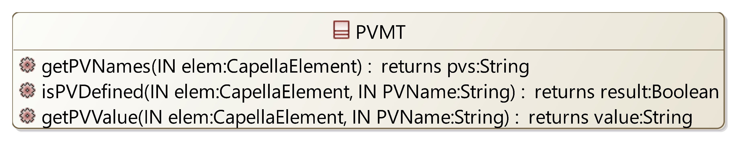

## [Type] PVMT

Description:

*No description*

Direct super types:

*No direct super type*

Direct sub-types:

*No direct sub-type*

Possible parent elements:

*No possible parent defined*

Attributes:

*No attribute defined*

Relations:

*No relation defined*

Methods:

|  |  |  |  |
| --- | --- | --- | --- |
| **Method** | **Description** | **IN Param** | **Result** |
| getPVNames |  | elem: CapellaElement | pvs: String |
| isPVDefined |  | elem: CapellaElement  PVName: String | result: Boolean |
| getPVValue |  | elem: CapellaElement  PVName: String | value: String |

# [Package] Requirement

Diagrams:

Here are the diagrams of representing the elements introduced in this package:

[CDB] Requirement:

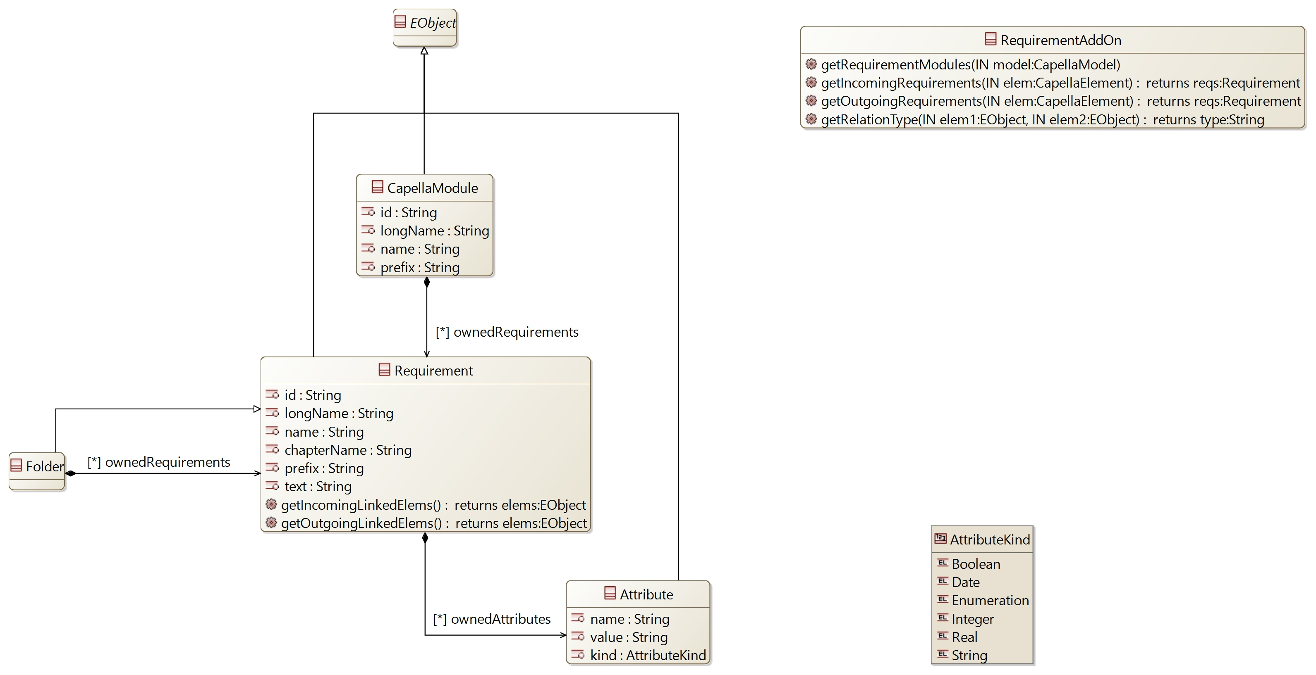

## [Type] RequirementAddOn

Description:

*No description*

Direct super types:

*No direct super type*

Direct sub-types:

*No direct sub-type*

Possible parent elements:

*No possible parent defined*

Attributes:

*No attribute defined*

Relations:

*No relation defined*

Methods:

|  |  |  |  |
| --- | --- | --- | --- |
| **Method** | **Description** | **IN Param** | **Result** |
| getRequirementModules |  | model: CapellaModel |  |
| getIncomingRequirements |  | elem: CapellaElement | reqs: Requirement |
| getOutgoingRequirements |  | elem: CapellaElement | reqs: Requirement |
| getRelationType |  | elem1: EObject  elem2: EObject | type: String |

## [Type] CapellaModule

Description:

*No description*

Direct super types:

* **EObject**

Direct sub-types:

*No direct sub-type*

Possible parent elements:

*No possible parent defined*

Attributes:

|  |  |  |
| --- | --- | --- |
| **Attribute name** | **Attribute type** | **Defined on** |
| id | String | *defined on type* |
| longName | String | *defined on type* |
| name | String | *defined on type* |
| prefix | String | *defined on type* |

Relations:

|  |  |  |  |  |
| --- | --- | --- | --- | --- |
| **Ref. name** | **Kind** | **Card.** | **Target Type** | **Defined on** |
| ownedDiagrams | COMPOSITION | [0 *] | **Diagram** | **EObject** |
| elementOfInterestForDiagrams | ASSOCIATION | [0 *] | **Diagram** | **EObject** |
| contextualElementForDiagrams | ASSOCIATION | [0 *] | **Diagram** | **EObject** |
| representingDiagrams | ASSOCIATION | [0 *] | **Diagram** | **EObject** |
| ownedRequirements | COMPOSITION | [0 *] | **Requirement** | *defined on type* |

Methods:

*No method defined*

## [Type] Requirement

Description:

*No description*

Direct super types:

* **EObject**

Direct sub-types:

* **Folder**

Possible parent elements:

* CapellaModule
* Folder

Attributes:

|  |  |  |
| --- | --- | --- |
| **Attribute name** | **Attribute type** | **Defined on** |
| id | String | *defined on type* |
| longName | String | *defined on type* |
| name | String | *defined on type* |
| chapterName | String | *defined on type* |
| prefix | String | *defined on type* |
| text | String | *defined on type* |

Relations:

|  |  |  |  |  |
| --- | --- | --- | --- | --- |
| **Ref. name** | **Kind** | **Card.** | **Target Type** | **Defined on** |
| ownedDiagrams | COMPOSITION | [0 *] | **Diagram** | **EObject** |
| elementOfInterestForDiagrams | ASSOCIATION | [0 *] | **Diagram** | **EObject** |
| contextualElementForDiagrams | ASSOCIATION | [0 *] | **Diagram** | **EObject** |
| representingDiagrams | ASSOCIATION | [0 *] | **Diagram** | **EObject** |
| ownedAttributes | COMPOSITION | [0 *] | **Attribute** | *defined on type* |

Methods:

|  |  |  |  |
| --- | --- | --- | --- |
| **Method** | **Description** | **IN Param** | **Result** |
| getIncomingLinkedElems |  |  | elems: EObject |
| getOutgoingLinkedElems |  |  | elems: EObject |

## [Type] Folder

Description:

*No description*

Direct super types:

* **Requirement**

Direct sub-types:

*No direct sub-type*

Possible parent elements:

* CapellaModule
* Folder

Attributes:

|  |  |  |
| --- | --- | --- |
| **Attribute name** | **Attribute type** | **Defined on** |
| id | String | **Requirement** |
| longName | String | **Requirement** |
| name | String | **Requirement** |
| chapterName | String | **Requirement** |
| prefix | String | **Requirement** |
| text | String | **Requirement** |

Relations:

|  |  |  |  |  |
| --- | --- | --- | --- | --- |
| **Ref. name** | **Kind** | **Card.** | **Target Type** | **Defined on** |
| ownedDiagrams | COMPOSITION | [0 *] | **Diagram** | **EObject** |
| elementOfInterestForDiagrams | ASSOCIATION | [0 *] | **Diagram** | **EObject** |
| contextualElementForDiagrams | ASSOCIATION | [0 *] | **Diagram** | **EObject** |
| representingDiagrams | ASSOCIATION | [0 *] | **Diagram** | **EObject** |
| ownedAttributes | COMPOSITION | [0 *] | **Attribute** | **Requirement** |
| ownedRequirements | COMPOSITION | [0 *] | **Requirement** | *defined on type* |

Methods:

*No method defined*

## [Type] Attribute

Description:

*No description*

Direct super types:

* **EObject**

Direct sub-types:

*No direct sub-type*

Possible parent elements:

* Requirement
* Folder

Attributes:

|  |  |  |
| --- | --- | --- |
| **Attribute name** | **Attribute type** | **Defined on** |
| name | String | *defined on type* |
| value | String | *defined on type* |
| kind | **AttributeKind** | *defined on type* |

Relations:

|  |  |  |  |  |
| --- | --- | --- | --- | --- |
| **Ref. name** | **Kind** | **Card.** | **Target Type** | **Defined on** |
| ownedDiagrams | COMPOSITION | [0 *] | **Diagram** | **EObject** |
| elementOfInterestForDiagrams | ASSOCIATION | [0 *] | **Diagram** | **EObject** |
| contextualElementForDiagrams | ASSOCIATION | [0 *] | **Diagram** | **EObject** |
| representingDiagrams | ASSOCIATION | [0 *] | **Diagram** | **EObject** |

Methods:

*No method defined*

## [Enumeration] AttributeKind

List of values:

* Boolean
* Date
* Enumeration
* Integer
* Real
* String

Used by:

* **Attribute**